JavaScript Data Structures & Algorithms

DSA for the Cracking the Coding Interview. Animated Examples for Faster Learning and Deeper Understanding.

Instructor: Scott Barrett
links: https://www.udemy.com/course/data-structures-algorithms-javascript/

Table of Contents
1. Header 1 3
1.1 Header 2 3
1.1.1 Header 3 3
2. sdfsdf 4
2.1 dfgdfg 4
2.1.1 dfgvdfg 4

BigO notation
BigO notations a technique that allows us to “measure” (theoretically) code efficiency.
We can measure Time Complexity and Space Complexity.
Notation | Ω | θ | O
Greek letter | Omega | Theta | Omicron
Describes | Best case | Average case | Worst case

Time Complexity | Example | On graph | Description
O(1) | simple command | horizontal line | constant
O(log n) | sorting algorithms |  | divide and conquer
O(n) | simple loop | straight line | proportional
O(n^2) | loop within a loop | parabola | parabolic

BigO has a few main rules that allow us to simplify the process
1. Drop the constants
O(n) + O(142n) + O(333) = O(143n+333) = O(n)
2. Drop non-dominants
O(n^2) + O(125n^2) + O(3n) + O(125) = O(n^2 + 125n^2 + 3n + 125) = O(n^2)
3. Different Terms Of Input
O(n) + O(m) = O( m+n )
O(n) * O(m) = O( n*m )
https://www.bigocheatsheet.com/
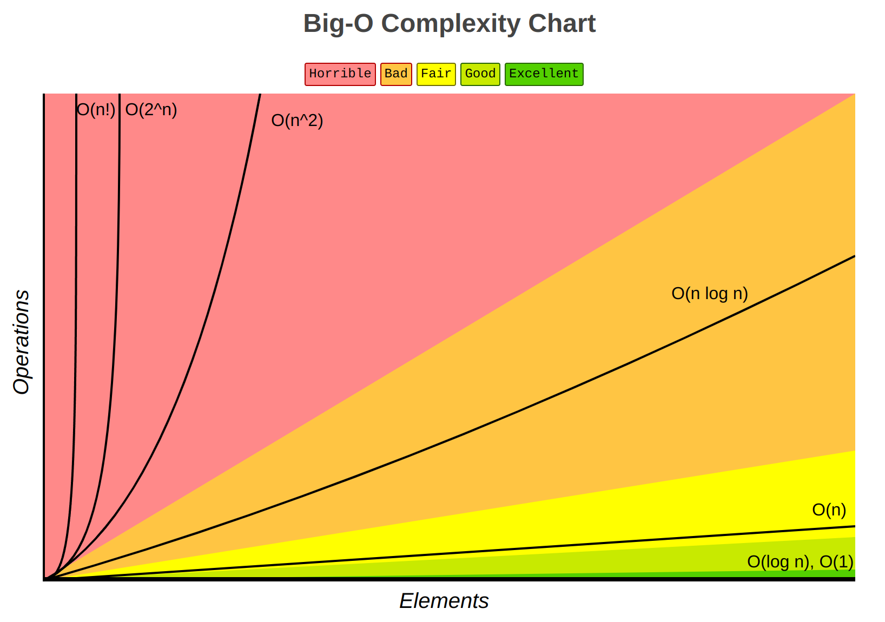

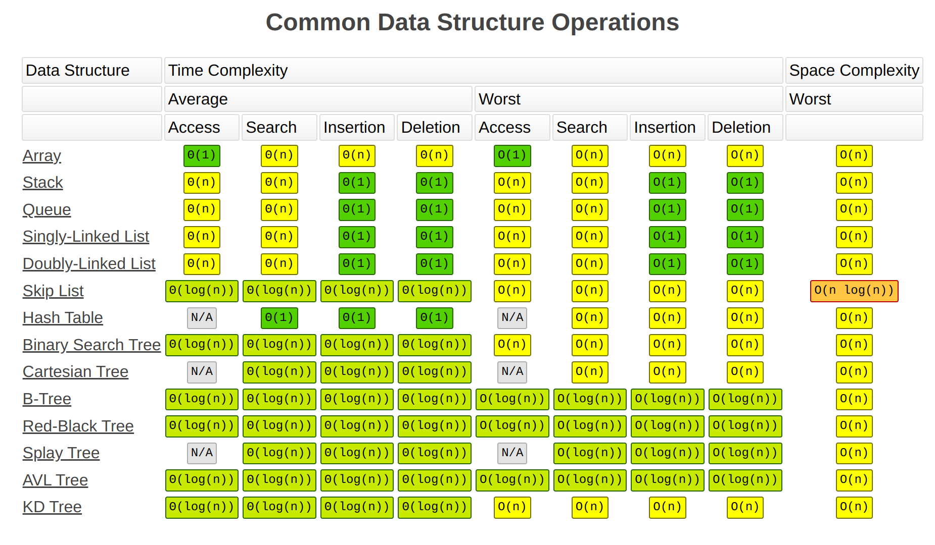
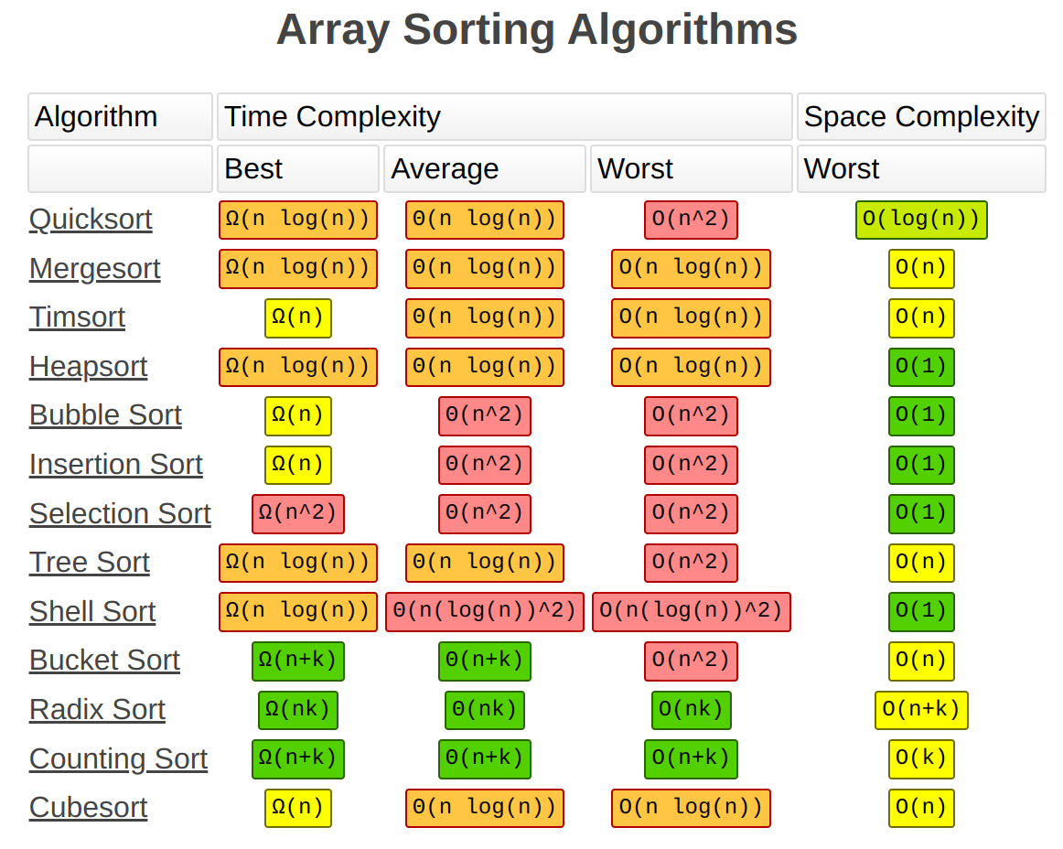

Classes and Pointers
class Cookie {
constructor(color) {
this.color = color;
}
}
const cookie1 = new Cookie('red');
const cookie2 = new Cookie('blue');

console.log('Cookie #1 is ', cookie1);
console.log('Cookie #2 is ', cookie2);
console.log(`Cookie #2 has ${cookie2.color} color!`);

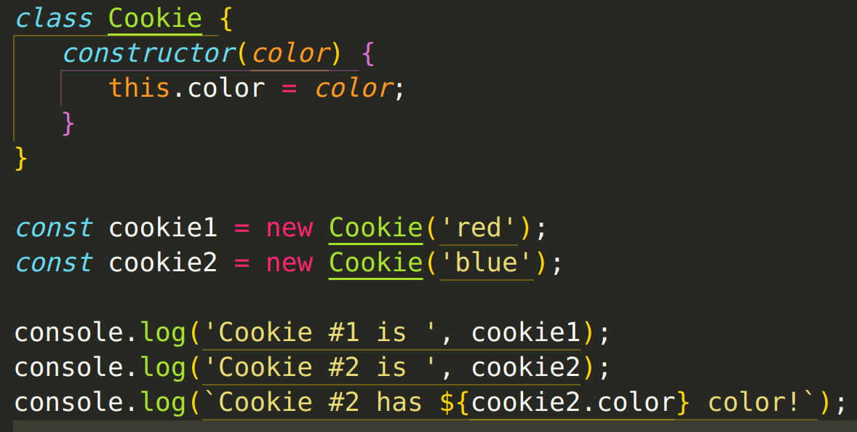
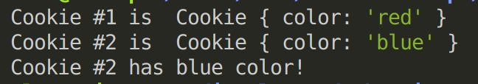

class CookieAdvanced {
constructor(color) {
this.color = color;
}
getColor() {
return this.color;
}
setColor(newColor) {
return (this.color = newColor);
}
}
const cookie1a = new CookieAdvanced('red');
const cookie2a = new CookieAdvanced('blue');
console.log('CookieAdvanced #1 is ', cookie1a);
console.log('CookieAdvanced #2 is ', cookie2a);
console.log(`CookieAdvanced #2 has ${cookie2.color} color!`);
console.log(cookie1a.getColor());
cookie1a.setColor('cyan');
console.log('CookieAdvanced #1 is ', cookie1a);
console.log('CookieAdvanced #2 is ', cookie2a);
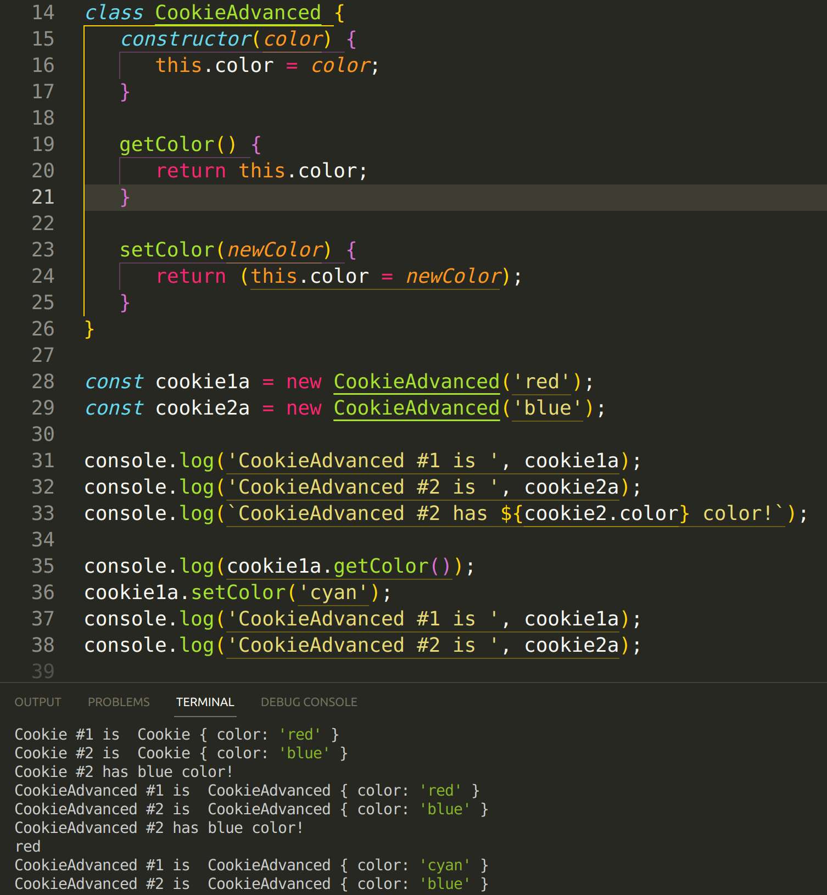
console.clear();
let object1 = { value: 555 };
let object2 = object1;
console.log('\n Object 1 is: ', object1);
console.log(' Object 2 is: ', object2);

object1.value = 10;
console.log('\n Object 1 is: ', object1);
console.log(' Object 2 is: ', object2);
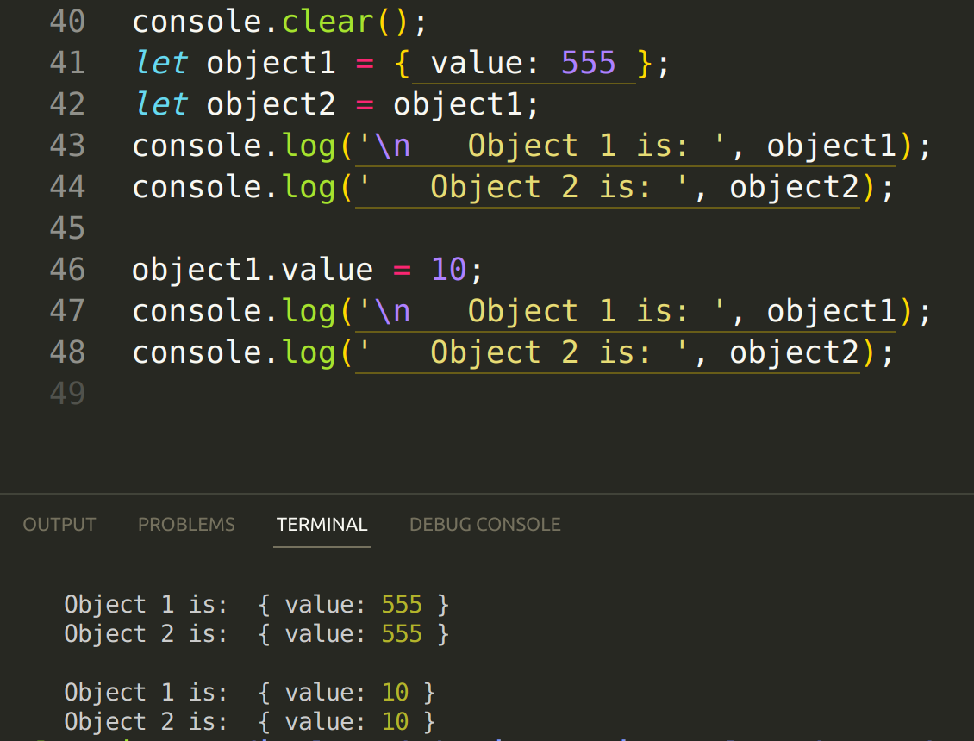
https://github.com/ILopatenko/dsa-course.git
3. Linked List
