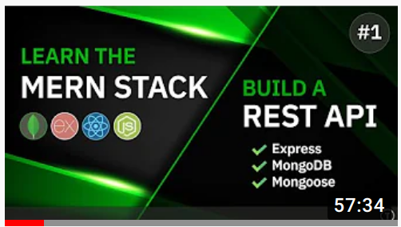
Learn The MERN Stack -
Express & MongoDB Rest API

YOUTUBE
express
dotenv
mongoose
colors

nodemon

Table of Contents
1. Project initial setup 3
1.1 Create an empty gitHub repository for the project 3
1.2 Clone the repository to the local computer 3
1.3 Initialize a new NPM project 3
1.4 Project structure 3
1.5 Install additional packages 3
1.6 Change the start npm script 3
2. Backend 5
3. Frontend 6

1. Project initial setup

1.1 Create an empty gitHub repository for the project

1.2 Clone the repository to the local computer
CLI=> git clone https://github.com/ILopatenko/mern-app.git

1.3 Initialize a new NPM project
CLI=> npm init -y

1.4 Project structure
All the files that belongs to backend should be stored inside ./backend folder
Main backend file – ./backend/server.js

1.5 Install additional packages
CLI=> npm i express dotenv mongoose colors
CLI=> npm i -D nodemon

1.6 Change the start npm script
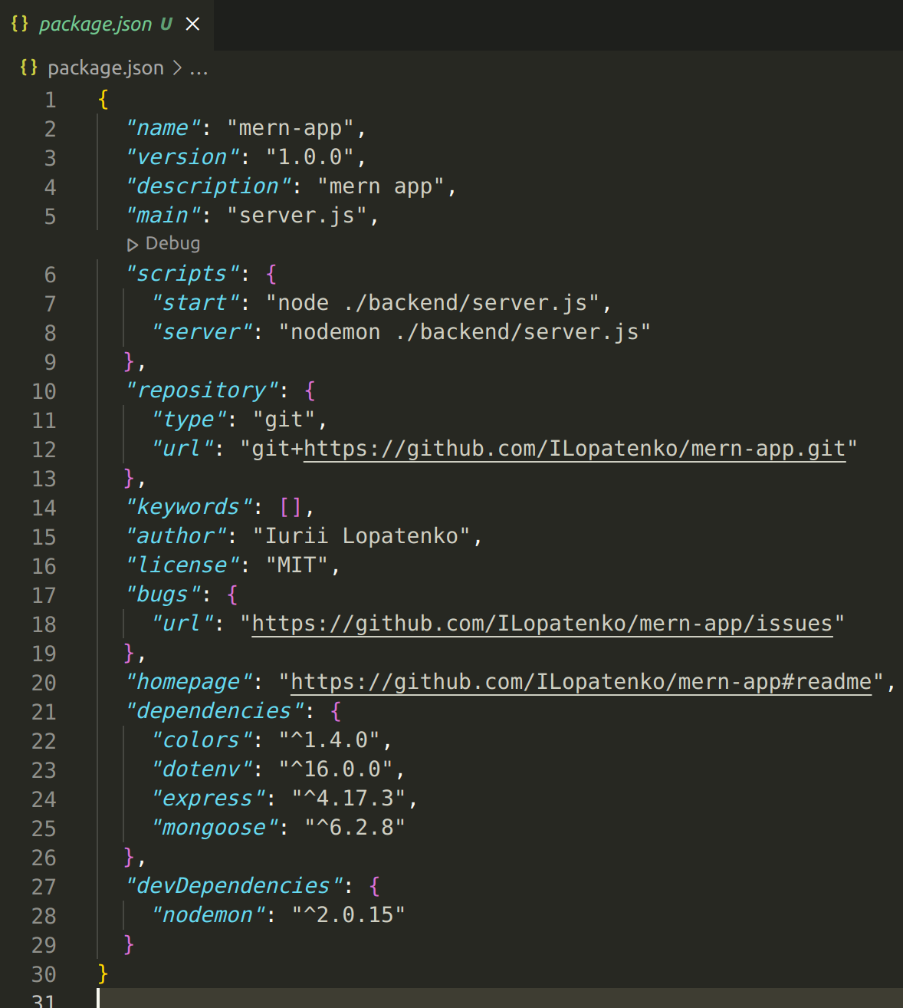
Now I can use npm run start to start my server with node.js and npm run server to start my server with nodemon

2. Backend

3. Frontend

