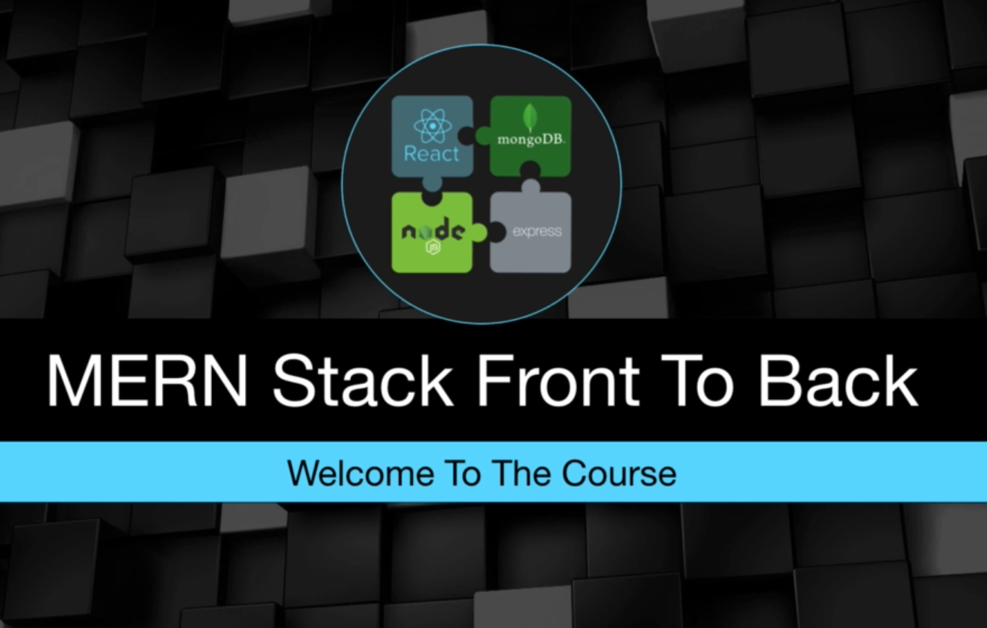

MERN Stack Front To Back: Full Stack React, Redux & Node.js (2020)

https://www.udemy.com/course/mern-stack-front-to-back/
by Brad Traversy

Table of Contents
0. Introduction 3
0.1 Environment & Setup 3
0.1.1 Node.js 3
0.1.2 Visual Studio Code (VSC) 3
0.1.3 GIT 3
0.1.4 Postman 4
0.1.5 React Developer Tools chrome extension 4
0.1.6 Redux DevTools chrome extension 4
0.1.7 VSC extensions 4
1. Express & MongoDB Setup 5
1.1 MongoDB (create a new cluster for project) 5
1.1 Express (install a package and setup a server) 6
1.2 Create a connection with mongoDB. 9
1.3 Create routes. 11
What was used in project? 14

0. Introduction
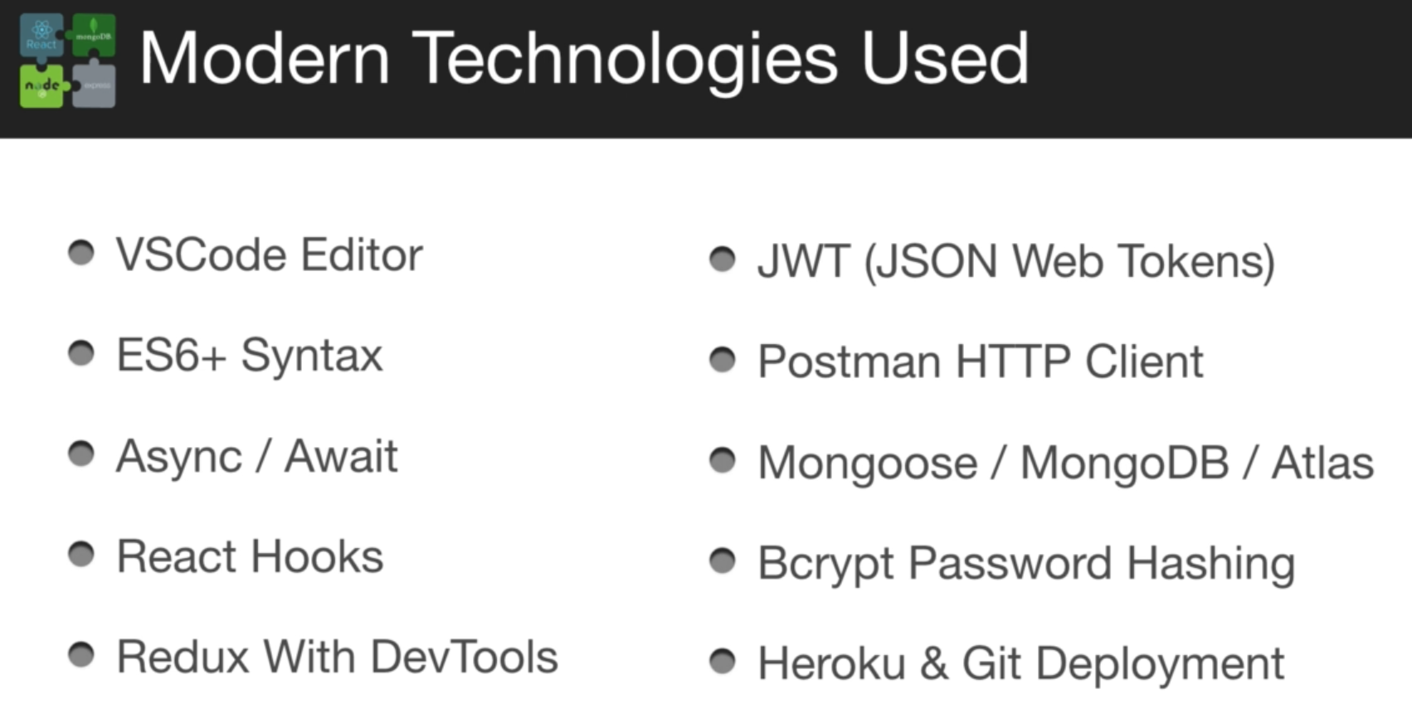

0.1 Environment & Setup

0.1.1 Node.js
Windows: https://nodejs.org/en/ - just download and install with GUI.
Linux:
CLI=> sudo apt-get update
CLI=> sudo apt install curl build-essential
CLI=> curl -sL https://deb.nodesource.com/setup_14.x | sudo -E bash -
CLI=> sudo apt install -y nodejs
CLI=> node -v [=> v14.16.1]

0.1.2 Visual Studio Code (VSC)
Windows: https://code.visualstudio.com/ - just download and install with GUI.
Linux:
CLI=> sudo apt-get update
CLI=> sudo apt install code

0.1.3 GIT
Windows: https://git-scm.com/ just download and install with GUI.
Linux: GIT is a basic component

0.1.4 Postman
Windows: https://www.postman.com/ - just download and install with GUI.
Linux: https://www.postman.com/downloads/ - download archive tar.gz https://dl.pstmn.io/download/latest/linux64

go to download folder and unpack that file with command tar xvzf [PACKAGENAME].tar.gz
CLI=> tar xvzf Postman-linux-x64-8.6.1.tar.gz
go to folder and use shortcut

0.1.5 React Developer Tools chrome extension

0.1.6 Redux DevTools chrome extension

0.1.7 VSC extensions
- Bracket Pair Colorizer - https://marketplace.visualstudio.com/items?itemName=CoenraadS.bracket-pair-colorizer
- ES7 React/Redux/GraphQL/React-Native snippets - https://marketplace.visualstudio.com/items?itemName=dsznajder.es7-react-js-snippets
- Prettier - Code formatter - https://marketplace.visualstudio.com/items?itemName=esbenp.prettier-vscode
VSC=>Manage=>Settings=> “format on save” should be enable

1. Express & MongoDB Setup

1.1 MongoDB (create a new cluster for project)
Create an account at https://www.mongodb.com/. Sign in to an account.
Create a new project – MERN-devconnector
Create a new cluster - Cluster0
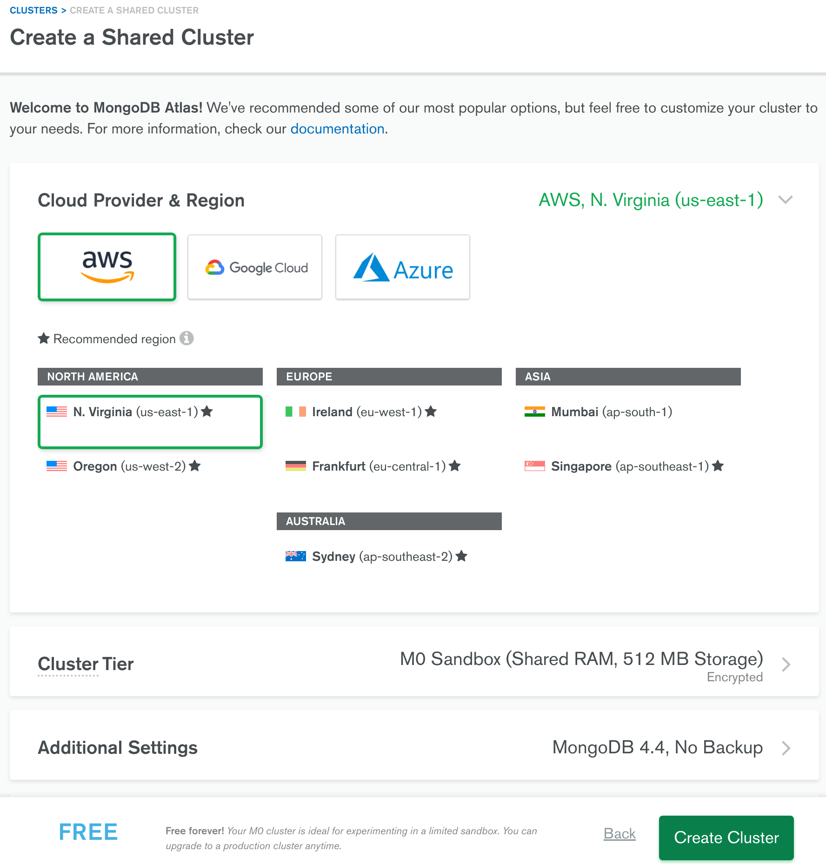
Push button “CONNECT” and add your IP adress and create a new database user to connect to a DB.
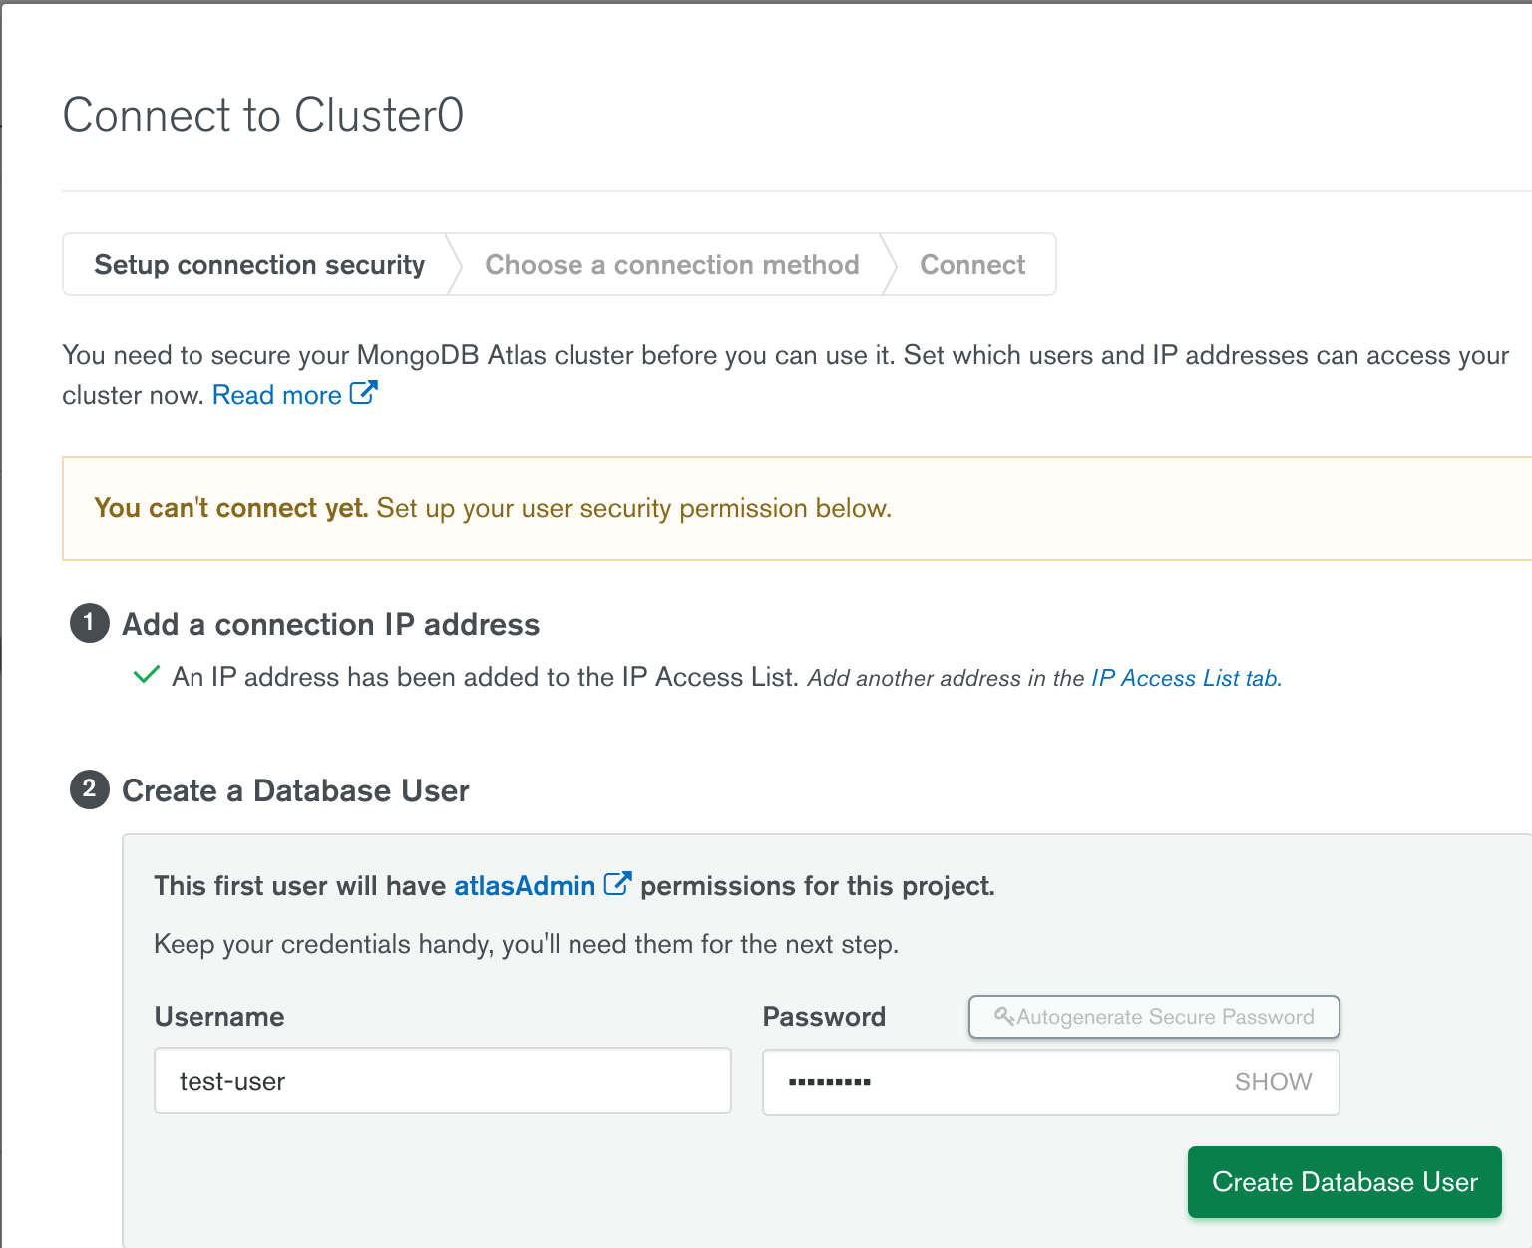
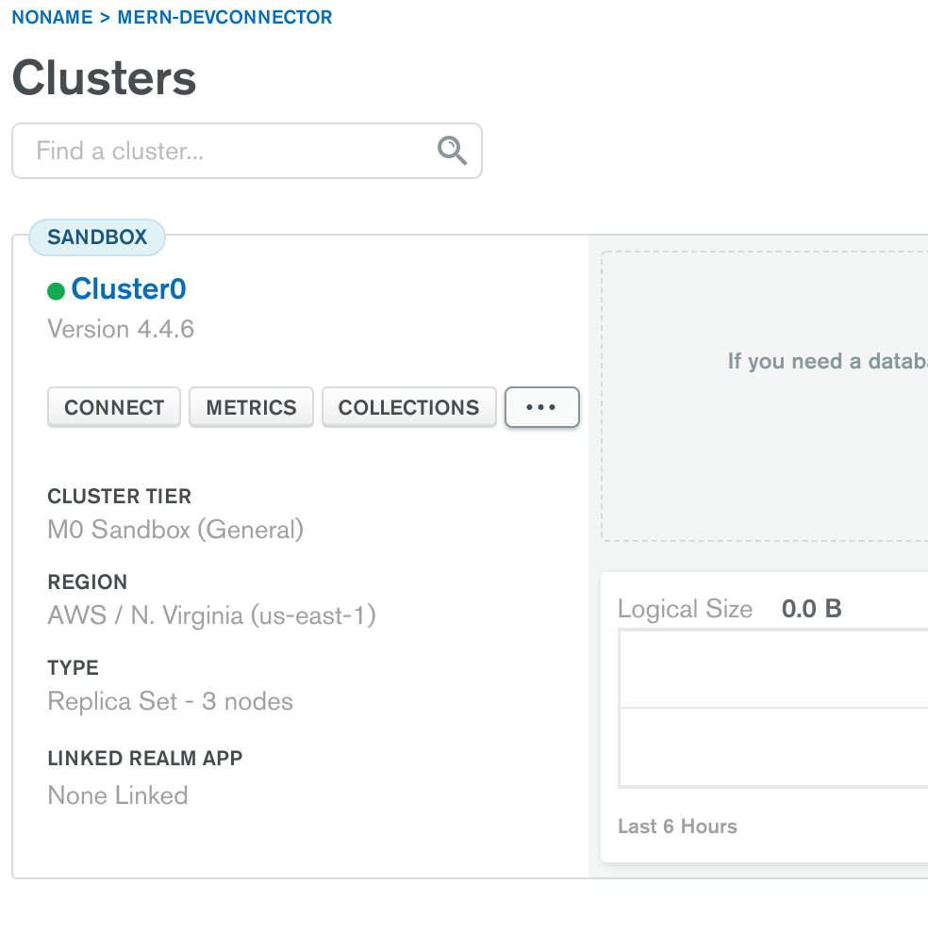
Push button “Choose a connection methood” and “connect your application” and save that link
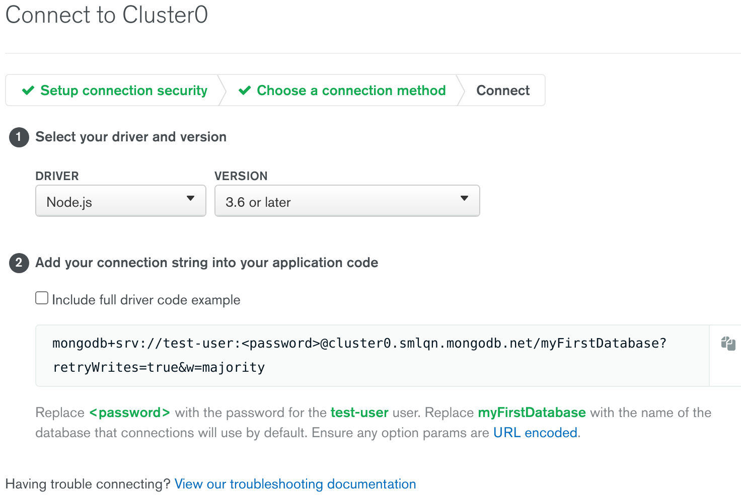

1.1 Express (install a package and setup a server)
1.1.1 Create a .gitignore file
It is a file with list of files/folders witch will be ignored by GIT. Add node_modules folder

1.1.2 Initialize an NMP project and setup entry point
CLI=> npm init -y
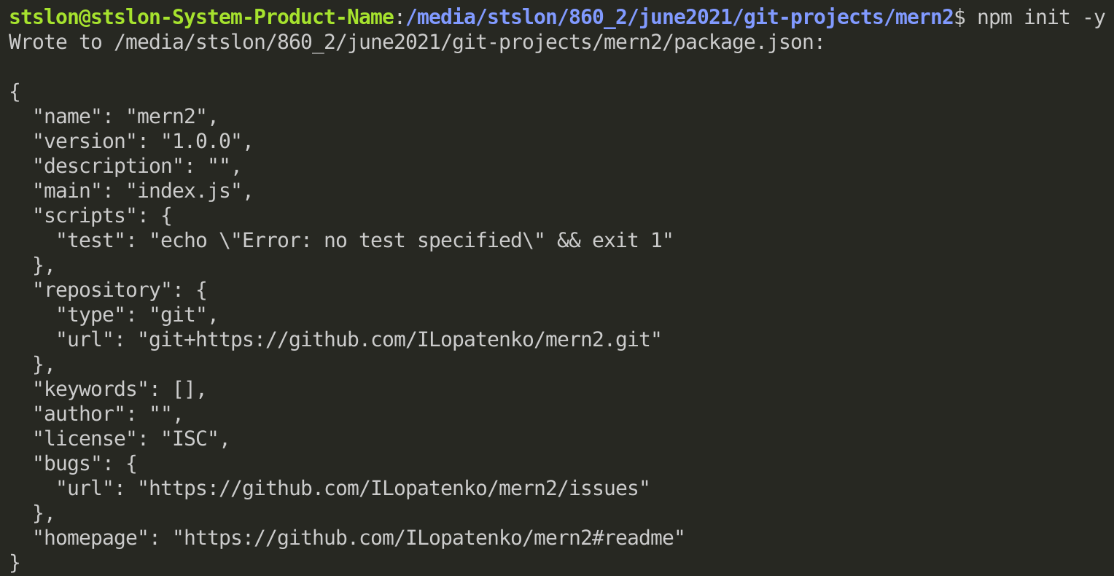
This command creates a new file package.json with basic information about project and all the dependencies. I’m going to change entry point (“main”:“server.js”) for this project to server.js

1.1.3 Install all the packages as regular dependencies
I’am going to use in this project next packages:
- express – backend server;
- express-validator – for validation data;
- bcryptjs – for making hash for passwords;
- config – for making global variables;
- gravatar – for working with user’s avatars;
- jsonwebtoken – for working with JWT;
- mongoose – for working with mongoDB database;
- request – for working with another API based services;
CLI=> npm install express express bcryptjs config gravatar jsonwebtoken mongoose request

1.1.4 Install all the packages as DEV dependencies
DEV dependencies will be installed without direct reference to a project (npm will add them to package.json file as a devDependencies)
- nodemon – will track all the changes and make a restart server automatically;
- concurrently – allows me to run few scripts at the same time with a single command;
CLI=> npm install -D nodemon concurrently
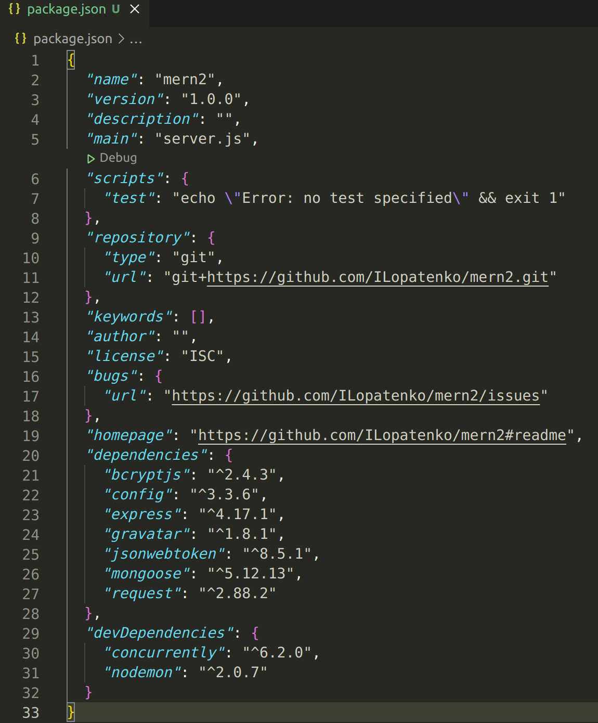
1.1.5 Create an express server
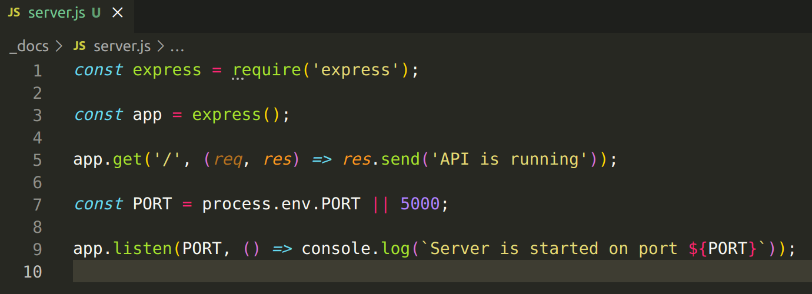

1.1.6 Change run script at package.json
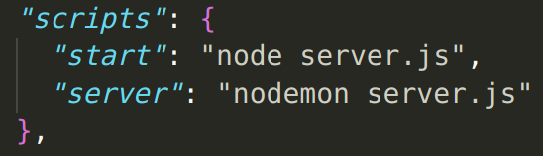
Now command “npm run start” will run server.js with node.js and command “npm run server” will run server.js with nodemon

1.1.7 The first run
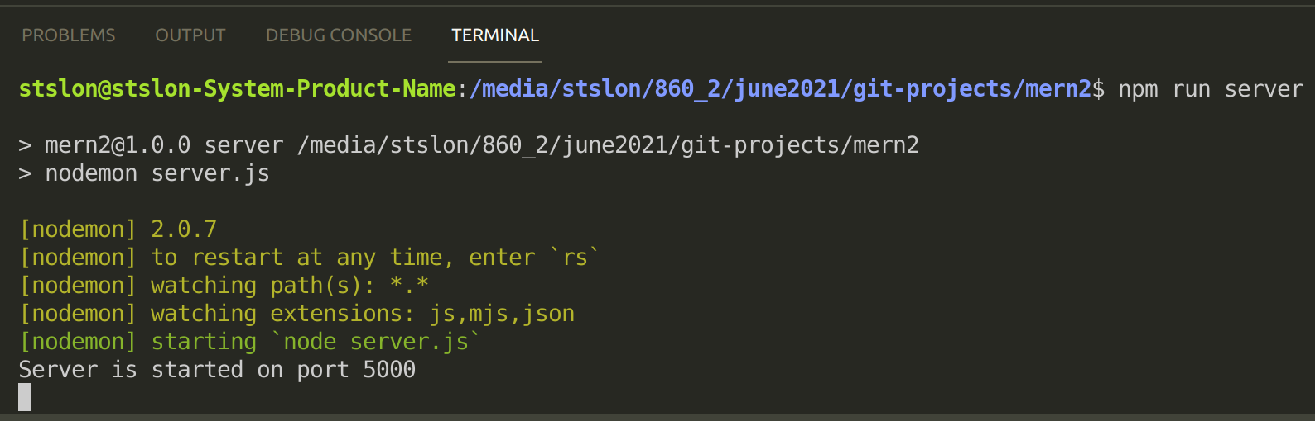
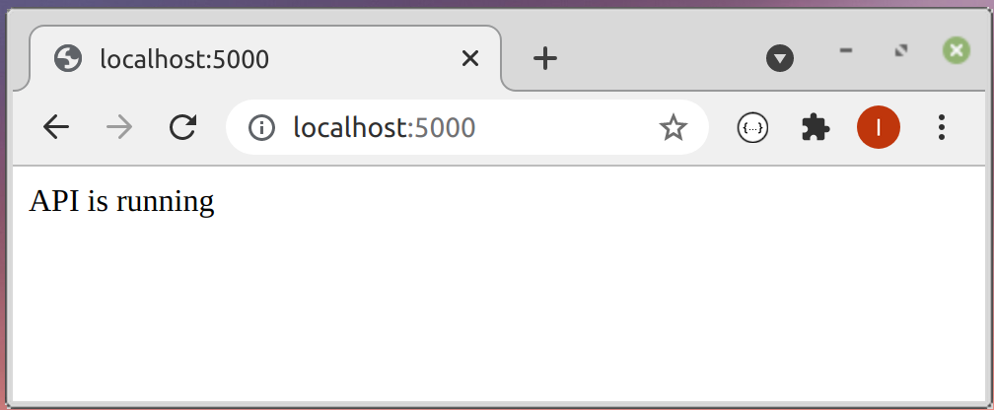
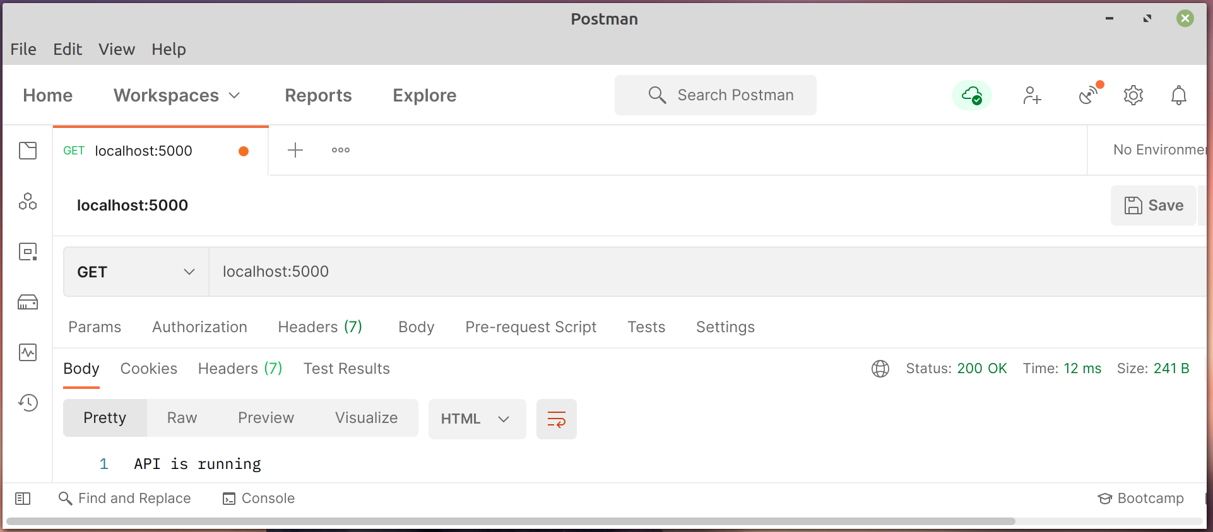

1.2 Create a connection with mongoDB.
Create a new folder config. Inside this folder create a new file – default.json – with information to connect with a database
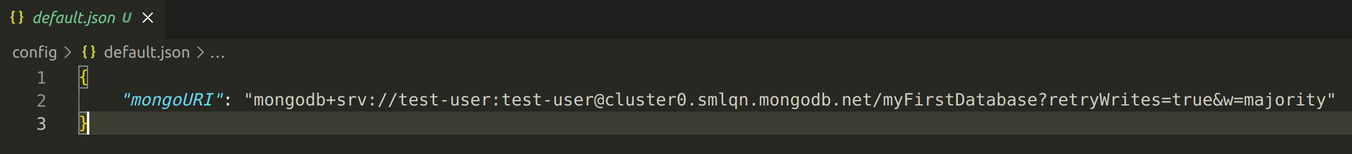
Create a new file – db.js – with connection logic
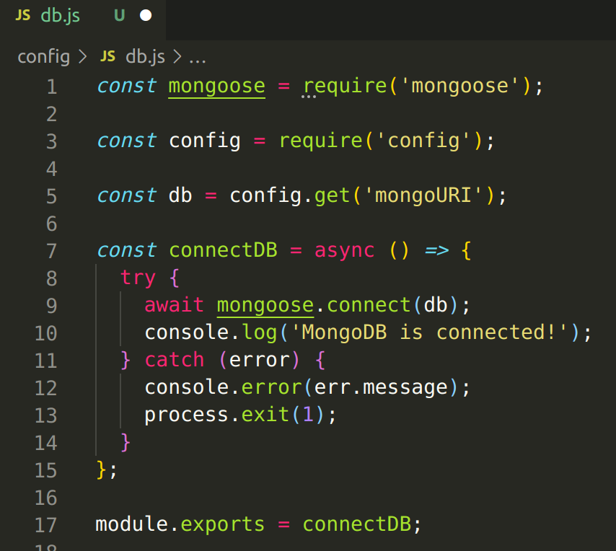
Add db.js to a server.js
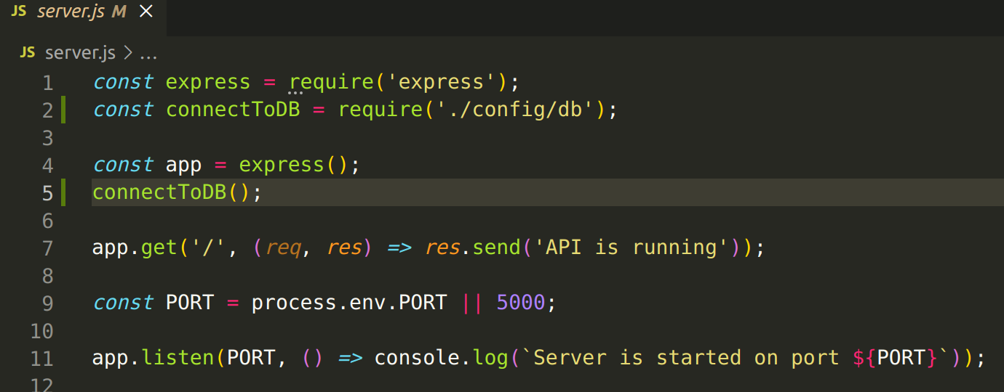
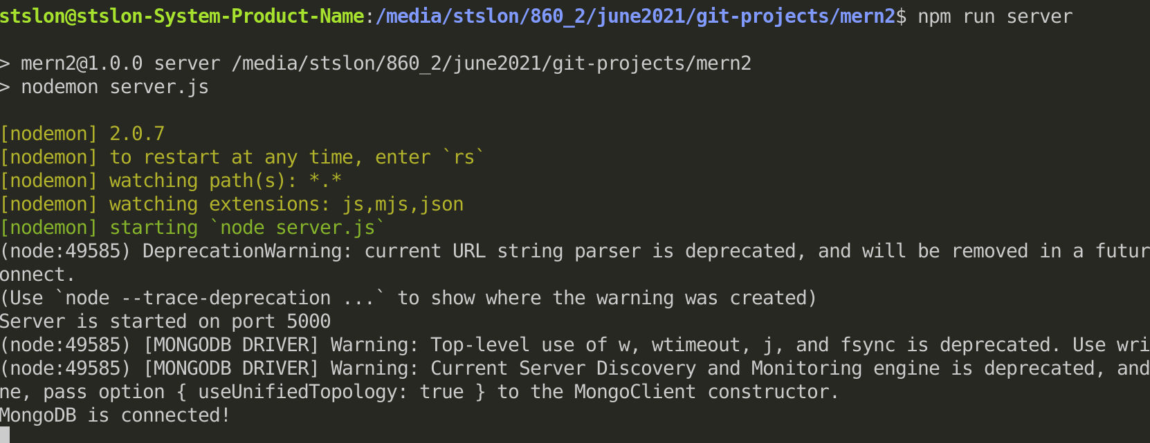
Fix all the warnings and run a server again:
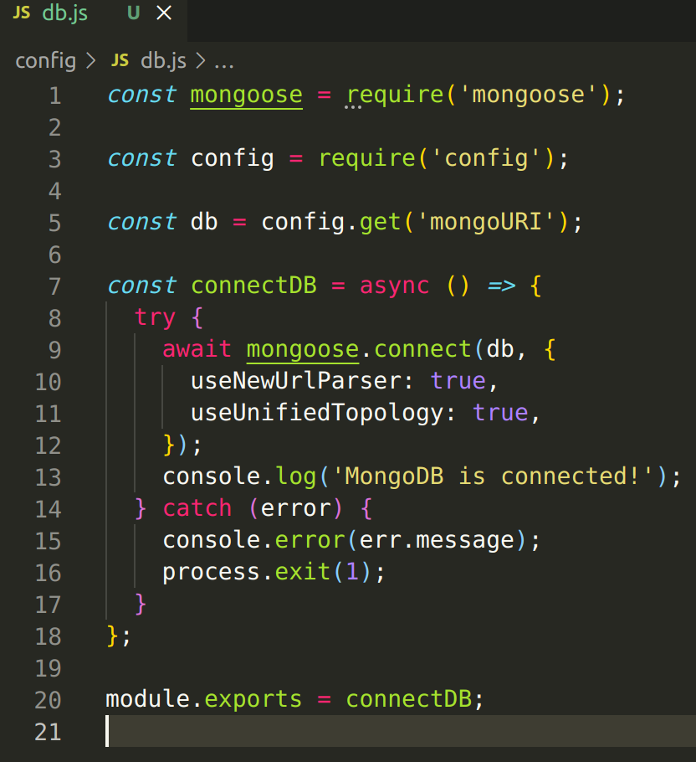
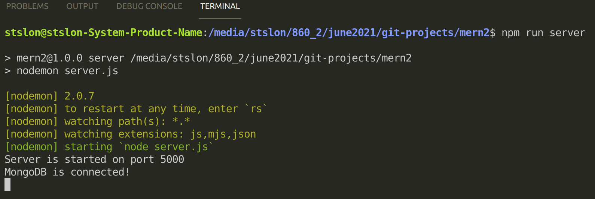

1.3 Create routes.
Create a new folder – routes/api – to store and work with all the routes.
Inside this folder create new files – user.js, profile.js, post.js and auth.js
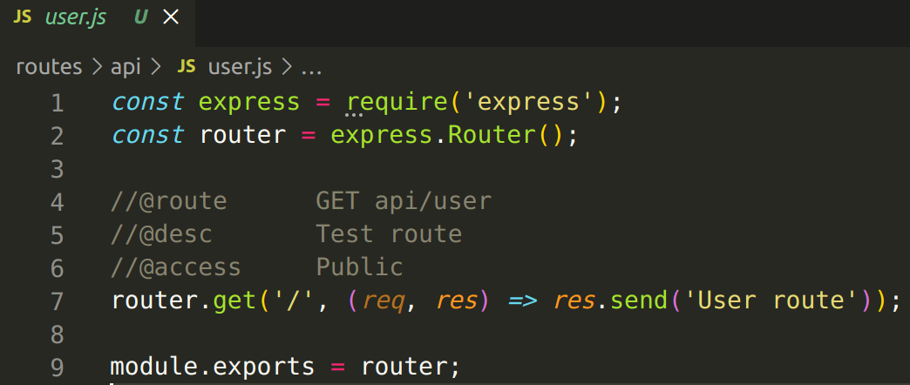
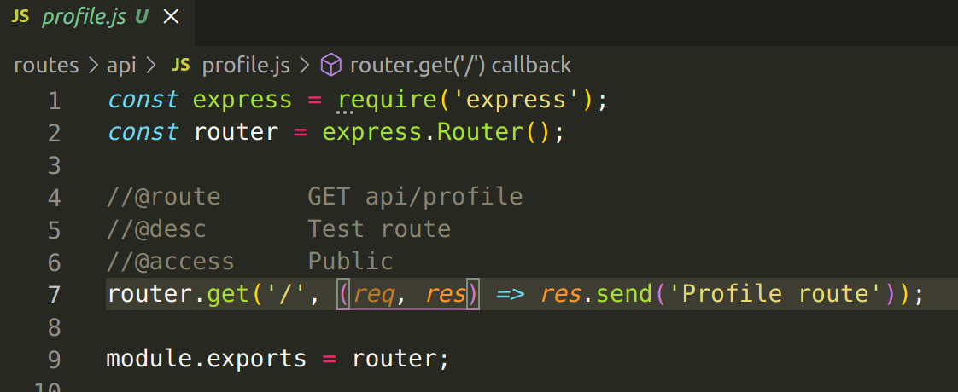
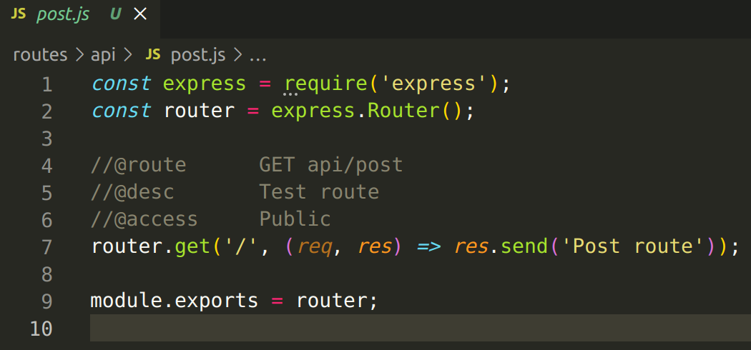
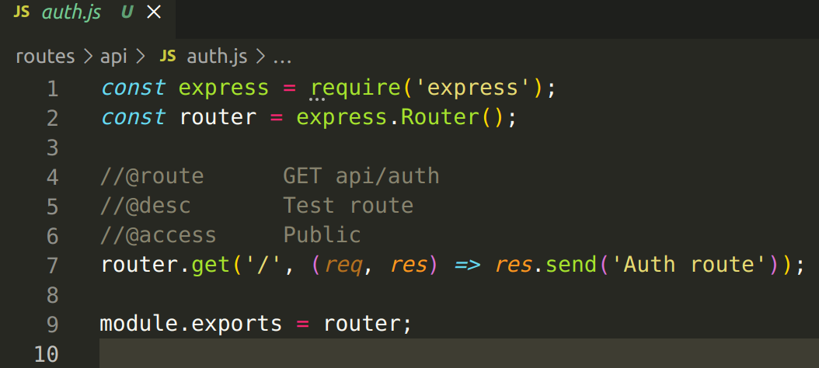
Add all these routes to server.js
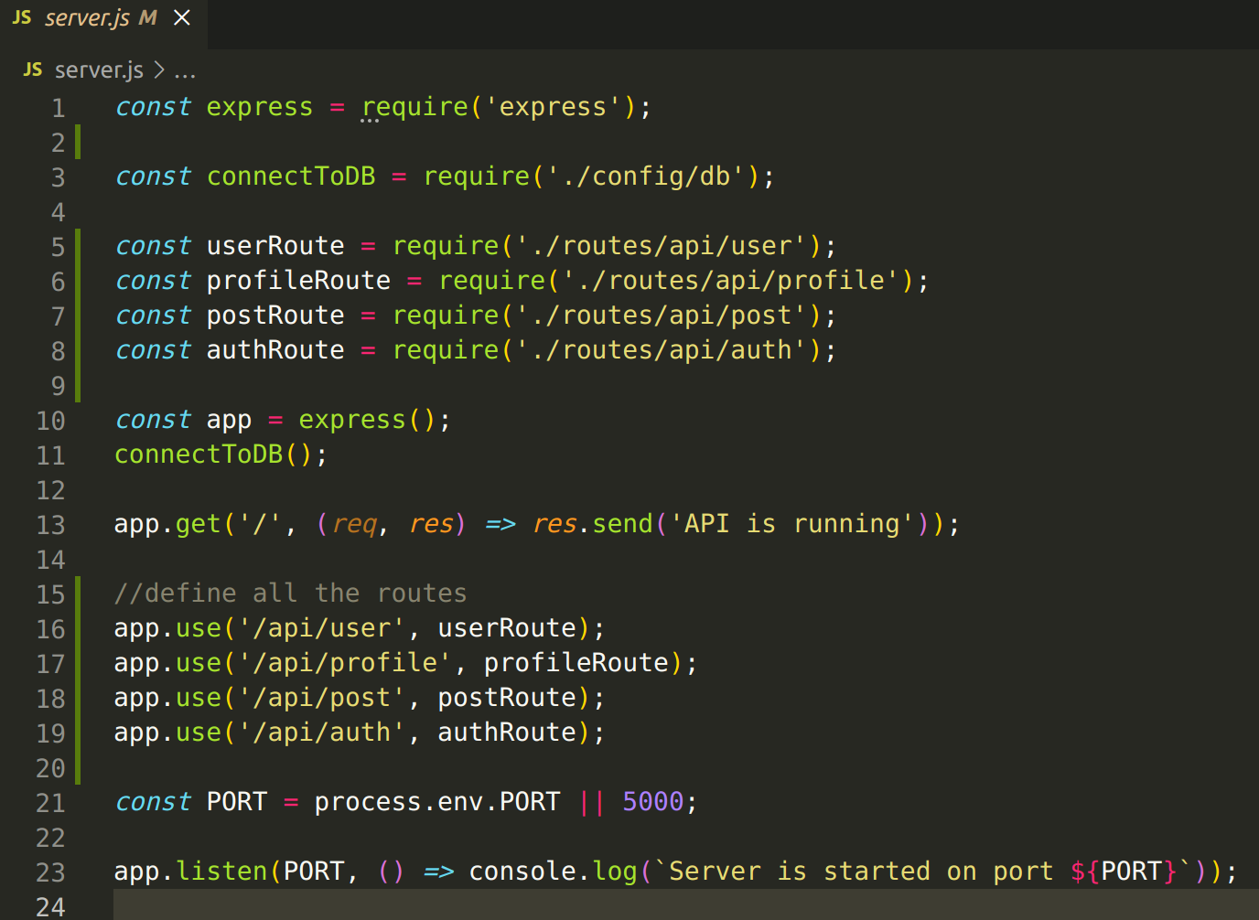
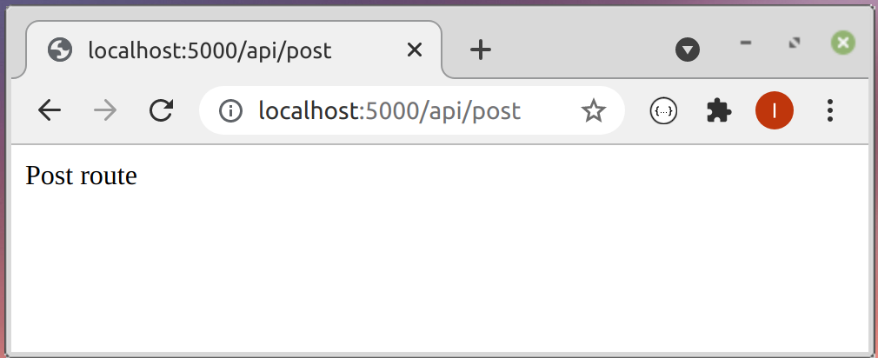
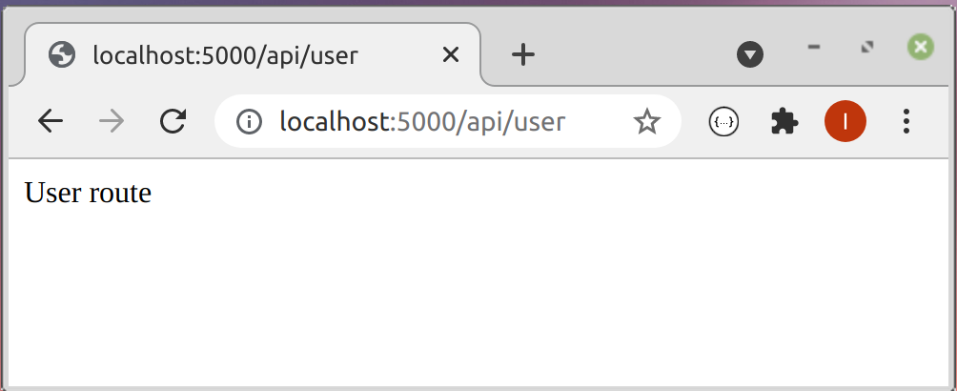
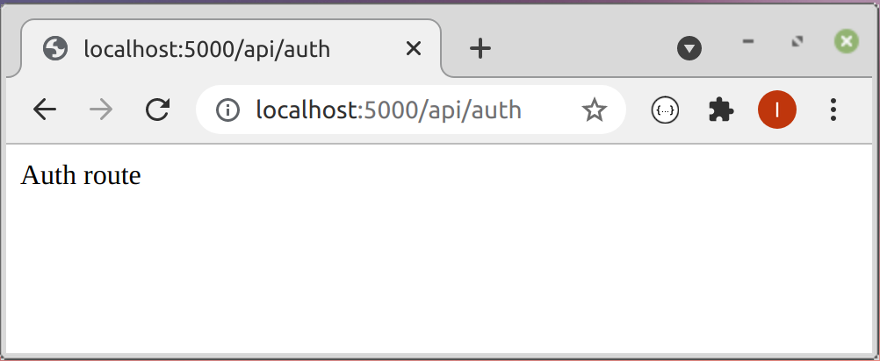
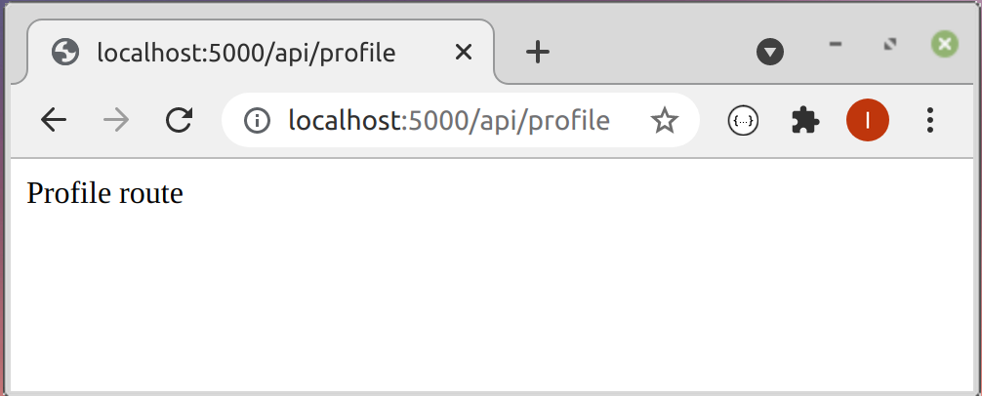
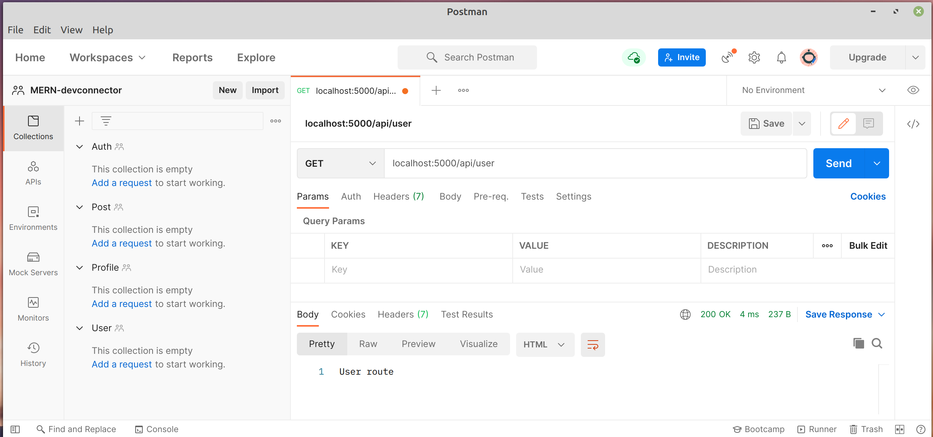

What was used in project?
Operating Systems: Linux Mint 20.1 and Windows 10

Node.js – javascript runtime enviroment.
NPM
GIT -

MongoDB
Mongoose

nodemon
postman

