[PICTURE]

Bash Mastery: The Complete Guide to Bash Shell Scripting

Master Bash Shell Scripting to Automate Tasks, Save Time, and Boost Your Career. Practical Projects + All Code Included.

https://www.udemy.com/course/bash-mastery/

Table of Contents
1 How to build a bash script 3
1.1 Intro 3
1.2 Shell vs Script 3
1.4 Core components of BASH script 3
1.5 PRO components of BASH script 3
1.6 Setting up secure script permissions 4
1.8 system PATH 4
2 Variables and shell expansions 5
2.1 Intro 5
2.2 User-defined variables and shell expansions 5
2.3 Shell/environment variables 5
2.4 Parameter expansion tricks 6
2.6 Command substitution $(command) 6
2.9 Arithmetic expansion 6
2.10 Decimal numbers with bc command 7
2.12 Tilda expansion 7
2.14 Brace expansion 7

1 How to build a bash script

1.1 Intro
Check that your default shell is BASH
CLI=> echo $SHELL
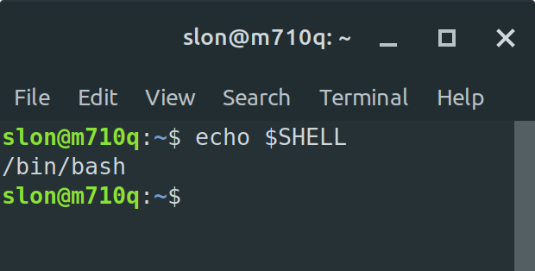
It should be bash. If it isn’t use next command
CLI=> chsh -s /bin/bash

1.2 Shell vs Script
Shell is a program that interprets the commands that you type in your terminal and passes them to the OS.
The purpose of the shell is to make it more convenient for you to issue commands to your computer.

There are lots of different shells. But we are going to use BASH.
BASH = Bourne Again Shell (it based on Bourne Shell – SH – that was created by Stephen Bourne in 1979).

BASH script is a file that contains commands for the BASH shell. Shell reads commands 1-by-1 and execute them.

1.4 Core components of BASH script
1. Each script should have the same first line:
#!/bin/bash
2. Some commands
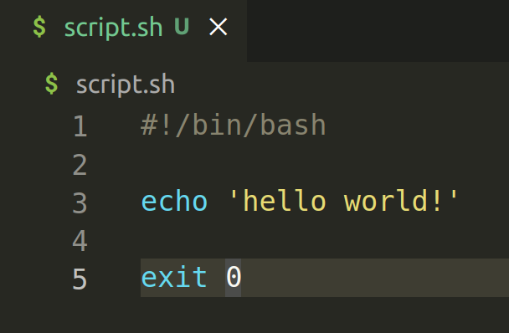
3. Exit statement (not required)
Technically your script don’t need the file extension.
Your script should be executable.
CLI=> chmod +x script.sh
Now you can run your script:
CLI=> ./script.sh

1.5 PRO components of BASH script
For comments you can use #
It might a good idea to add into your script info about your name, date of creation, short description and how to use it.

1.6 Setting up secure script permissions
To view file permissions you can use
CLI=> ls -l
- rwx rwx rwx 1 root root 40 Oct 17 15:39 script.sh
The first symbol shows a type. Dash (-) means that it is a file. (d) means that it is a directory.
Next 3 symbols show permissions for the owner of this file (read-wrire-execute).
Next 3 symbols show permissions for the owner group of this file (read-wrire-execute).
Next 3 symbols show permissions for the other users (read-wrire-execute).

Read – 4
Write – 2
Execute – 1

You can set permissions using 3-digit number
CLI=> chmod 711 script.sh

1.8 system PATH
You can check all the system paths using:
CLI=> echo $PATH

Main file with the settings is /home/slon/.profile
you can open it with any text editor (nano in my case):
CLI=> nano ~/.profile

You can add a link to your local folder with all the scripts
export PATH="$PATH:/media/860-files/_projects_/open-docs/_LINUX/_SHELL_SCRIPTING/1/files/1"

Now you need to update that system parameters
CLI=> source $PATH

and check that your folder is a system path now
CLI=> echo $PATH

After all these actions you can execute any bash scripts (that are stored in that folder) from any folder

2 Variables and shell expansions

2.1 Intro
Variables allow us to store useful data under convenient names.
Shell expansions are very powerful features that allow us to retrieve data, process command output and perform calculations.

2.2 User-defined variables and shell expansions
Parameter is any entity that stores values. Shell parameters are used to store and reference useful data that we can use in our scripts.

There are 3 main types of shell parameters:
1. Variables
2. Positional parameters.
3. Special parameters.

Variable is a parameter that we can manually change.

#!/bin/bash
student="John"
echo "Hello ${student}!"

!don’t use any spaces next to equal sign
!naming convention – only lower case letters
!parameter expansion it’s when shell insert value of your variable/parameter (${student} OR just $student)

2.3 Shell/environment variables
Shell variables can be:
1. Bourne shell variables (were introduced in bourne shell in 1979) – 10 in total
PATH variable stores the list of folders that the shell will search for executable files to run as command names.
HOME variable stores the absolute path to the current user’s home directory.
USER variable stores the username of the current user.
HOSTNAME variable stores the name of the current computer.
HOSTTYPE variable stores the type of processor architecture the current computer is using.
PS1 variable stores the prompt string shown in the terminal before each command.
2. BASH shell variables (were introduced in more modern BASH shell) – about 95 in total

2.4 Parameter expansion tricks
Changing (actually value of the variable won’t be changed) text/string:
1. Change the first letter to Lower Case – echo ${student,}
2. Convert string to Upper Lower – echo ${student,,}
3. Change the first letter to Upper Case (caret symbol) – echo ${student^}
4. Convert string to Upper Case – echo ${student^^}
5. Define a length of the string – echo ${#student}
6. Slicing – echo ${student:[OFSET]:[LENGTH]}

phrase="Hello world!"

Slicing from the beginning
echo ${word:0:5} //Hello
echo ${word:3:5} //lo wo
echo ${word:7} //orld! - slicing all the symbols from 7th symbol
echo ${word:7:} //empty string

Slicing from the end
echo ${word: -5:3} //orl - !PUT THE SPACE BEFORE -5 !
echo ${word: -5} //orld!

2.6 Command substitution $(command)
Command substitution is a shell feature that allows you to grab the output of a command and use it inside another commands
#!/bin/bash
time=$(date +%H:%m:%S)
echo "Hello ${USER^^}! It’s $time right now!"

2.9 Arithmetic expansion
#1/bin/bash
echo $((4+2))
x=25
y=5
echo "$x + $y = $(($x+$y))"
echo "ORDER OF PRECEDENCE:"
echo "1. Everything inside brackets ()"
echo "BRACKETS: 3 * (2 + 4) = $((3 * (2 + 4)))"
echo "2. Exponentiation (**)"
echo "EXPONENTIATION: $x + $y ** 2 = $((x+y**2))"
echo "3. Division (/), Multiplication (*) and Modular (%)"
echo "DIVISION: 3 + $x / $y = $((3+x/y))"
echo "MULTIPLICATION: 5 + $x * $y = $((5+x*y))"
echo "MODULAR: ($x + 1) % $y = $(((x+1)%y))"
echo "4. Addition (+) and Substraction (-)"
echo "ADDITION: $x + $y = $((x+y))"
echo "SUBSTRACTION: $x - $y = $((x-y))"

!By default we can work with INTEGERS only!

2.10 Decimal numbers with bc command
Bc is a tool that you can use inside your terminal to do some basic calculations.
You can pipe result of calculus to bc and setup how many symbols after dot you want to see
CLI=> echo “5/2” | bc //2
CLI=> echo "scale=2; 5/2" | bc //2.50
!In bc you need to use a^b instead of a**b!

2.12 Tilda expansion
Tilda (~) contains the path to the current user’s home directory
CLI=> echo ~ //home/slon
You can print out the absolute path to the home directory of another user:
CLI=> echo ~anotheruser //home/anotheruser

$PWD (OR ~+) and $OLDPWD (OR ~-)

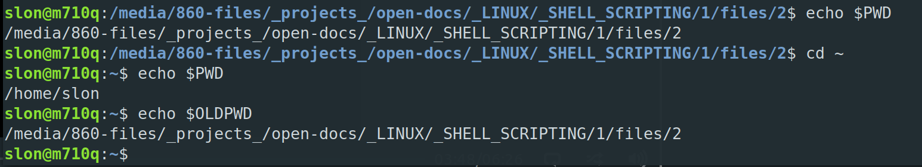
2.14 Brace expansion
String list
CLI=> echo {12,d,hello,true} //12 d hello true
Range list
CLI=> echo {1..10} //1 2 3 4 5 6 7 8 9 10
CLI=> echo {z..a} //z y x w v u t s r q p o n m l k j i h g f e d c b a
CLI=> echo {500..10000..2500} //500 3000 5500 8000
CLI=> echo month{1..12} //month1 month2 month3 month4 month5 month6 month7 month8 month9 month10 month11 month12
CLI=> echo month{01..12} //month01 month02 month03 month04 month05 month06 month07 month08 month09 month10 month11 month12
CLI=> echo month{01..12}
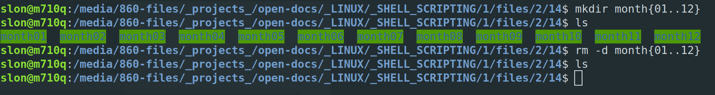
CLI=> mkdir month{01..12} //will create 12 new folders
CLI=> touch month{01..12}/day{01..31}.txt //will create 31 new text files in each folder
CLI=> ls month{01..12} //will print out content of each folder
CLI=> rm -dr month{01..12} //will delete all the folders with all the files
!You can use a string list the same way as an range list!
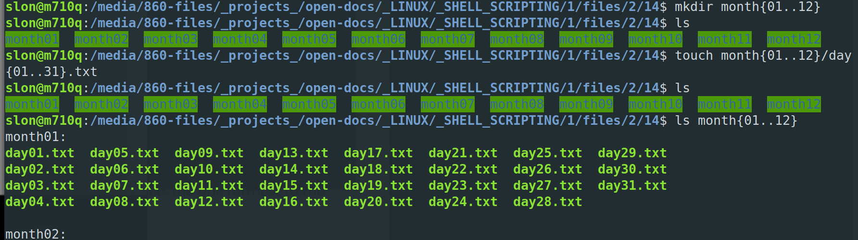

3 How bash processes command lines

3.2 Overview
Shell workflow:

Step 1 is Tokenisation.
Token is a sequence of characters that is considered as a single unit by the shell. Metacharacters (| & ; () <> space, tab and newline)
Word is a token that doesn’t contain a unquoted metacharachter.
Operator is a token that contain at least one unquoted metacharachter

Step 2 is Command Identification.
Simple commands are just a bunch of individual words, and each simple command is terminated by a control operator
Compound commands provide bash with it’s programming constructs (statements, loops etc.)

Step 3 is Shell Expansions.

Step 4 is Quote removal.

Step 5 is Redirections.

Step 6 is Execution the result.

3.3 Quoting
There are 3 main types of quotes:
1. backslashes (\) remove special meaning from NEXT character.
2. single quotes (') remove special meaning from ALL characters inside them.
3. double quotes (") remove special meaning from ALL EXCEPT dollar signs ($) and backticks (`).

3.4 Step 1 is Tokenisation.
Token is a sequence of characters that is considered as a single unit by the shell.
Metacharacter is a special symbol that you can use to mark a special action.
Bash recognizes 10 possible metacharacters:
- pipe (|),
- ampersand (&),
- semicolon (;),
- left and right parenthesis ( () ),
- less then (<) and greater than (>) signs
- widespase characters: space, tab and newline

Word is a token that doesn’t contain any unquoted metacharacters.
Operator is a token that contains at least 1 unquoted metacharacter.

There ate 2 main types of operators:
1. control operators: newline, |, ||, &, &&, ;, ;;, ;&, ;;&, |&; (, )
2. redirection operators: <, >, <<, >>, <&, >|, <<-, <>, >&
Control and redirection operators only matter if they are unquoted

3.7 Step 2 is Command Identification.
There are 2 main types of commands:
1. Simple commands (most common type): echo hello.
2. Compound commands are essentially bash’s programming constructs. Each compound command starts with a reserved word and is terminated by a corresponding reserved word (if, for, while etc.). Compound words can be written over multiple lines.

3.9 Step 3 is Shell Expansions.
There are 4 main stages:
Stage 1: brace expansion
Stage 2:
2.1 parameter expansion
2.2 arithmetic expansion
2.3 command substitution
2.4 tilde expansion
Stage 3: word splitting
Stage 4: globbing

3.11 Step 4 is Word splitting.
Word splitting is a process the shell performs to split the result of some unquoted expansions into separate words.

