PICTURE

The Git & Github Bootcamp

Master the essentials and the tricky bits: rebasing, squashing, stashing, reflogs, blobs, trees, & more!

https://www.udemy.com/course/git-and-github-bootcamp/

Table of Contents
1 General information 3
2 Introduction to Git 3
3 Installation and initial setup 3
3.5 Configuring Your Git Name & Email (015) 3
3.6-3.10 Terminal 3
4 Git Basics 4
4.1 What really matters in this section (021) 4
4.2 What is Git repository (repo) (022) 4
4.3 How to create (initialize) a new Git repository? (023) 4
4.4 Don’t initialize a new Git repository inside another (025) 4
4.5 Committing workflow (026) 4
4.6 Staging changes (027) 5
4.7 Creating a new commit (028) 6

1 General information

2 Introduction to Git

3 Installation and initial setup

3.5 Configuring Your Git Name & Email (015)
How to check that Git was installed (and to check the current version)?
CLI=> git --version
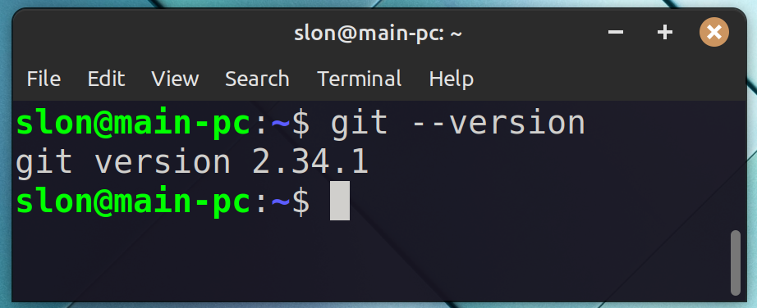
How to set information about current user (name and email)?
CLI=> git config --global user.name "Iurii Lopatenko"
CLI=> git config --global user.email "yalopatenko@gmail.com"

How to check information about git user?
CLI=> git config --global user.name
CLI=> git config --global user.email

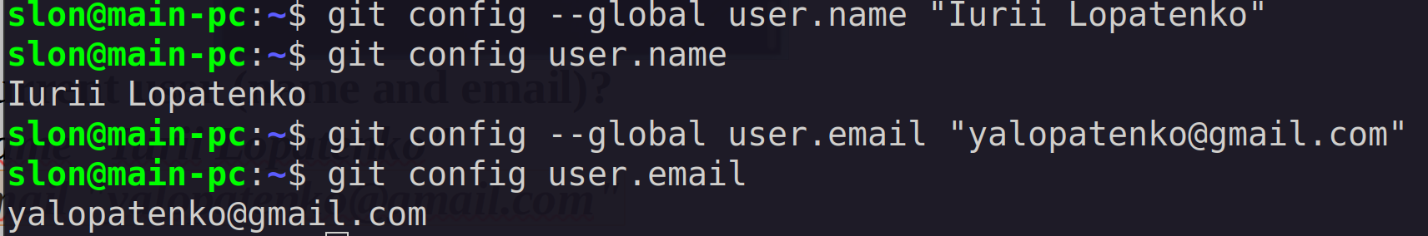
3.6-3.10 Terminal

4 Git Basics

4.1 What really matters in this section (021)

4.2 What is Git repository (repo) (022)
Git repository is a workspace which tracks and manages files within a folder.

4.3 How to create (initialize) a new Git repository? (023)
Open a folder with your files (existing project) or create a new folder to start working on a brand new project

BEFORE creating a new Git repository let’s change a default naming for the 1st (default) branch for all the local Git projects (according to a modern reality – the 1st branches will be called main instead of master)

CLI=> git config --global init.defaultBranch main
CLI=> git init
How to check that Git repository was created?
CLI=> git status
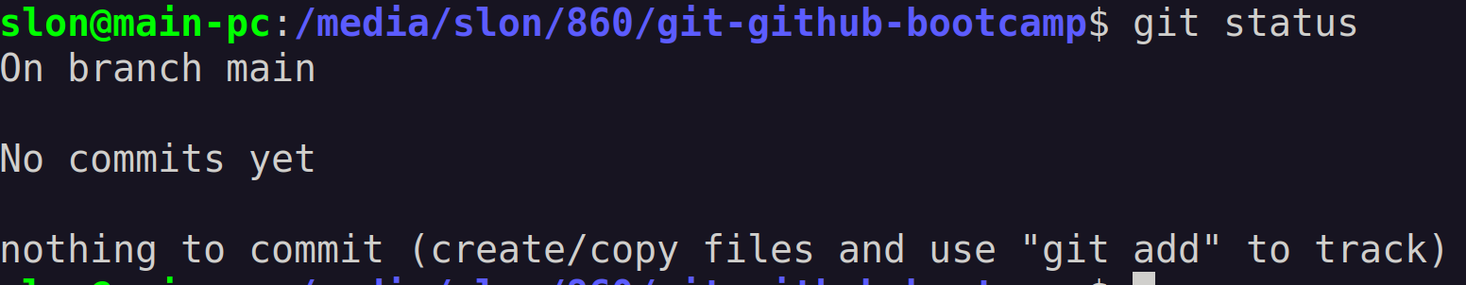

4.4 Don’t initialize a new Git repository inside another (025)

4.5 Committing workflow (026)
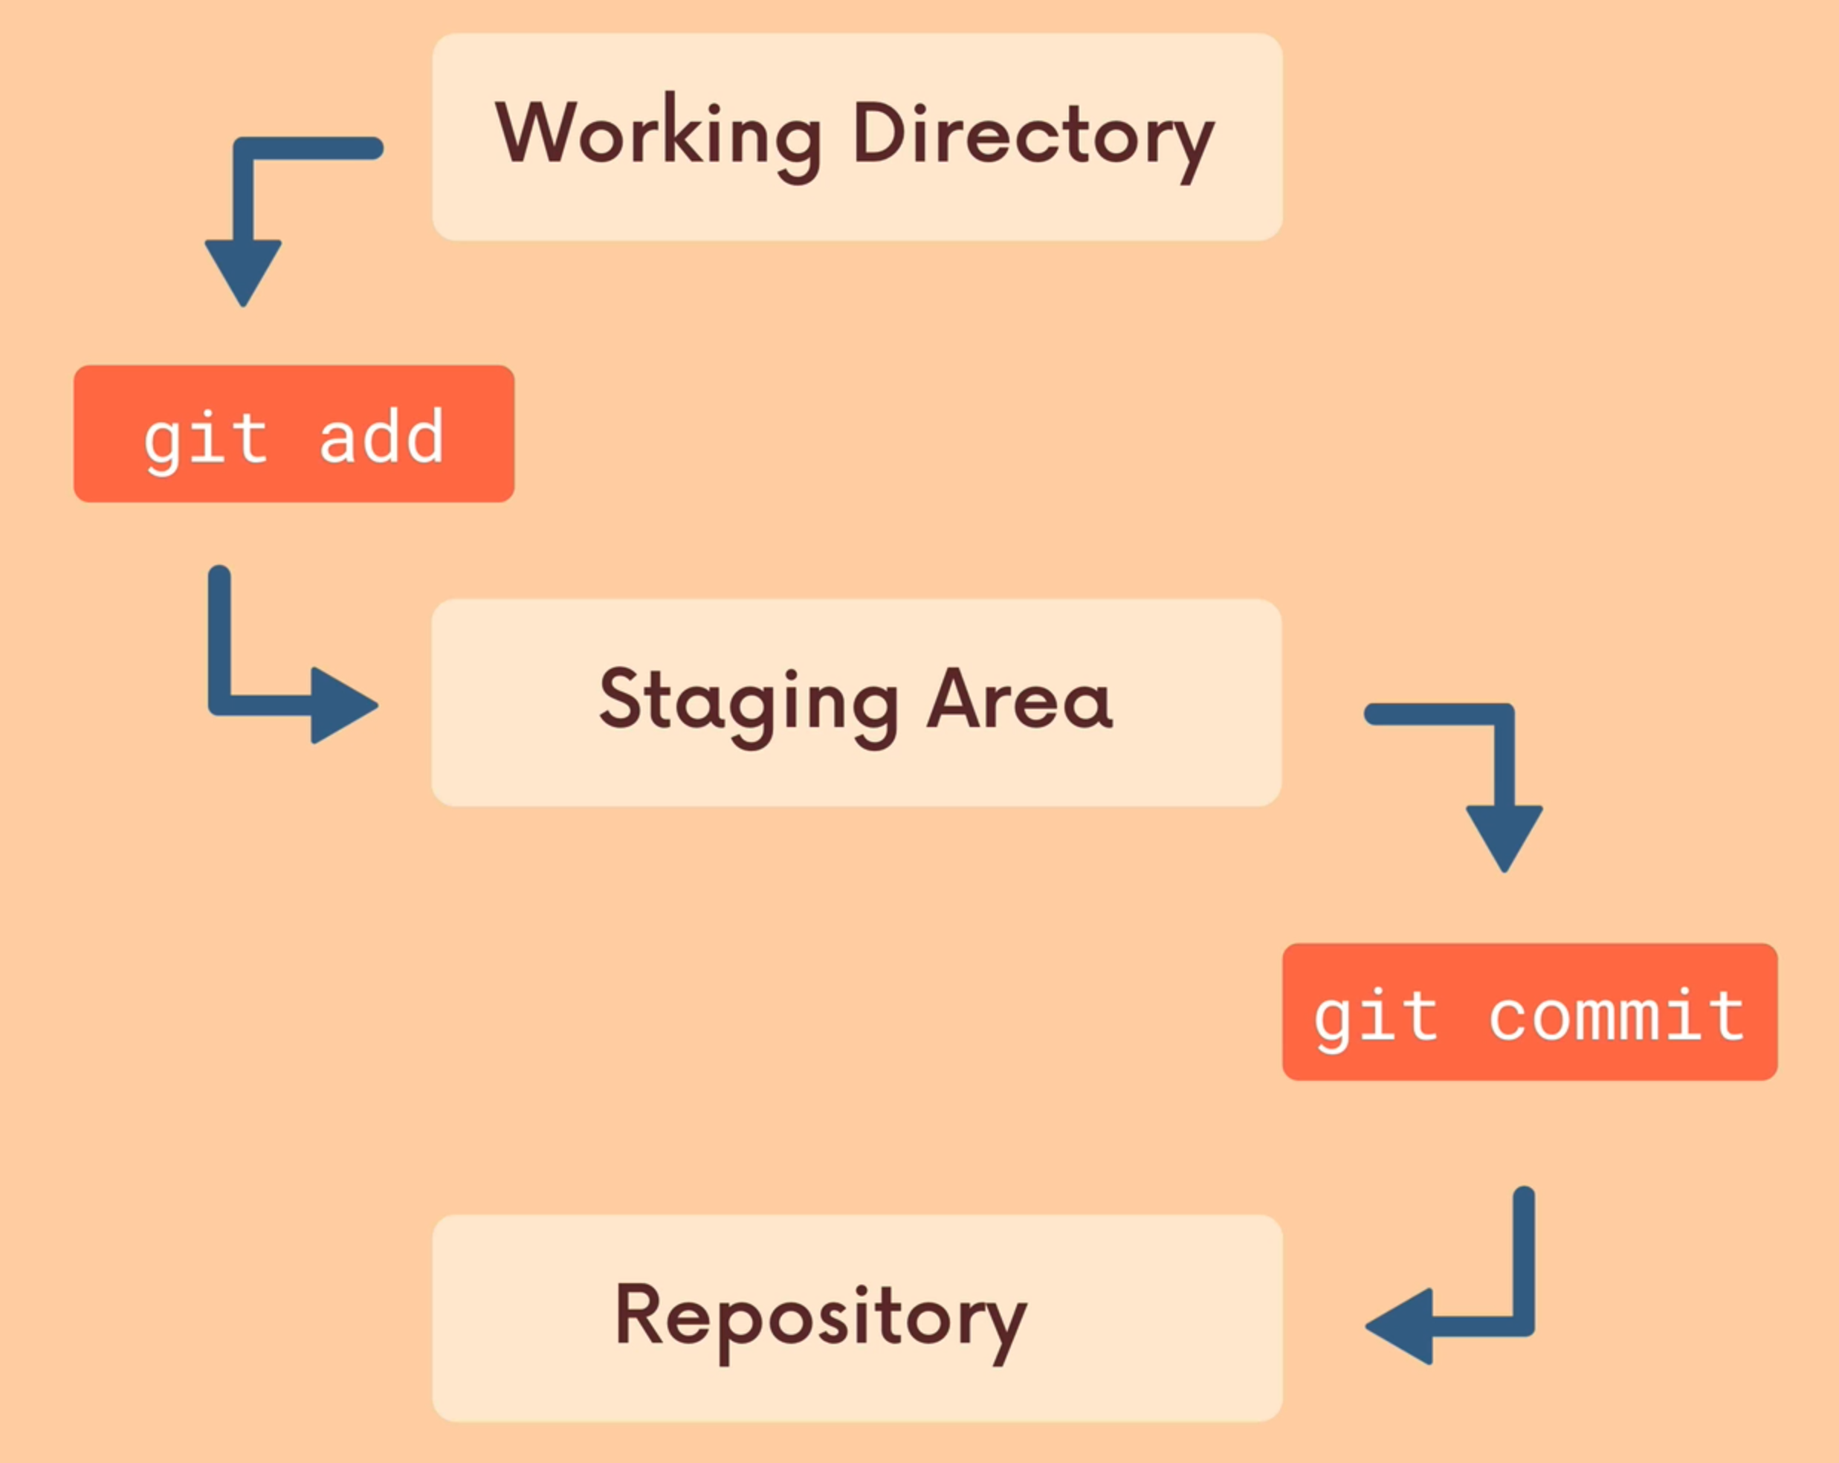

4.6 Staging changes (027)
First of all you need to make some changes. Let’s create 2 new files with some content.
CLI=> echo "console.log('Hello World')" > index.js
CLI=> echo "console.log('some text')" > description.txt
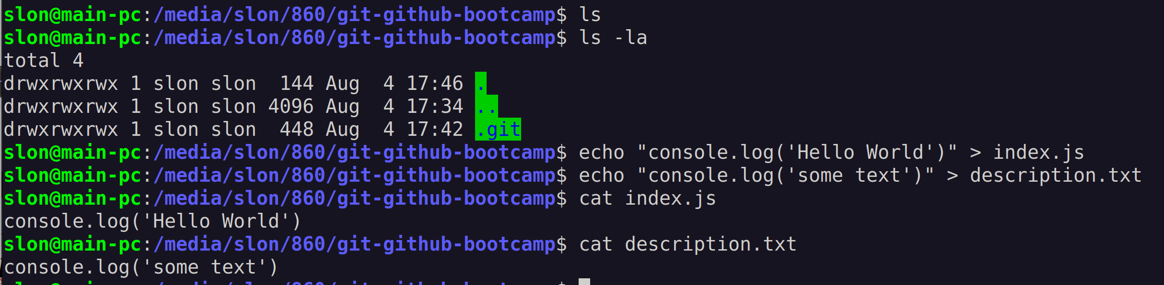
Let’s check all the changes
CLI=> git status
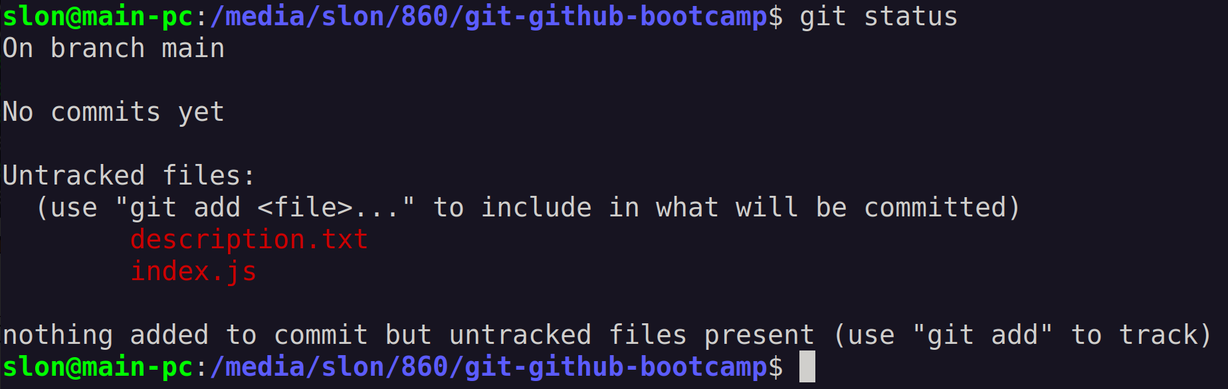
Now you need to add all the changes (or just a part of the changes) to a staging area
How to add a specific file to a staging area?
CLI=> git add index.js
CLI=> git status
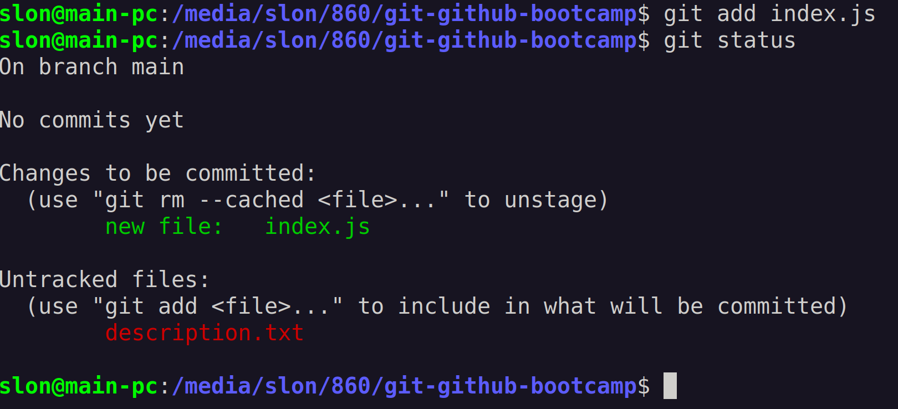
How to add all the changes to a staging area?
CLI=> git add .
CLI=> git status
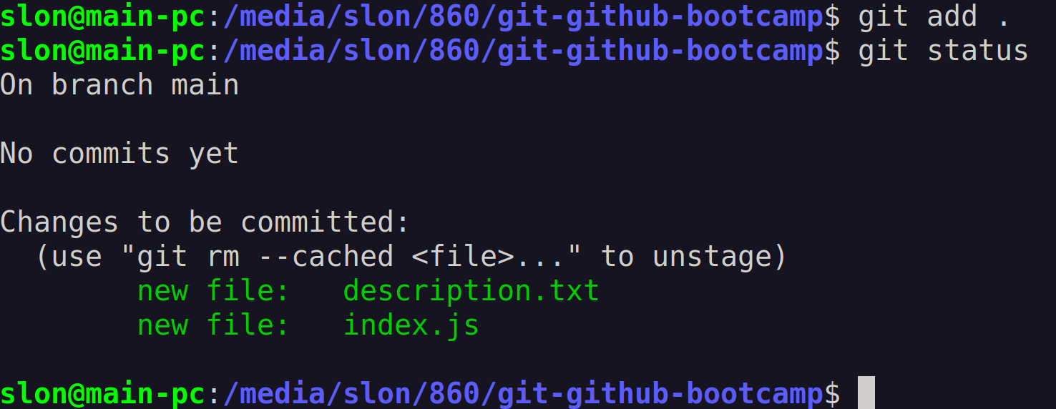

4.7 Creating a new commit (028)
git commit -m '[MAIN COMMIT MESSAGE]' -m '[ADDITIONAL COMMIT MESSAGE]'

CLI=> git commit -m 'My first commit' -m 'Added 2 new files: index.js and description.txt'
