[PICTURE]

Bash Mastery: The Complete Guide to Bash Shell Scripting

Master Bash Shell Scripting to Automate Tasks, Save Time, and Boost Your Career. Practical Projects + All Code Included.

https://www.udemy.com/course/bash-mastery/

Table of Contents
1 How to build a bash script 3
1.1 Intro 3
1.2 Shell vs Script 3
1.4 Core components of BASH script 3
1.5 PRO components of BASH script 3
1.6 Setting up secure script permissions 4
1.8 system PATH 4

1 How to build a bash script

1.1 Intro
Check that your default shell is BASH
CLI=> echo $SHELL
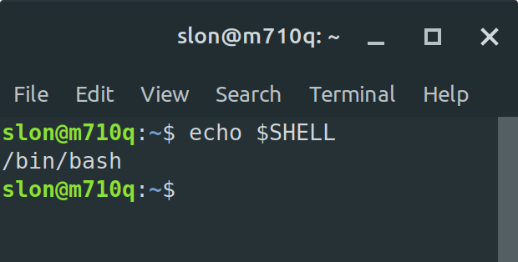
It should be bash. If it isn’t use next command
CLI=> chsh -s /bin/bash

1.2 Shell vs Script
Shell is a program that interprets the commands that you type in your terminal and passes them to the OS.
The purpose of the shell is to make it more convenient for you to issue commands to your computer.

There are lots of different shells. But we are going to use BASH.
BASH = Bourne Again Shell (it based on Bourne Shell – SH – that was created by Stephen Bourne in 1979).

BASH script is a file that contains commands for the BASH shell. Shell reads commands 1-by-1 and execute them.

1.4 Core components of BASH script
1. Each script should have the same first line:
#!/bin/bash
2. Some commands
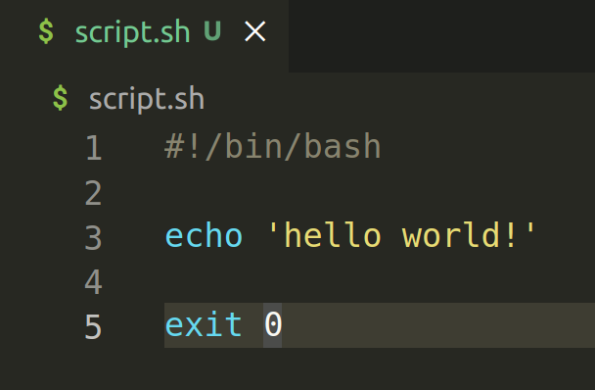
3. Exit statement (not required)
Technically your script don’t need the file extension.
Your script should be executable.
CLI=> chmod +x script.sh
Now you can run your script:
CLI=> ./script.sh

1.5 PRO components of BASH script
For comments you can use #
It might a good idea to add into your script info about your name, date of creation, short description and how to use it.

1.6 Setting up secure script permissions
To view file permissions you can use
CLI=> ls -l
- rwx rwx rwx 1 root root 40 Oct 17 15:39 script.sh
The first symbol shows a type. Dash (-) means that it is a file. (d) means that it is a directory.
Next 3 symbols show permissions for the owner of this file (read-wrire-execute).
Next 3 symbols show permissions for the owner group of this file (read-wrire-execute).
Next 3 symbols show permissions for the other users (read-wrire-execute).

Read – 4
Write – 2
Execute – 1

You can set permissions using 3-digit number
CLI=> chmod 711 script.sh

1.8 system PATH
You can check all the system paths using:
CLI=> echo $PATH

Main file with the settings is /home/slon/.profile
you can open it with any text editor (nano in my case):
CLI=> nano ~/.profile

You can add a link to your local folder with all the scripts
export PATH="$PATH:/media/860-files/_projects_/open-docs/_LINUX/_SHELL_SCRIPTING/1/files/1"

Now you need to update that system parameters
CLI=> source $PATH

and check that your folder is a system path now
CLI=> echo $PATH

After all these actions you can execute any bash scripts (that are stored in that folder) from any folder

