This mini project consists of 2 scripts:
1. send-script-to-server.sh - script that allows you to sent another file to a remote server.
2. ubuntu-server-setup.sh - script that allows you to update your server, install common tools, Node.js, Docker and Docker Compose

send-script-to-server.sh

This script (by default) takes in last part of local server (102 for example will be used to create a ssh connection to 192.168.0.102 as test) and sends ubuntu-server-setup.sh to /home/test/ directory

To run this script open terminal in the same folder. Use command
./ send-script-to-server.sh 102

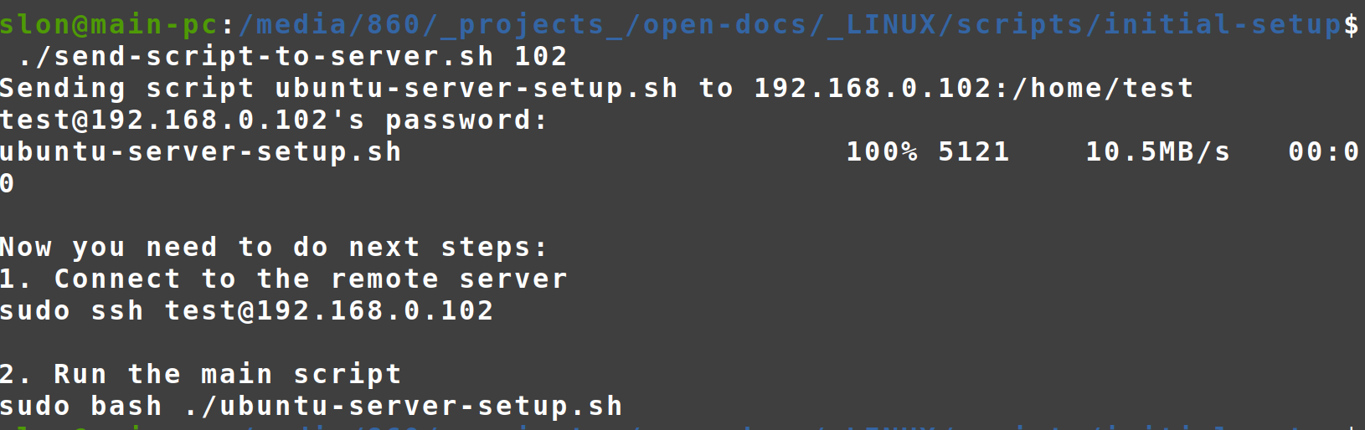
ubuntu-server-setup.sh
This script uses sudo GUI interface.
