#MODULE 1
? What is REACT ?
REACT is a JavaScript (JS) library for building User Interfaces (UI).

? What is COMPONENT ?
COMPONENT is a general building block (like HEADER, SIDEBAR or FOOTER at any web page), which can contain another COMPONENTS.

? What is PROPS ?
PROPS is a special way to sent any data to a function in REACT

##index.thml
<div id =’p1’></div>
<div id =’p2’></div>

function SomeFunction(props){
return (
<div>
<h1>Your name is {props.name}!</h1>
<h3>Your age is {props.age}</h3>
</div>
);
}

ReactDOM.render(<SomeFunction name=’Max’ age=’28’ />, document.querrySelector(‘#p1’));
ReactDOM.render(<SomeFunction name=’Max’ age=’28’ />, document.querrySelector(‘#p2’));

#MODULE 2 – ES6 features

let – it is a way to define a variable with a local scope.
const – it is a way to define a constant (a special variable, which will not be changed).

arrow function
const myFunc1 = () => console.log(‘hello’);
const myFunc2 = (name) => console.log(`Hello ${name}`);
const myFunc3 = (num1, num2) => num1 * num2 [will return num1 * num2]

const myFunc = (arg) => arg >= 0 ? 'YES' : 'NO';
console.log(myFunc(-200));

Exports and Imports

export default person;
export const = ………

import person from ‘./person.js’;
import prs from ‘./person.js’

import {baseData} from ‘./person.js’
import {baseData as newDataFromAnotherModule} from ‘./person.js’
import * as bundled from ‘./person.js’

Classes

class Person { Property
name = ‘Max’ Method
call = () => console.log(‘hello’)
}

const myPerson = new Person();
console.log(myPerson.name);

Spread and Rest operators
create a duplicate return an array with all the arguments

Destructuring
can extract array elements or object properties and store them in variables

const arr = [0, 1, 2, 3, 4, 5];
[num1, , , num4, ,] = arr;
console.log(num1, num4);

Primitives and references types

Array methods
map, filter

#MODULE 3 – React

review tools
Dependency Management Tool – npm or yarn
Bundler – webpack
Compiler – Babel + Presets
Development server

create react app
How to install that library globally?
CLI => npm install -g create-react-app

How to create a new React app?:
CLI => create-react-app [name-with-dashes] – it will create a new folder [name-with-dashes] with all the start files inside.

Navigate to a new project folder: cd [name-with-dashes]
Run the app: npm start – it will start a developer server and open a browser with start page of react app

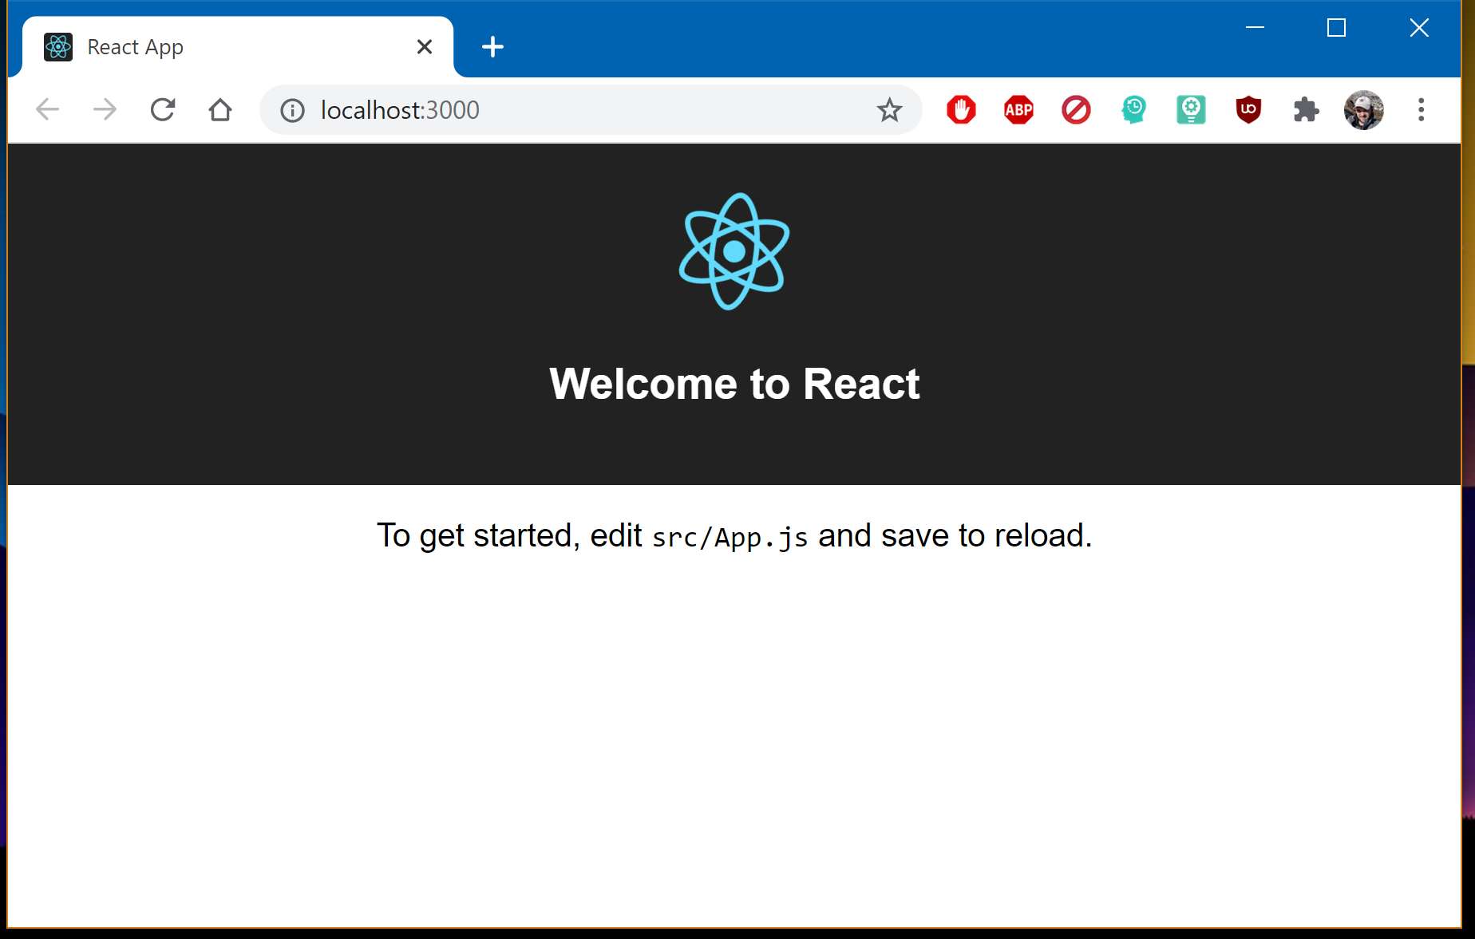
!!! In course we have used another command: create-react-app [name-with-dashes] --scripts-version 1.1.5 !!! – to have the same start files at a new project.
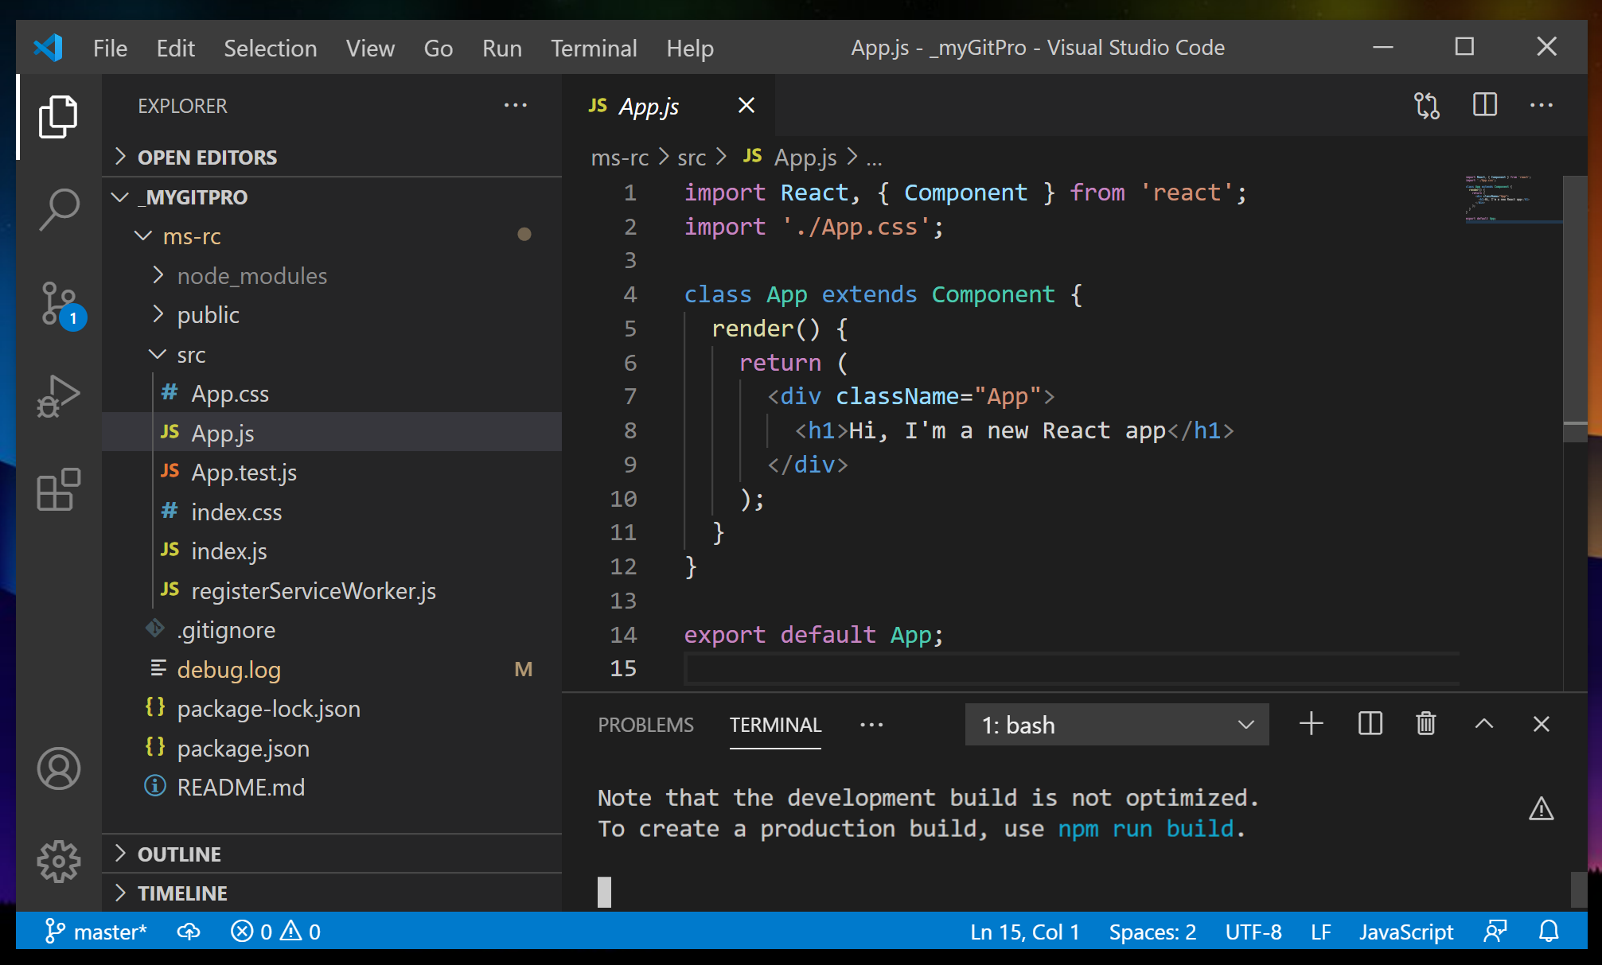
The new component as a class of Component from React.

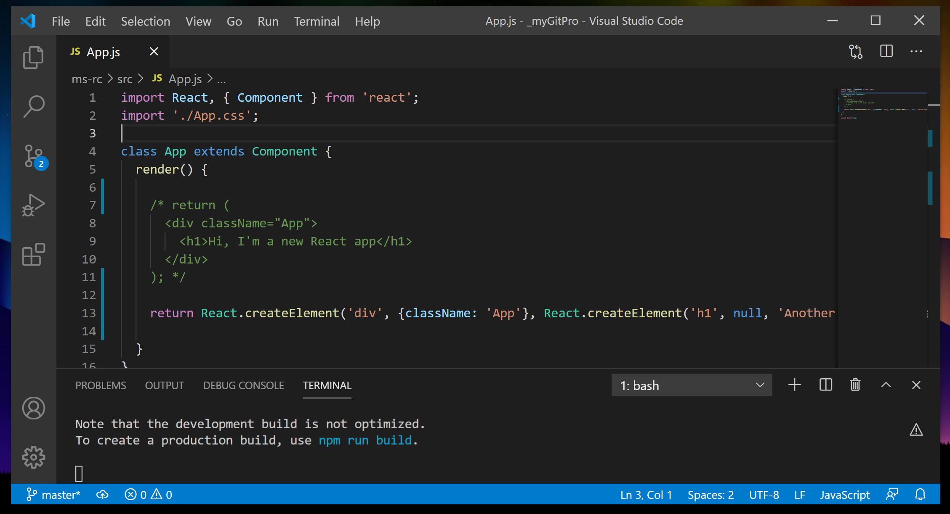
Difference between using JSX and React.createElement

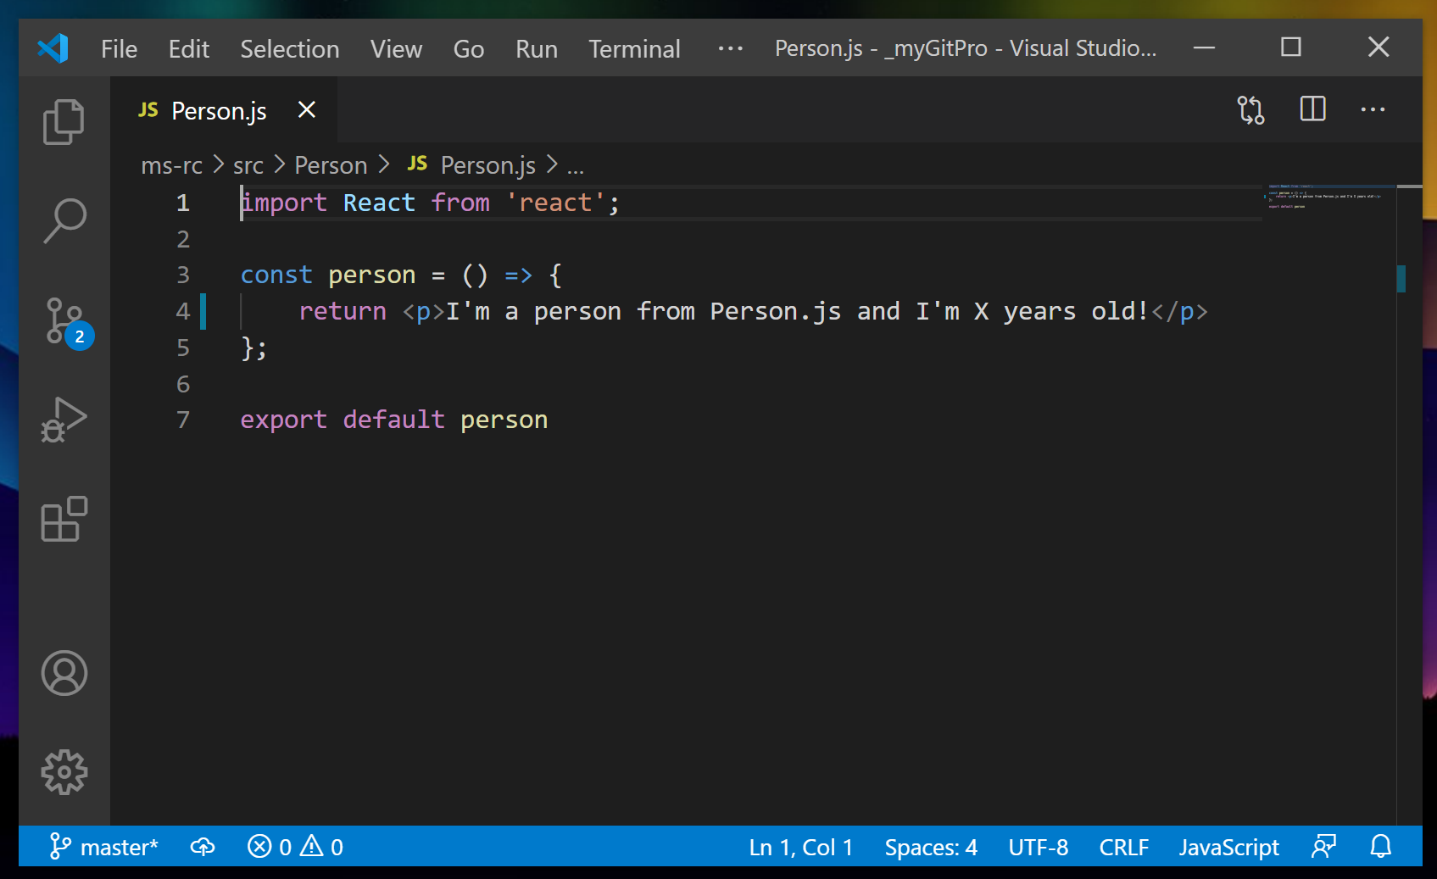

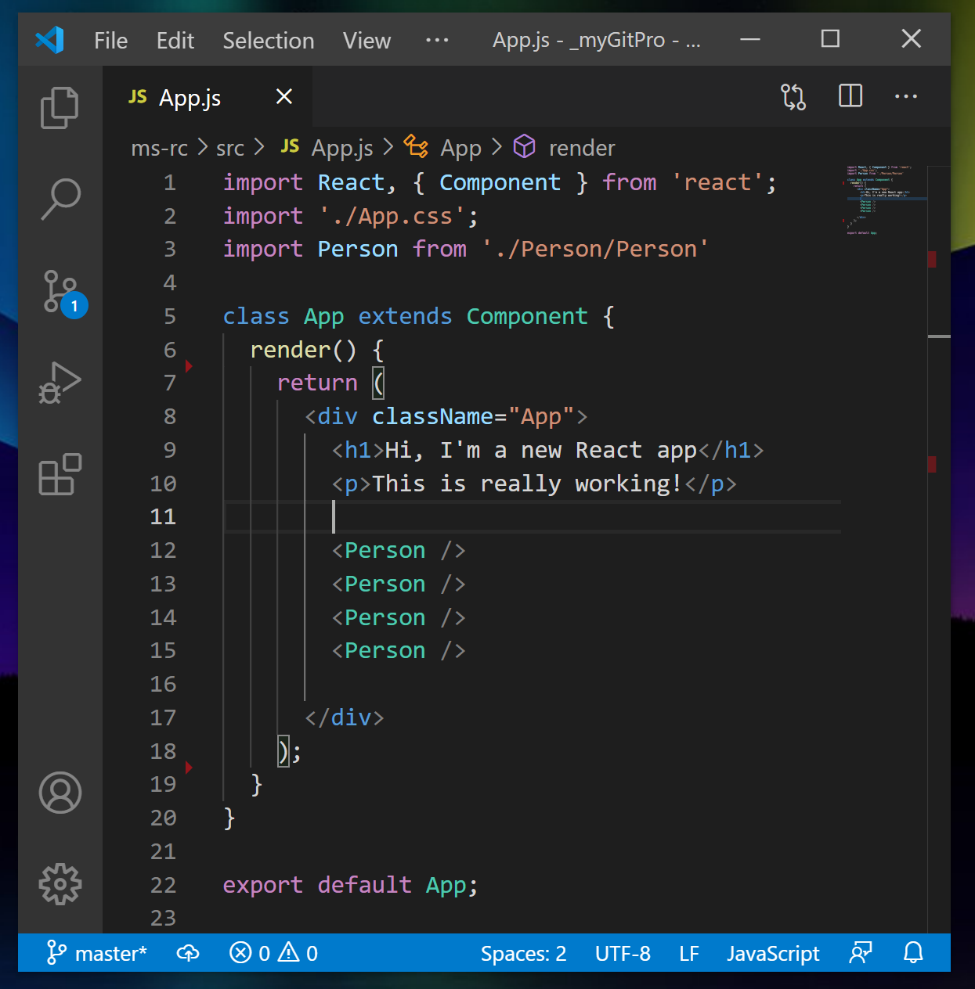
Creating a functional component (with using an arrow function) and reusing it in App
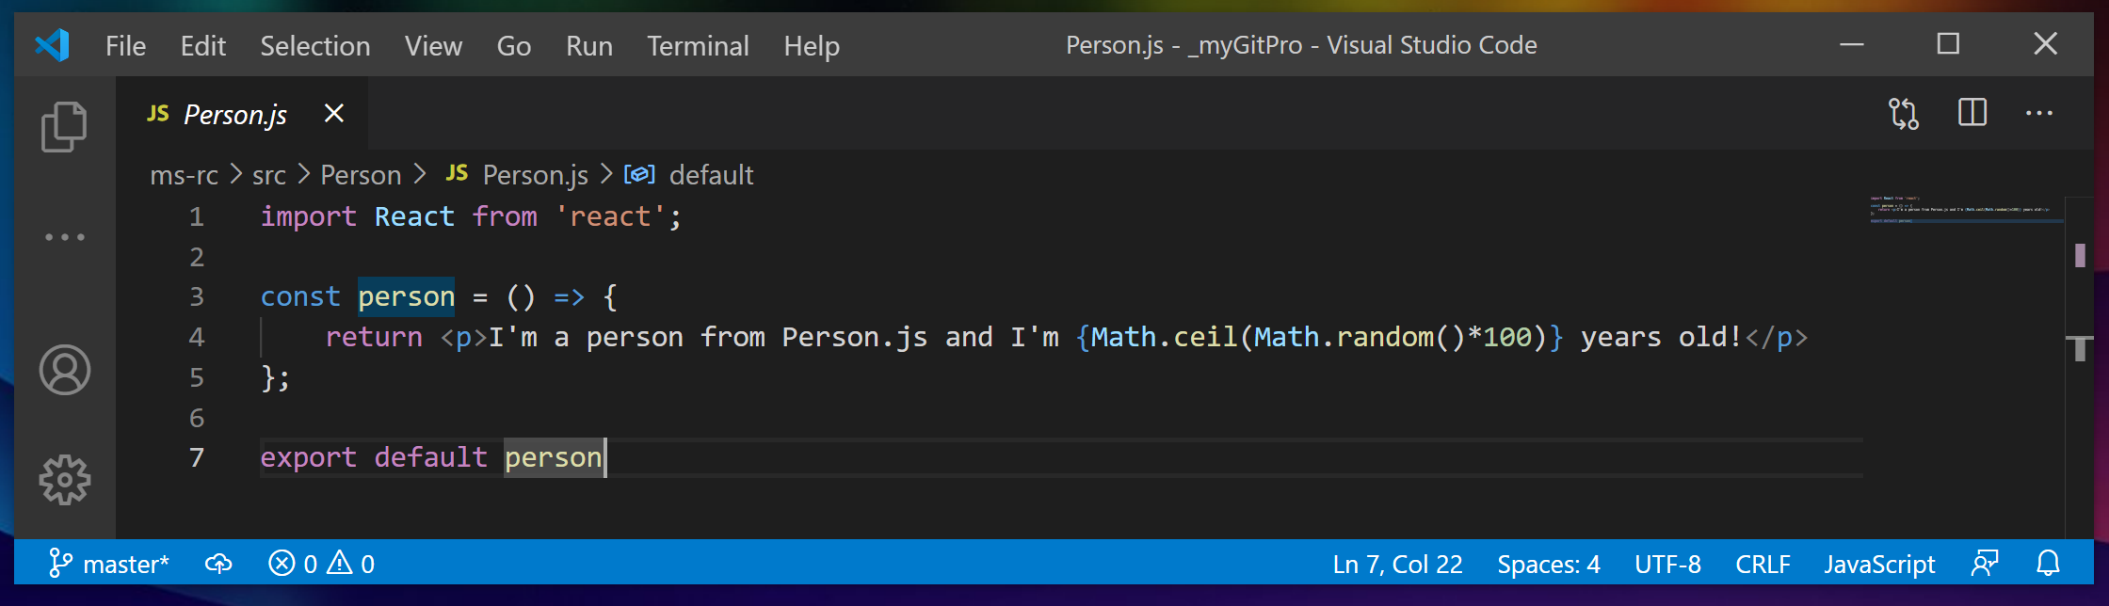
Outputting dinamic content (injection simple JS code into JSX )

Lesson 3.12 – PROPS
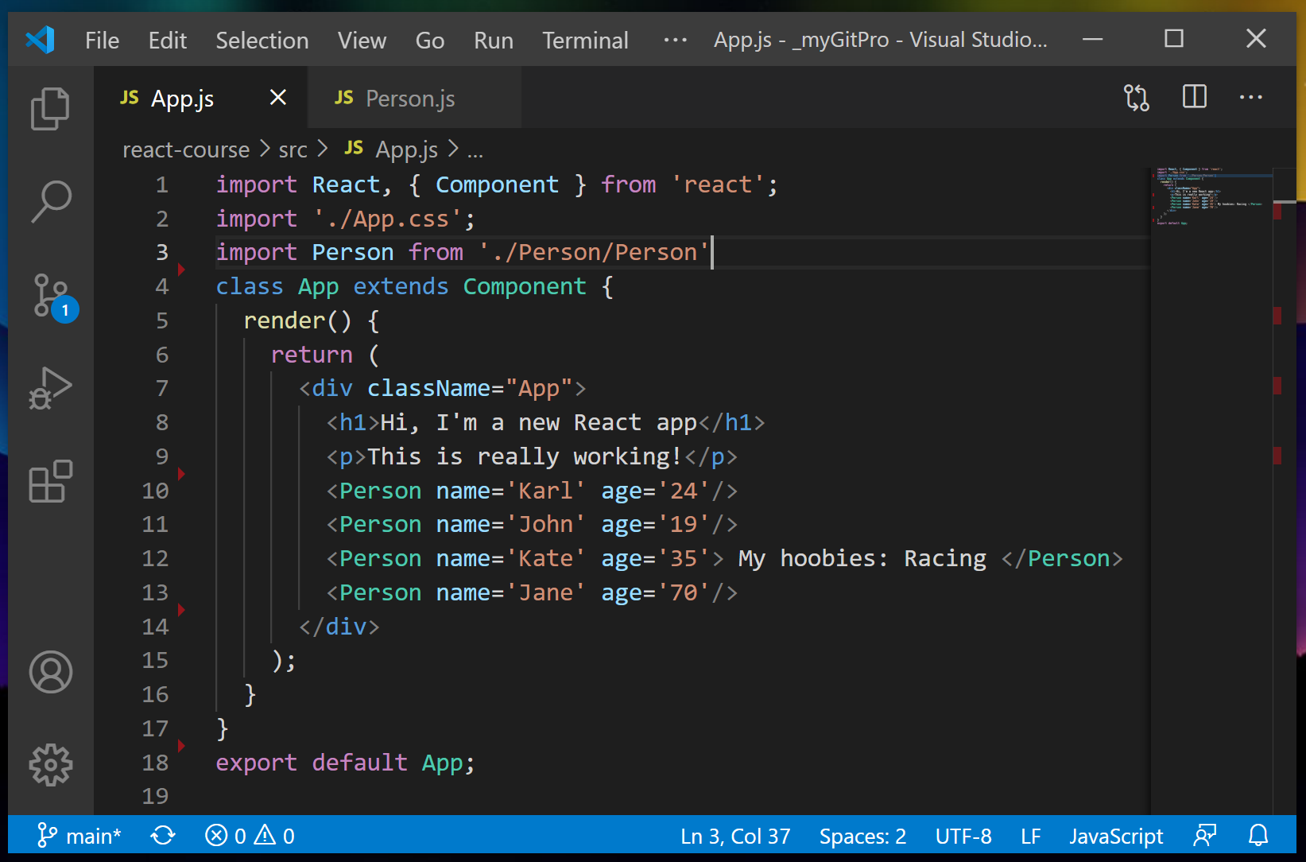

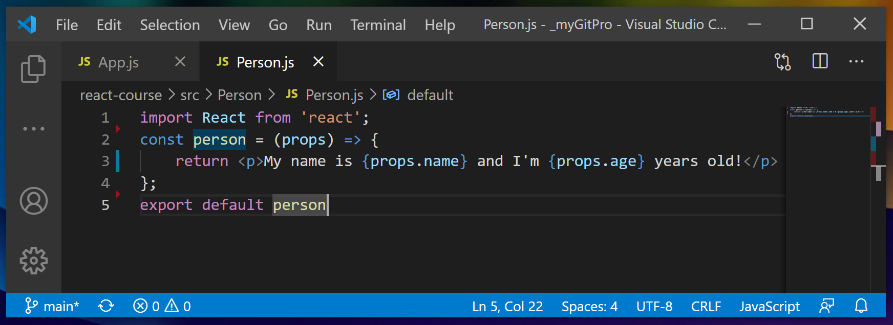

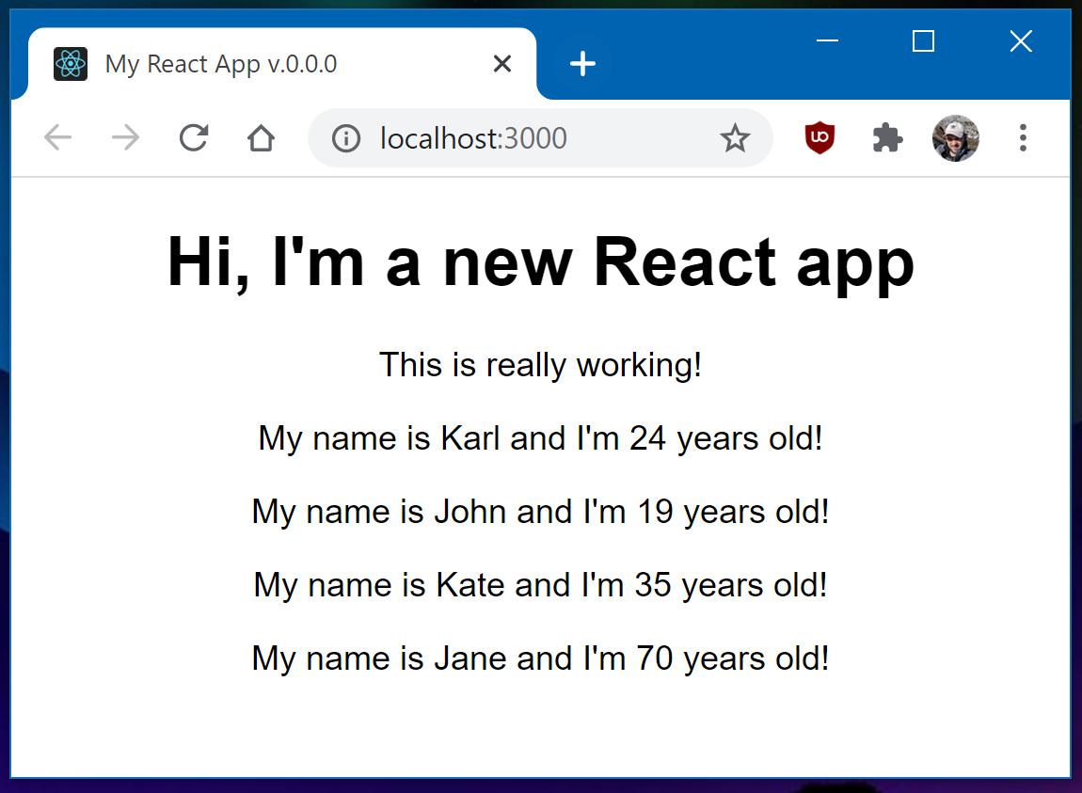

Lesson 3.13 – CHILDREN of PROPS

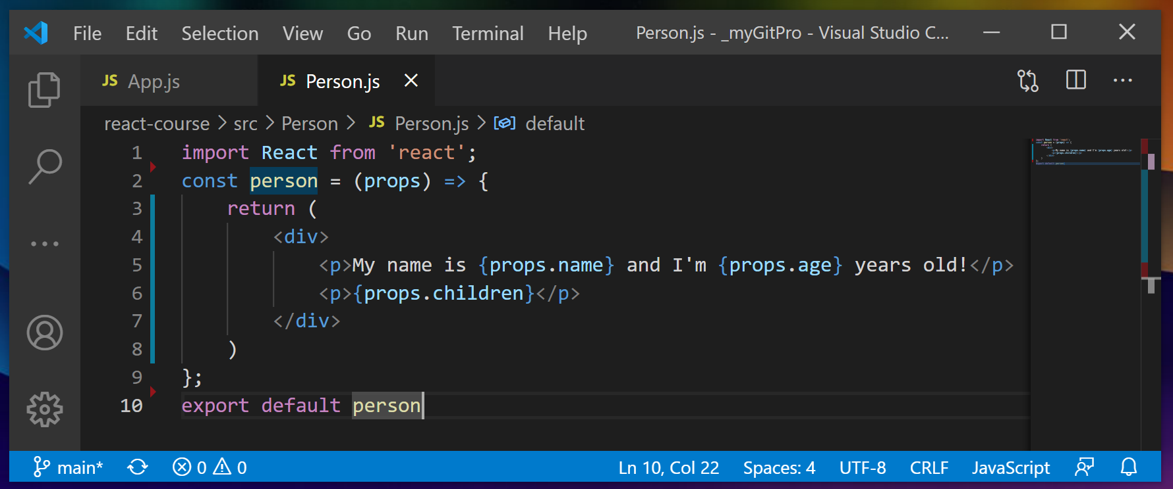

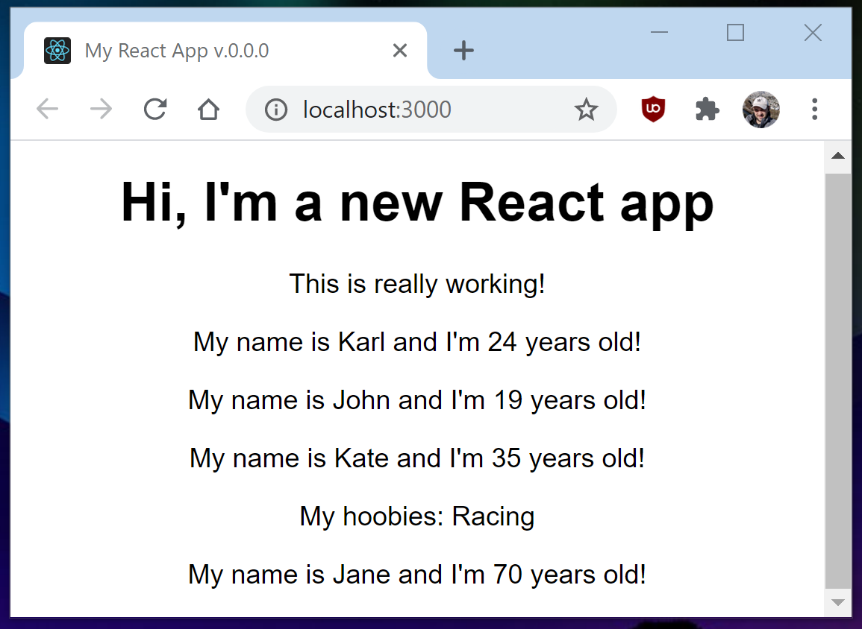

Lesson 3.14 – Understanding and using STSTE.
We can use STATE only with class based React components (and we can’t use STATE with function-based components) – old way
in React 16.9 we can also use STATE with function-based components – now it calls HOOKS!
STATE is JS object.
If state is changed – it leads to rerender the DOM!
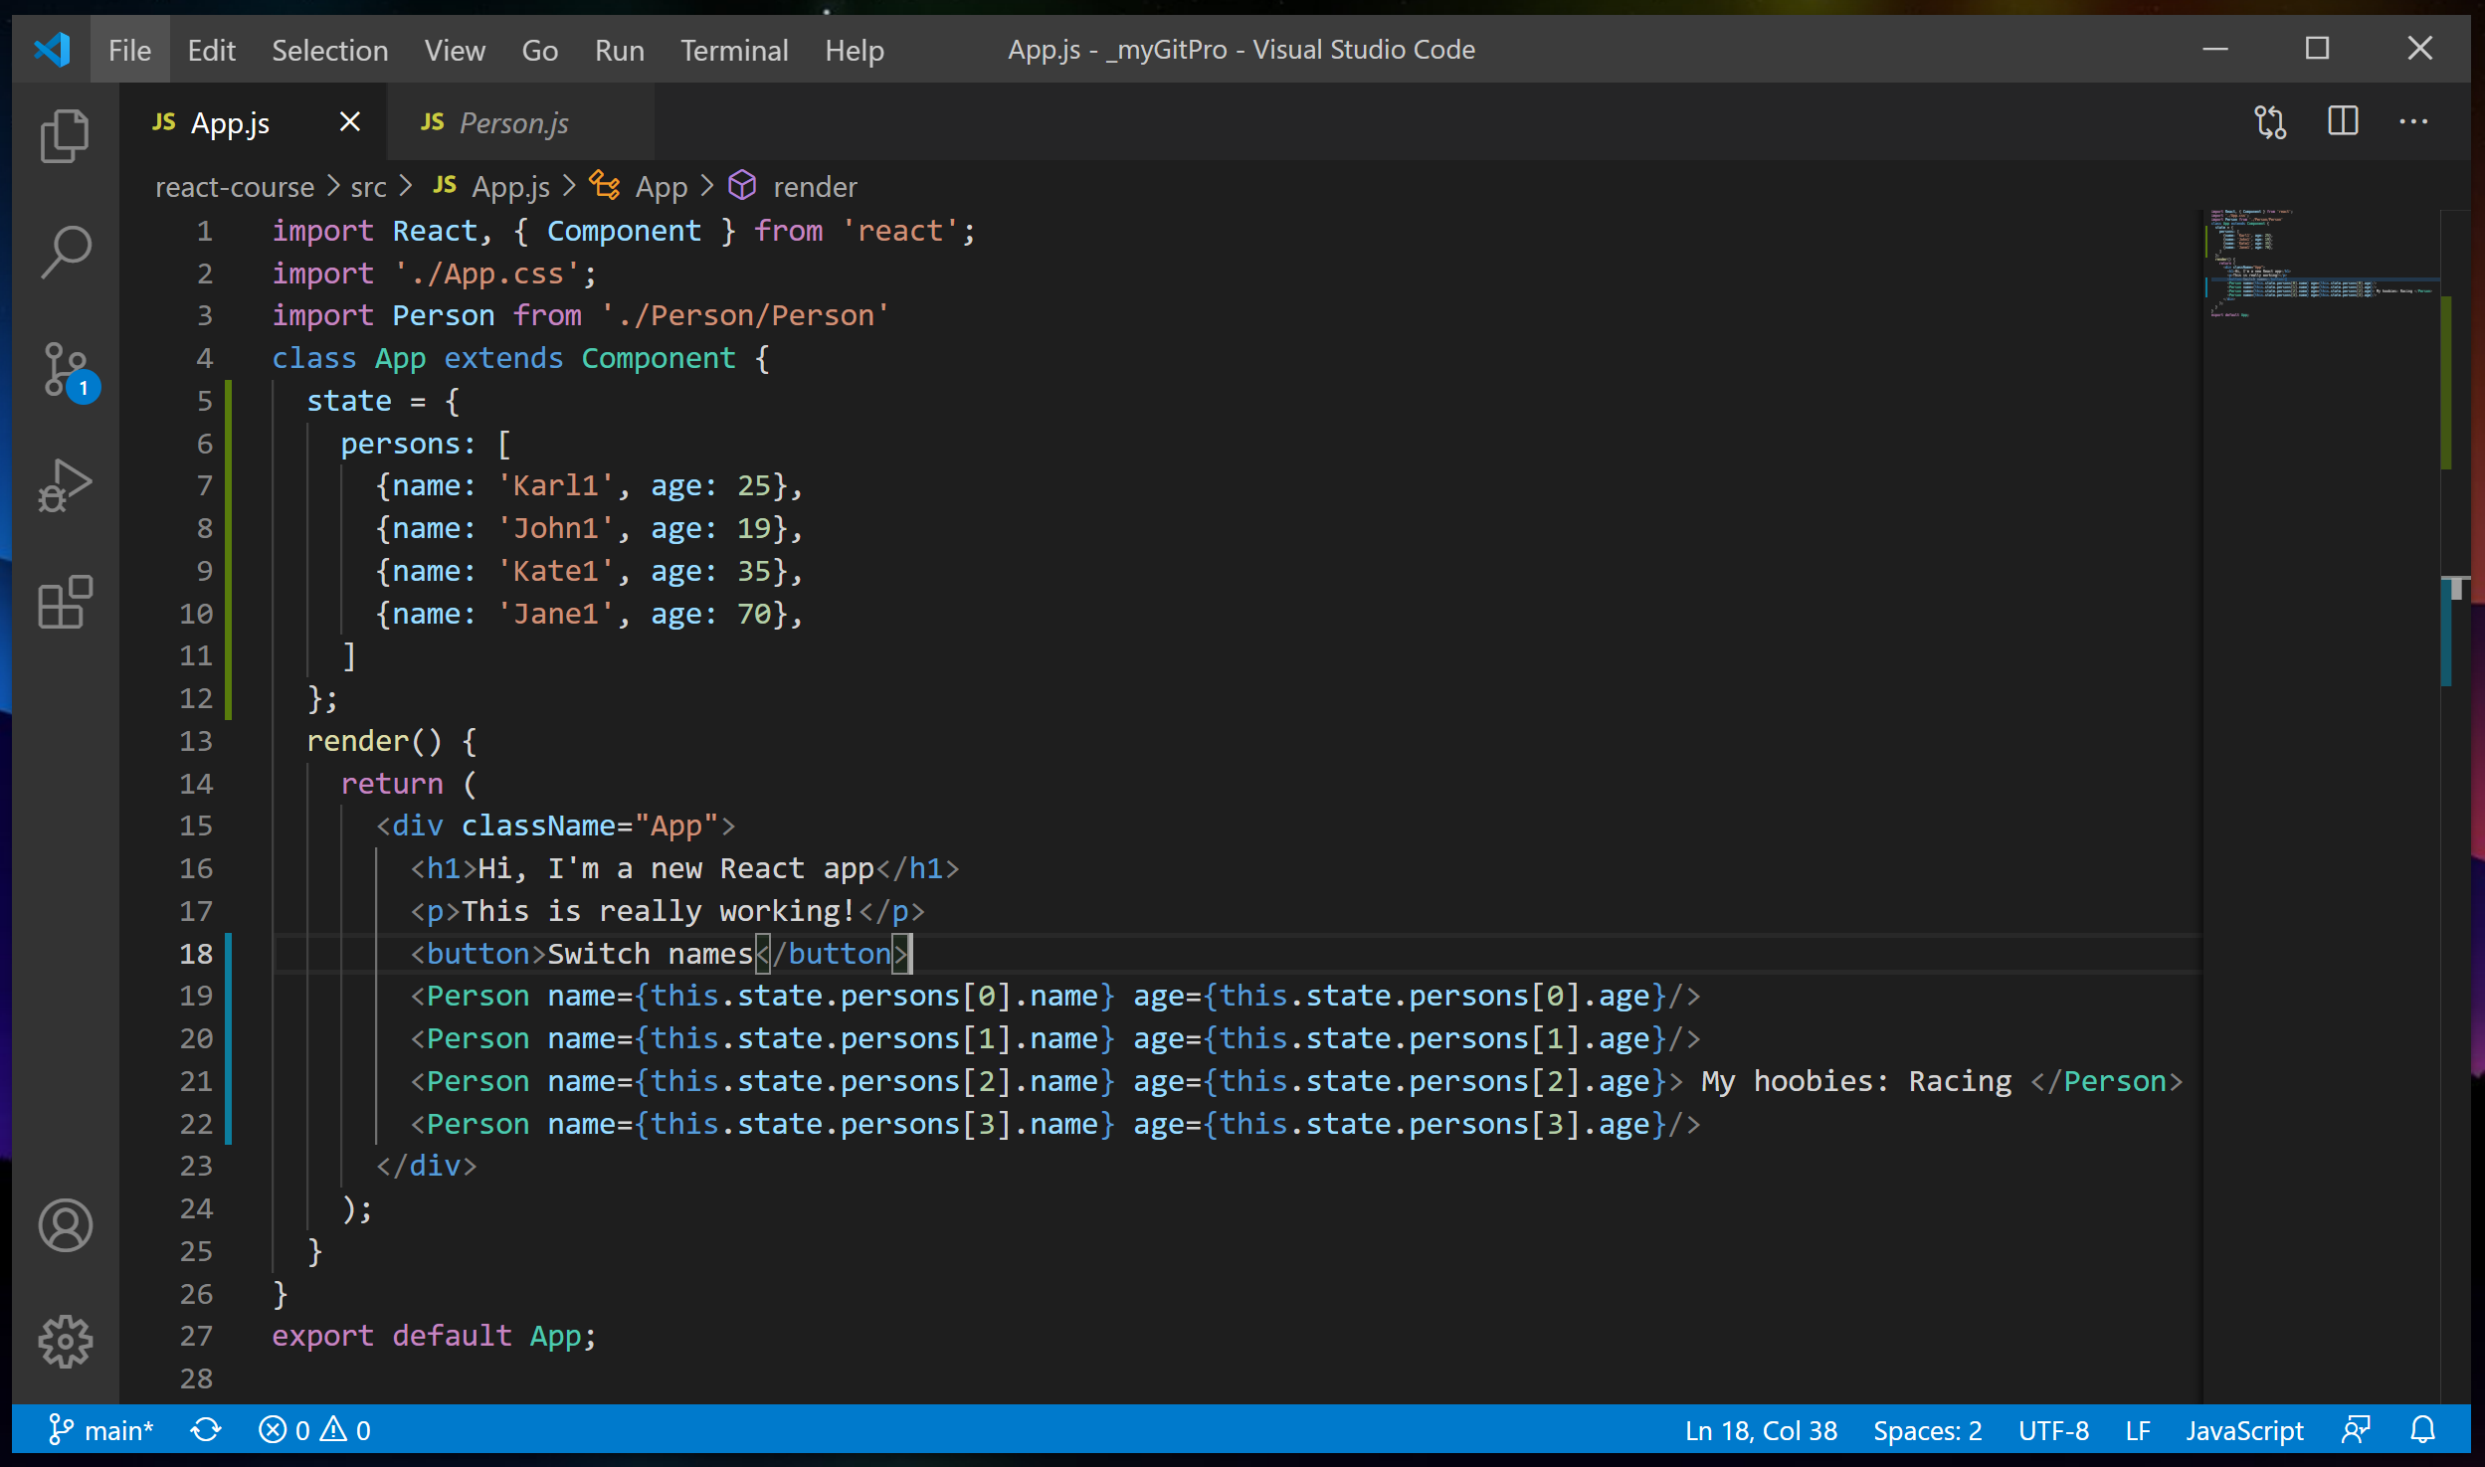

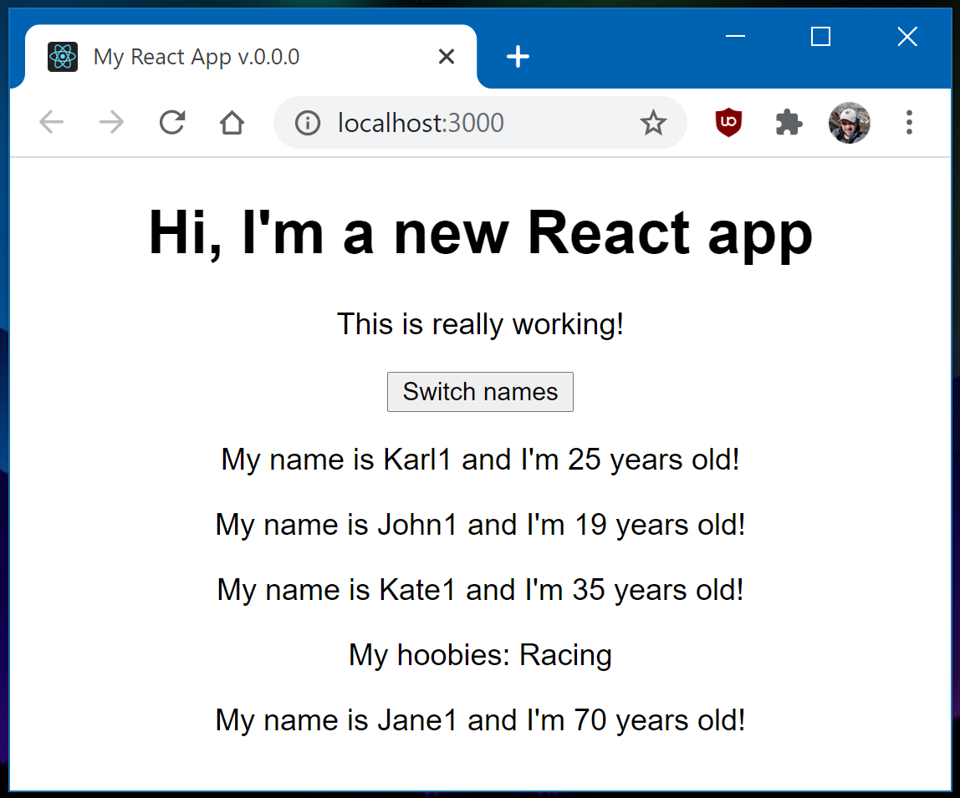

Lesson 3.16 – Handling events with methods
