ReactJS. Front to backend. BT 2022
Project 2 - Github-finder

https://github.com/PacktPublishing/React-Front-to-Back-2022
Table of Contents
0 Hints 3
1 React basics and JSX 4
1.1 Intro 4
1.2 Setup Tailwind and Daisy UI 4
1.2.1 Tailwind 4
1.2.2 Daisy UI 5
1.3 Navbar component 6

0 Hints

1 React basics and JSX

1.1 Intro

1.2 Setup Tailwind and Daisy UI

1.2.1 Tailwind
First of all you need to create a new project
CLI=> npx create-react-app github-finder --use-npm
Go to the new folder (github-finder)
CLI=> npm install -D tailwindcss postcss autoprefixer
CLI=> npx tailwindcss init -p
Open file tailwind.config.js and paste
/** @type {import('tailwindcss').Config} */
module.exports = {
content: [
"./src/**/*.{js,jsx,ts,tsx}",
],
theme: {
extend: {},
},
plugins: [],
}

Open index.css
@tailwind base;
@tailwind components;
@tailwind utilities;

1.2.2 Daisy UI
CLI=> npm i daisyui
Open file tailwind.config.js
plugins: [require('daisyui')],

Now you can start your react app using npm start.
Change main component App.js => App.jsx (to be able to work with tag plugin)
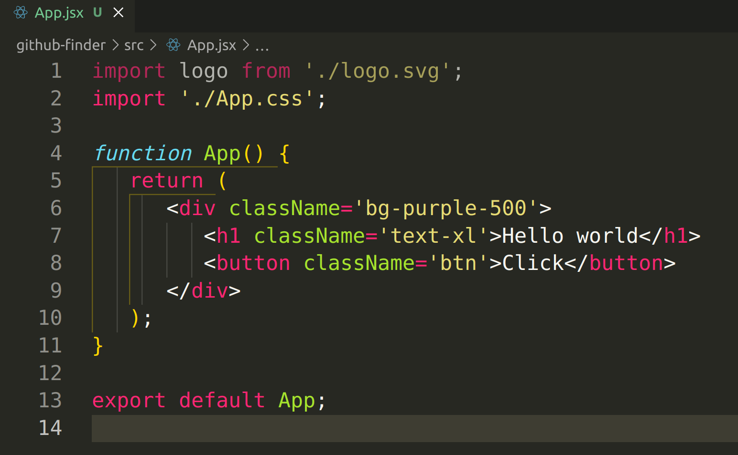
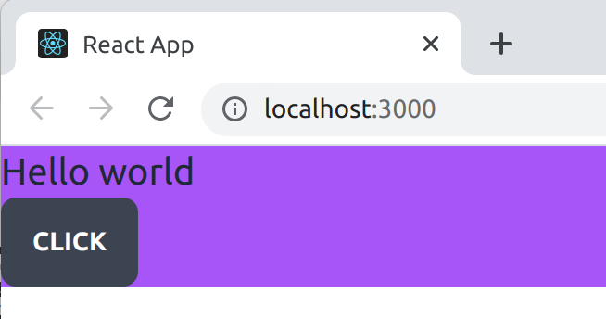

1.3 Navbar component
You need to install react-router-dom and react-icons
CLI=> npm i react-router-dom react-icons
Create a new Navbar.jsx component in github-finder/src/components/layout
