ReactJS. Front to backend. BT 2022
Project 3 - mrketplace

https://github.com/PacktPublishing/React-Front-to-Back-2022
Table of Contents
0 Advanced React hooks 3
0.1 Intro 3
0.2 useRef hook example 1 4
0.3 useRef hook example 2 4

0 Advanced React hooks

0.1 Intro
Create a new React app for practice
CLI=> npx create-react-app react-hooks-practice
Add it to index.html (before page title)
<link
href="https://cdn.jsdelivr.net/npm/bootstrap@5.1.3/dist/css/bootstrap.min.css"
rel="stylesheet"
integrity="sha384-1BmE4kWBq78iYhFldvKuhfTAU6auU8tT94WrHftjDbrCEXSU1oBoqyl2QvZ6jIW3"
crossorigin="anonymous"
/>

0.2 useRef hook example 1
This hook allows you to create a reference to the DOM element inside a functional component.
Create a new folder to store components react-hooks-practice/components
Create a new file UseRefExample1.jsx (rafce)
Import it to App.js
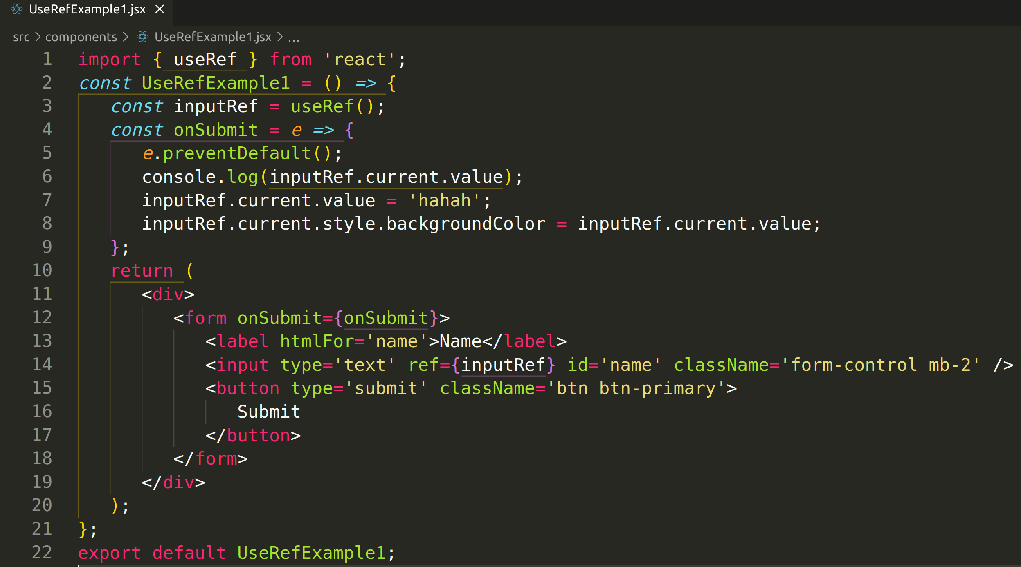
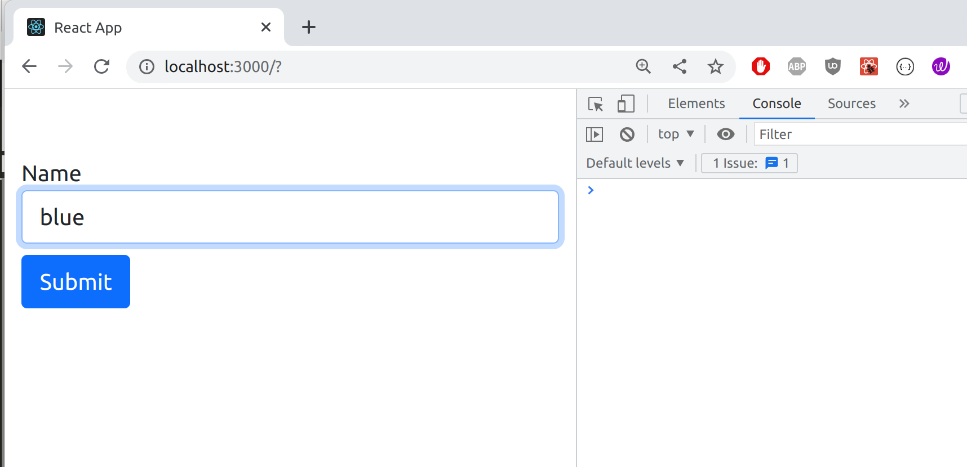
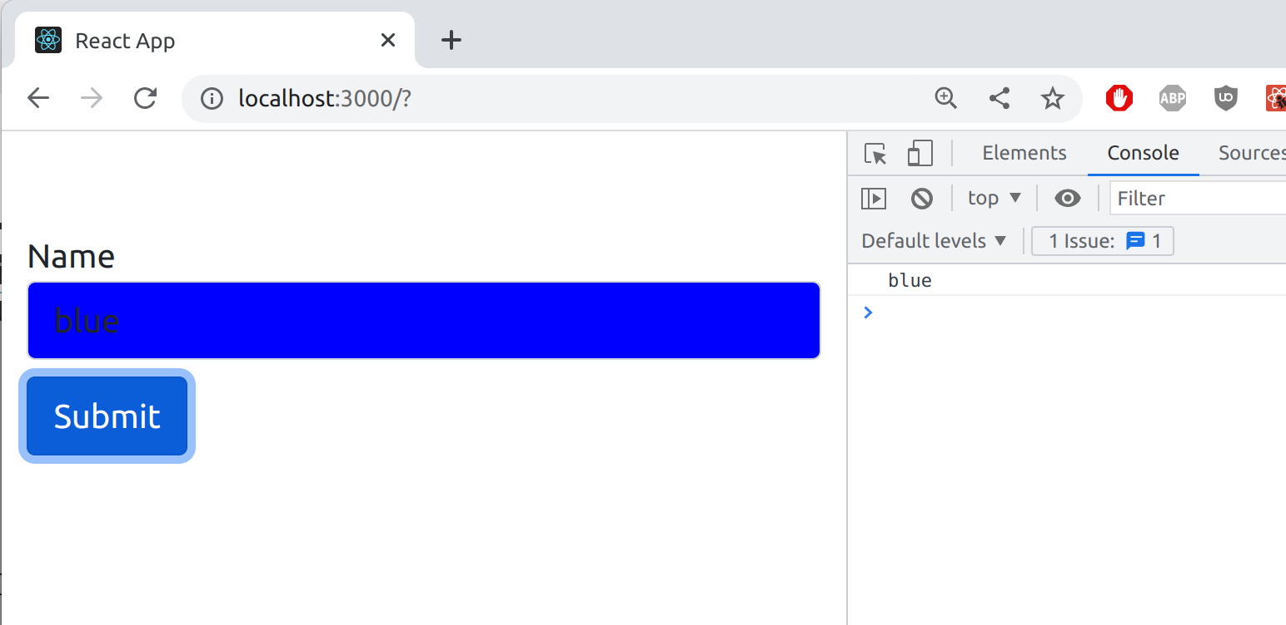

0.3 useRef hook example 2
