ReactJS. Front to backend. BT 2022

Table of Contents
1 Hints 3
2 React basics and JSX 4
2.1 Feedback project intro 4
2.2 Create react app 4
2.3 Initializing React 4
2.3.1 How to create a new tag on your page with ReactDOM and vanilaJS? 4
2.3.2 How to create a main App.js file (main component)? 4
2.3.3 How to add a main css file? 5
2.4 Intro to JSX 5
2.5 Dynamic values and lists in JSX 5
2.6 Conditionals in JSX 5

1 Hints
[tagName].[className] | div.main-element | <div className=”main-element”></div>
[tagName]#[idName] | div#root | <div id=”root”></div>
ul>li*[quantity] | ul>li*[quantity] | unordered list with 25 list items will be created

VSCode settings:
{
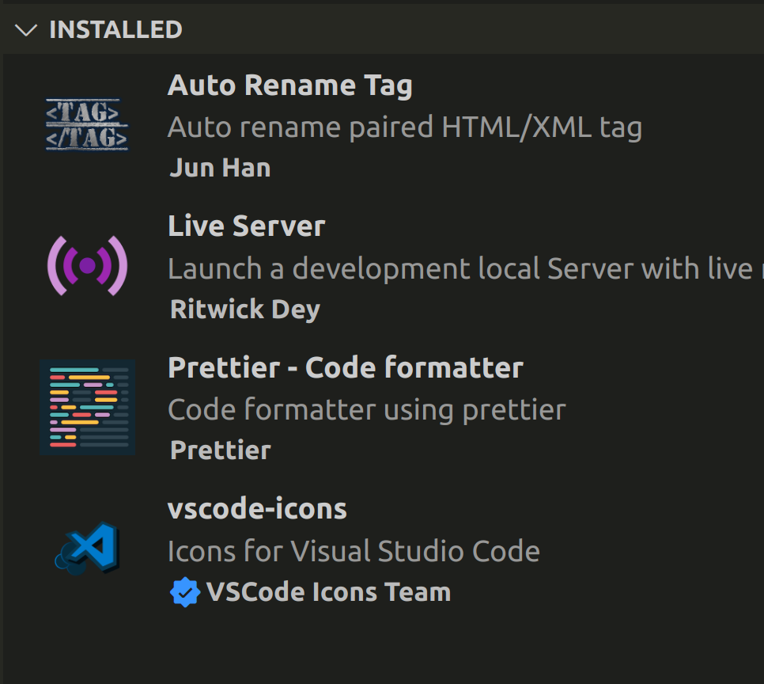
"editor.fontSize": 18,
"editor.tabSize": 3,
"editor.bracketPairColorization.independentColorPoolPerBracketType": true,
"editor.guides.bracketPairs": true,
"editor.guides.bracketPairsHorizontal": true,
"editor.wordWrap": "on",
"workbench.colorTheme": "Monokai",
"window.zoomLevel": 2,
"prettier.arrowParens": "avoid",
"prettier.jsxSingleQuote": true,
"prettier.printWidth": 50,
"prettier.singleQuote": true,
"editor.formatOnSave": true,
"[javascript]": {
"editor.defaultFormatter": "esbenp.prettier-vscode"
},
"[jsonc]": {
"editor.defaultFormatter": "esbenp.prettier-vscode"
},
"[json]": {
"editor.defaultFormatter": "esbenp.prettier-vscode"
},
"[javascriptreact]": {
"editor.defaultFormatter": "esbenp.prettier-vscode"
}
}

2 React basics and JSX

2.1 Feedback project intro

2.2 Create react app
You can create a new ReactJS app using next command:
CLI=> npx create-react-app feedback-app –use-npm
You can start your ReactJS app using next command (the terminal should be opened in root folder of your ReactJS app – in this case feedback-app):
CLI=> npm run server
Delete all the files from folder feedback-app/src

2.3 Initializing React
Create a main file feedback-app/src/index.js

2.3.1 How to create a new tag on your page with ReactDOM and vanilaJS?
import React from 'react';
import ReactDOM from 'react-dom';
ReactDOM.render(<h1>My App</h1>, document.getElementById('root'));

2.3.2 How to create a main App.js file (main component)?
Create a main component feedback-app/src/App.js and do some changes in index.js
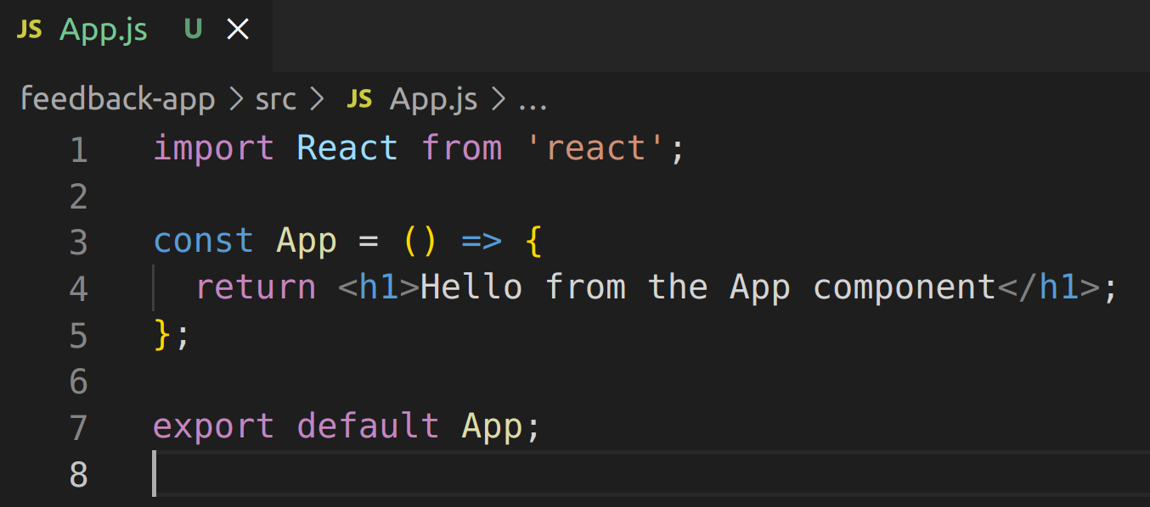
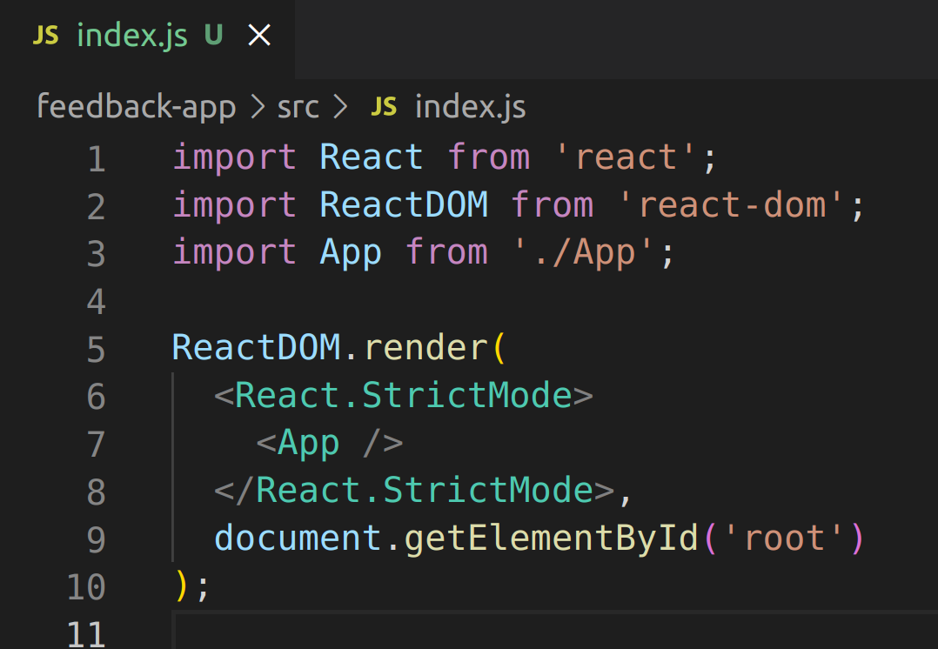
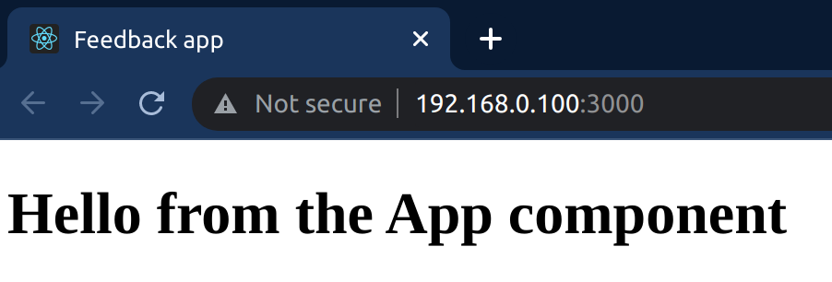

2.3.3 How to add a main css file?
Create a main css file feedback-app/src/index.css and import it to index.js

2.4 Intro to JSX
Each React component should return only 1 main/root/parent element. It’s such a common case to use fragment element as a parent element <>some JSX</>
You can’t use class attribute (as in HTML) instead of it you have to use className.
You can’t use for attribute (as in HTML) instead of it you have to use htmlFor.

2.5 Dynamic values and lists in JSX
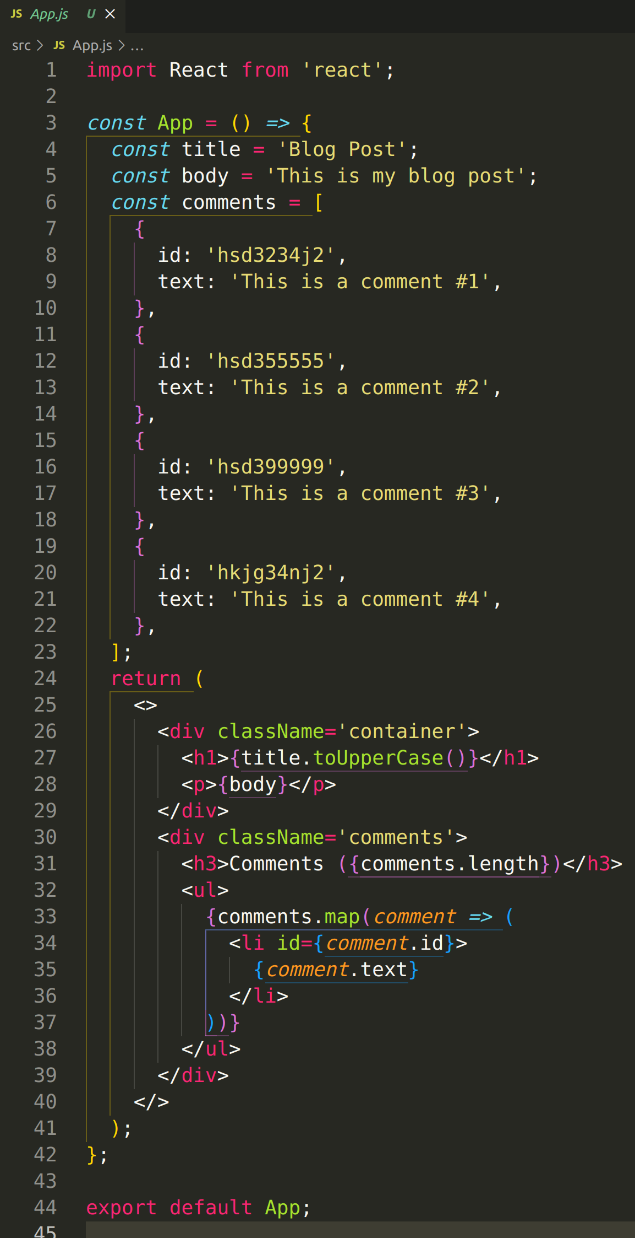
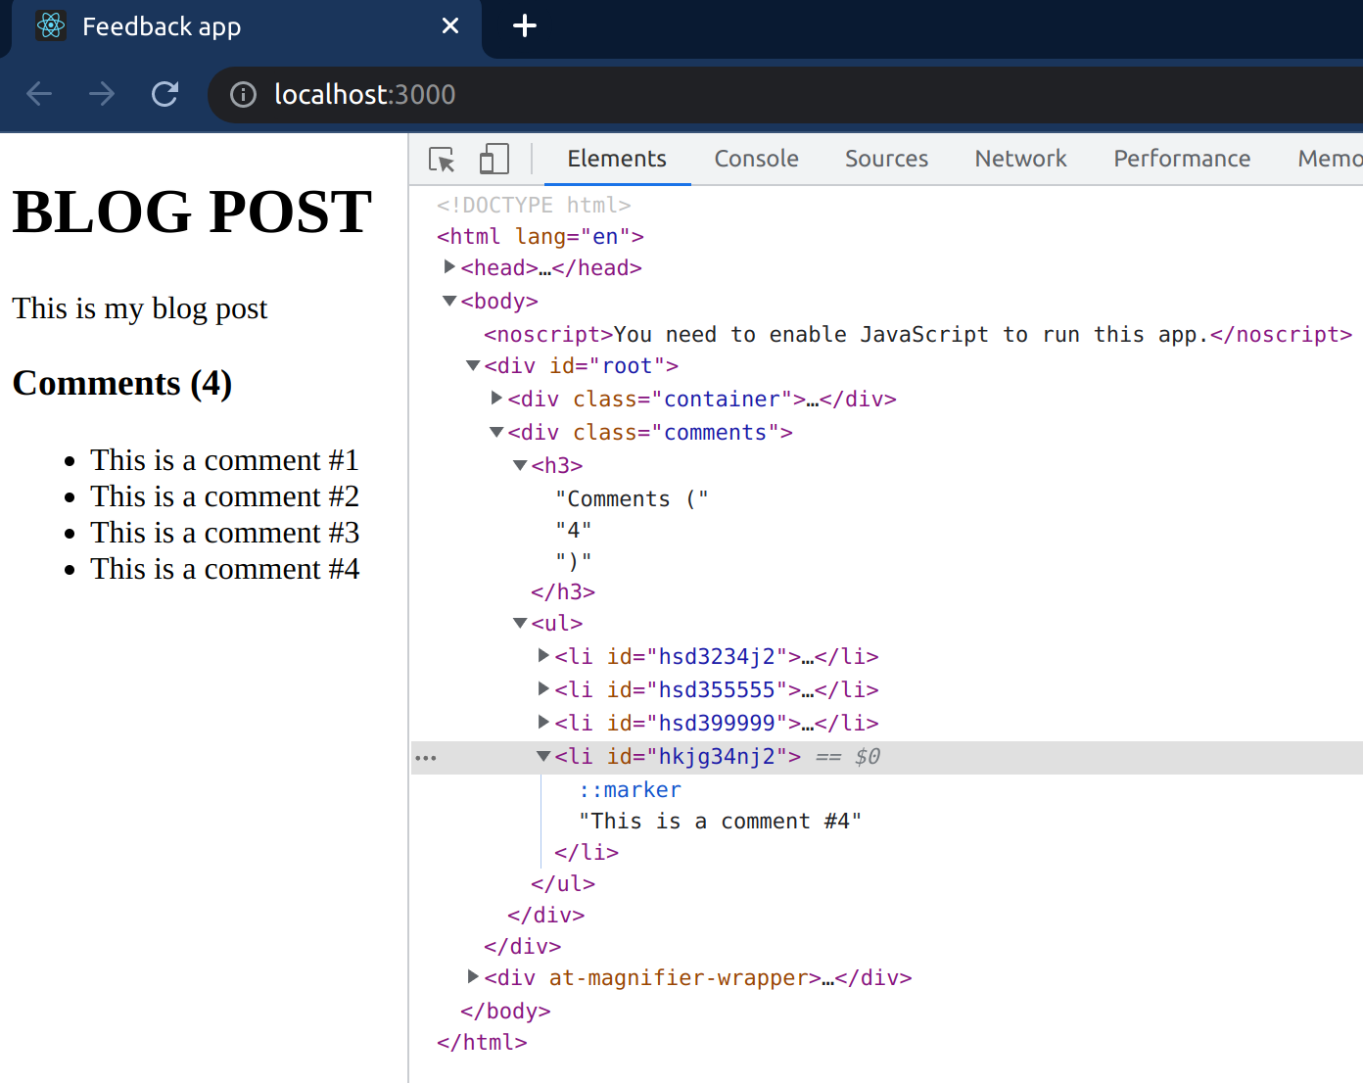

2.6 Conditionals in JSX

