Typical test task for SDET

Table of Contents
0. Preconditions 3
0.1 Create a new GitHub repository 3
0.2 Clone the new repository to your PC 3
0.3 Initialize the new npm project 3
0.4 Install cypress 9.6.0 3
0.5 Change the default run script that opens cypress GUI 3
0.6 Change the default cypress settings 3
0.7 Change the default cypress settings in cypress/support/index.js 3
1. Project architecture 4
2. Home Page 5
3. Login Page 6
4. Register Page 9
5. Run Scripts 12
6. gitHub Actions pipeline 13

0. Preconditions

0.1 Create a new GitHub repository

0.2 Clone the new repository to your PC

0.3 Initialize the new npm project
CLI=> npm init -y

0.4 Install cypress 9.6.0
CLI=> npm i cypress@9.6.0

0.5 Change the default run script that opens cypress GUI
In file package.json
"scripts": {
"test": "npx cypress open"
},
After that action you can start cypress GUI just typing npm test in the terminal

0.6 Change the default cypress settings
In file cypress.json add base url, skip video recording, increase the timeout, and ignore examples specs
{
"baseUrl":"https://www.shopltk.com/",
"video":false,
"defaultCommandTimeout":7000,
"ignoreTestFiles":["**/1-getting-started/*","**/2-advanced-examples/*"]
}

0.7 Change the default cypress settings in cypress/support/index.js
afterEach(() => {
//Code to Handle the Sesssions in cypress.
//Keep the Session alive when you jump to another test
let str = [];
cy.getCookies().then((cook) => {
cy.log(cook);
for (let l = 0; l < cook.length; l++) {
if (cook.length > 0 && l == 0) {
str[l] = cook[l].name;
Cypress.Cookies.preserveOnce(str[l]);
} else if (cook.length > 1 && l > 1) {
str[l] = cook[l].name;
Cypress.Cookies.preserveOnce(str[l]);
}
}
});
});

1. Project architecture
Create a new folder tets-specs (inside ./cypress/integration/) - to store all the specs for the project.
Inside this folder I’m going to create a separate folder for each main page (home, register, login and so on).
Inside each these folders I’m going to create separate files for each type of tests: main page elements and their base functionality, smoke tests (positive and negative), detailed tests that check each requirement.

Create a new folder page-objects (inside ./cypress/support/) - to store all the Page Object Models for the project.
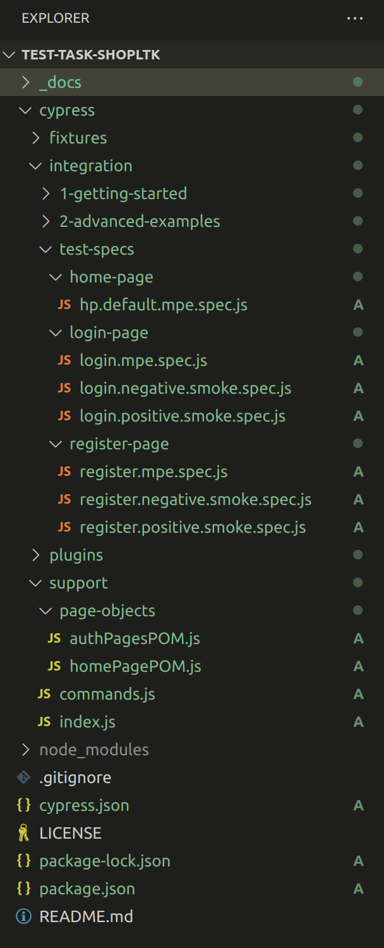

2. Home Page
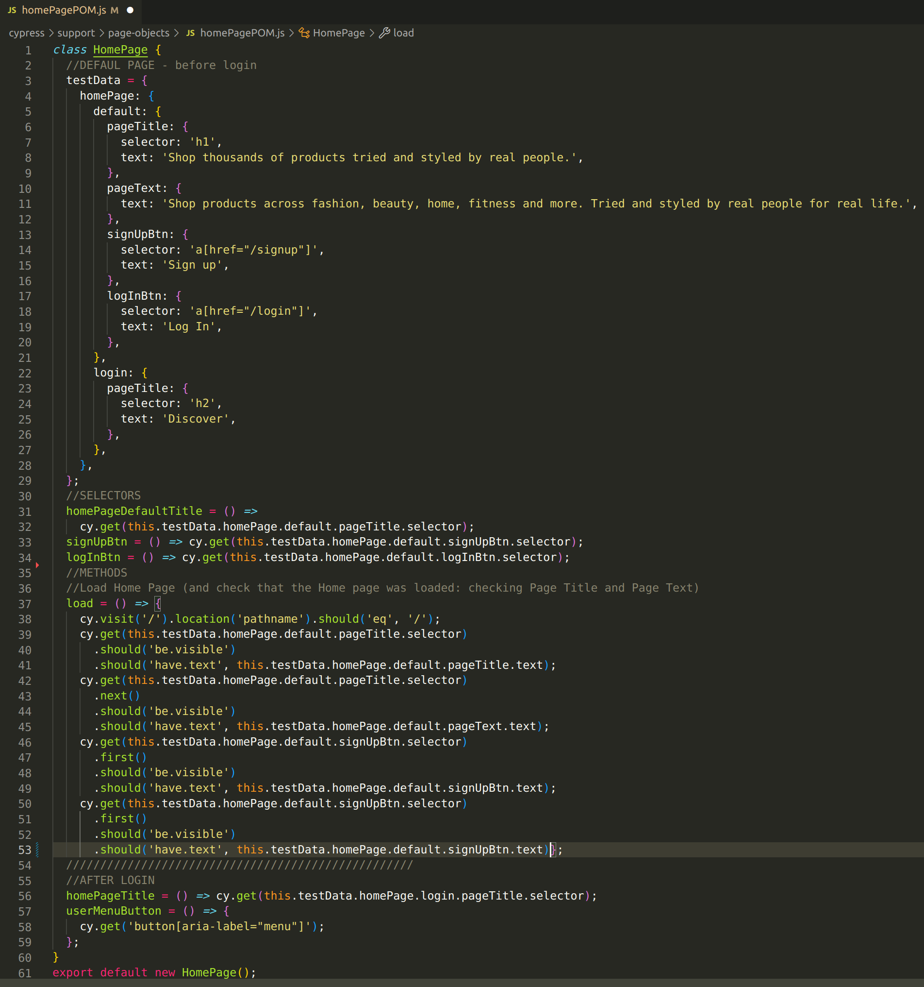
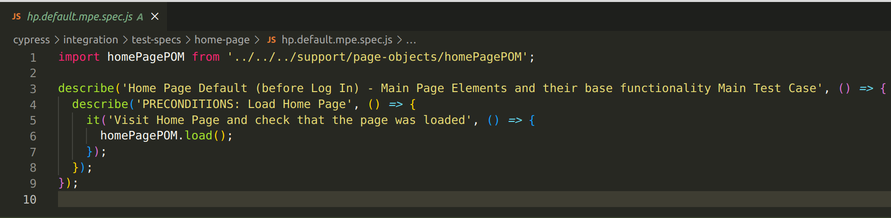

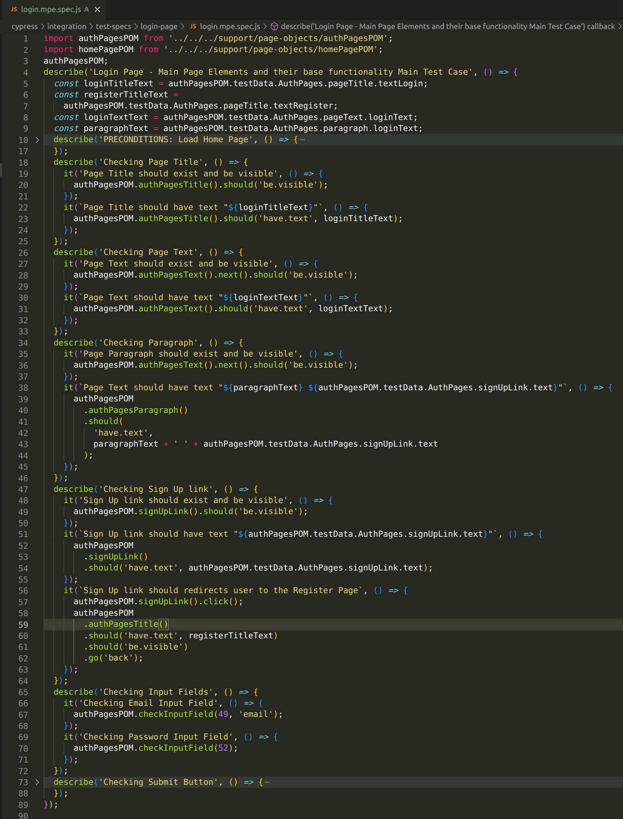
3. Login Page
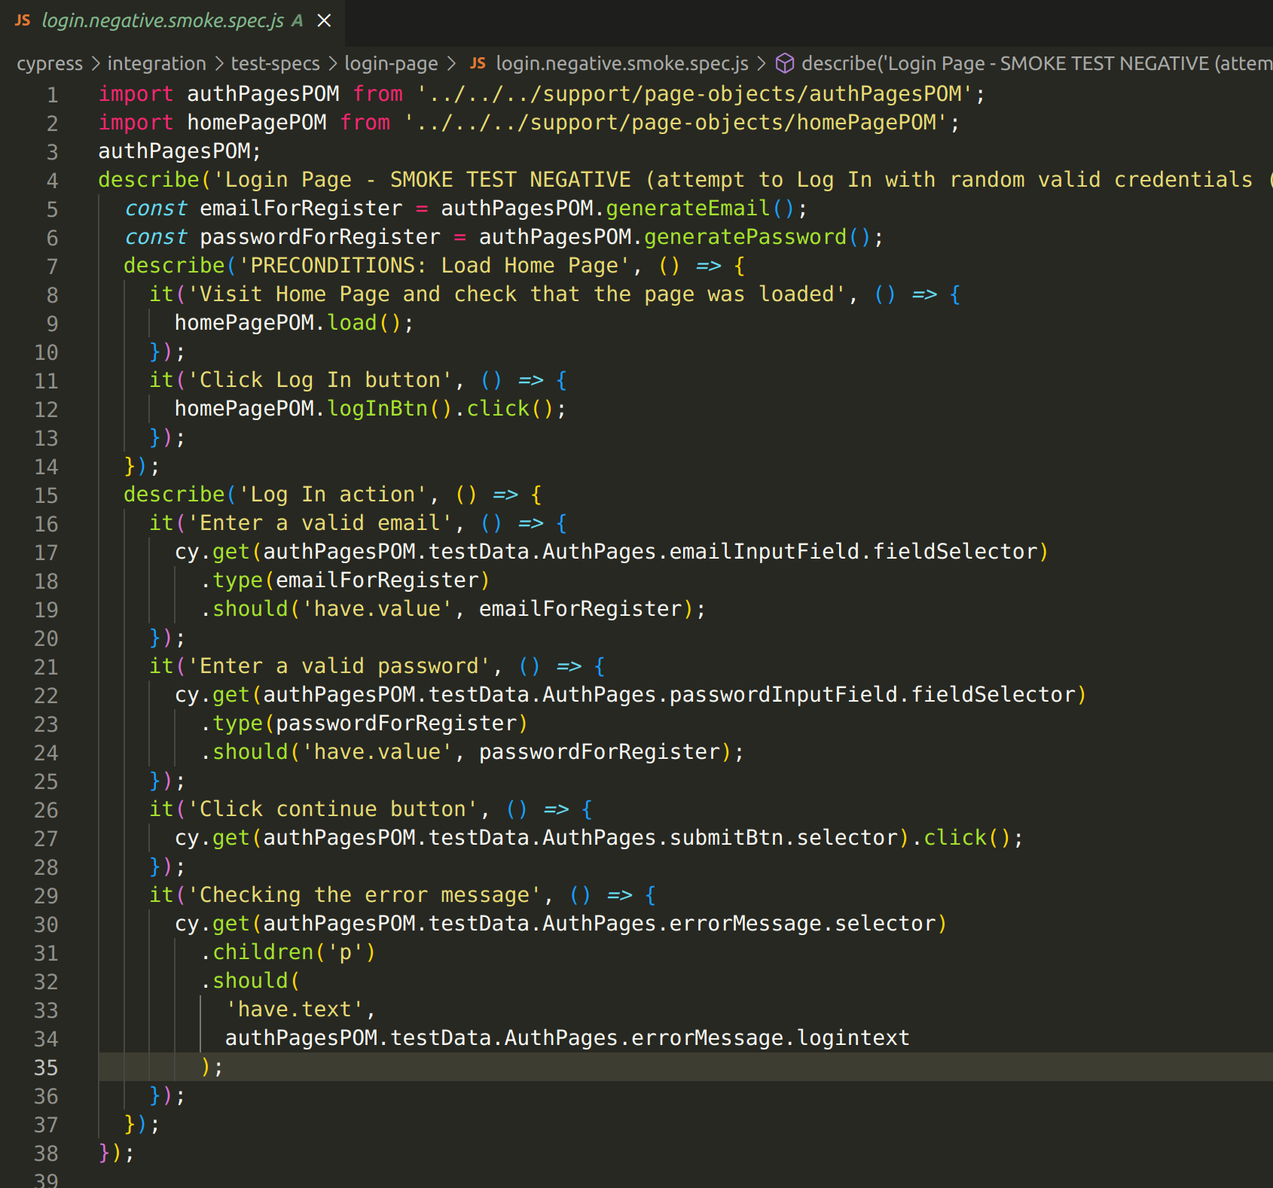
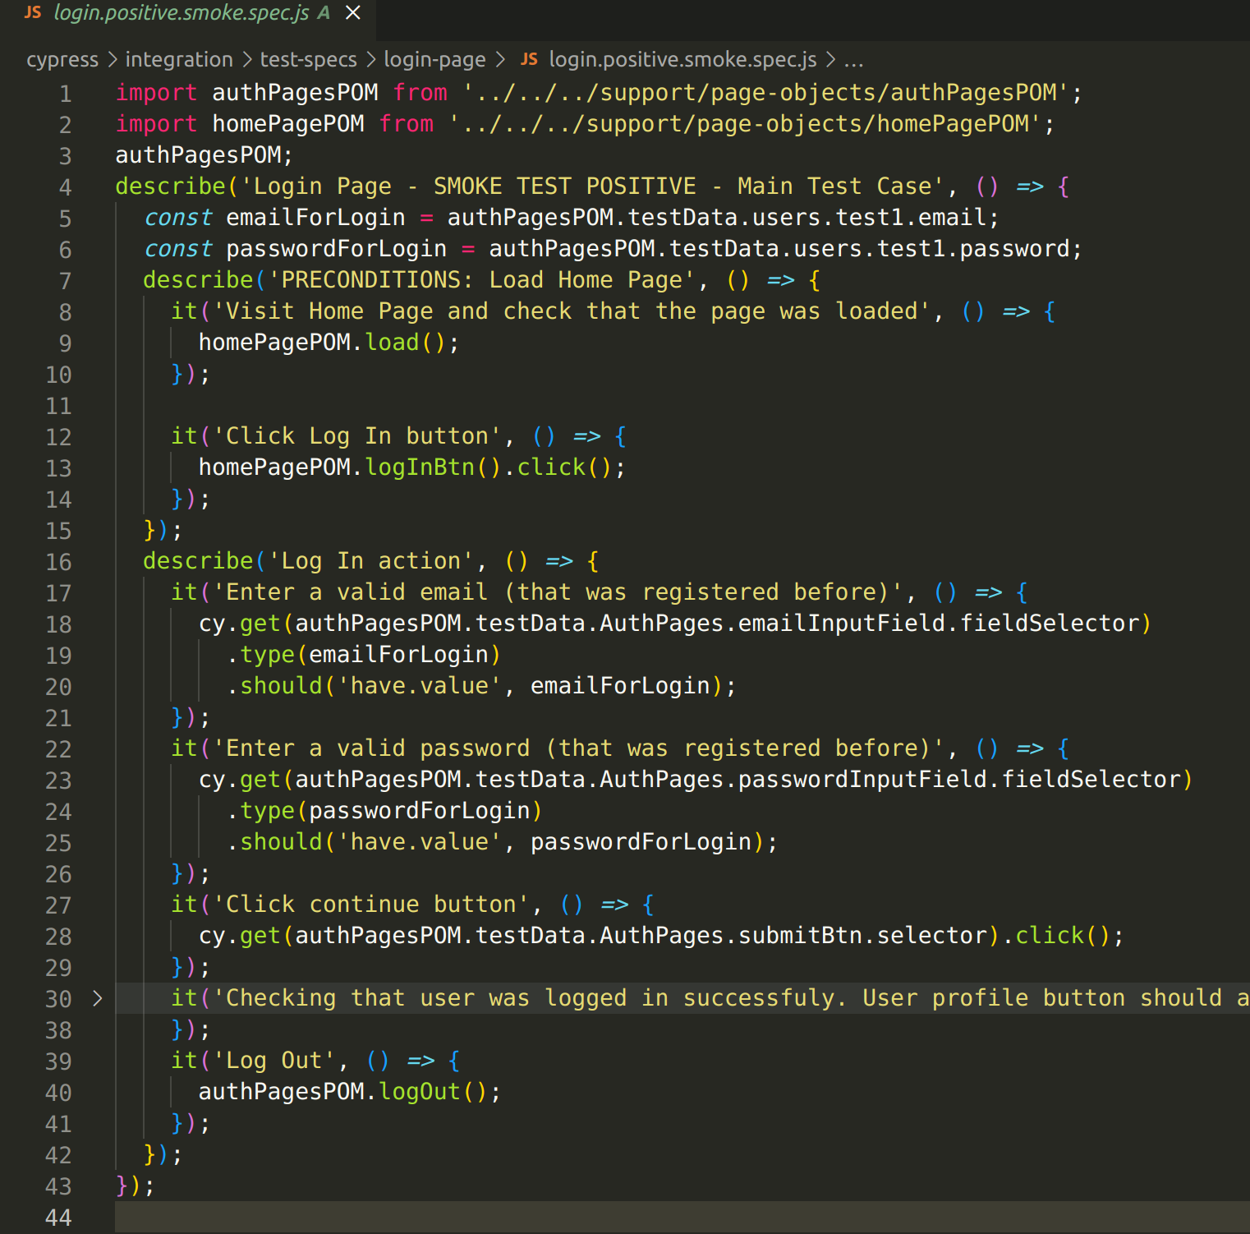

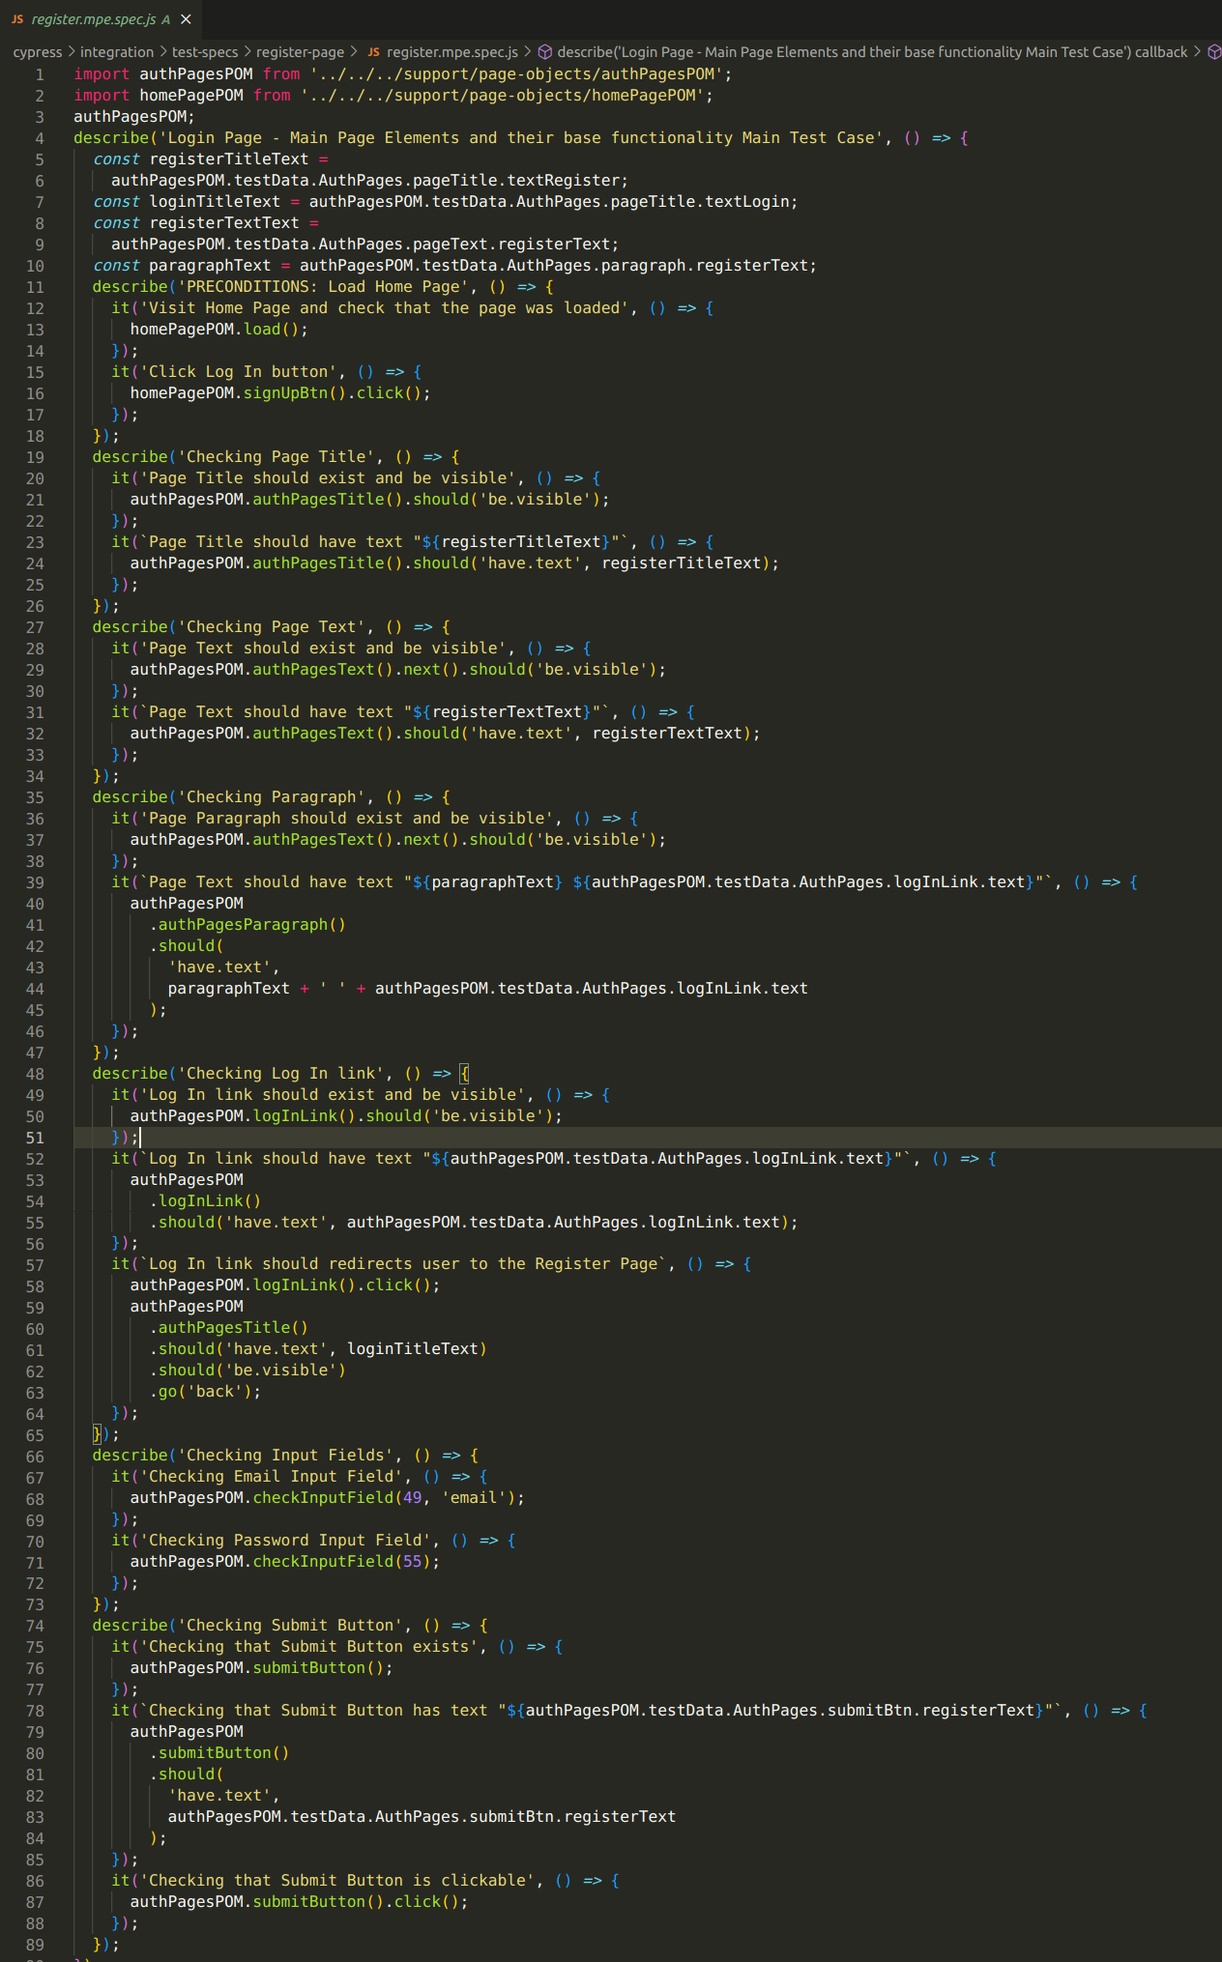
4. Register Page
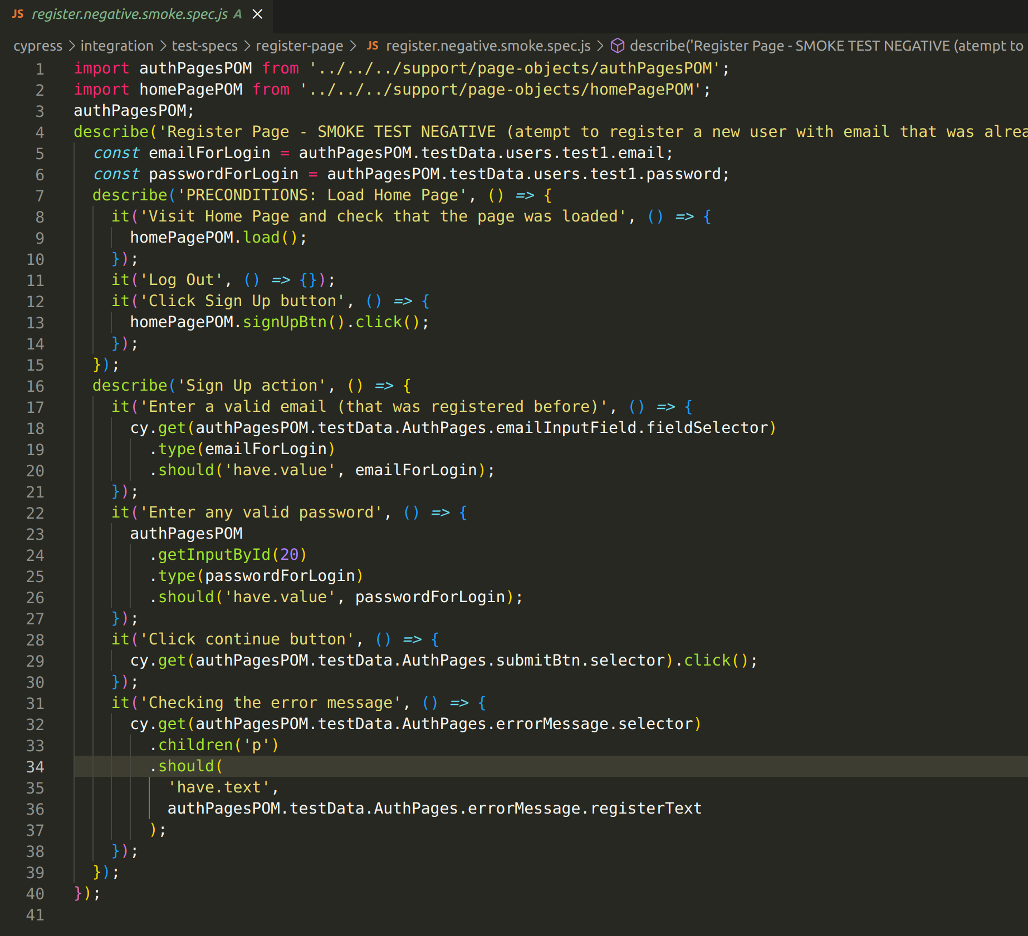
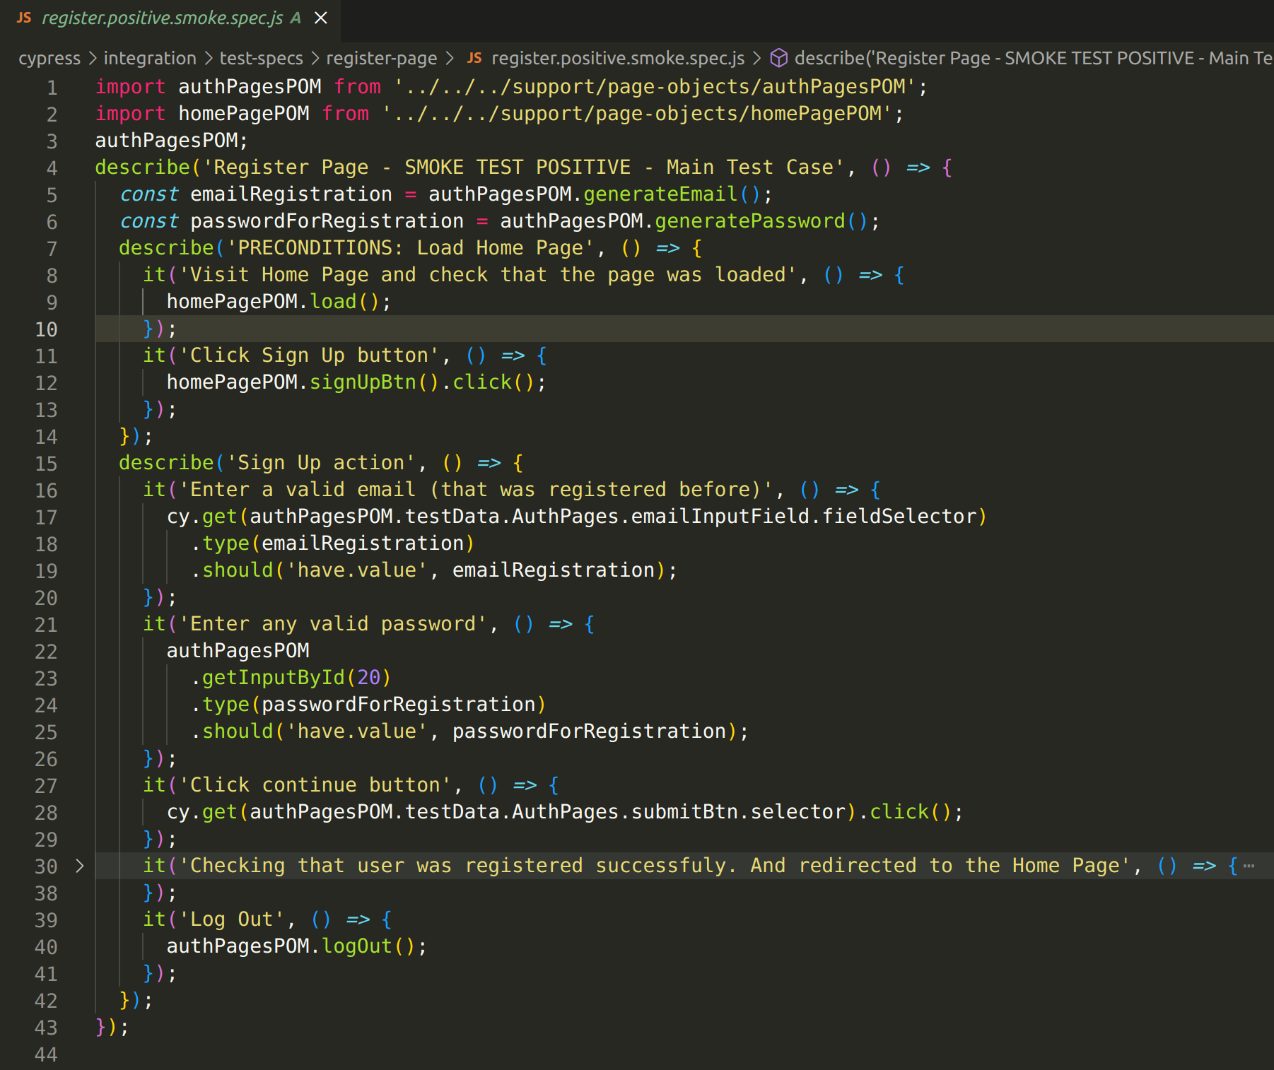

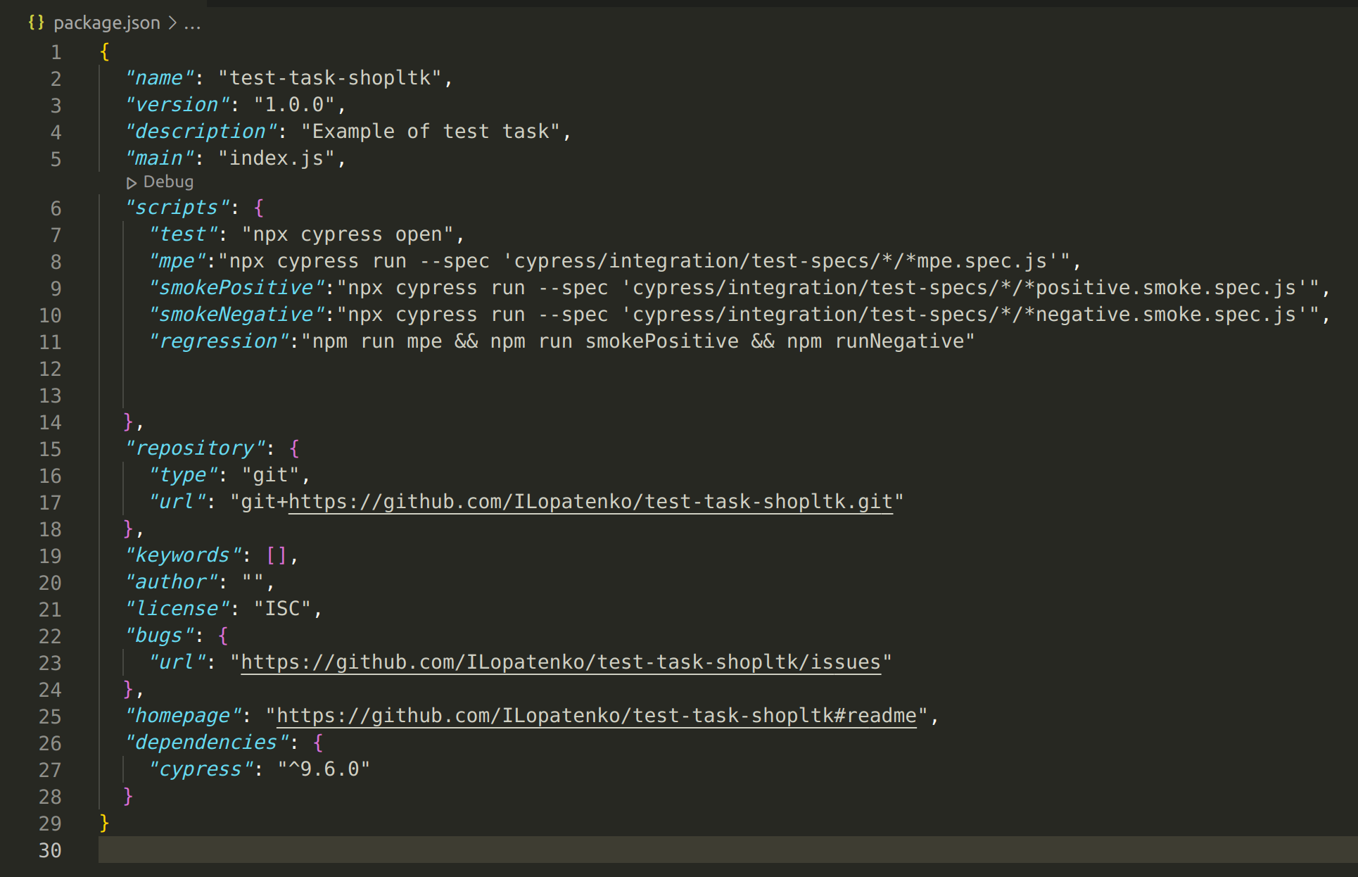
5. Run Scripts

6. gitHub Actions pipeline
