How to perform automated unit testing using Mocha/Chai

Table of Contents
0 Preconditions 3
0.1 Software 3
0.2 GitHub repository 3

0 Preconditions

0.1 Software
You need to have: VSCodse, Nodejs, git (if you want to store your project on github)

0.2 GitHub repository
Create a new github repository for your project and clone it to your local computer.

1 Unit test framework
Initialize a new npm project
npm init -y

1.1 Install Mocha and Chai
npm i mocha chai

1.2 Settings
Create a new folder to store all the tests (specifications = specs).
mkdir specs
Create a new file .mocharc.js
module.exports = {
spec: 'onTest/**/*spec.js',
};

Open package.json and change test script:
"scripts": {
"test": "npx mocha --config .mocharc.js",
"onTest": "npx mocha --config .mocharc.js"
},

Create a new test spec
touch specs/example.spec.js
const { expect } = require('chai');

describe('hi', () => {
it('hiit', () => {
let a = true;
let b = true;
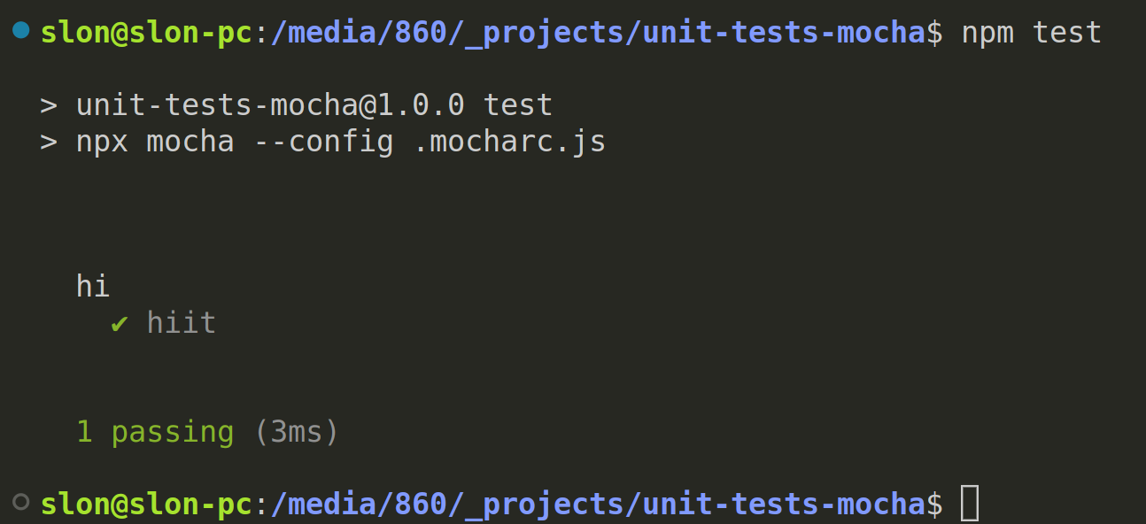
expect(a).to.eq(b);
});
});

Now you can run your first test using
npm test

1.3 Project structure/architecture
This project was created for testing task solutions (codeWars, hackerRank, leetCode etc).
The root folder contains _tested folder. _tested folder contains hackerrank folder. Hackerrank folder contains all the task that were solved and tested.
Folder onTest contains the task that I currently working on (palindromeIndex for example). Each task folder contains all the files that related to the task and has the same structure.
There are 3 main files:
palindromeIndex.js – solution (with module export).
palindromeIndex.spec.js – main test file
palindromeIndex.helper.js – main helper file for this task

The root folder contains _helper folder that contains MainHelper.js file. It contains all the common logic.
The root folder contains _templates folder that contains all the tamplates.
The root folder contains _tested folder that contains all the solved tasks.

