Install and setup a test automation framework (TAF) based on WEBdriverIO from scratch
Table of Contents
0 Preconditions 3
1 Create a new GitHub repository 3
2 Clone your new repository to your computer 5
3 Initiate a new Node Package Manager project 6
4 Add WebdriverIO to your project 7
5 Run your first auto test (default example) 8
5 Settings 9
5.1 Setup running additional web browsers 9
5.1.1 Safari 9
5.1.2 Firefox 9

0 Preconditions
You need to have git and node.js installed on your computer. You need to have GitHub account.

1 Create a new GitHub repository
Open github and sigh in to your account.
Click the button “New”
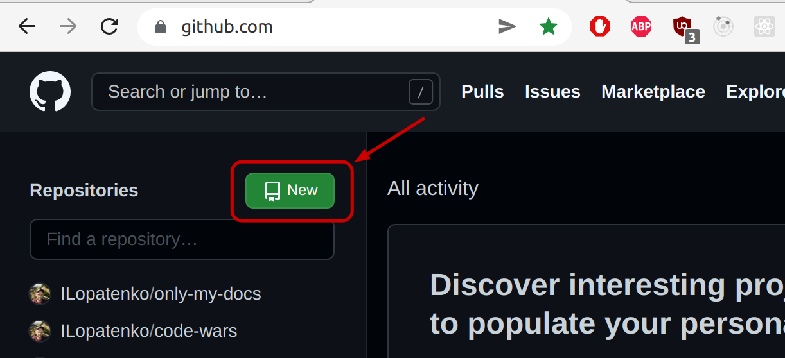
Fill in all the information and click the button “Create repository”.
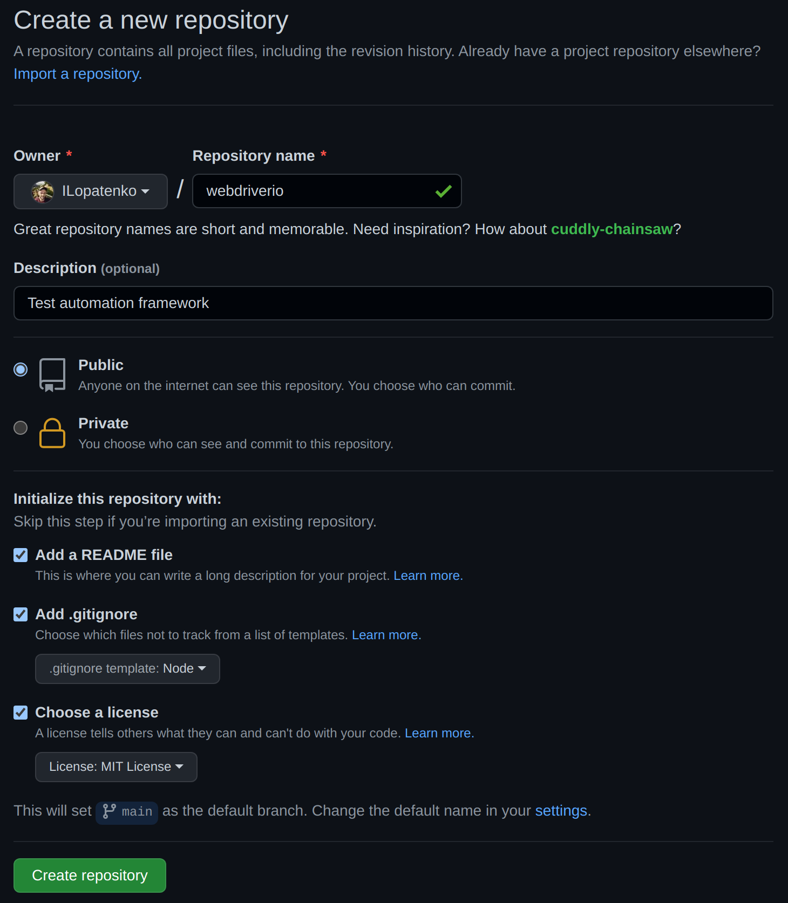
You will see a new page with some info about your new repository.
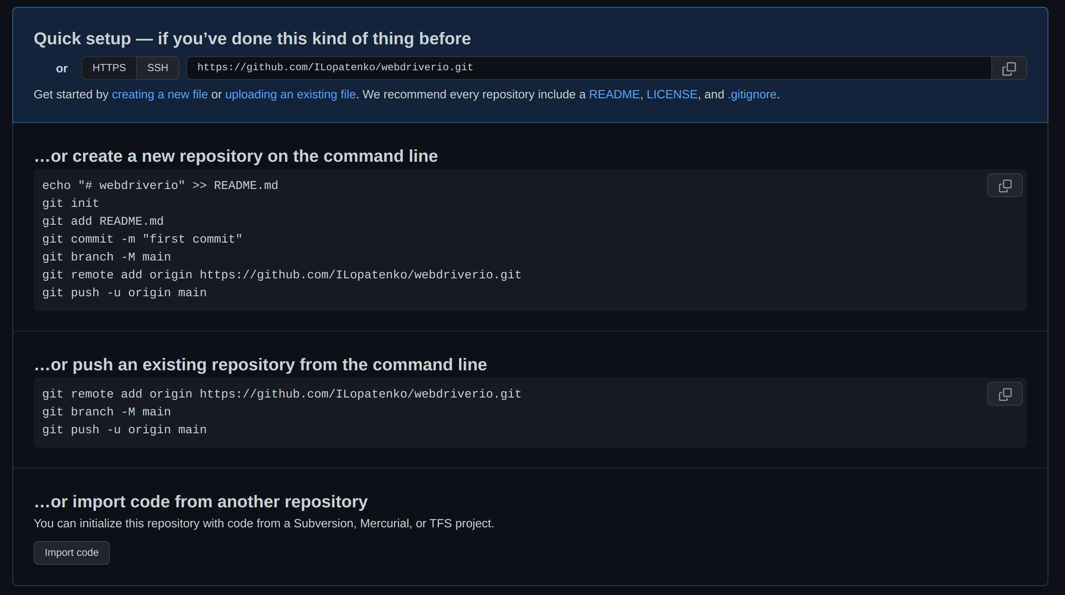
Copy the link to your new repository [in my case it is https://github.com/ILopatenko/webdriverio.git]

2 Clone your new repository to your computer
Open a new terminal
Go into folder where you want to store your new project folder [in my case I store all my projects inside /media/970-rest/_projects_].
CLI=>cd /media/970-rest/_projects_
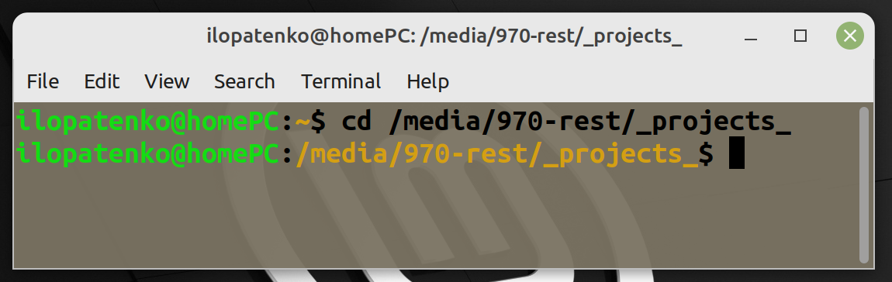
Clone your new github repository inside current folder (new local project folder will appear)
CLI=>git clone https://github.com/ILopatenko/webdriverio.git
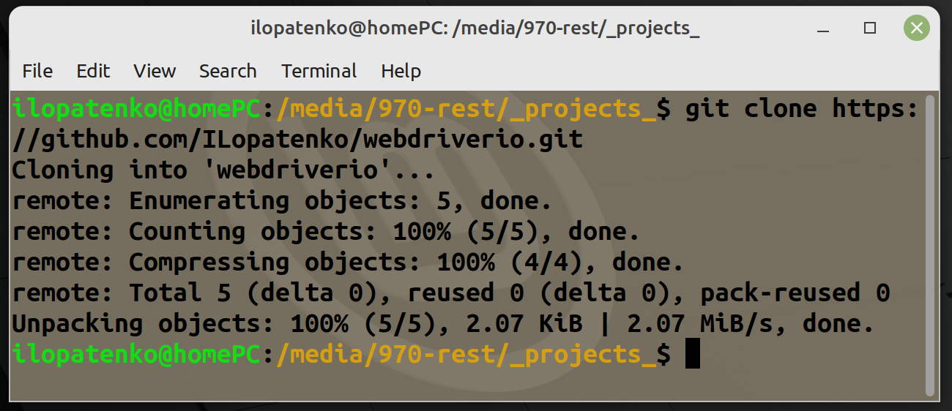
Go into local project folder
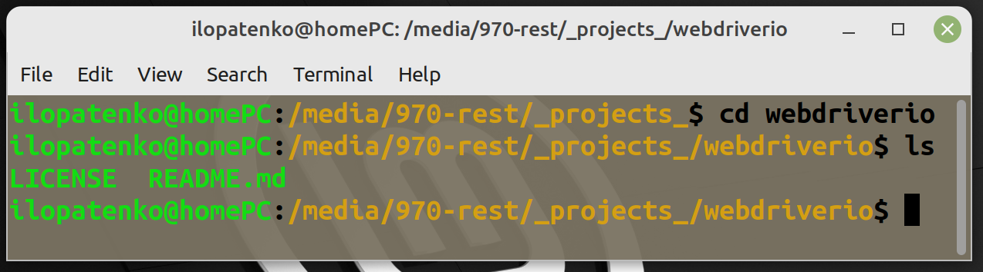
CLI=>cd webdriverio

3 Initiate a new Node Package Manager project
It will allow you to use 3rd party packages/modules in your project
Open your local project folder with IDE [I will use VSCode]
Initiate a npm init -ynew npm project
CLI=>npm init -y
key -y will set all the settings to default values
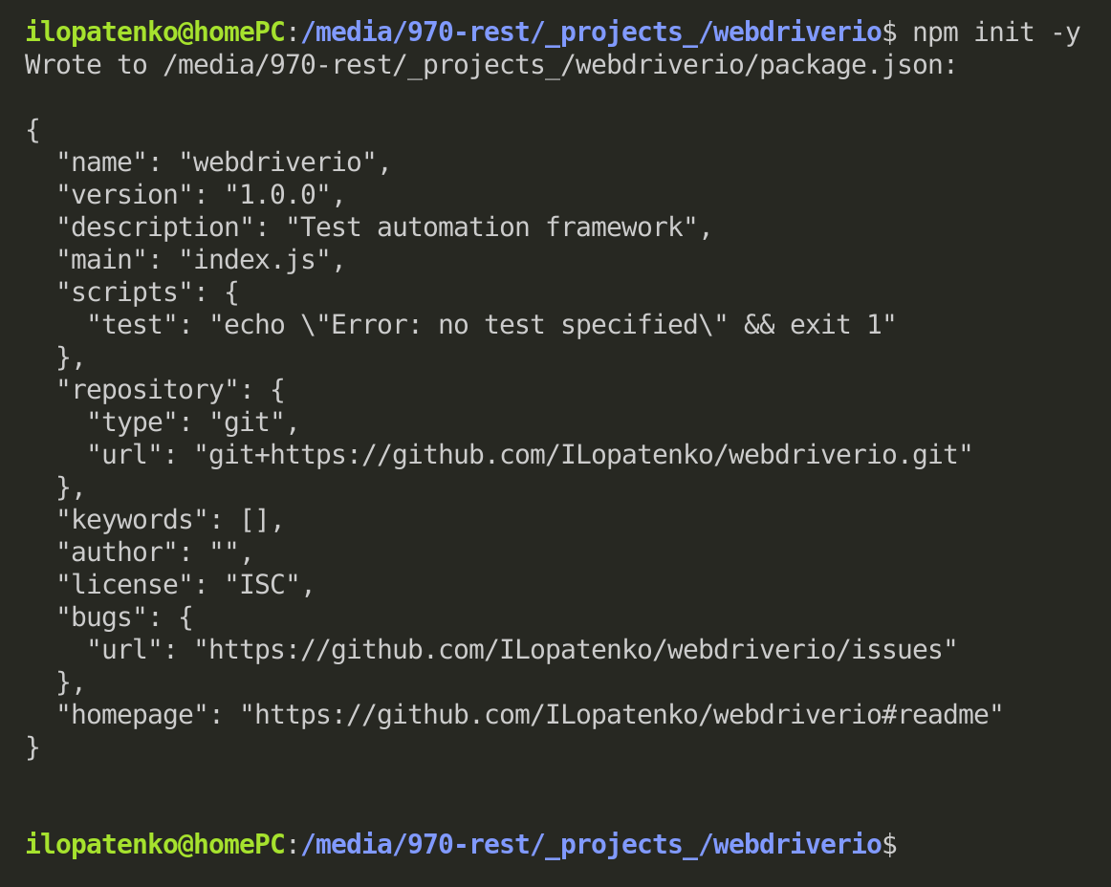

4 Add WebdriverIO to your project
CLI=>npm init wdio . -y
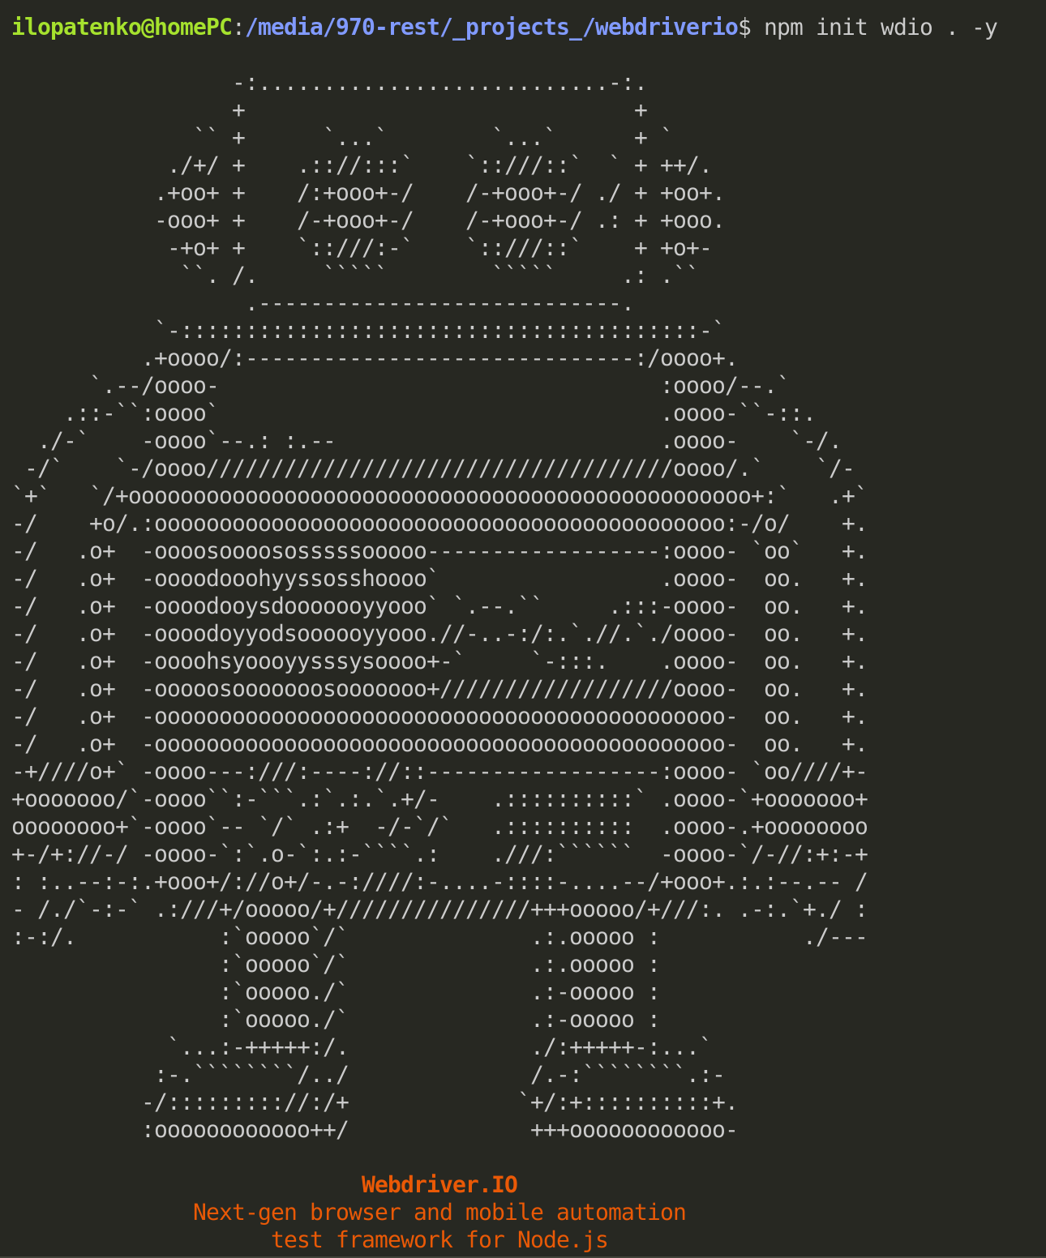
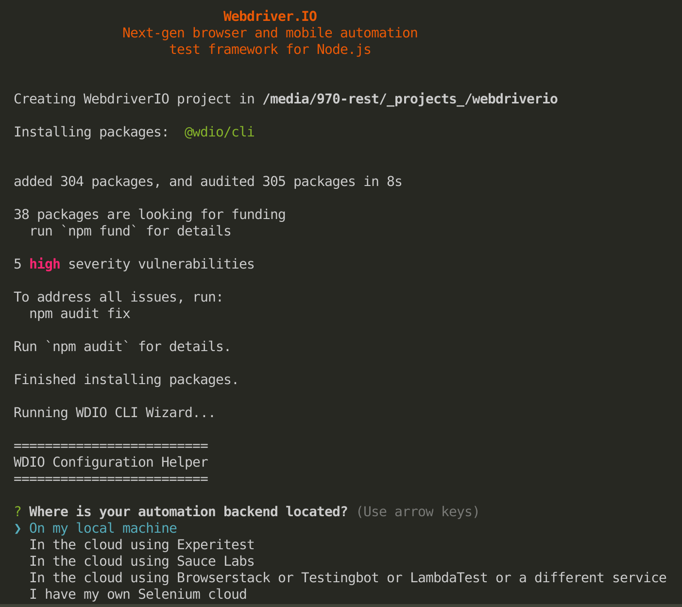
Now you have to setup your framework (you have to answer to 11 questions. To change an answer use ARROW UP and ARROW DOWN, to select few answers use SPACE, to confirm selection use ENTER)
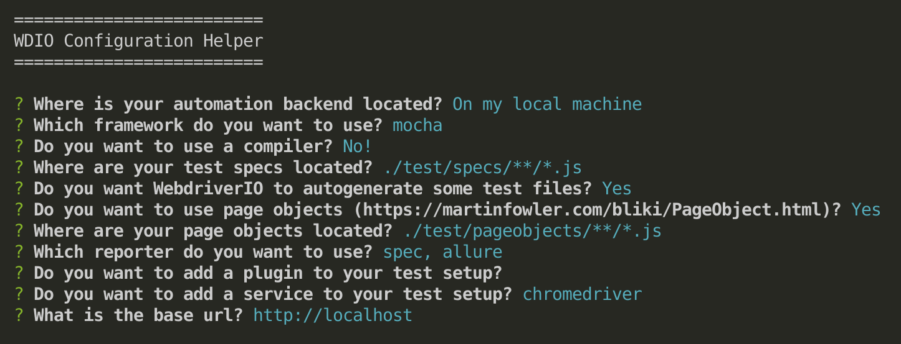
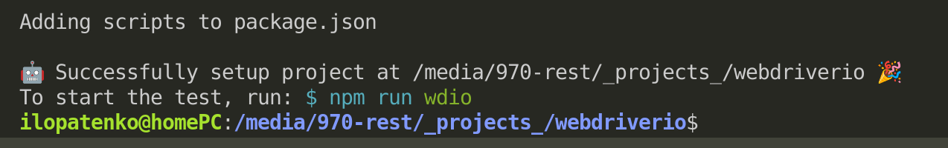

5 Run your first auto test (default example)
CLI=>npx wdio wdio.conf.js
You will see lots of information in terminal, new Chrome window should be opened automatically and closed after some time/actions and finally you will see in terminal your firs test report
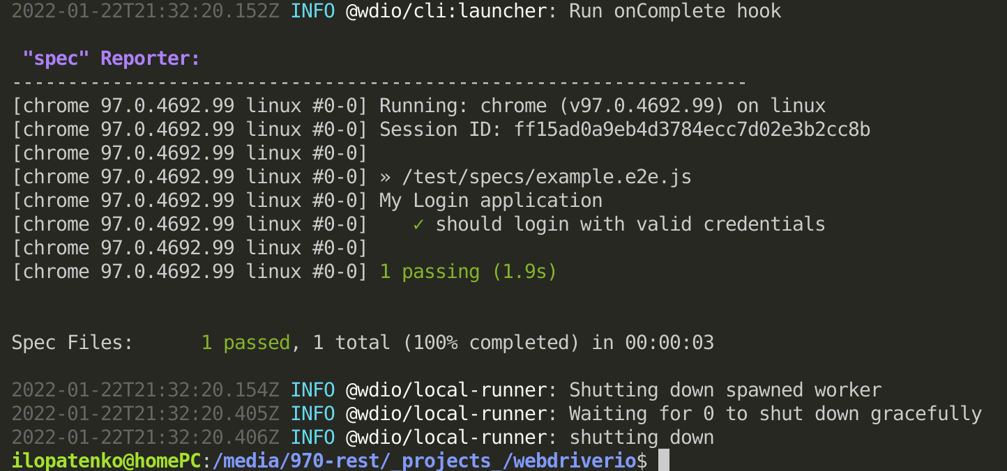
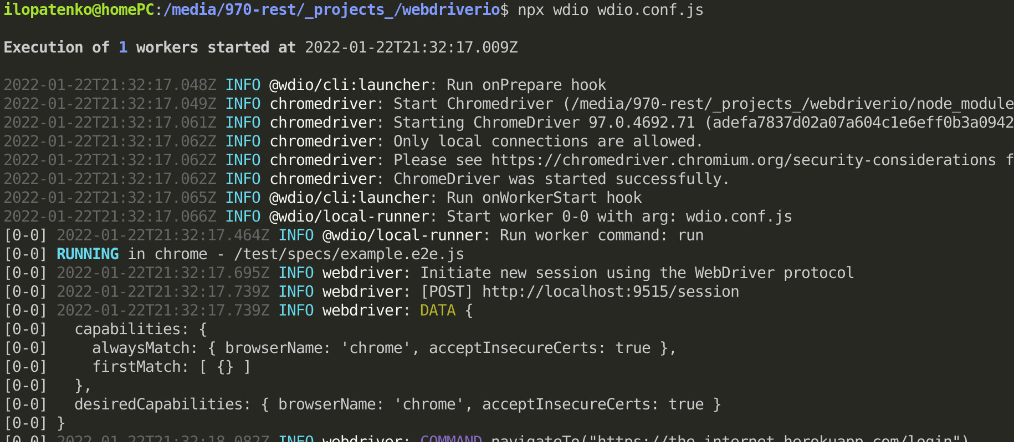
So far so good. You can create a new commit and push it to your repo (you will save installed and working webdriverio)
CLI=>git status
CLI=>git add .
CLI=>git commit -m 'Framework successfully executed 1 test'
CLI=>git push

5 Settings

5.1 Setup running additional web browsers

5.1.1 Safari
If you are using MacOS and want to be able to run your tests in Safari web browser
CLI=>npm install wdio-safaridriver-service --save-dev

5.1.2 Firefox
If you want to run your tests in Firefox web browser
CLI=>npm install geckodriver –save-dev
CLI=>npm install wdio-geckodriver-service --save-dev

5.2 Add new browsers to config file
Open wdio.conf.js (it should be in root of your project folder) and change capabilities, services properties and add safariDriverArgs: ['-p 4444']
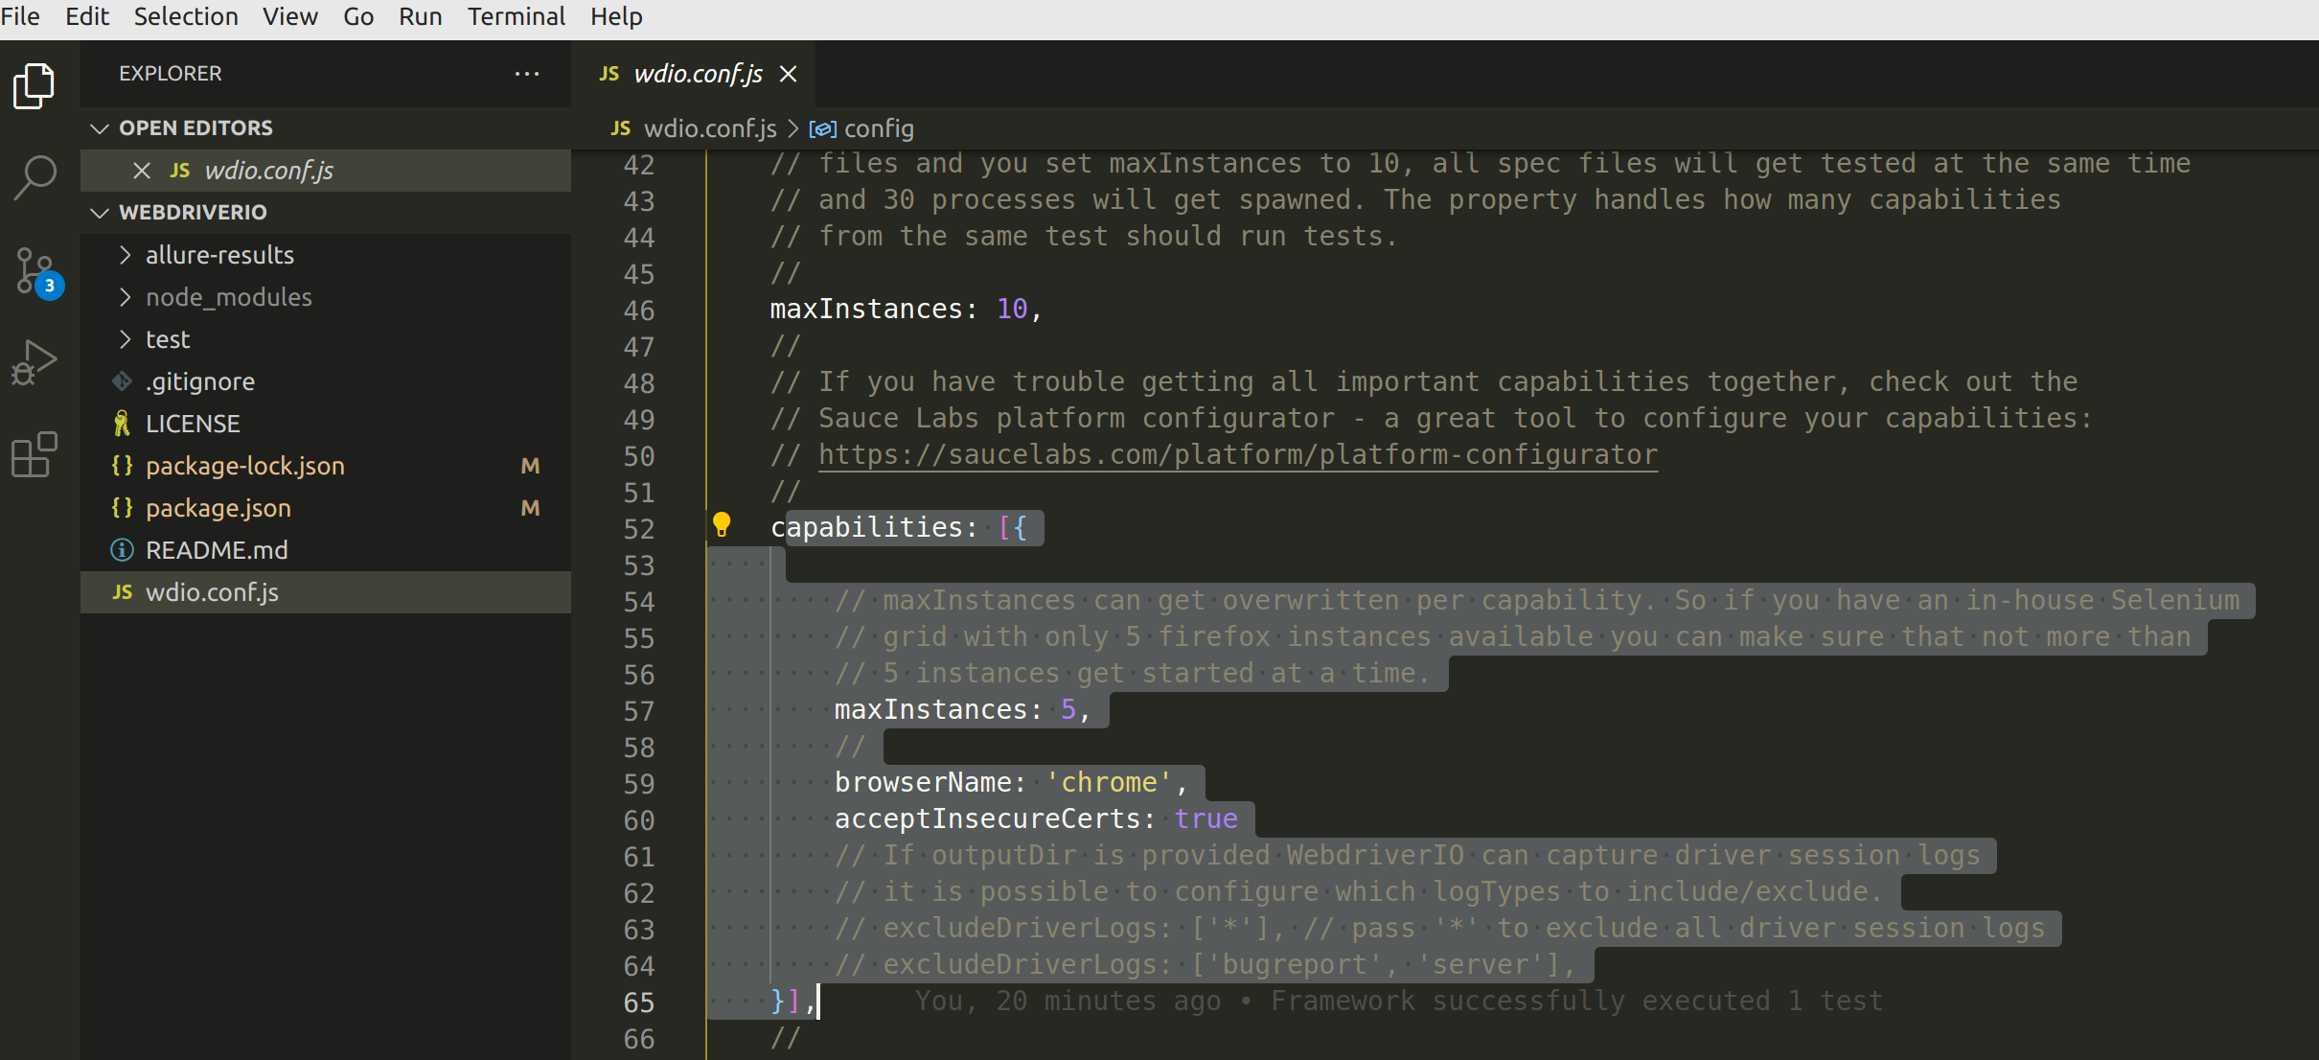
capabilities: [
{
maxInstances: 1,
browserName: 'chrome',
},
{
maxInstances: 1,
browserName: 'firefox',
},
],
services: ['chromedriver', 'geckodriver'], safariDriverArgs: ['-p 4444'],
Test a new configuration
CLI=>npx wdio wdio.conf.js
You will see lots of information in terminal, new Chrome window should be opened automatically and closed after some time/actions and finally as well as Firefox window you will see in terminal your 2 test reports
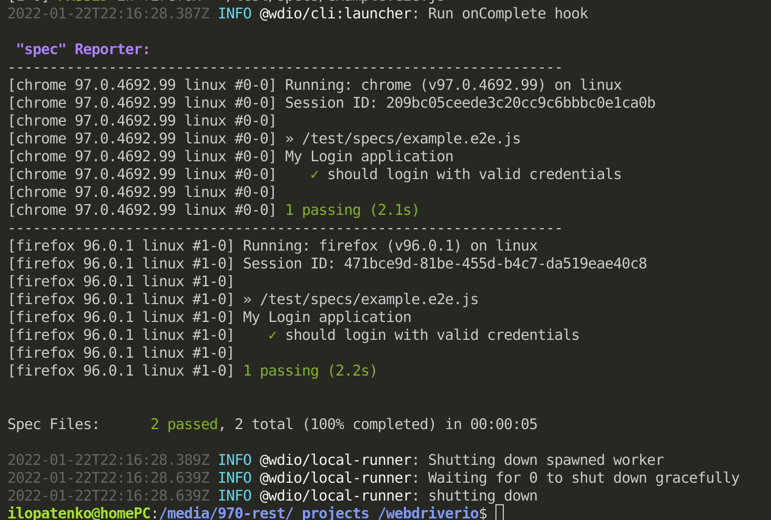
You can create a new commit and push it to your repo (you will save installed and working webdriverio that now can run test in chome and firefox)

