Installing neovim and cloning configuration files for IDE to .config folder:

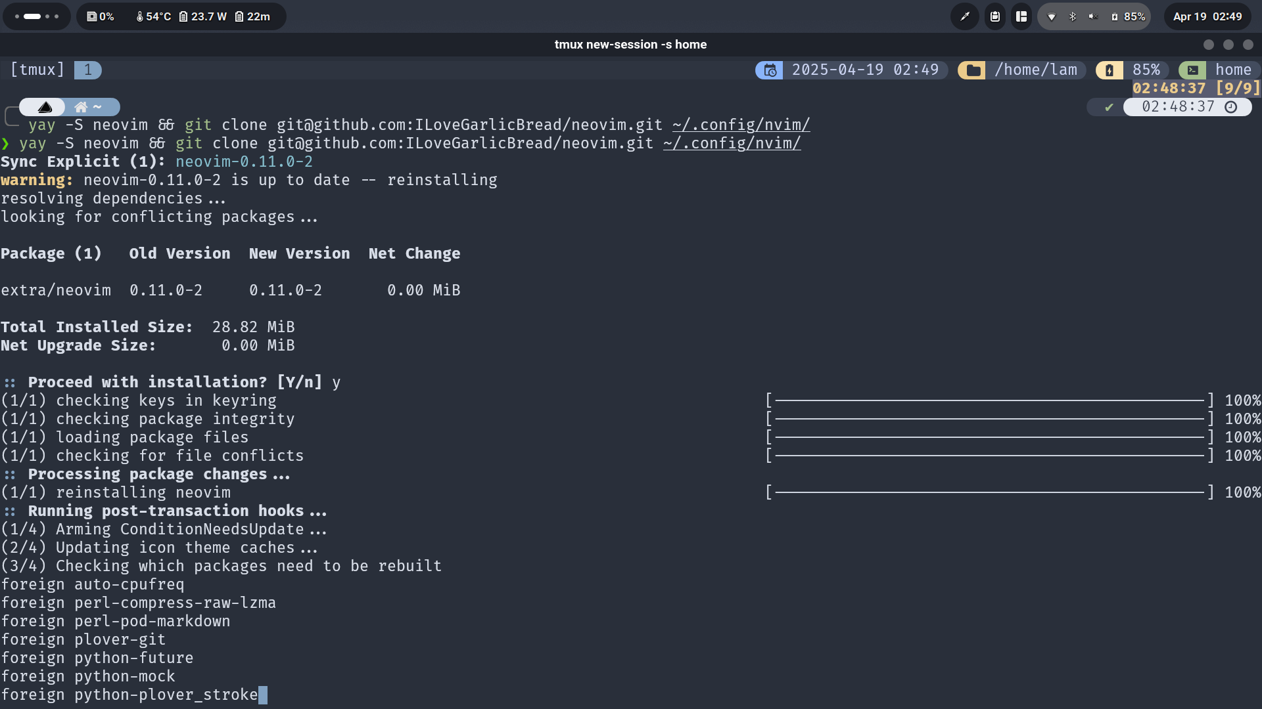

10 advantages of an IDE:

Version control integration

Code completion

Code suggestion

Built-in compiler or interpreter

Debugging

Syntax highlighting

Ease of setup

Code formatting

Integrated testing tools

Code template/snippets