

IMACS GmbH

Mittelfeldstrasse 25

D – 70806 Kornwestheim

[www.radcase.com](http://www.radcase.com/)

[support@radcase.com](mailto:support@radcase.com?subject=Installation%20Manual)

Tel.: +49 (0) 7154 80 83 - 14

IMACS GmbH reserves the right to make changes without further notice to any products herein. IMACS GmbH makes no warranty, representation or guarantee regarding the suitability of its products for any particular purpose, nor does IMACS GmbH assume any liability arising out of the application or use of any product or circuit, and specifically disclaims any and all liability, including without limitation consequential or incidental damages. “Typical” parameters which may be provided in IMACS GmbH data sheets and/or specifications can and do vary in different applications and actual performance may vary over time. All operating parameters, including “Typicals” must be validated for each customer application by customer’s technical experts. IMACS GmbH does not convey any license under its patent rights nor the rights of others.

Copyright © IMACS GmbH 2019. All rights reserved.

Reproduction, in part or whole, without the prior written consent of IMACS GmbH is prohibited.

Table of Contents

1 Overview 4

2 Quick installation guide 5

3 Installation of radCASE 6

3.1 Software Requirements 6

3.2 Hardware Requirements 7

3.3 Installation 7

4 Installation of Microsoft Visual Studio/C++ Express 8

4.1 Updating Visual Studio 9

5 Licensing Procedures 10

5.1 Overview 10

5.1.1 Step 1 10

5.1.2 Step 2 10

5.2 Single license with *Sentinel HASP/HL MAX* dongle 10

5.3 Single license with SuperPro dongle 10

5.4 Network license with *Sentinel HASP/HL NET* dongle 11

5.4.1 Server Installation 11

5.4.2 Client Installation 11

5.5 Network license with SuperPro dongle 12

5.6 Copy the license file (radCASE.lic or radon.lic) 12

5.7 Install the driver for the HASP dongle 13

5.7.1 Install the HASP driver using windows update 13

5.7.2 Install the HASP driver using an installer 14

5.8 Check the installation of the HASP dongle driver 14

5.8.1 Check Firewall settings 16

5.9 Install the Sentinel Protection Installer 16

5.10 Set up the license server (computer) 17

5.10.1 Install the radCASE license server (software) 17

5.11 Configure radCASE to use the license server 18

6 Troubleshooting 20

6.1.1 Visual Studio / Visual C++ / Environment Variable MSVC_BIN 20

6.1.2 visual.lic 21

# Overview

This document describes the installation of **radCASE,** Microsoft Visual Studio (VS) and the licensing of **radCASE**.

For experienced users a quick installation guide is available see Quick installation guide. For uncertain users and in case of trouble a detailed instruction is given:

1. Installation of **radCASE:** Installation
2. Installation of Microsoft Visual Studio/C++ Express
3. Licensing Procedures  
   If you bought a license of radCASE, follow the steps in chapter Licensing Procedures.   
   If not, skip this step. You can still work in the trial mode (refer to Information on the radCASE Trial License in the Readme First)

If problems occur, check out the document **FAQ.pdf** and the chapter Troubleshooting.

# Quick installation guide

1. Download and install **radCASE**:

<http://download.radcase.de/> Password: radCASE

1. Download and install Microsoft Visual Studio 2017 **Express**:

<http://download.radcase.de/> Password: radCASE

Microsoft server: <https://visualstudio.microsoft.com/de/vs/express/>

1. Download and install the Dongle driver:

<http://download.radcase.de/> Password: radCASE

Gemalto server:

<https://supportportal.gemalto.com/csm?id=kb_article_view&sys_kb_id=61fb0ee1dbd2e78cfe0aff3dbf9619ab&sysparm_article=KB0018320>

1. Copy your personal license file into your radEDIT folder: %ProgramFiles%\radCASE\radEDIT
2. Start **radCASE**

# Installation of radCASE

## Software Requirements

|  |  |
| --- | --- |
|  | **Administrator rights are required** on your computer for the *installation, first-time setup and licensing* of **radCASE** as well as for the *installation of 3rd-party software*. |

|  |  |
| --- | --- |
|  | The installation file as well the installation process can cause **anti-virus warnings** depending on your antivirus software. In this case, disconnect your network interfaces (LAN / WLAN) and disable your antivirus software. |

|  |  |
| --- | --- |
|  | **Read Access to the registry is required** for the *usage* of **radCASE** as well as for Visual Studio.The following command on the command prompt must complete without errors: reg query HKEY_LOCAL_MACHINE. For more information refer to the FAQ.pdf. |

|  |  |
| --- | --- |
| Component | Version / Information |
| Operating System | Windows 10  Windows 8/8.1  Windows 7 |
| Microsoft  Visual Studio (VS) | Visual Studio 2017, 2015, 2013, 2012, 2010 **with C++**.  *Must be downloaded and installed separately by the user.*  **VS2017 Express** is *recommended* for use with radCASE.  **VS2015** may work, but due to various problems is *not recommended*.  IMACS will not provide any support when using VS2015. |
| Microsoft  .NET Framework | .NET 4.0 or higher  *Will be downloaded and installed by the radCASE Installer if needed.* |
| Microsoft  Visual C++ Redistributables | *Will be downloaded and installed by the radCASE Installer if needed.* |

## Hardware Requirements

|  |  |
| --- | --- |
| Component | Dimension |
| CPU | 2 GHz |
| RAM | 1 GB (32‐bit Windows)  2 GB (64 bit Windows) |
| Disk Space | approx. 300 MB (without samples), approx. 600 MB (with samples) |

## Installation

Start the **radCASE** installer radCASE_<version>_xxx_Setup.exe.

In case the “User Account Control” of Microsoft Windows pops up, allow the program to make changes by choosing “Yes”.

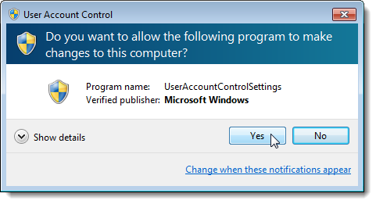

A wizard will guide you through the installation process of radCASE.

|  |  |
| --- | --- |
|  | It is recommended to **leave all settings at default values**, especially for first-time users of **radCASE**. |

|  |  |
| --- | --- |
|  | If the installer shows a warning regarding the missing Visual Studio, confirm it and continue with the installation of **radCASE**. |

# Installation of Microsoft Visual Studio/C++ Express

Microsoft Visual Studio (VS) is required for the **radCASE** features simulation and visualization.

1. Select an appropriate Version of VS

* For use with radCASE, the VS **Express-Versions** are sufficient. Make sure that the **support for C++** gets installed.
* **It is recommended to use the highest VS version that is supported by radCASE.**

If lower version must be used for whatever reason (not recommended), refer to the chapter “Disable VS Versions for use with radCASE” in the *FAQ.pdf*.

1. Download VS

* Download the VS Version from Microsoft. For older versions you may need a Microsoft Live account.

|  |  |
| --- | --- |
|  | Select the VS installation in the same language as the language of your Windows operating system. |

|  |  |
| --- | --- |
|  | Hints:  For 2012 and later go for “Express for Windows Desktop”  For 2010, choose “Visual C++ Express”. Note: Service Pack 1 (SP1) is required, too. |

1. Install the software according to the Microsoft instructions and make sure to observe the hints marked with :

|  |  |
| --- | --- |
|  | **Always apply the latest service packs and updates for your version of Visual Studio!** Refer to Updating Visual Studio |

|  |  |
| --- | --- |
|  | For VS 2015:  In case the installer offers a “Custom Installation”, choose it instead of the “Typical Installation”. Then, in “Programming Languages” 🡪 ”Visual C++” check the following to options: “Common Tools for Visual C++ 2015” and “Windows XP Support for C++”. |

|  |  |
| --- | --- |
|  | For VS 2012:  Make sure to apply all available updates of Visual Studio: Menu Tools 🡪 Extensions and Updates… In the tree select Updates 🡪 Product updates and install all updates available. |

|  |  |
| --- | --- |
|  | For VS 2010:  Make sure to install the service pack SP1 if you install other versions of VS in parallel to VS2010. You will probably need a Microsoft Account to be able to download it.  Also refer to the **FAQ.pdf**, chapter MS VS/VC++ Express 2010 – SP1. |

|  |  |
| --- | --- |
|  | Microsoft Silverlight and Microsoft SQL Server are not needed by radCASE. |

|  |  |
| --- | --- |
|  | For users of older radCASE versions: As of radCASE 4.9.0r, the environment variable MSVC_BIN is not needed any longer and can be deleted. |

## Updating Visual Studio

Older Visual Studio versions can be updated though the MENU: Help – Check for Updates.

Newer Visual Studio versions can be updated using Windows Update – see

[www.update.microsoft.com/windowsupdate/](http://www.update.microsoft.com/windowsupdate/)

**Verwenden Sie das Startmenü, um nach Updates zu suchen.**   
  
Windows Update steht in der Systemsteuerung zur Verfügung. So suchen Sie nach Updates  
  
http://www.update.microsoft.com/windowsupdate/v6/shared/images/vista/vistaarrow.jpg  Klicken Sie auf **Start**, dann auf **Alle Programme** und anschließend auf **Windows Update**.

|  |  |
| --- | --- |
| http://www.update.microsoft.com/windowsupdate/v6/shared/images/win7/de/select_all_programsWin7.gif | http://www.update.microsoft.com/windowsupdate/v6/shared/images/win7/de/select_wuWin7.gif |

|  |  |
| --- | --- |
|  | Make sure you enabled the following option under Windows Update – Changes Settings / EInstellungen ändern:  “Give me updates for other Microsoft products when I update Windows”  “Updates für Microsoft-Produkte beim Ausführen von Windows Update bereitstellen und nach neuer optionaler Microsoft-Software suchen"”  More Info:  <https://e-tutor-bangladesh.blogspot.de/2016/04/update-office-and-your-computer-with.html> |

# Licensing Procedures

## Overview

A **radCASE** license consists of a USB-hardware dongle and license files (radon.lic or radCASE.lic, optionally server.lic and sometimes visual.lic).

Perform the following 2 steps to license your product:

### Step 1

There are different mechanisms of licensing. Depending on the kind of dongle and the license files you received, follow the instructions in the corresponding chapter:

* Single license with Sentinel HASP/HL MAX dongle
  + A green dongle with the inscription “HASP HL” or “Sentinel®” is used
* Single license with SuperPro dongle
  + A dongle without the inscription “HASP” is used. The file server.lic is not provided.
* Network license with Sentinel HASP/HL NET dongle
  + A red dongle with the inscription “HASP HL” or “Sentinel®” is used
* Network license with SuperPro dongle
  + A dongle without the inscription “HASP” is used and a license file server.lic is provided

### Step 2

After completing the above steps, follow the instructions in chapter visual.lic.

## Single license with Sentinel HASP/HL MAX dongle

The following steps need to be done on the computer on which **radCASE** is installed.

1. Copy the license file (radCASE.lic or radon.lic)
2. Plug the HASP dongle into a USB-Port.
3. Install the driver for the HASP dongle
4. Check the installation of the HASP dongle driver
5. **radCASE** is licensed

## Single license with SuperPro dongle

The following steps need to be done on the computer on which **radCASE** is installed.

1. Copy the license file (radCASE.lic or radon.lic)
2. Install the Sentinel Protection Installer
3. Plug the SuperPro dongle into a USB-Port
4. **radCASE** is licensed

## Network license with Sentinel HASP/HL NET dongle

This licensing mechanism provides network licenses, also called floating licenses. The license(s) is/are installed on a “server” and can be used on multiple “clients”. **radCASE** runs on the client and uses the network license.

The number of clients that can use **radCASE** *simultaneously* is programmed in the Sentinel NET dongle.

|  |  |
| --- | --- |
|  | The network (firewalls, routers, etc) must be configured to allow communications as defined by Sentinel: “Sentinel LDK communicates via TCP and UDP on port 1947. This port is IANA-registered exclusively for this purpose. At the end user site, the firewall must be configured so that communication via this port is not blocked.” |

|  |  |
| --- | --- |
|  | The clients and the server must be in the same subnet (same subnet mask). |

Do the following steps:

* Server Installation
* Client Installation

### Server Installation

The following steps need to be done on the “server”:

1. Plug the HASP dongle into a USB-Port.
2. Install the driver for the HASP dongle

### Client Installation

The following steps need to be done on each “client” computer that is to use a **radCASE** network license.

1. Disable the usage of the License Server:
   1. Start radEDIT
   2. Open the MENU: Tools – Settings, TAB General
   3. Uncheck the checkbox “Use” to the right of the IP address:

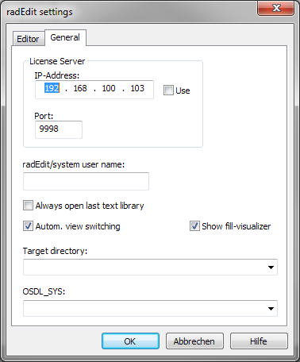

1. Install the driver for the HASP dongle
2. Copy the license file (radCASE.lic or radon.lic)
3. **radCASE** is licensed

## Network license with SuperPro dongle

|  |  |
| --- | --- |
|  | An exception for the Windows and/or network firewall may be needed to allow communication of radCASE and the license server over a TCP/IP port (see Configuring the TCP/IP port). |

Do the following steps:

1. Set up the license server
2. Configure radCASE to use the license server
3. **radCASE** is licensed

## Copy the license file (radCASE.lic or radon.lic)

IMACS will ship one of the above license files. It must be copied into the radEDIT directory. Do the following steps:

1. Make sure, you have administrator rights on Windows
2. Change to radEDIT directory of the radCASE *installation*, typically %ProgramFiles%\radCASE\radEDIT
3. radCASE.lic / radon.lic
   1. If the file radCASE.lic exists, rename it to radCASE_old.lic
   2. If the file radon.lic exists, leave it unchanged (do not remove or rename it)
4. Copy the obtained license file (radCASE.lic or radon.lic) to the radEDIT directory.
5. In case you use another copy of radEDIT (not the installed one), do steps 3 and 4 in that directory, too.

## Install the driver for the HASP dongle

There are two options:

* Install the HASP driver using windows update
* Install the HASP driver using an installer

|  |  |
| --- | --- |
|  | It is highly recommended to Check the installation of the HASP dongle driver afterwards. |

### Install the HASP driver using windows update

Requirements:

* Connection to the internet is available
* Windows update is enabled

When the HASP dongle is plugged into a USB port, the assistant for installing new hardware appears. Choose automatic installation of software and follow the assistant.

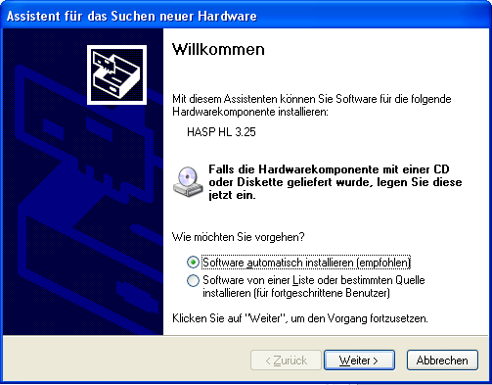

### Install the HASP driver using an installer

1. Download the latest installer “Sentinel HASP LDK - Windows GUI Run-time Installer” (Sentinel_LDK_Run-time_setup.zip) from the following URL: <https://sentinelcustomer.gemalto.com/sentineldownloads/>
2. Install the driver.

V1: Installer von obigem Link (http://sentinelcustomer.safenet-inc.com/DownloadNotice.aspx?dID=8589947119) ist hier lokal abgelegt:

"v:\radCASE_intern\Release\Accounts\radCASE_3rd_party\HASP dongle driver\2015_vonSafeNetWebSite"

V2: Selber suchen: „Sentinel HASP/LDK - Windows GUI Run-time Installer”

V3: Weiterer Fallback:

Folgenden Installer habe ich von SafeNet bekommen:

Lokal:   
"v:\radCASE_intern\Release\Accounts\radCASE_3rd_party\HASP dongle driver\2014_vonSafeNetSupport\HASP4 API older than v8.0.zip"

Download Tool:

If the above link is broken, you can download the installer here  
<Info aus "v:\radCASE_intern\Release\Accounts\radCASE_3rd_party\HASP dongle driver\Email_Template_Auslieferung_HASP dongle driver.msg" > hier reinkopieren:

URL: <IMACS dld Tool>

User name:

Pass word:

## Check the installation of the HASP dongle driver

1. Open a web browser
2. Type the following URL into the address field: <http://localhost:1947>  
   This will open the “Admin Control Center”
3. Then select “Sentinel Keys”

If the correct HASP/HL key is displayed, the driver is installed correctly.

* In case of a single license, the corresponding HASP/HL MAX dongle (green) is displayed
* In case of a network license, the HASP/HL NET dongle (red) of the “server” is displayed  
  Note: The **NET** dongle must be displayed in the “Admin Control Center” of the server as well as of the clients.

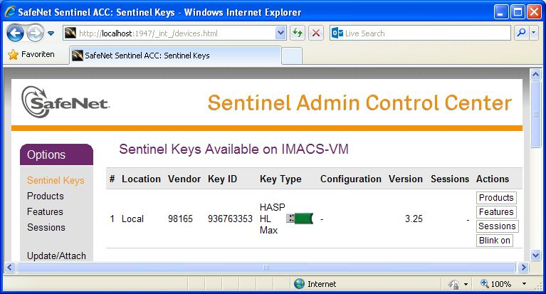

If the HASP/HL NET dongle is not displayed on the **client side**,

* check your firewall first – see chapter Check Firewall settings
* If it still does not work, do the following steps in the “Admin Control Center” of the client – see figure below:

1. Click on **Configuration** and then **Access to Remote License Managers** and check the following options:
   1. **Allow Access to Remote Licenses**
   2. **Broadcast Search for Remote Licenses**
   3. **Aggressive Serach for Remote Licenses**
2. Wait a few minutes, the check, if the dongle is now displayed.
3. If the dongle is still not displayed, enter the IP address of the Server in the field **Remote License Search Parameters**

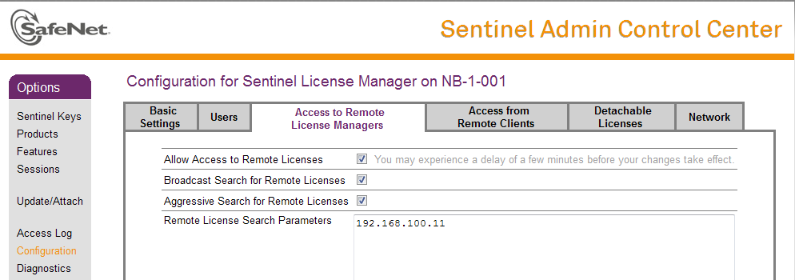

### Check Firewall settings

Make sure, the the following port is not blocked by a firewall:

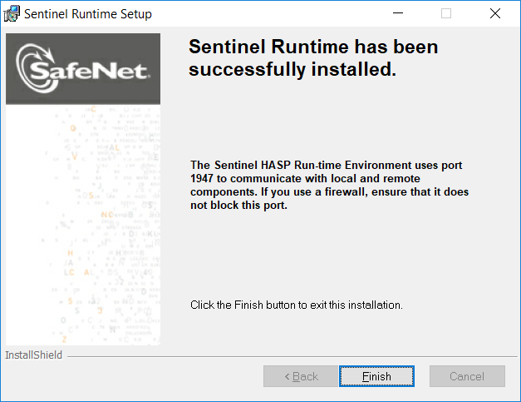

## Install the Sentinel Protection Installer

The dongle driver is provided by Sentinel for download. Do the following steps to install the driver:

* Go to the following website: <http://www.safenet-inc.de/support-downloads/sentinel-drivers/>
* If the above link is broken, try to search the web for “Sentinel Protection Installer”.
* Download the Sentinel Protection Installer
* Install the driver

Note, that the driver is officially supported up to Windows 8.1 only. If there are problems on newer operating systems, you may need to try the windows compatibility mode.

## Set up the license server (computer)

The following steps need to be done on a computer in the same network as the computers that are to use the **radCASE** network license.

The following things are needed:

* Sentinel Protection Installer
* SuperPro dongle with authorization “F”
* License file server.lic
* **radCASE** license server

Do the following steps:

1. Install the Sentinel Protection Installer
2. Plug the SuperPro dongle into a USB-Port
3. Install the radCASE license server

### Install the radCASE license server (software)

The license server is shipped as a zip file. Unzip it and copy the directory LicServer onto the computer on which the license server is to run. The file server.lic must be copied into the directory LicServer. Then, start the license server radCaseLicServer.exe.

The license server is now running and ready to use with the default port. To change it, refer to chapter Configuring the TCP/IP port.

Optionally, the license server can be added to the the Autostart of Windows.

To show the GUI with more information, click on the **radCASE** icon in the Windows system tray:

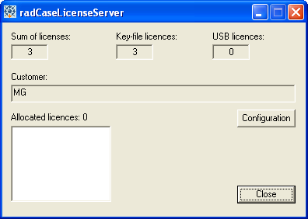

#### How to find out the version of the license server

Click the icon in the window title bar, then click “Info about the radCASELicServer ...”

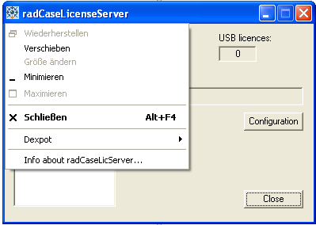

#### Configuring the TCP/IP port

The default Port Number used for communication between radCASE and the license server is 9998.

You can change the port, if needed. To do so: Click the Button “Configuration” and enter the port number to be used:

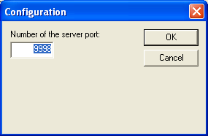

Then restart the license server.

Remember to configure all radCASE installations that use the license server to use the same port (refer to chapter Configure radCASE to use the license server)

## Configure radCASE to use the license server

The following steps need to be done on each computer that is to use a **radCASE** network license.

1. Copy the license file (radCASE.lic or radon.lic)
2. Logon to Windows with the user account under which **radCASE** is to be used later on.
3. Start radEDIT
4. Set the IP address and port of the license server
   1. In the radEDIT menu, open Tools – Settings – TAB General.

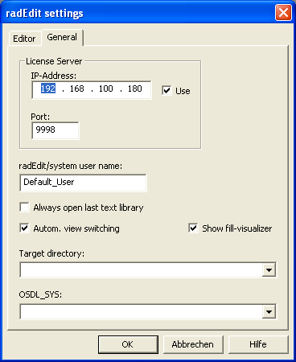

* 1. Enter the IP address and the port of the license server. In case of an installation of the license server on a local computer enter the IP address 127.0.0.1.
  2. Check the checkbox Use.
  3. The Port Number is set by default to 9998 and can be changed within the license server. If the Port Number is changed in the license server, then this must be adjusted accordingly in the radEDIT settings.

# Troubleshooting

### Visual Studio / Visual C++ / Environment Variable MSVC_BIN

radCASE version 4.9.0r and newer

The environment variable MSVC_BIN is not needed any longer and can be deleted.

radCASE versions prior to 4.9.0r

MSVC is used below as abbreviation for Microsoft Visual Studio or Microsoft Visual C++.

For monitoring (simulation and visualization) **radCASE** requires an environment variable (MSVC_BIN), which contains the path to your MSVC installation (*VC\BIN directory*).

In some cases, the variable cannot be set automatically during installation or needs to be adjusted later. Refer to chapter Setting MSVC_BIN manually.

#### Problem during Installation

The MSVC_BIN variable is created automatically during the **radCASE** installation, provided you have installed the MSVC to its standard directory prior to the installation of **radCASE**. Should MSVC not be found, the following error message will appear:

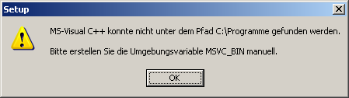

#### Setting MSVC_BIN manually

In these cases, please create the environment variable MSVC_BIN manually with the absolute path to the.*.\VC\bin directory* as the value. A typical path for MS Visual Studio 2008 is: "c:\Program Files\Microsoft Visual Studio 9.0\VC\bin" (without quotation marks).

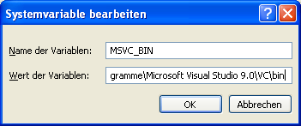

### visual.lic

radCASE version 4.8.0r and newer

The file “visual.lic” is not needed anymore. Remove the file from the DEVELOP directory of your project.

Otherwise you will get the following error, when starting the Monitoring (simulation or visualization): “Lizenzdatei beschädigt”

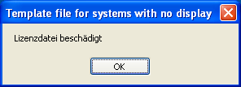

radCASE versions prior to 4.8.0r

The file “visual.lic” must be copied to the DEVELOP directory of each project.

Otherwise you will get the following error, when starting the Monitoring (simulation or visualization): “Kein Lizenzfile vorhanden! ... ”

