Solavita页面

1、文案修改
①SOLAR POWER FOR NIGERIAN HOMES去掉“NIGERIAN”，包括其他网页都请删除Nigeria这个单词。

②标题：
Ditch The Generator. Power Your Life. (渐变落在 Ditch The Generator)

③文案：
Slash fuel costs and blackouts with 24/7 solar and battery.
From Solavita factory to your home, business, or community.
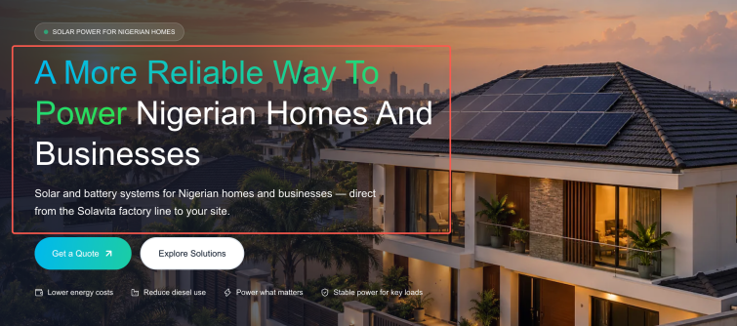

2、文案修改
①副标题：
End blackouts and cut diesel costs. We bring factory-direct solar power to keep your life and business running smoothly.
②Homes：
Keep lights on and appliances running during outages. From essential backup to full energy independence, designed for Nigerian homes.
③Business：
Protect your business from grid failures with robust three-phase systems. Save on fuel and power critical equipment 24/7.
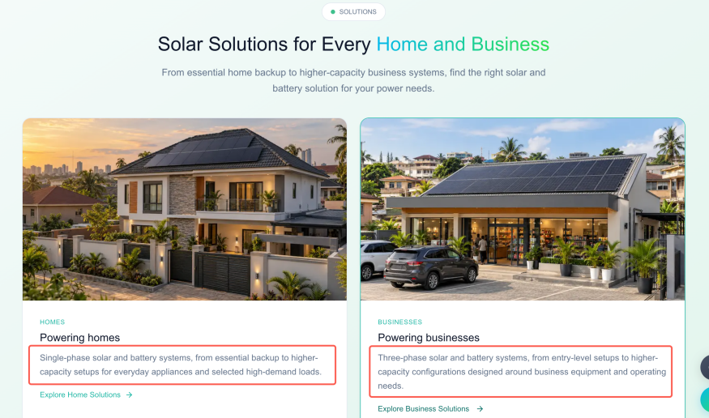

3、文案修改
柴发：
Fuel bills, noise, and constant worries — diesel drains more than power.
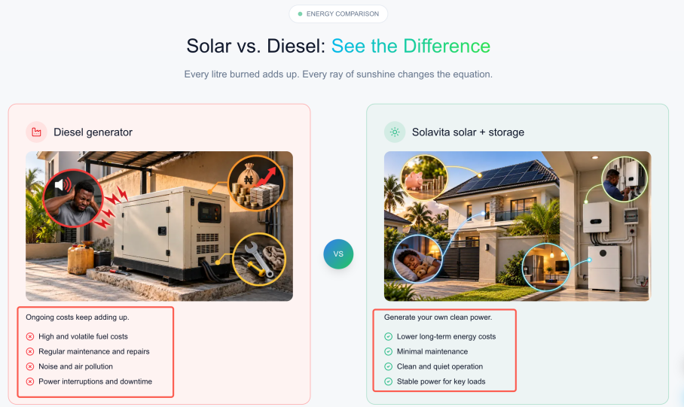
×Volatile fuel prices & daily refueling
×Frequent breakdowns & high upkeep
×Loud, smoky, and disruptive
×Fuel theft & startup failures

Solavita：
Clean, quiet power that puts you in control.
√Slash long-term energy bills
√Low maintenance, high durability
√Clean, quiet and fume-free
√24/7 stable power, built for yours

4、文案修改
①Site Assessment
Evaluate your site, energy needs & goals.
②Professional Installation
Expert setup of panels, storage & gear.
③增加第五步：
Go Green
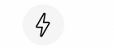
Start enjoying clean, sustainable energy.
符号可参考
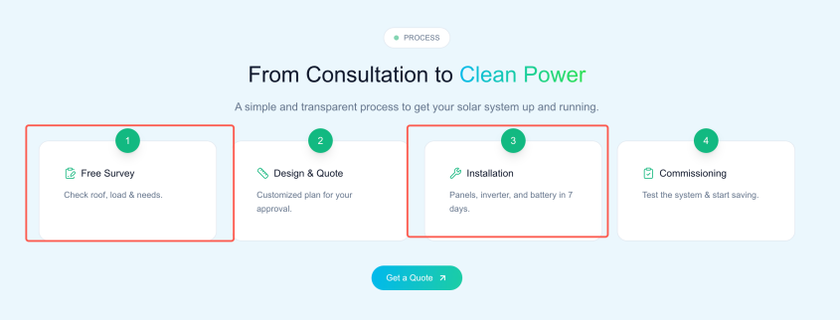

5、文案修改
①标题下方文案（分为两段，居中对齐）：
No more midnight fuel runs. No more unexpected blackouts.
Just clean, quiet power — ready when you are.
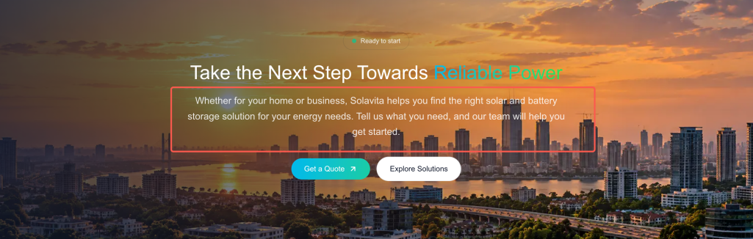

6、Get a Quote点击后的表格内容修改（共四步）
第一步（1个问题）：新增
问题1：What kind of solutions are you interested in？
[ ] Home Solar solutions
[ ] Business Solar solutions
[ ] I'm not sure / Just exploring
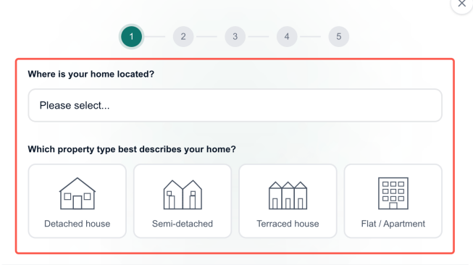
第二步（2个问题）：原第一步
①问题1：Which city is your property in?
②问题2下方选项修改：
[ ] Detached / Semi-detached
[ ] Terraced / Apartment
[ ] Commercial / Shop
[ ] Others

第三步（3个问题）：去掉屋顶问答，改成下列问题
①问题1：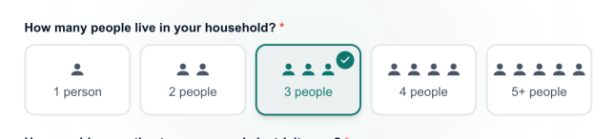
②问题2和问题3：
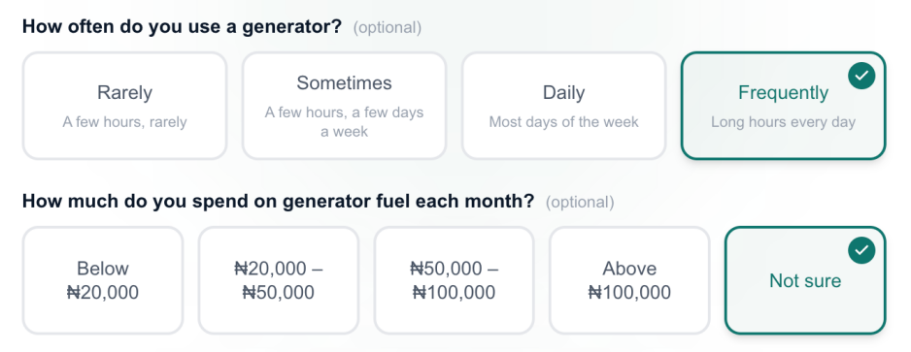

第四步：客户信息咨询表格信息请以这个形式修改（替代原第四和第五步）
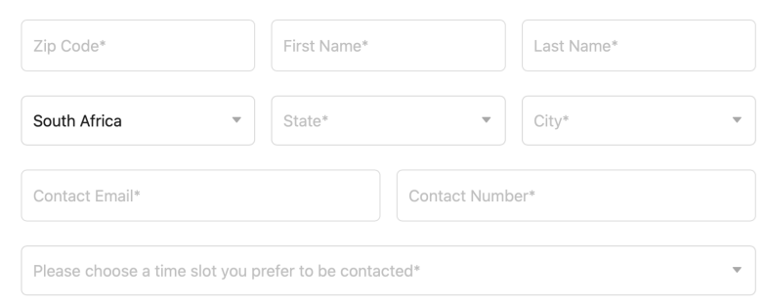

- 请把页面中所有“Get a Quote”或“Get Free Quote”全部统一为“Get Free Quote”

For Home页面（标准套餐 + 产品介绍-折叠模块 + 客制化套餐 + APP介绍 + FAQ ）

1、文案修改
主标题：
Power Your Home. Stay In Control.
副文案：
Fewer blackouts, lower fuel runs. From essential backup to full-home control, Solavita delivers clean, dependable energy — so you can worry less and live more.
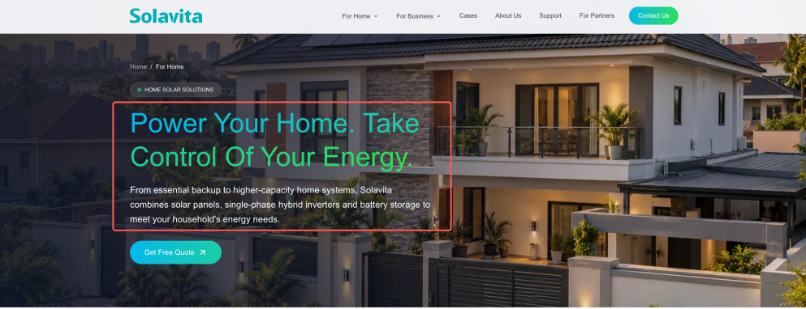

2、套餐文案修改
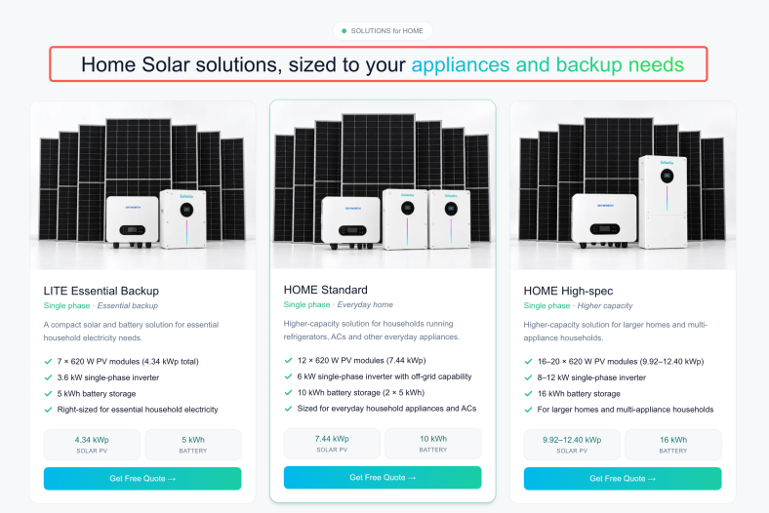
文案
配置，并删除最后一行
副标
①总标题：
Home Solar Solutions, Sized for Your Life and Backup Needs
(渐变落在 Life and Backup Needs)

②套餐1：LITE Essential Backup
副标：
Essential Backup · Ditch the diesel

文案（分两行）：
Built for essential homes, from apartments to starter families.
Compact solar and battery for everyday peace of mind.

配置：
√PV Modules：620Wp×7pcs
√Inverter：3.6kW
√Battery：5kWh

③套餐2：HOME Standard
副标：
Everyday Home · 24/7 Stable Power

文案：
Built for everyday families who want comfort without the fuel runs.
Higher capacity to slash fuel costs and blackouts.

配置格式参考“套餐1”

④套餐3：HOME High-Spec
副标：
Higher Capacity · Built for Yours

文案：
Built for larger homes, multi-appliances, and home-based businesses.
Ultimate diesel replacement.

配置格式参考“套餐1”

3、在“Solutions for HOME”套餐后增加一个条目“LOAD & RUNTIME”
①标题：Not sure which fits? Request a tailored config.

②展现形式：负载图标/名称 + Est.时长 + 场景图——可参考PPT文件（套餐组合-负载及运行时间-参考示意）

③注释：
Based on average 5.5 peak sun hours/day for representative Nigerian off-grid towns (Lagos/Abuja/North-Central band, NASA POWER / GVE 10-yr monitoring avg), after 5.9% system losses, 96% inverter efficiency, clipping and battery round-trip losses. Wet-season worst-month PSH ~3.5–4.0h in Lagos / ~4.0–4.5h in Abuja — actual savings may run 10–20% lower in peak rainy months, higher in dry season.

4、在“LOAD”下方增加一个条目“PRODUCT”（作为默认折叠模块，供深度意向用户点击查看）
①标题：
What's Included in Your Kit?

内容：
分三个Tab（光伏组件 | 混合逆变器 | 储能电池）。

套餐所涵盖的产品介绍（①产品图片+②简要参数+③性能优势-如高效发电、智能、离网切换快）
还需要有一个类似鼠标放在产品图片上显现“Learn More”按钮→点击跳转到“Support”，support里面需要设置一个“Download”章节，里面上传所有产品规格书。
这部分，我会单独整理成文件夹发给你。

5、在“NOT A STANDARD FIT”后增加一个条目“Smart Monitor & APP Control”
配图1：参考下图1 ；配图2：APP界面里类似收益曲线图，参考下图2。
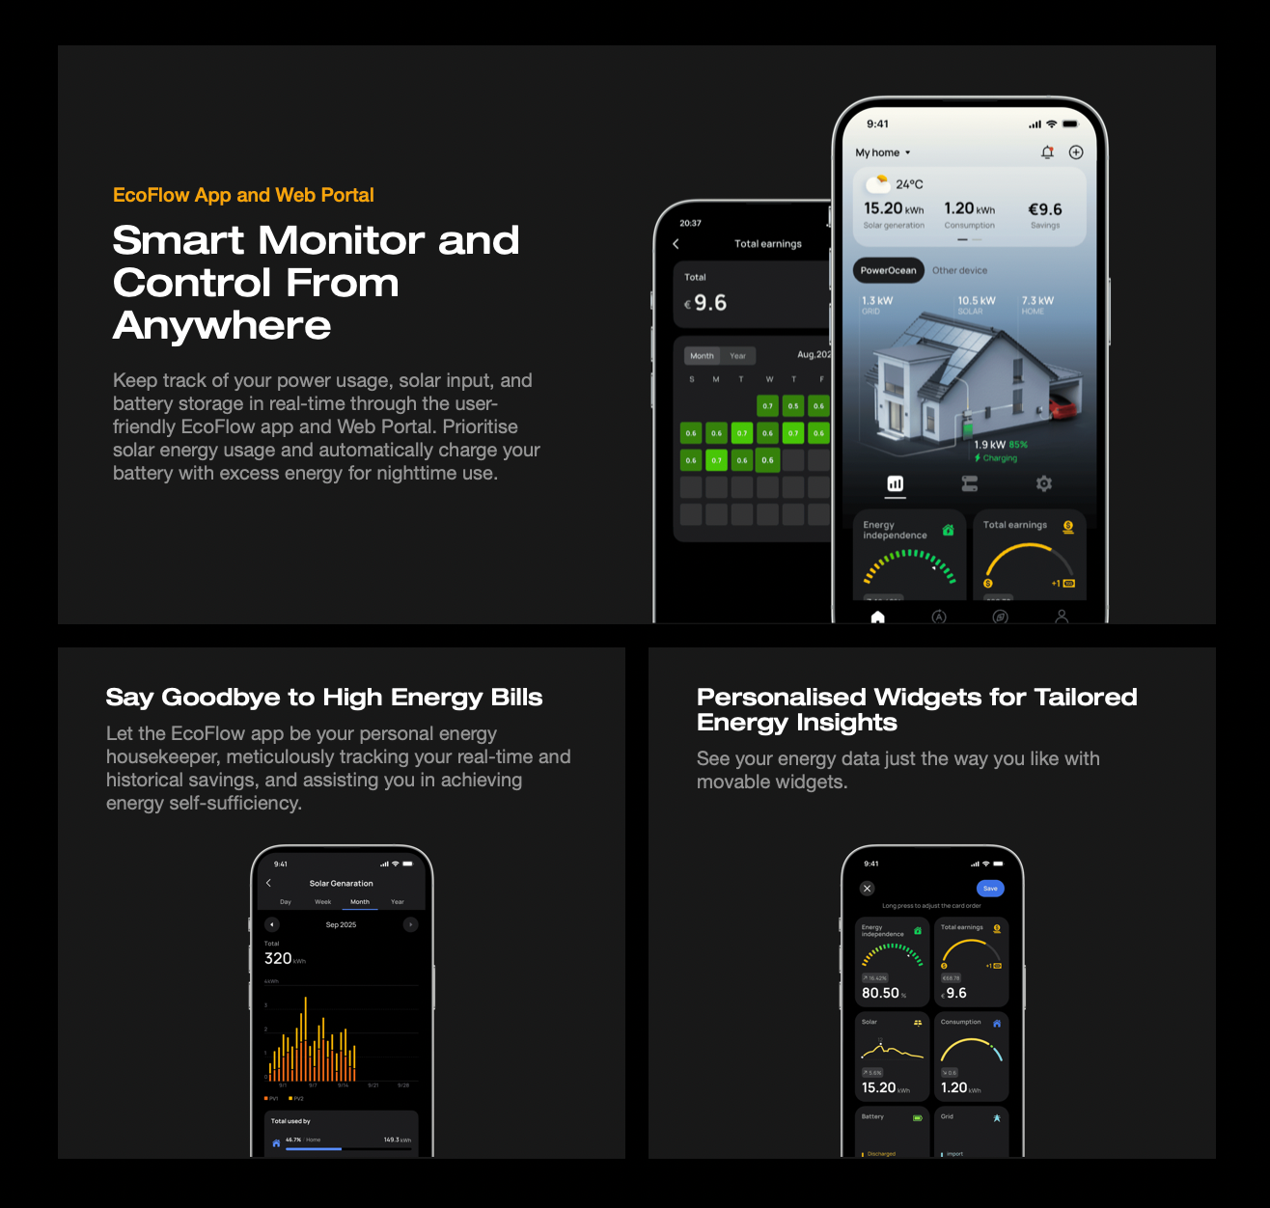
标题1：Take Full Control of Your Power, Anywhere​
文案1：Monitor generation, consumption, and battery status in real time. Switch modes, set schedules, and maximize savings — all from your phone, whether you're home or away.

标题2：One App. Total Visibility. Real Savings.
文案2：Track solar generation, battery level, and load consumption live on one screen. No guesswork — just clear data that puts you in charge.

6、FAB修改（图中打叉部分的问题替换）
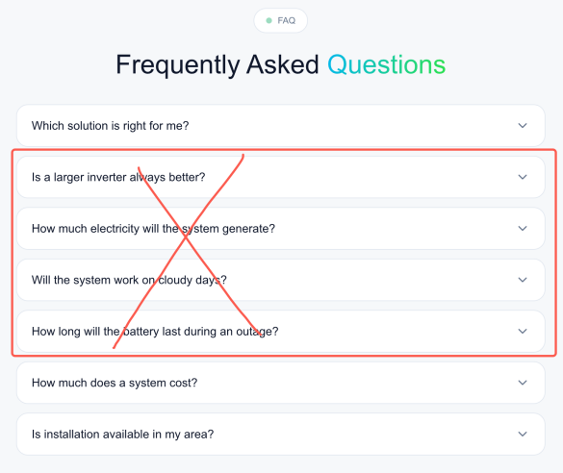
Q1：Will this really save me money?
A1：Yes. You'll use less expensive grid power and buy far less diesel for your generator. Most families see their monthly bills drop significantly, making it a smart investment.

Q2：What happens when the power goes out?
A2：Your lights, fridge, and Wi-Fi stay on. The system automatically switches to battery power instantly, so your family stays comfortable and safe, day or night.

Q3：How long will the battery last?
A3：It's built to last. With a 5-year warranty and 6,000 cycles, this battery can power your home for over 10 years-even with daily use.

Q4：Is it hard to maintain?
A4：Not at all. Just keep the panels clean. We monitor your system remotely and have local experts ready to help if you need us.

For Business页面

1、文案修改
副文案：
Slash diesel bills and stay ahead of outages. Solavita's solar and battery systems deliver reliable, round-the-clock energy — sized for your business, built to keep you moving.
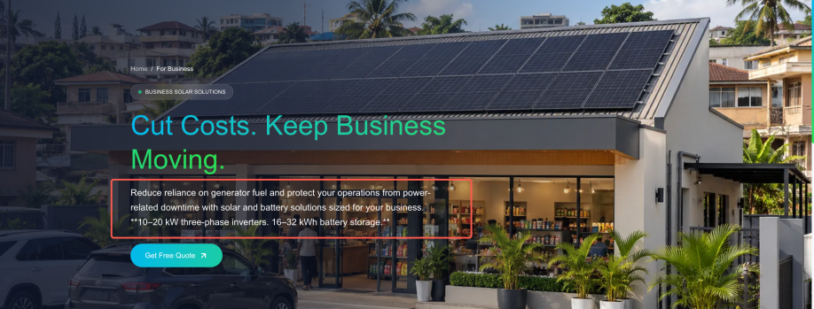

- 套餐文案修改
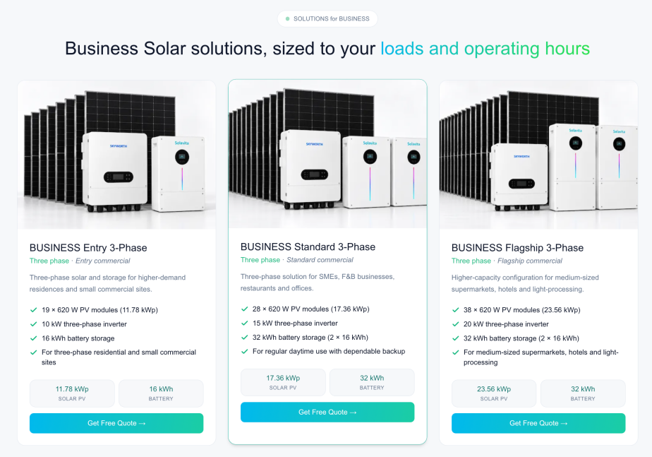
配置，并删除最后一行
文案
副标
①总标题：
Business Solar Solutions, Built to Keep You Running
(渐变落在 Keep You Running)

②套餐1：BUSINESS Entry 3-Phase
副标：
Starter Commercial · Cutting Fuel Runs​

文案（分两行）：
Built for small shops, clinics, and higher-demand households.
Keeps essentials running through outages—while cutting fuel runs.

配置：
√PV Modules：620Wp×19pcs
√Inverter：10kW
√Battery：16kWh

③套餐2：BUSINESS Standard 3-Phase
副标：
SMEs & F&B · Slash Diesel Bills​

文案：
Built for SMEs, F&B, restaurants, and offices.
Power daytime loads with reliable backup to stay ahead of outages.

配置格式参考“套餐1”

④套餐3：BUSINESS Flagship 3-Phase
副标：
Large Sites · A Step Beyond Diesel

文案：
Higher capacity for medium supermarkets, hotels, and light-processing.
A strong step toward ditching diesel.

配置格式参考“套餐1”

3、在“Solutions for HOME”套餐后增加一个条目“LOAD & RUNTIME”
①标题：Not sure which fits? Request a tailored config.

②展现形式：负载图标/名称 + Est.时长 + 场景图——可参考PPT文件（套餐组合-负载及运行时间-参考示意）

③注释：
Based on average 5.5 peak sun hours/day for representative Nigerian off-grid towns (Lagos/Abuja/North-Central band, NASA POWER / GVE 10-yr monitoring avg), after 5.9% system losses, 96% inverter efficiency, clipping and battery round-trip losses. Wet-season worst-month PSH ~3.5–4.0h in Lagos / ~4.0–4.5h in Abuja — actual savings may run 10–20% lower in peak rainy months, higher in dry season.

4、在“LOAD”下方增加一个条目“PRODUCT”（作为默认折叠模块，供深度意向用户点击查看）
标题：
What's Included in Your Kit?

内容：
分三个Tab（光伏组件 | 混合逆变器 | 储能电池）。

套餐所涵盖的产品介绍（①产品图片+②简要参数+③性能优势-如高效发电、智能、离网切换快）
还需要有一个类似鼠标放在产品图片上显现“Learn More”按钮→点击跳转到“Support”，support里面需要设置一个“Download”章节，里面上传所有产品规格书。
这部分，我会单独整理成文件夹发给你。

5、在“PPODUCT”后增加一个条目“Smart Monitor & APP Control”
配图1：参考下图1 ；配图2：APP界面里类似收益曲线图，参考下图2。
标题1：Take Full Control of Your Power, Anywhere​
文案1：Monitor generation, consumption, and battery status in real time. Switch modes, set schedules, and maximize savings — all from your phone, whether you're home or away.

标题2：One App. Total Visibility. Real Savings.
文案2：Track solar generation, battery level, and load consumption live on one screen. No guesswork — just clear data that puts you in charge.

6、FAB修改（图中打叉部分的问题替换）
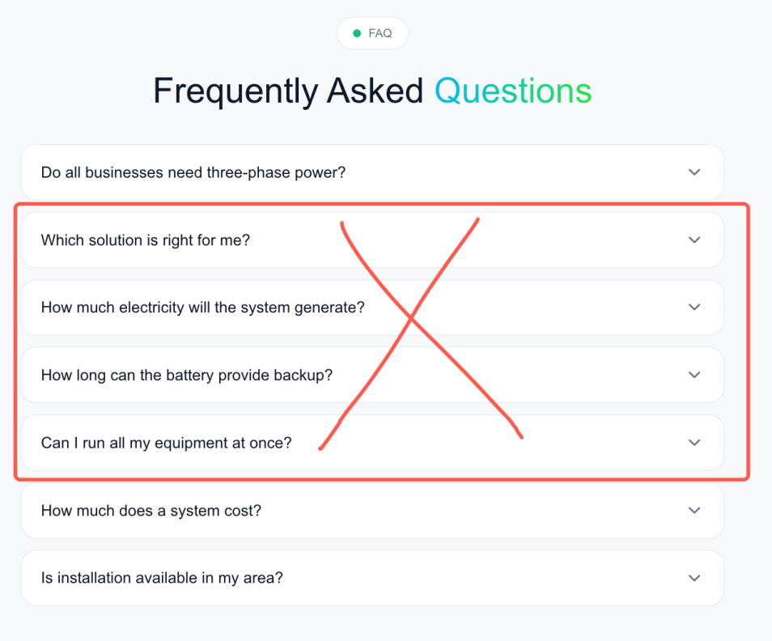
Q1：Will this really save me money?
A1：Yes. You'll use less expensive grid power and buy far less diesel for your generator. Most families see their monthly bills drop significantly, making it a smart investment.

Q2：What happens when the power goes out?
A2：Your lights, fridge, and Wi-Fi stay on. The system automatically switches to battery power instantly, so your family stays comfortable and safe, day or night.

Q3：How long will the battery last?
A3：It's built to last. With a 5-year warranty and 6,000 cycles, this battery can power your home for over 10 years-even with daily use.

Q4：Is it hard to maintain?
A4：Not at all. Just keep the panels clean. We monitor your system remotely and have local experts ready to help if you need us.

For Partners页面（Why Partner with Solavita + ）

①文案修改
Power the Energy Shift. Build What's Next.

②图片替换：类似此图

- WHY PARTNER
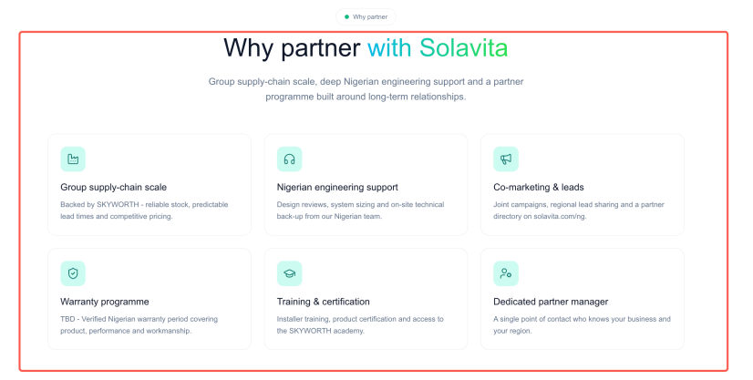修改参考PPT
3、修改参考PPT
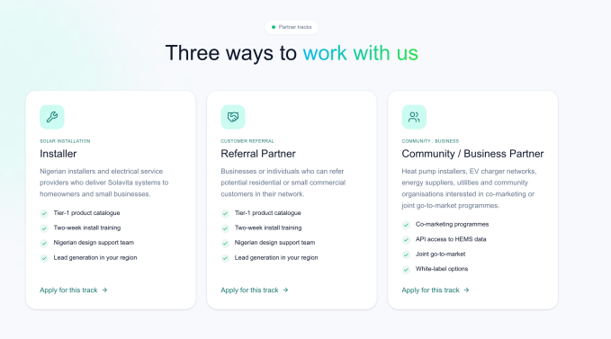修改参考PPT

4、“Become a Solavita Partner”
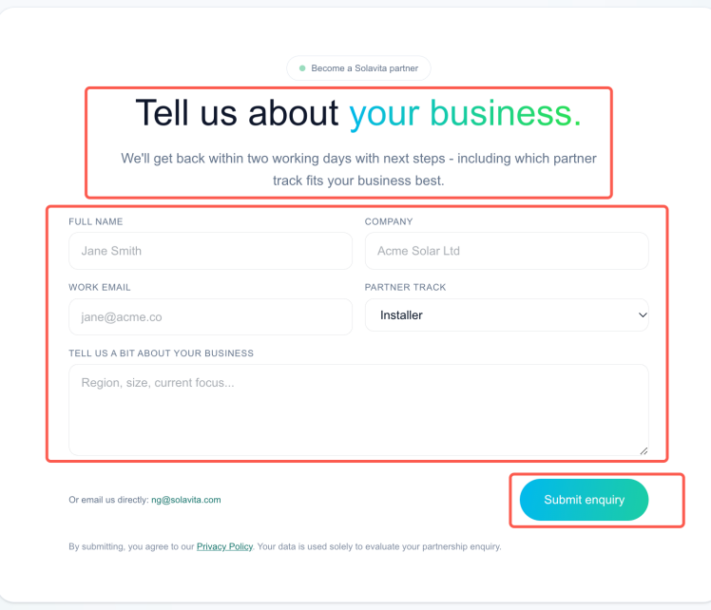
①标题：Are you ready to become a Solavita partner?

②标题下的文案：Join us now.

③表格：
- Full Name
- WhatsApp
- Email
- Business / Company
- Partner Track : Core Service Partner / Certified Installer / Lead Partner / Let's Talk（下拉表格）
- Message : "Tell us about your team, location, or current business."

④点击按钮：Get in Touch

5、提交表格后的界面
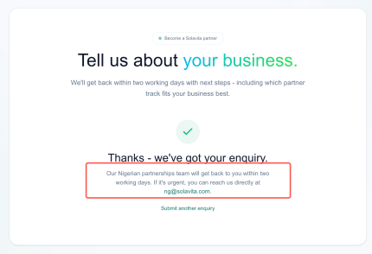
①标题：Are you ready to become a Solavita partner?
标题下的文案：Join us now.

②标题下文案：Our Nigerian partnerships team will review your details and be in touch soon. For urgent matters, reach us directly on WhatsApp​ or ng@solavita.com.

- 邮件名称这里的Nigeria可以删除吗？
（后续销售区域将从尼日利亚扩大至肯尼亚等其他地区）
改成”We've received your Solavita partner enquiry”


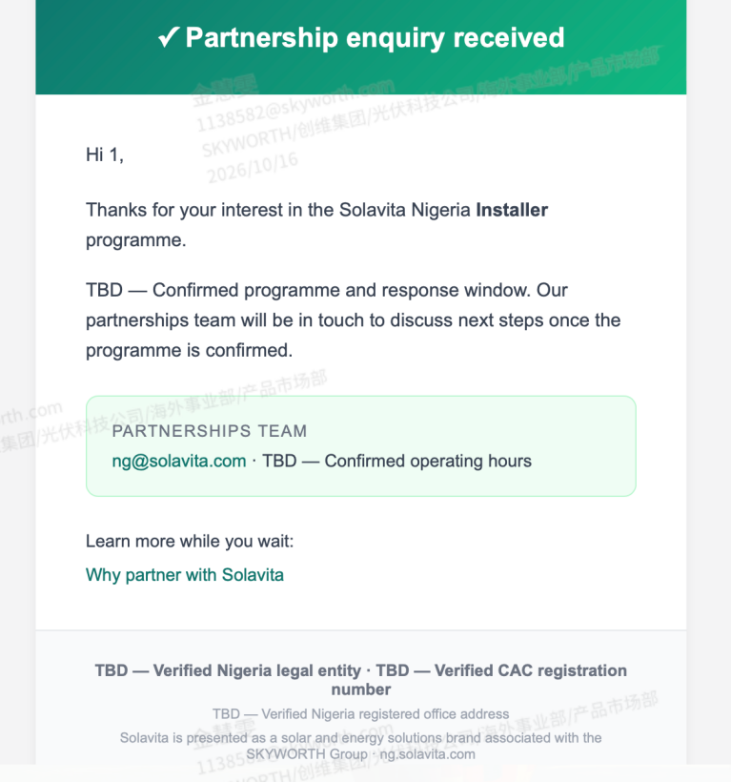
邮件内容：
Hi xxx,

Thanks for your interest in the Solavita partner programme.

We've received your details. Our local partnerships team will review your application and be in touch soon to discuss the next steps (including the best partner track for your business).

For urgent matters or if you'd like to chat now, reach us directly on email us at ng@solavita.com.

Learn more while you wait:
Why partner with Solavita [链接]

---
Solavita is presented as a solar and energy solutions brand associated with the SKYWORTH Group。

①删除Nigerian
②Replies soon (no long waits)
③We'll be in touch soon.


