Eastern Zone 2023-2025 Size-limit Changes

Jaime McAllister

2024-07-08

Table of Contents

# Background

Since 2019 a series of Size Limit changes have gradually been introduced to the fishery with the aim of providing three years of protection post reproductive maturity of abalone populations around Tasmania. That required an increase in the Legal Minimum Length (LML) for the Tasmanian Eastern Zone blacklip fishery from 138 mm to 145 mm. This increase in LML was scheduled to occur in three steps, with the first step (138 mm to 140mm)implemented in 2023. The second step (140 mm to 142 mm) in 2024, and third (142 mm to 145 mm) is scheduled for 2025.

Of concern is the impact of the LML on the outcomes of the Empirical Harvest Control Rule (EHCR) and reduced access to ‘stunted’ or slower growing populations. The former has been addressed in the response to the Little review and standalone document. The purpose of these analysis is to examine size structure trends in the actaeons to assess the effect of LML increases on access to populations in the actaeons.

# Length-weight data preparation

## Initial length-weight data check

An initial plot of all length and weight data collected since 2019 to look for any obvious data outliers.

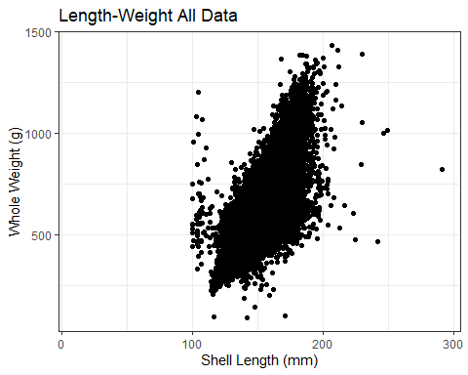 ## Length-weight data filtering Length weight data have been collected since 2019 using Scielex NextGen measuring boards with integrated platform scales at various abalone processing factories around Tasmania.

However, there are several erroneous length and weight data collected:

1. Abalone weights <200 g or >1500 g are highly unlikely.
2. Calibration and practice measurements taken at the default return position of the measuring gates (i.e. 100 mm).
3. Measurement errors caused by operator error where animals are below the LML for a particular Zone especially where the measurement is >5 mm below the LML (e.g. animals being measured shell side down or passed through the gates at an angle).
4. Failure to tare scales and abalone weights unlikely to correspond to appropriate length depending on the Zone (e.g. EZ - shell length > 175 mm and whole weight <600 g; shell length > 180 mm and whole weight <1000 g).

## Summary of available length-weight data for zone and block

Summary of catches measured in chosen Zone and numbers by Block where the catch can be assigned to a specific Block (i.e. only one Block listed on docket).

Summary of catches measured from commerical abalone catch sampling data for EZ Blocks collected between 2019-2024.

| FishingYear | Zone | BlockNo | Catches | n | Mean Length | Mean Weight |
| --- | --- | --- | --- | --- | --- | --- |
| 2019 | E | 13 | 10 | 912 | 146 | 510 |
| 2019 | E | 14 | 1 | 97 | 157 | 683 |
| 2019 | E | 16 | 1 | 92 | 150 | 588 |
| 2019 | E | 21 | 1 | 96 | 152 | 598 |
| 2020 | E | 13 | 45 | 3966 | 148 | 565 |
| 2020 | E | 14 | 7 | 580 | 152 | 593 |
| 2020 | E | 20 | 5 | 405 | 150 | 583 |
| 2020 | E | 21 | 7 | 670 | 153 | 601 |
| 2020 | E | 29 | 1 | 92 | 147 | 528 |
| 2020 | E | 31 | 2 | 174 | 148 | 602 |
| 2021 | E | 13 | 83 | 8041 | 149 | 551 |
| 2021 | E | 14 | 12 | 1164 | 151 | 577 |
| 2021 | E | 17 | 1 | 19 | 151 | 623 |
| 2021 | E | 20 | 5 | 483 | 149 | 571 |
| 2021 | E | 21 | 12 | 1164 | 153 | 584 |
| 2021 | E | 29 | 1 | 98 | 150 | 568 |
| 2022 | E | 13 | 96 | 9242 | 147 | 551 |
| 2022 | E | 14 | 16 | 1539 | 151 | 592 |
| 2022 | E | 20 | 5 | 469 | 151 | 588 |
| 2022 | E | 21 | 16 | 1534 | 154 | 597 |
| 2023 | E | 13 | 40 | 3765 | 150 | 582 |
| 2023 | E | 14 | 2 | 189 | 154 | 631 |
| 2023 | E | 20 | 2 | 194 | 151 | 616 |
| 2023 | E | 21 | 7 | 702 | 156 | 624 |
| 2023 | E | 29 | 1 | 100 | 154 | 591 |
| 2024 | E | 13 | 3 | 159 | 153 | 645 |
| 2024 | E | 14 | 1 | 92 | 156 | 682 |

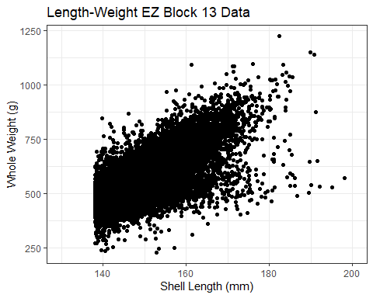

Block 13 EZ: Length-weight relationship of commercial abalone catch sampling data collected between 2019-2024.

## Selected Zone and Block data filtering

For the selected Zone and Block there are specific erroneous data which are apparent based on known size and likely weights. For the EZ Block 13, shell length >175 mm and whole weight <600 g, or shell length >180 mm and whole weight <1000 g are likely to be operator errors and the failure to tare platform scales.

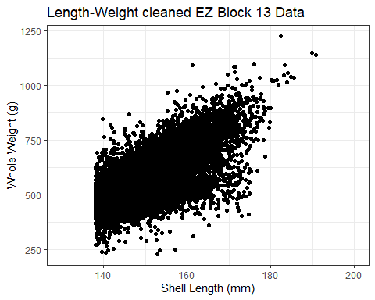 # Calculation of length-weight relationships The LML increase will create an effect on numbers of animals handled however, in order to evaluate the effect of the LML increase on catch rates (kg/hr), a length-weight relationship was required.

## Calculate length-weight relationship for selected Zone and Block

Estimated length-weight model parameters from commerical abalone catch sampling data for EZ Block 13 collected between 2019-2024.

| Zone | BlockNo | a | b | n |
| --- | --- | --- | --- | --- |
| E | 13 | 0.0052023 | 2.31443 | 26019 |

## Calculate percent contribution of abalone by weight and numbers

Using the calculated length-weight model parameters for the Zone and Block, estimate the individual abalone weight for each 1 mm size class above the previous LML (i.e. 138 mm) to then calculate the total weight of each size class and percentage by weight and numbers to the overall size composition data.

Estimated percentage contribution of each 1 mm size class by weight and numbers to EZ Block 13 using length-weight model parameters from commerical abalone catch sampling data collected between 2019-2024 (a = 0.0052; b = 2.314).

| Shell Length (mm) | Estimated weight (g) | n | Catch Weight (g) | Percent Weight | Percent n |
| --- | --- | --- | --- | --- | --- |
| 138 | 466.4 | 790 | 368456 | 2.571 | 3.029 |
| 139 | 474.3 | 1236 | 586235 | 4.090 | 4.738 |
| 140 | 482.2 | 1579 | 761394 | 5.312 | 6.053 |
| 141 | 490.2 | 1703 | 834811 | 5.824 | 6.529 |
| 142 | 498.3 | 1744 | 869035 | 6.063 | 6.686 |
| 143 | 506.5 | 1728 | 875232 | 6.106 | 6.624 |
| 144 | 514.7 | 1650 | 849255 | 5.925 | 6.325 |
| 145 | 523.0 | 1601 | 837323 | 5.842 | 6.138 |
| 146 | 531.4 | 1513 | 804008 | 5.609 | 5.800 |
| 147 | 539.9 | 1335 | 720766 | 5.029 | 5.118 |
| 148 | 548.4 | 1272 | 697565 | 4.867 | 4.876 |
| 149 | 557.0 | 1081 | 602117 | 4.201 | 4.144 |
| 150 | 565.7 | 1047 | 592288 | 4.132 | 4.014 |
| 151 | 574.5 | 943 | 541754 | 3.780 | 3.615 |
| 152 | 583.3 | 859 | 501055 | 3.496 | 3.293 |
| 153 | 592.3 | 831 | 492201 | 3.434 | 3.186 |
| 154 | 601.3 | 660 | 396858 | 2.769 | 2.530 |
| 155 | 610.3 | 608 | 371062 | 2.589 | 2.331 |
| 156 | 619.5 | 561 | 347540 | 2.425 | 2.151 |
| 157 | 628.7 | 456 | 286687 | 2.000 | 1.748 |
| 158 | 638.0 | 404 | 257752 | 1.798 | 1.549 |
| 159 | 647.4 | 401 | 259607 | 1.811 | 1.537 |
| 160 | 656.9 | 294 | 193129 | 1.347 | 1.127 |
| 161 | 666.4 | 250 | 166600 | 1.162 | 0.958 |
| 162 | 676.0 | 220 | 148720 | 1.038 | 0.843 |
| 163 | 685.7 | 219 | 150168 | 1.048 | 0.840 |
| 164 | 695.5 | 166 | 115453 | 0.805 | 0.636 |
| 165 | 705.3 | 145 | 102268 | 0.713 | 0.556 |
| 166 | 715.3 | 126 | 90128 | 0.629 | 0.483 |
| 167 | 725.3 | 107 | 77607 | 0.541 | 0.410 |
| 168 | 735.4 | 97 | 71334 | 0.498 | 0.372 |
| 169 | 745.6 | 72 | 53683 | 0.375 | 0.276 |
| 170 | 755.8 | 72 | 54418 | 0.380 | 0.276 |
| 171 | 766.1 | 61 | 46732 | 0.326 | 0.234 |
| 172 | 776.5 | 50 | 38825 | 0.271 | 0.192 |
| 173 | 787.0 | 37 | 29119 | 0.203 | 0.142 |
| 174 | 797.6 | 30 | 23928 | 0.167 | 0.115 |
| 175 | 808.3 | 28 | 22632 | 0.158 | 0.107 |
| 176 | 819.0 | 18 | 14742 | 0.103 | 0.069 |
| 177 | 829.8 | 11 | 9128 | 0.064 | 0.042 |
| 178 | 840.7 | 12 | 10088 | 0.070 | 0.046 |
| 179 | 851.7 | 6 | 5110 | 0.036 | 0.023 |
| 180 | 862.7 | 12 | 10352 | 0.072 | 0.046 |
| 181 | 873.8 | 12 | 10486 | 0.073 | 0.046 |
| 182 | 885.1 | 3 | 2655 | 0.019 | 0.012 |
| 183 | 896.3 | 7 | 6274 | 0.044 | 0.027 |
| 184 | 907.7 | 8 | 7262 | 0.051 | 0.031 |
| 185 | 919.2 | 5 | 4596 | 0.032 | 0.019 |
| 186 | 930.7 | 3 | 2792 | 0.019 | 0.012 |
| 189 | 965.8 | 3 | 2897 | 0.020 | 0.012 |
| 190 | 977.7 | 2 | 1955 | 0.014 | 0.008 |
| 191 | 989.7 | 2 | 1979 | 0.014 | 0.008 |
| 192 | 1001.7 | 1 | 1002 | 0.007 | 0.004 |
| 195 | 1038.3 | 1 | 1038 | 0.007 | 0.004 |
| 198 | 1075.6 | 1 | 1076 | 0.008 | 0.004 |
| 203 | 1139.5 | 1 | 1140 | 0.008 | 0.004 |
| 213 | 1273.7 | 1 | 1274 | 0.009 | 0.004 |

# Results

## Percentage contribution of scheduled LML increases to catch

Summing the estimated percentage contribution by weight and numbers of each size class that falls within the scheduled LML increment, there would be a 35% reduction to exploitable biomass and 40% reduction in catch numbers under a scenario where the LML was increased from 138 mm to 145 mm within a single step (Table @ref(tab:lml-sum-tab)).

Approx 60% of catch since 2019 has been larger than scheduled maximum LML increase to 145 mm in 2025.

Estimated percentage contribution of abalone by weight and numbers to size classes representing the scheduled LML increases for EZ Block 13 using length-weight model parameters from commerical abalone catch sampling data collected between 2019-2024 (a = 0.0052; b = 2.314).

| Size Class (mm) | Percent Weight | Percent n | Sum wt | Sum n |
| --- | --- | --- | --- | --- |
| 138-139 mm | 6.7 | 7.8 | 6.7 | 7.8 |
| 140-141 mm | 11.1 | 12.6 | 17.8 | 20.4 |
| 142-144 mm | 18.1 | 19.6 | 35.9 | 40.0 |
| ≥ 145 mm | 64.1 | 60.0 | 100.0 | 100.0 |

## Percentage contribution of size classes to catch

Significant period of re-build and recruitment during mid 2000s where a higher proportion of smaller individuals dominated catches.

Catches have been dominated by at least 50% of abalone >145 mm throughout time series

Apparent cycles in dominance of larger individuals becoming progressively dominant in catches in consecutive years from the early 2010s and in more recent times since 2019.

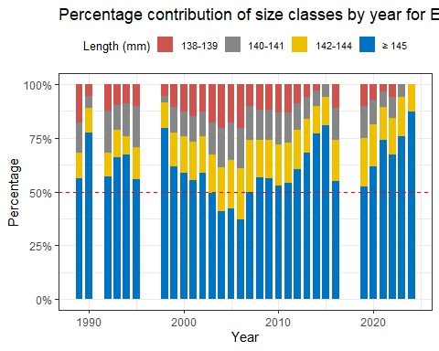 # Within year size composition 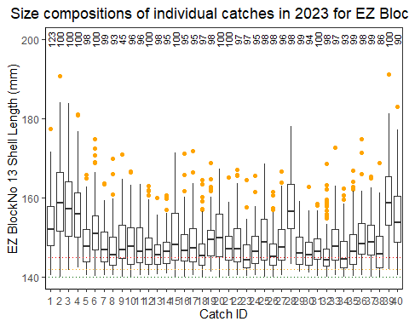 # Between years size composition 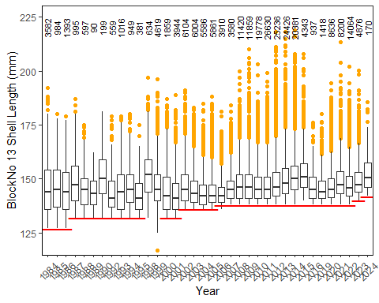 # Between year size composition

# Conclusions - these are just notes from various emails thus far

Animals have mostly come from a fairly narrow band 138-150 mm; there are certainly not too many large cohorts remaining above 160 mm however there are evidence of large animals existing so if given a chance to grow they would attain larger max size.

Exploitation rate is too high (still) in the Eastern Zone, so it remains something of a recruit based fishery - high explotaion and harvest rate and aniamls are taken before they are given a chance to attain larger sizes. Thus, any external events (storms, MHW, crap year ), means that the harvest has to switch to larger size classes (> 145mm) of which there is not much, and CPUE falls quickly.

DOES NOT support the idea that the growth in these populations is limiting and that something like a 145mm size limit is to high.

About 70% of catch is <150 mm and the data points to a reliance on very much a recruit-based fishery, where individuals are taken as soon as they enter the fishery, and larger cohorts have effectively been picked off gradually over the years to the point that when the fishery does need to shift to bigger fish (i.e. now) they simply aren’t there or have never had the chance to reach those larger sizes.

Increasing size structure since 2021 with a possible recruitment pulse in 2022 however fewer animals nearer to the LML in more recent years.

Actaeons habitat is low complexity and limited cryptic space compared to other EZ areas - therefore animals emerge from crypsis at an earlier and smaller size. These animals are therefore more apparent to the fishery but have not yet had the chance to attain larger sizes given the higher rate of exploitation.

# References