Assessing growth dynamics and connectivity of blacklip abalone (Haliotis rubra) populations

Size-at-maturity (SAM)

Jaime McAllister

Last Updated on 04 February, 2025

Table of contents

# Data checks and summaries

Quick summary plots to look for outliers in length data. Summary counts for each of the target size classes from dive collections.

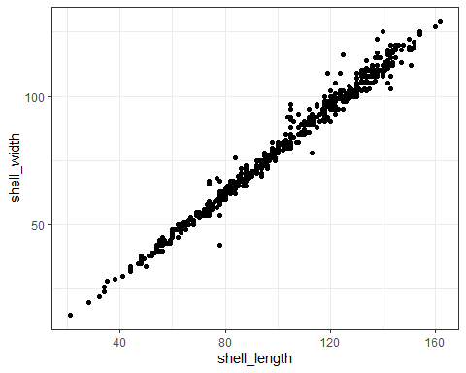

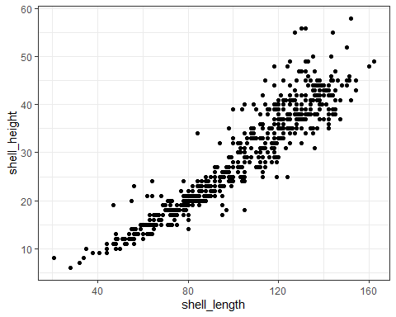

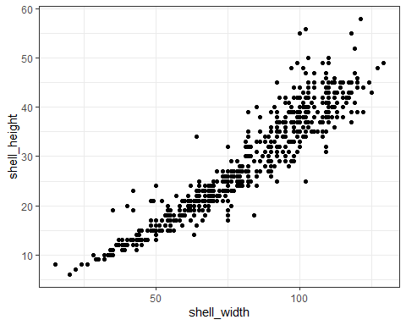

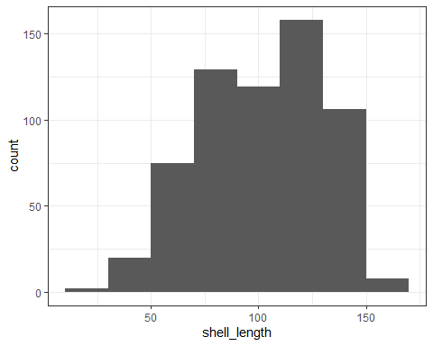

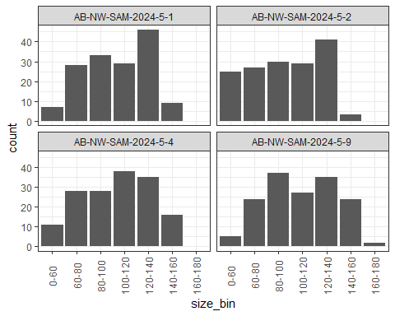

# Size-at-maturity estimation

Size at maturity (SAM) estimation using ‘biology’ package developed by Malcom Haddon.

Maturity status was determined following Jones et al. 2009:

* Stage 0, has no apparent development of gonad (immature).
* Stage 1, gonad development has started, such that it is possible to determine sex of animal, although the gonad at this stage is very slight, at its most developed form it is translucent so that the digestive gland is still visible underneath (immature).
* Stage 2, gonad is obvious at the extremities of the digestive gland, it is opaque but not yet fully formed. The eggs in females are visible at low magnification while males are viscous creamy yellow (mature).
* Stage 3, fully formed gonad (mature). Stages 1 to 3 can be grouped by sex but only stages 2 and 3 are considered mature as although in stage 1 sex may be determined, that individual is unlikely to be reproductive and so is categorised as immature male or female (mature).

A dataframe has been created to run the ‘fitmaturity’ function where maturity has been classified as:

* I = stages 0-1
* M = stages 2-3.

library(biology)  
library(hplot)  
library(codeutils)  
  
# Convert lowercase to uppercase sex.  
sam_dat <- sam_dat %>%   
 mutate(sex = toupper(sex))  
  
# Classify gonad stage 1 abalone as immature.  
sam_dat <- sam_dat %>%   
 mutate(sex_adj = case_when(gonad_score %in% c(0, 1) ~ 'I',  
 gonad_score >= 2 ~ sex),  
 mature = case_when(gonad_score >= 2 ~ 1,  
 gonad_score <= 1 ~ 0))  
  
# Create dataframe for fitmaturity function (site, sex, length, maturity)  
tas_ab <- sam_dat %>%  
 select(site, sex_adj, shell_length, mature) %>%  
 dplyr::rename(sex = 'sex_adj',  
 length = 'shell_length') %>%  
 filter(sex != 'T') #filter any trematodes  
  
# Re-classify sex as mature or immature  
tas_ab <- tas_ab %>%   
 mutate(sex = case_when(sex %in% c('M', 'F') ~ 'M',  
 sex == 'I' ~ 'I'))  
  
# Quick summary of samples by site and matuirty status(sex)  
table(tas_ab$site, tas_ab$sex)

I M  
 AB-NW-SAM-2024-5-1 77 75  
 AB-NW-SAM-2024-5-2 97 58  
 AB-NW-SAM-2024-5-4 92 64  
 AB-NW-SAM-2024-5-9 79 75

# Create parameters for loop and plots  
sites <- sort(unique(tas_ab$site))  
nsite <- length(sites)  
scenes <- c("AB-NW-SAM-2024-5-1", "AB-NW-SAM-2024-5-2", "AB-NW-SAM-2024-5-4", "AB-NW-SAM-2024-5-9")  
models <- makelist(scenes)  
count <- 0  
  
# Run model across each site for sexes combined  
for (i in 1:nsite) { # i = 1  
 count <- count + 1  
 picksite <- which(tas_ab$site == sites[i])  
 models[[count]] <- fitmaturity(tas_ab[picksite,],  
 length="length",mature="mature",lower=50,upper=160)  
 }  
  
str1(models)

List of 4  
 $ AB-NW-SAM-2024-5-1:List of 4  
 $ AB-NW-SAM-2024-5-2:List of 4  
 $ AB-NW-SAM-2024-5-4:List of 4  
 $ AB-NW-SAM-2024-5-9:List of 4

str1(models[["Site1"]])

NULL

# Create matuirty plots for each site  
plotprep(width=10, height=8)  
parset(plots=c(2,2))  
for (i in 1:length(models)) {  
 plotmaturity(models[[i]],label=scenes[i],col=2,xmin=0,xmax=0,CI=FALSE,  
 setpar=FALSE,lwd=2)   
}

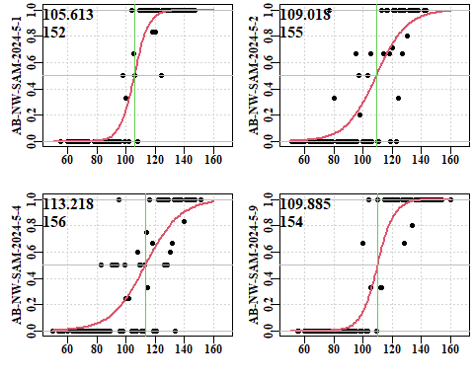

# Shellology maturity status

A quick summary plot comparing Prince ‘shellology’ classification of internal shell scaring and maturity status determined from macroscopic examination of gonads. A summary of the Shell_internal_score:

1. No scar formation.
2. Some pitting.
3. Quite pitted.
4. Secondary deposition forming.
5. Seconadry deposition covers most of muscle attachment site.
6. Seconadry deposition covers all of muscle attachment site.

