Tasmanian Seafoods Commercial Catch Sampling
Jaime McAllister
Last Updated on 23 June, 2025
Table of contents

Weight Grading
Since 2020, catches have been predominantly composed of medium grade abalone (Figure 1). However, the proportion of large grade abalone has steadily increased, particularly from 2022 onward, while small grade abalone have declined in relative proportion.
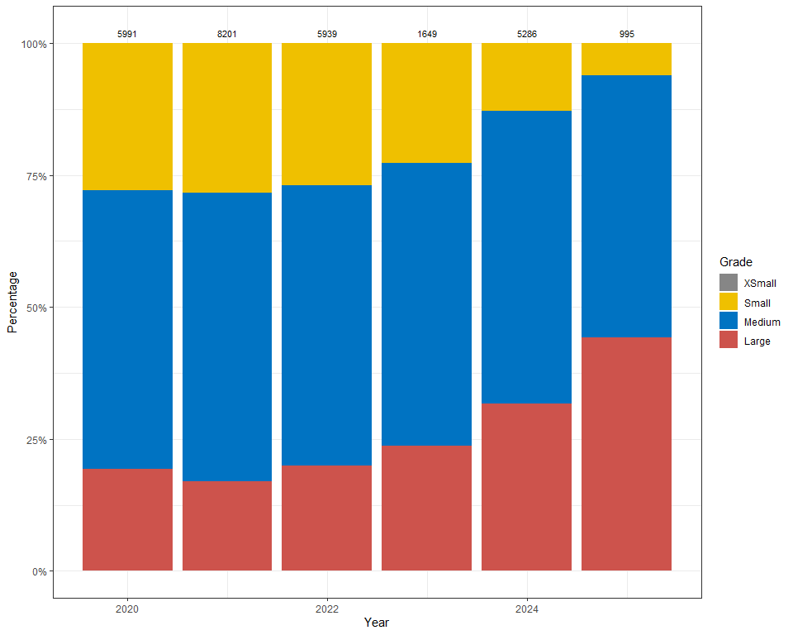
Figure 1: Stacked frequency distribution of weight gradings across extra small, small, medium and large abalone, illustrating the relative contribution of each weight grade to the overall distributions in the Western Zone between 2020 and 2025. Number of abalone measured above each boxplot.

Length Frequency
Size composition in the western zone has remained relatively stable since 2020, with catches consistently centered around a median length of 155–160 mm (Figure 2). In 2025, catches have been dominated by generally larger abalone, with a median length closer to 160 mm.
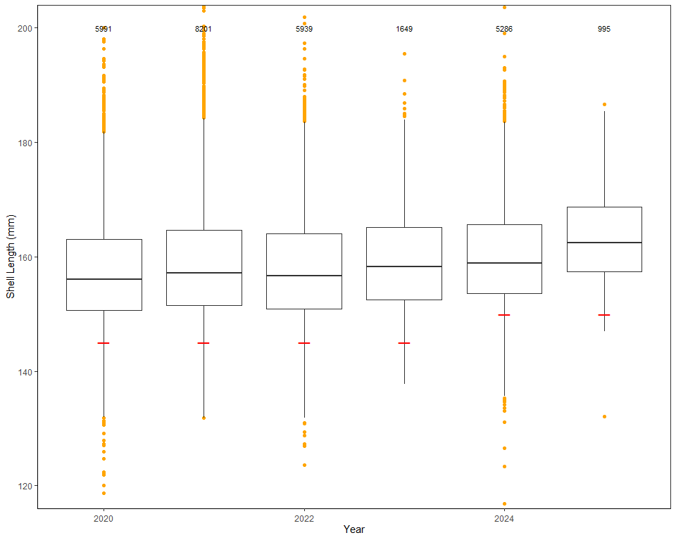
Figure 2: Boxplot of length frequency distributions between 2020 and 2025 for the Western Zone. Red line under each boxplot indicates the LML for that year. Number of abalone measured given above each boxplot.

