Section 1: Map of observation sites and table of site locations, elevations, and corrected temperature data
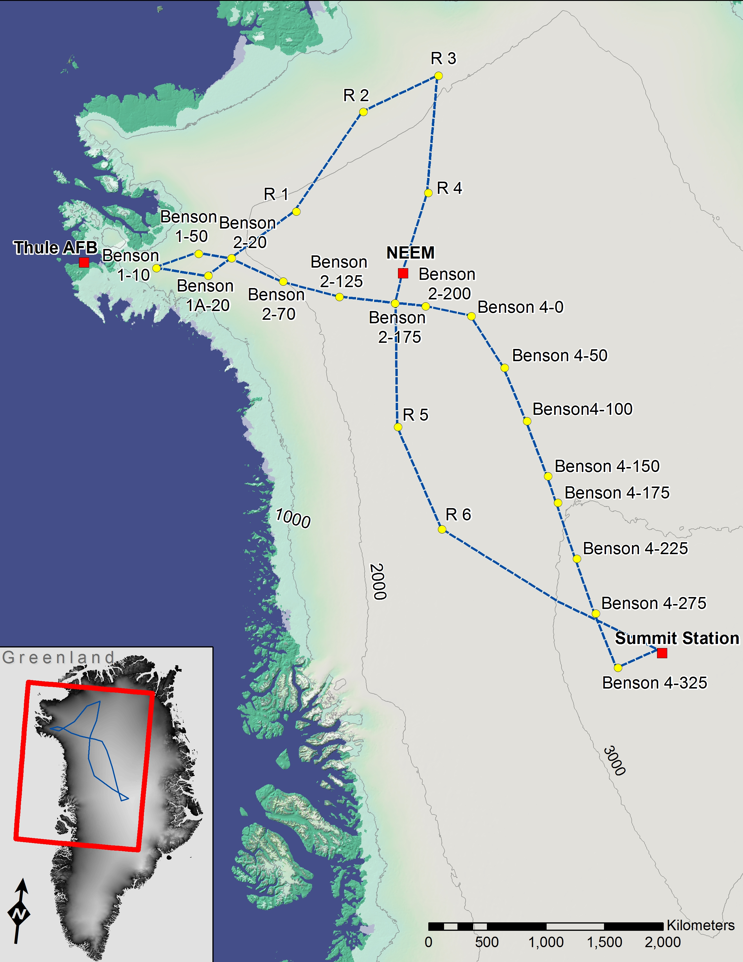
Figure fs01.jpg: Map of our traverse route in NW Greenland showing observation sites. Sites named starting with Benson are coincident with sites from Benson’s 1952-55 route. Surface elevation contours are from Howat et al. [2014]

Table ts01.xls – Site locations, elevation, and temperatures

Section 2: Additional information on temperature corrections applied to observed temperatures:
Figure fs02 - Graphical representation of seasonal variation in firn temperature and correction process

The temperature correction we apply simply removes the seasonal variation expected at the time the observations were collected. This figure shows seasonal temperature variability at depth predicted using methodology from Benson [1962]. Predicted maximum and minimum variation from the mean annual temperature at any point in the year are presented in gray solid lines and mean temperature is shown as a dashed black line. Four scenarios for the temperature deviation from mean annual temperature that would be expected at depth are shown for the first day of spring, summer, fall, and winter. Finally, temperature observations, collected at 3m, 4m, and 8m at site 4-150 by Benson are shown along with temperatures calculated after seasonal variation is removed. The three corrected temperatures were then averaged to produce the mean annual firn temperature at the site, commonly referred to as the ‘10m temperature’. We apply the same methodology to our temperature observations, though our temperature corrections are typically much smaller than Benson’s. While snow surface temperature can range about from -60C in winter to 0C in summer, both direct observations and modeling show that at depths below about 10m in dry firn the maximum variation from the mean annual temperature is typically less than 0.5C [Benson, 1962; Steffen, 1996]. Our results relying primarily on temperature observations below 7.5 m depth, collected in May, a time of the year when corrections at these depths are so small (<0.3C) as to be hard to see when plotted on this graph.

Section 3: Placing Firn Temperatures in Context
Firn temperatures high on the ice sheet show no change since Benson’s work, while warming observed at lower elevations is attributed entirely to percolation in our paper. At first glance these results imply that mean surface temperatures on the interior ice sheet are very similar during the early 2010s to those experienced in the early 1950’s. This would be an unexpected conclusion, and therefore bears closer examination. Unchanged firn temperatures observed at high elevations can be reconciled with warming expected from other observations by modeling the response of firn temperature in a changing climate. By modeling the time response of firn in warming and cooling climates, the response lag of firn temperature in a non-static climate, therefore, can explain much of the discrepancy between apparently unchanged firn temperature and rising observed surface temperatures without impacting our conclusions about enhanced percolation warming in the paper.
Broad analyses of surface temperature observations show that both global and Arctic wide mean temperatures declined from the 1950’s until about 1975, and have risen rapidly since [Hansen et al., 2010]. The rise since about 1975 dominates net change, such that global temperatures are ~0.6C higher in the early 2010’s than in the early 1950’s, and Arctic temperatures are ~1.4C higher [Hansen et al., 2010]. Analyses of temperatures around the periphery of the ice sheet show similar trajectories [Hanna et al., 2012] with a net warming of 1.125C when the 1940-1970 interval is compared to the 2000-2011 interval. On the interior ice sheet, observations spanning the 1952-2013 interval are extremely limited, however Ohmura [1987] conducted a synthesis reducing early observations to the 1950-1960 standard decade to create temperature distribution maps which can be compared to current GC-Net observations [Steffen and Box, 2001]. Steffen and Box [2001] analyze these datasets to find a warming of approximately 2C in the interior ice sheet from the 1950 standard decade to the late 1990s. We update their analysis with current GC-Net data and find a warming of approximately 2.9C over the full 1950’s-2010’s interval.
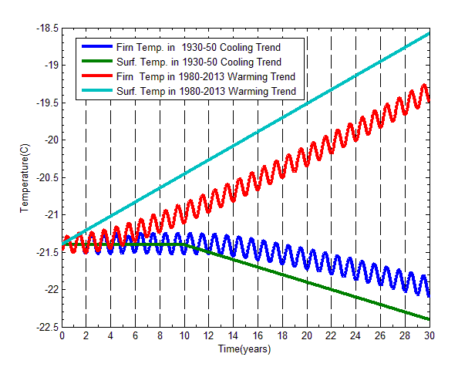
Figure fs03 – 10m Firn temperature response to changing mean annual surface temperature

A warming this large should be apparent in our firn temperature observations unless the relationship between firn temperature and surface temperature in the dry snow facies has changed. Ohmura [1987] makes a comparison of 10m temperatures with mean annual air temperatures in the dry snow facies during the 1950 standard decade and finds firn temperatures, on average, exceed mean annual site temperatures by 0.8C, with 14 out of 18 sites showing firn temperatures that exceed air temperatures. Meanwhile, Steffen and Box [2001] conduct a similar analysis during the late 1990’s and find instead that firn temperatures are lower than mean annual site air temperatures by an average of 1.5C during the late 1990s (7 out of 7 stations). Again we update Steffen and Box’s [2001] analysis using GC-Net air and firn temperature observations available since their paper was published and find that 10m temperatures at sites with minimal percolation (defined here as where mean annual air temperature is <-20C) tend to be lower than mean annual air temperature (22 out of 26 site-years) by a mean margin of 1.1C.
Considering climatic trends prior to our firn observations (cooling for the 1950’s and rapid warming for the 2010’s) helps to reconcile the deviation between firn and mean annual air temperatures as well as the lack of firn warming with expected changes mean annual surface temperature. In Figure fs02 we model the response of firn temperature in a dry snow environment typical of the north-central ice sheet near NEEM to changes in surface temperature similar to those expected prior to the 1950’s and 2010s. If interior conditions mirrored coastal trends, the climate on the interior ice sheet during the 1950s would have been cooling from peaks 0.5C to 1C higher in the early 1930’s [Mernild et al., 2010; Hanna et al., 2012], while the 2010’s were preceded by warming that is likely at least 1C/decade over the preceding 30 years [Steffen and Box 2001; Box et al., 2009; Box et al., 2012; Hall et al., 2012; Comiso et al., 2004; Hall et al., 2013]. The modeled firn temperature in both cases lags the changing surface temperature, producing an expected bias of about +0.4C in the 1950’s and -0.9C in the 2010s, nearly matching observed deviations between firn and air temperatures. The response of firn temperature in a non-static climate, therefore, can explain much of the discrepancy between apparently unchanged firn temperature and rising observed surface temperatures. This minor lag in firn temperature warming behind surface observations does not impact our conclusions about enhanced percolation warming made in the paper.

Section 4: – Description of the 1D Thermodynamic Model
We employ a finite difference scheme to calculate heat transport within the firn on an hourly timestep, using Fourier’s Law $[q=-k\left(\frac{dT}{dx}\right)]$ to calculate heat flux based on the temperature difference between adjacent cells of 1cm thickness and iterating a second order backward difference until convergence. Thermal conductivity is set as a function of snow density according to the third order polynomial of Van Dusen [1929]. Density profile is initialized based on prior observations in the dry snow facies [Herron and Langway, 1980] or using our field observations in areas where we initialized with a firn column that has experienced past percolation. The density profile is treated as constant with time except for additions of mass at depth due to refreezing percolation. In these cases, density is simply increased according to the amount of meltwater refrozen in place during percolation events. Density is not permitted to exceed 850kg/m³. Percolating meltwater proceeds past any cells that have reached this density, so long as there is lower density firn below. This behavior is consistent with field observations which indicate that firn columns do not form impermeable layers, and are capable of transitioning to near solid ice as percolation increases [Humphrey et al., 2012]. Snow accumulation rate is variable, and set according to the accumulation observed in our pits at the site of interest.
The model is forced by setting snow surface temperature to 2010 hourly air temperature observations from NEEM, adjusted for the elevation of the site being modeled by offsetting temperatures using the lapse rate 0.75C/100m elevation. Surface temperatures are not permitted to exceed 0C and, because the model does conduct a full surface energy balance treatment, meltwater production at the surface is prescribed manually. Behavior of the meltwater as it percolates away from the surface can be adjusted in several ways. A minimum depth that percolation reaches can be set, matching field observations that indicate meltwater often moves vertically through the prior year’s accumulation and doesn’t spread out and refreeze until striking the prior year’s summer hoar layer. Below the minimum depth, further percolation is governed by requiring latent heat delivery from the percolating water to raise each layer of firn to a threshold temperature of -2C before percolation can proceed deeper. The model releases all latent heat contained in the meltwater upon deposition of meltwater in a layer, effectively refreezing delivered meltwater immediately and warming the firn with the released energy. Field observations show that it is not necessary to raise firn temperature to 0C in order for percolation to proceed through a layer, and that percolation often occurs in isolated columns passing through firn layers as cold as -10C [Benson, 1962]. It may be necessary to execute a more complex modeling scheme to represent the percolating water fully, however we found that using a percolation threshold of -2C resulted in distributions of refrozen melt similar to that observed in pits along our route, and therefore use that value as our threshold for controlling further percolation. We also acknowledge that meltwater which has percolated into the upper firn layers has been observed to remain liquid for days, weeks, or, in special cases of high accumulation and high melt, even months [e.g. Miller et al., 2013]. The model is not sensitive to timing of energy delivery on day to week scales, however, so the approximation of instant refreezing and energy release at depth is reasonable for the low percolation cases we model where limited amounts of meltwater percolate into relatively cold firn, refreezing within, at most, a few weeks.
We validated the model in dry snow by setting the temperature profile to that observed by Benson at site B 2-200, and fixing the snow surface cell temperature to the air temperature observed by the GC-Net station at NEEM and allowing the model to run for several years. After equilibrating, the model reproduces the temperatures observed at depth by the GC-Net station well, with largest errors in the surface where convection, neglected by the model, is likely important. Temperature evolution below 5m matches observations within less than 1C. We furthered this validation in the percolation facies by comparing the temperature profile produced by the model with profiles measured by Humphrey et al. [2012] in the percolation facies during active percolation. Quantitative validation is not possible, because precise amounts of percolating meltwater produced are not known, but the character and magnitude of temperature warming observed could be reproduced with reasonably expected quantities of meltwater.

