**Effects of Category Learning Strategies on Recognition Memory**

**Supplementary Information (SI)**

Kevin O’Neill1, Audrey Liu1, Siyuan Yin1,6, Timothy Brady2, and Felipe De Brigard1,3,4,5

1. Center for Cognitive Neuroscience, Duke University
2. Department of Psychology, University of California in San Diego
3. Department of Philosophy, Duke University, Durham
4. Department of Psychology and Neuroscience, Duke University
5. Duke Institute for Brain Sciences, Duke University
6. Department of Marketing, University of Pennsylvania

Correspondence

Kevin O’Neill, Center for Cognitive Neuroscience, Duke University, Durham, NC 27708

Email: [kevin.oneill@duke.edu](mailto:kevin.oneill@duke.edu).

|  |  |  |  |  |  |
| --- | --- | --- | --- | --- | --- |
| Parameter | Median | HDI | pd | ROPE | % in ROPE |
| Intercept | 0.29 | [0.15, 0.43] | 1 | [-0.15, 0.15] | 0.01 |
| P | -0.08 | [-0.29, 0.13] | 0.76 | [-0.15, 0.15] | 0.76 |
| I | -0.08 | [-0.27, 0.12] | 0.78 | [-0.15, 0.15] | 0.79 |
| L | 0.33 | [0.10, 0.53] | 1 | [-0.15, 0.15] | 0.04 |
| NL | 0.18 | [-0.03, 0.38] | 0.95 | [-0.15, 0.15] | 0.4 |
| P:I | 0.17 | [-0.12, 0.46] | 0.88 | [-0.15, 0.15] | 0.44 |
| P:L | 0.08 | [-0.23, 0.42] | 0.68 | [-0.15, 0.15] | 0.61 |
| I:L | 0.05 | [-0.26, 0.33] | 0.62 | [-0.15, 0.15] | 0.69 |
| P:NL | -0.07 | [-0.37, 0.24] | 0.67 | [-0.15, 0.15] | 0.65 |
| I:NL | 0.05 | [-0.22, 0.34] | 0.64 | [-0.15, 0.15] | 0.71 |
| L:NL | -0.12 | [-0.48, 0.24] | 0.75 | [-0.15, 0.15] | 0.51 |
| P:I:L | -0.18 | [-0.62, 0.26] | 0.79 | [-0.15, 0.15] | 0.39 |
| P:I:NL | 0.01 | [-0.40, 0.43] | 0.52 | [-0.15, 0.15] | 0.55 |
| P:L:NL | -0.17 | [-0.74, 0.34] | 0.73 | [-0.15, 0.15] | 0.37 |
| I:L:NL | -0.01 | [-0.51, 0.47] | 0.51 | [-0.15, 0.15] | 0.47 |
| P:I:L:NL | 0.33 | [-0.41, 1.07] | 0.82 | [-0.15, 0.15] | 0.23 |

**Table S1:** Posterior medians, 95% HDIs, *pd*s, ROPEs, and % in ROPEfor hits.

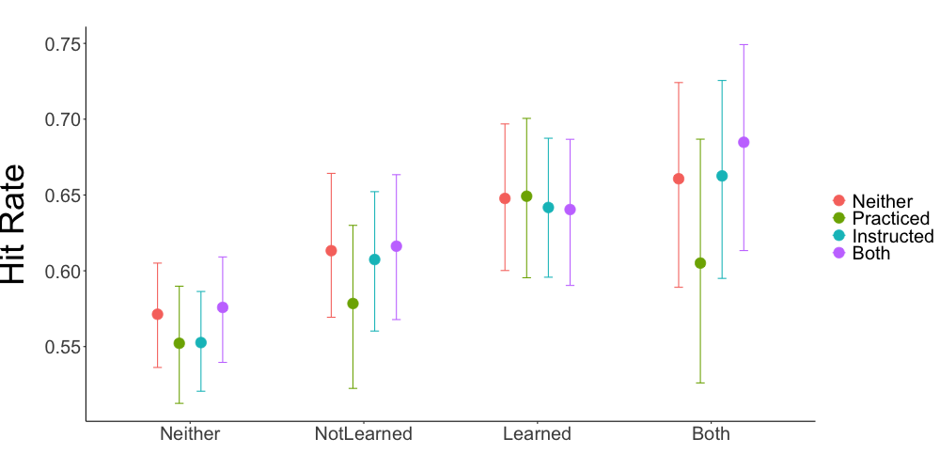

**Table S2:** Fittedposterior medians and 95% HDIsfor hits.

|  |  |  |  |  |  |
| --- | --- | --- | --- | --- | --- |
| Parameter | Median | HDI | pd | ROPE | % in ROPE |
| Intercept | -0.15 | [-0.28, -0.02] | 0.99 | [-0.15, 0.15] | 0.53 |
| P | -0.03 | [-0.23, 0.16] | 0.62 | [-0.15, 0.15] | 0.89 |
| I | 0.11 | [-0.07, 0.28] | 0.88 | [-0.15, 0.15] | 0.67 |
| L | 0.26 | [0.08, 0.43] | 1 | [-0.15, 0.15] | 0.09 |
| NL | 0.09 | [-0.06, 0.24] | 0.86 | [-0.15, 0.15] | 0.82 |
| P:I | -0.03 | [-0.30, 0.24] | 0.59 | [-0.15, 0.15] | 0.75 |
| P:L | 0.04 | [-0.21, 0.31] | 0.61 | [-0.15, 0.15] | 0.76 |
| I:L | 0.05 | [-0.19, 0.29] | 0.66 | [-0.15, 0.15] | 0.77 |
| P:NL | 0.01 | [-0.21, 0.24] | 0.53 | [-0.15, 0.15] | 0.85 |
| I:NL | -0.19 | [-0.38, 0.02] | 0.96 | [-0.15, 0.15] | 0.36 |
| L:NL | -0.08 | [-0.32, 0.17] | 0.75 | [-0.15, 0.15] | 0.71 |
| P:I:L | -0.14 | [-0.50, 0.21] | 0.78 | [-0.15, 0.15] | 0.49 |
| P:I:NL | 0.31 | [0.00, 0.61] | 0.98 | [-0.15, 0.15] | 0.14 |
| P:L:NL | -0.04 | [-0.41, 0.32] | 0.59 | [-0.15, 0.15] | 0.59 |
| I:L:NL | 0.04 | [-0.29, 0.38] | 0.6 | [-0.15, 0.15] | 0.63 |
| P:I:L:NL | 0.15 | [-0.35, 0.64] | 0.72 | [-0.15, 0.15] | 0.41 |

**Table S3:** Posterior medians, 95% HDIs, *pd*s, ROPEs, and % in ROPEfor false alarms.

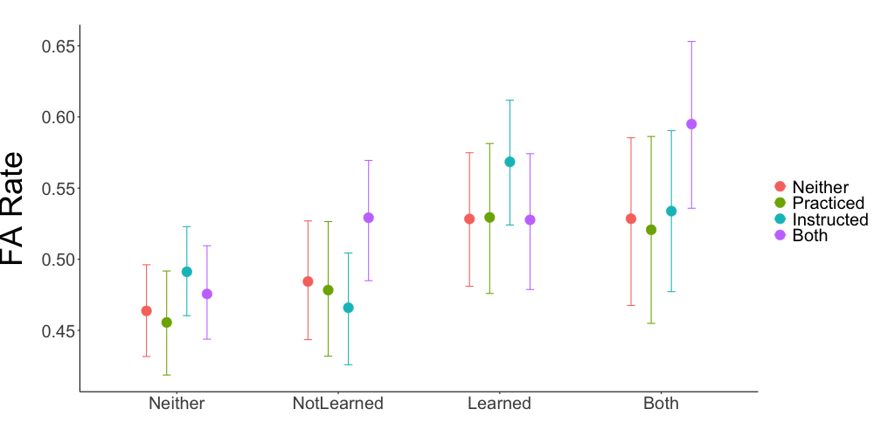

**Table S4:** Fittedposterior medians and 95% HDIsfor false alarms.

|  |  |  |  |  |  |
| --- | --- | --- | --- | --- | --- |
| Parameter | Median | HDI | pd | ROPE | % in ROPE |
| Intercept | -0.08 | [-0.16, -0.01] | 0.99 | [-0.07, 0.07] | 0.4 |
| P | -0.02 | [-0.13, 0.09] | 0.65 | [-0.07, 0.07] | 0.81 |
| I | 0.07 | [-0.04, 0.17] | 0.89 | [-0.07, 0.07] | 0.57 |
| L | 0.16 | [0.05, 0.26] | 1 | [-0.07, 0.07] | 0.04 |
| NL | 0.05 | [-0.04, 0.14] | 0.86 | [-0.07, 0.07] | 0.71 |
| O | 0.27 | [0.18, 0.36] | 1 | [-0.07, 0.07] | 0 |
| P:I | -0.02 | [-0.17, 0.13] | 0.58 | [-0.07, 0.07] | 0.7 |
| P:L | 0.03 | [-0.13, 0.18] | 0.64 | [-0.07, 0.07] | 0.66 |
| I:L | 0.03 | [-0.11, 0.17] | 0.66 | [-0.07, 0.07] | 0.69 |
| P:NL | 0.01 | [-0.13, 0.15] | 0.54 | [-0.07, 0.07] | 0.75 |
| I:NL | -0.11 | [-0.23, 0.02] | 0.96 | [-0.07, 0.07] | 0.29 |
| L:NL | -0.05 | [-0.19, 0.09] | 0.76 | [-0.07, 0.07] | 0.62 |
| P:O | -0.03 | [-0.17, 0.10] | 0.66 | [-0.07, 0.07] | 0.7 |
| I:O | -0.11 | [-0.24, 0.01] | 0.96 | [-0.07, 0.07] | 0.28 |
| L:O | 0.04 | [-0.10, 0.19] | 0.69 | [-0.07, 0.07] | 0.67 |
| NL:O | 0.06 | [-0.09, 0.20] | 0.78 | [-0.07, 0.07] | 0.59 |
| P:I:L | -0.09 | [-0.31, 0.11] | 0.8 | [-0.07, 0.07] | 0.41 |
| P:I:NL | 0.18 | [-0.00, 0.37] | 0.97 | [-0.07, 0.07] | 0.11 |
| P:L:NL | -0.03 | [-0.24, 0.19] | 0.62 | [-0.07, 0.07] | 0.51 |
| I:L:NL | 0.03 | [-0.17, 0.22] | 0.6 | [-0.07, 0.07] | 0.55 |
| P:I:O | 0.12 | [-0.07, 0.31] | 0.89 | [-0.07, 0.07] | 0.32 |
| P:L:O | 0.03 | [-0.18, 0.25] | 0.62 | [-0.07, 0.07] | 0.5 |
| I:L:O | 0.01 | [-0.19, 0.21] | 0.53 | [-0.07, 0.07] | 0.57 |
| P:NL:O | -0.05 | [-0.26, 0.16] | 0.68 | [-0.07, 0.07] | 0.48 |
| I:NL:O | 0.15 | [-0.05, 0.35] | 0.92 | [-0.07, 0.07] | 0.23 |
| L:NL:O | -0.04 | [-0.28, 0.23] | 0.6 | [-0.07, 0.07] | 0.44 |
| P:I:L:NL | 0.09 | [-0.19, 0.40] | 0.74 | [-0.07, 0.07] | 0.34 |
| P:I:L:O | -0.04 | [-0.32, 0.27] | 0.6 | [-0.07, 0.07] | 0.39 |
| P:I:NL: O | -0.18 | [-0.46, 0.14] | 0.88 | [-0.07, 0.07] | 0.21 |
| P:L:NL:O | -0.08 | [-0.45, 0.31] | 0.67 | [-0.07, 0.07] | 0.3 |
| I:L:NL:O | -0.04 | [-0.38, 0.31] | 0.58 | [-0.07, 0.07] | 0.33 |
| P:I:L:NL:O | 0.14 | [-0.39, 0.65] | 0.7 | [-0.07, 0.07] | 0.2 |

**Table S5:** Posterior medians, 95% HDIs, *pd*s, ROPEs, and % in ROPEfor the SDT model.

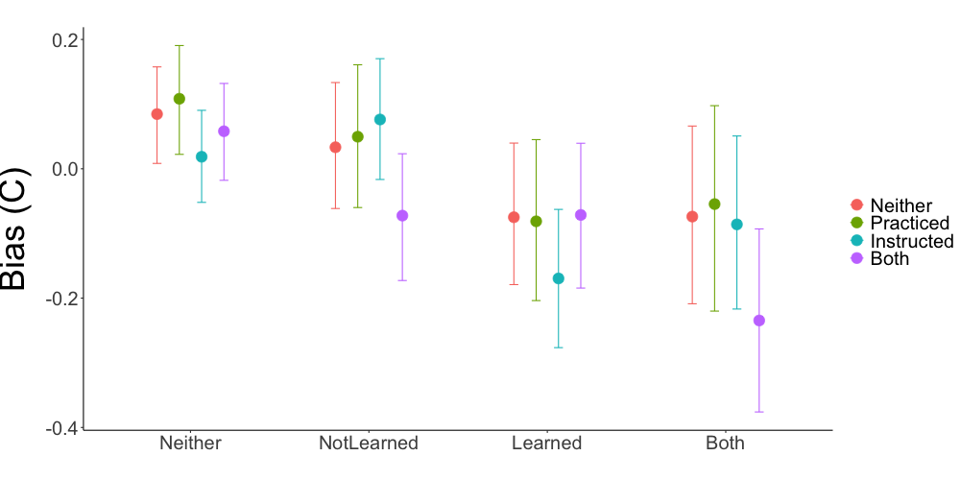

**Table S6:** Fittedposterior medians and 95% HDIsfor bias (*C*).

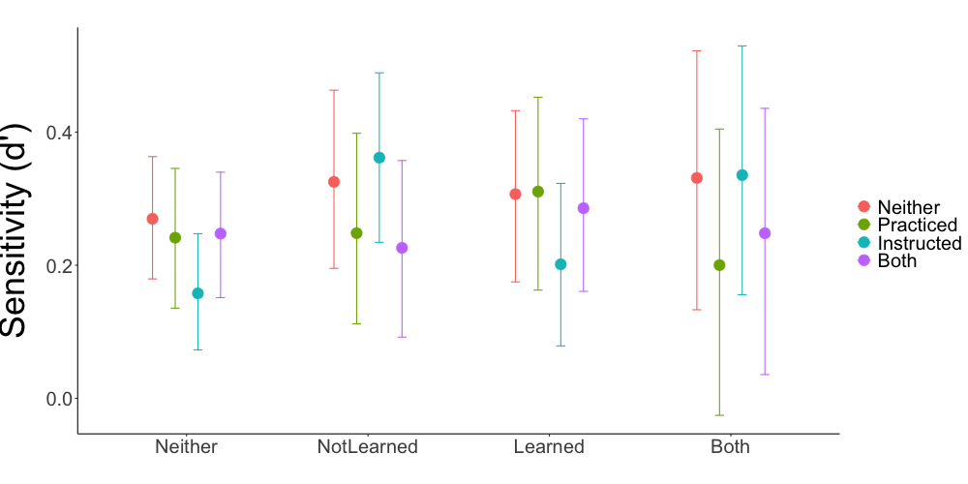

**Table S7:** Fittedposterior medians and 95% HDIsfor sensitivity (*d’*).

|  |  |  |  |  |  |
| --- | --- | --- | --- | --- | --- |
| Parameter | Median | HDI | pd | ROPE | % in ROPE |
| Intercept | 1.68 | [1.54, 1.82] | 1 | [-0.16, 0.16] | 0 |
| P | -0.09 | [-0.30, 0.12] | 0.77 | [-0.16, 0.16] | 0.75 |
| I | -0.1 | [-0.30, 0.10] | 0.82 | [-0.16, 0.16] | 0.74 |
| L | 0.01 | [-0.01, 0.04] | 0.87 | [-0.16, 0.16] | 1 |
| NL | 0 | [-0.03, 0.02] | 0.66 | [-0.16, 0.16] | 1 |
| O | 0.01 | [-0.01, 0.03] | 0.86 | [-0.16, 0.16] | 1 |
| P:I | 0.01 | [-0.28, 0.31] | 0.52 | [-0.16, 0.16] | 0.74 |
| P:L | -0.01 | [-0.05, 0.02] | 0.8 | [-0.16, 0.16] | 1 |
| I:L | -0.01 | [-0.05, 0.02] | 0.83 | [-0.16, 0.16] | 1 |
| P:NL | 0.02 | [-0.01, 0.05] | 0.89 | [-0.16, 0.16] | 1 |
| I:NL | 0.01 | [-0.02, 0.04] | 0.72 | [-0.16, 0.16] | 1 |
| L:NL | 0.03 | [-0.01, 0.07] | 0.93 | [-0.16, 0.16] | 1 |
| P:O | -0.02 | [-0.05, 0.02] | 0.84 | [-0.16, 0.16] | 1 |
| I:O | -0.01 | [-0.04, 0.02] | 0.78 | [-0.16, 0.16] | 1 |
| L:O | -0.01 | [-0.05, 0.03] | 0.7 | [-0.16, 0.16] | 1 |
| NL:O | -0.02 | [-0.06, 0.02] | 0.9 | [-0.16, 0.16] | 1 |
| P:I:L | 0.03 | [-0.02, 0.07] | 0.86 | [-0.16, 0.16] | 1 |
| P:I:NL | -0.03 | [-0.08, 0.01] | 0.91 | [-0.16, 0.16] | 1 |
| P:L:NL | -0.04 | [-0.10, 0.02] | 0.89 | [-0.16, 0.16] | 1 |
| I:L:NL | -0.03 | [-0.08, 0.02] | 0.89 | [-0.16, 0.16] | 1 |
| P:I:O | 0 | [-0.04, 0.05] | 0.55 | [-0.16, 0.16] | 1 |
| P:L:O | 0 | [-0.05, 0.06] | 0.53 | [-0.16, 0.16] | 1 |
| I:L:O | 0 | [-0.05, 0.05] | 0.52 | [-0.16, 0.16] | 1 |
| P:NL:O | 0 | [-0.05, 0.06] | 0.52 | [-0.16, 0.16] | 1 |
| I:NL:O | 0.01 | [-0.04, 0.06] | 0.71 | [-0.16, 0.16] | 1 |
| L:NL:O | 0 | [-0.07, 0.07] | 0.51 | [-0.16, 0.16] | 1 |
| P:I:L:NL | 0.02 | [-0.06, 0.09] | 0.69 | [-0.16, 0.16] | 1 |
| P:I:L:O | -0.04 | [-0.11, 0.04] | 0.86 | [-0.16, 0.16] | 1 |
| P:I:NL:O | 0.01 | [-0.06, 0.09] | 0.63 | [-0.16, 0.16] | 1 |
| P:L:NL:O | 0.03 | [-0.07, 0.12] | 0.71 | [-0.16, 0.16] | 1 |
| I:L:NL:O | 0 | [-0.09, 0.09] | 0.55 | [-0.16, 0.16] | 1 |
| P:I:L:NL:O | 0.01 | [-0.12, 0.14] | 0.55 | [-0.16, 0.16] | 1 |

**Table S8:** Posterior medians, 95% HDIs, *pd*s, ROPEs, and % in ROPEfor the μ parameter of the reaction time model.

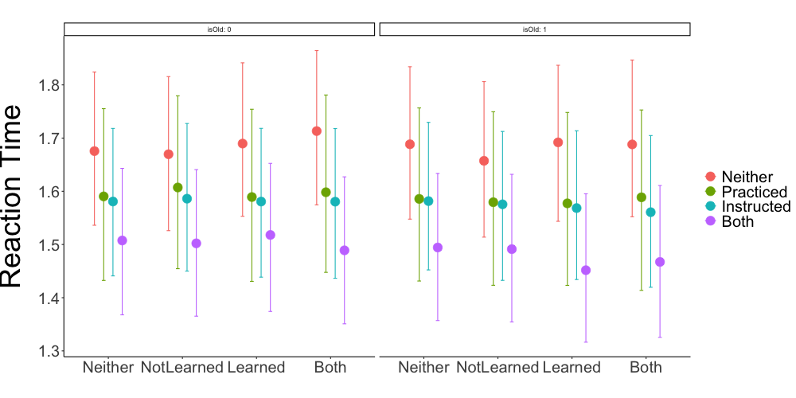

**Table S9:** Fittedposterior medians and 95% HDIsfor the μ parameter of the reaction time model.

|  |  |  |  |  |  |
| --- | --- | --- | --- | --- | --- |
| Parameter | Median | HDI | pd | ROPE | % in ROPE |
| Intercept | -0.4 | [-0.49, -0.30] | 1 | [-0.16, 0.16] | 0 |
| P | -0.11 | [-0.27, 0.03] | 0.93 | [-0.16, 0.16] | 0.72 |
| I | -0.08 | [-0.21, 0.05] | 0.89 | [-0.16, 0.16] | 0.9 |
| L | 0 | [-0.04, 0.04] | 0.51 | [-0.16, 0.16] | 1 |
| NL | -0.03 | [-0.08, 0.01] | 0.95 | [-0.16, 0.16] | 1 |
| O | 0.01 | [-0.04, 0.05] | 0.64 | [-0.16, 0.16] | 1 |
| P:I | 0.12 | [-0.07, 0.32] | 0.88 | [-0.16, 0.16] | 0.66 |
| P:L | -0.04 | [-0.10, 0.03] | 0.85 | [-0.16, 0.16] | 1 |
| I:L | 0 | [-0.06, 0.06] | 0.52 | [-0.16, 0.16] | 1 |
| P:NL | 0.04 | [-0.02, 0.11] | 0.91 | [-0.16, 0.16] | 1 |
| I:NL | 0.06 | [0.00, 0.11] | 0.97 | [-0.16, 0.16] | 1 |
| L:NL | 0.07 | [-0.00, 0.14] | 0.97 | [-0.16, 0.16] | 1 |
| P:O | -0.01 | [-0.08, 0.05] | 0.66 | [-0.16, 0.16] | 1 |
| I:O | 0 | [-0.06, 0.05] | 0.54 | [-0.16, 0.16] | 1 |
| L:O | 0.02 | [-0.05, 0.09] | 0.71 | [-0.16, 0.16] | 1 |
| NL:O | -0.03 | [-0.11, 0.04] | 0.78 | [-0.16, 0.16] | 1 |
| P:I:L | 0.02 | [-0.07, 0.11] | 0.64 | [-0.16, 0.16] | 1 |
| P:I:NL | -0.1 | [-0.19, -0.02] | 0.99 | [-0.16, 0.16] | 0.91 |
| P:L:NL | -0.04 | [-0.15, 0.07] | 0.76 | [-0.16, 0.16] | 1 |
| I:L:NL | -0.12 | [-0.22, -0.02] | 0.99 | [-0.16, 0.16] | 0.79 |
| P:I:O | -0.04 | [-0.14, 0.05] | 0.82 | [-0.16, 0.16] | 1 |
| P:L:O | -0.04 | [-0.15, 0.07] | 0.74 | [-0.16, 0.16] | 1 |
| I:L:O | -0.08 | [-0.18, 0.02] | 0.95 | [-0.16, 0.16] | 0.95 |
| P:NL:O | -0.03 | [-0.14, 0.08] | 0.71 | [-0.16, 0.16] | 1 |
| I:NL:O | -0.05 | [-0.16, 0.05] | 0.84 | [-0.16, 0.16] | 1 |
| L:NL:O | -0.03 | [-0.16, 0.10] | 0.67 | [-0.16, 0.16] | 1 |
| P:I:L:NL | 0.04 | [-0.10, 0.19] | 0.7 | [-0.16, 0.16] | 0.96 |
| P:I:L:O | 0.07 | [-0.08, 0.22] | 0.81 | [-0.16, 0.16] | 0.89 |
| P:I:NL:O | 0.17 | [0.02, 0.32] | 0.99 | [-0.16, 0.16] | 0.42 |
| P:L:NL:O | 0.11 | [-0.08, 0.30] | 0.88 | [-0.16, 0.16] | 0.69 |
| I:L:NL:O | 0.16 | [-0.01, 0.33] | 0.97 | [-0.16, 0.16] | 0.48 |
| P:I:L:NL:O | -0.23 | [-0.48, 0.03] | 0.96 | [-0.16, 0.16] | 0.29 |

**Table S10:** Posterior medians, 95% HDIs, *pd*s, ROPEs, and % in ROPEfor the τ parameter of the reaction time model.

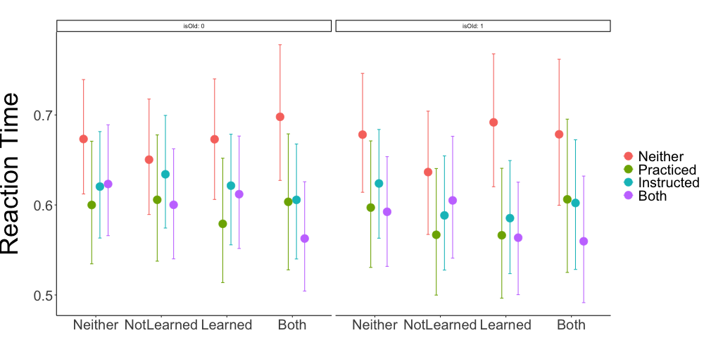

**Table S11:** Fittedposterior medians and 95% HDIsfor the τ parameter of the reaction time model.