**Introduction**

Whether with volitional control or spontaneous intuition, people are frequently engaged in causal reasoning. Evaluating causal candidates and establishing “the cause” allows people to modify their future behaviors to avoid harmful outcomes and achieve optimal ones. How people determine causal relationships, however, remains unclear, given that such reasoning is highly influenced by a variety of factors, such as perceived norms and expectations (e.g., Knobe, 2009; Knobe & Fraser, 2008), the degree to which candidate causes and effects covary (Cheng & Novick, 1991; Wasserman, Chatlosh, & Neunaber, 1983), events that did not happen (e.g., Henne, Niemi, Pinillos, De Brigard, & Knobe, 2019; Clarke, Shepherd, Stigall, Waller & Zarpentine, 2015), and causal structure (e.g., Icard, Kominsky, & Knobe, 2017). Inaccurately establishing causality presents potentially severe legal and/or social ramifications (Hart & Honoré, 1985), so to avoid such consequences, it is critical to understand the process by which people navigate the complexities of causal reasoning.

**Mechanistic accounts of causal reasoning**

*Process theories* of causality argue that, when determining causal relationships, people will focus on the direct interaction between covarying events to assess whether there was an exchange of some conserved quantity, such as energy or momentum, from the candidate cause to the given outcome (Dowe, 2000; Salmon, 1997; Wolff, 2007). Supportive evidence shows a greater propensity for people to attribute causation when there is a continuous mechanism that links an action (e.g., kicking a ball) to the outcome (e.g., the ball landing in the goal; Walsh & Sloman, 2011). Relatedly, events that are identified as candidate causes usually directly precede the outcome, and possible enabling conditions (e.g., effective coaching strategies) are less often judged as candidate causes (e.g., Goldvarg & Johnson-Laird, 2001). Therefore, process theories of causality argue that a single consideration of what *actually happened* between the candidate cause and the outcome will be sufficient, and preferred, for establishing causality.

As one alternative account, *counterfactual theories* of causal reasoning argue that people will engage in counterfactual thinking to determine causal relationships (e.g., Lewis, 1973). That is, they consider alternative scenarios to assess whether the candidate cause made a difference in the actual outcome. Counterfactual thinking, thus, engages cognitive (e.g., Weisberg & Gopnik, 2016) and neural (e.g., Parikh, Ruzic, Stewart, Spreng, & De Brigard, 2018; Kulakova, Aichhorn, Schurz, Kronbichler, & Perner, 2013) processes that support both memory reactivation as well as future simulation (for review, see De Brigard & Parikh, 2019). More nuanced accountsshow that counterfactual thinking frequently occurs when outcomes are negative and/or unexpected (Roese, 1997), but that the counterfactual alternative needs to be relevant (Halpern & Hitchcock, 2014; Icard et al., 2017; Kominsky & Phillips, 2018) and plausible (Petrocelli, Percy, Sherman, & Tormala, 2011) to impact causal judgments. Therefore, the idea underlying counterfactual theories of causality is that people will consider what actually happened relative to what reasonably *might have happened* had the candidate cause been absent or altered in some way.

Gerstenberg, Peterson, Goodman, Lagnado, & Tenenbaum (2017) attempted to adjudicate between process andcounterfactual theories of causal reasoning by using eye movements to characterize the internal thoughts engaged during casual reasoning. This approach was theoretically grounded in a large body of research showing a tight relationship between eye movements and the real-time visuospatial information-processing priorities of the visual system (e.g., Just & Carpenter, 1976; Kowler, Anderson, Dosher, & Blaser, 1995). That is, eye movements are thought to reveal what visuospatial information is being attended to, encoded, and/or recalled at a given moment in time. With this in mind, Gerstenberg et al., (2017) measured eye movements of participants watching videos of two balls moving toward a goal and colliding with each other. Prior to viewing, and as a between-subject design, participants were instructed to engage in one of three possible thoughts: 1) judge the extent to which Ball B did or did not score into the goal (outcome assessment condition), 2) assess what would have happened to Ball B had Ball A not been present (counterfactual thinking condition) or, 3) judge whether Ball A colliding into Ball B caused or prevented Ball B from scoring in the goal (causal reasoning condition). The authors then compared gaze behaviors across these three conditions to assess whether those engaged in causal reasoning showed more similar behaviors to those engaged in counterfactual thinking or outcome assessment.

Findings showed that participants in the causal reasoning and counterfactual thinking conditions exhibited the most similar gaze behaviors—a greater propensity to look to where Ball B might have headed had Ball A not interfered—compared to those in the outcome condition, who showed a greater tendency to just look directly at Ball B. This effect was most robust when Ball B did not score (i.e., a negative outcome). The authors therefore suggested that participants in the causal reasoning and counterfactual thinking conditions engaged similar cognitive processes.

Gerstenberg et al. (2017) further inferred that the participants engaged in causal reasoning were relying on counterfactual thinking to determine causality. They acknowledged, though, an alternative possibility, namely that because eye movements were measured while the stimuli remained on the screen, gaze behaviors might simply reflect an anticipatory simulation of Ball B’s heading rather than a counterfactual one. Indeed, participants in the outcome assessment condition would not need to engage in such anticipatory simulations because focusing on Ball B should provide sufficient information to assess the actual outcome. Therefore, there is still some question as to whether participants were indeed, to some degree, relying on counterfactual thinking to gauge causality. Still, Gerstenberg et al. (2017) did show that eye movements may provide an objective delineation of different types of internal thought and provide insights into which components of a given event are attended to during causal reasoning.

**The current work**

The current research builds on the findings from Gerstenberg et al. (2017) to further adjudicate between process andcounterfactual theories of causal reasoning. Specifically, eye movements and percept-related judgements will be used to predict the extent to which counterfactual thinking, as opposed to just outcome assessment, is engaged during causal reasoning. Participants will complete a ball-shooting-paradigm where they will try to shoot a ball into a goal and retrospectively reflect on the outcome. To do this, participants will 1) decide to shoot a ball to the left or right of a goal, 2) watch a video of the outcome (whether they successfully scored or whether a computer-controlled goalie blocked their ball), and, 3) as a within-subject manipulation, retrospectively think about/visualize what just occurred (*outcome assessment*), a possible alternative outcome (*counterfactual thinking*), or the candidate cause of the outcome (*causal reasoning*) while looking at a blank screen. Eye movements will be recorded both while participants watch the outcome and engage retrospective thoughts, each measurement providing unique insights (further described below).

**Insights from eye movements.** Eye movements recorded while participants watch the outcome video will indicate which components of the event were overtly attended and encoded into memory. Eye movements evoked from retrospective thoughts will then provide two important insights. First, measuring retrospective eye movements will ensure that such behaviors do not reflect online anticipatory simulations, such as those possibly observed in Gerstenberg et al., (2017). Secondly, these eye movements will reveal how each component of the encoded representation is attended when recalled. This idea is grounded in a large body of research suggesting that eye movements can facilitate the mental recreation of visuospatial information (see Ferreira et al., 2008 for review). For instance, while visualizing previously encoded images, people tend to spontaneously move their eyes in similar patterns as those enacted at initial encoding, which can improve the vividness of the mental image and subsequent memory performance (e.g., Damiano & Walther, 2019; Laeng & Teodorescu, 2002; Wynn, Ryan, & Buchsbaum, 2019). Moreover, when instructed to attend to a specific component of the mental image, people tended to move their eyes toward the components that they were in-the-moment attending (e.g., Johansson & Johansson, 2014; Noton & Stark, 1971). These collective findings suggest that eye movements, even in the absence of current visual inputs, can facilitate the mental recreation of visuospatial information in a way that can, in real-time, delineate which components of a mental image are being recalled and attended

In light of these collective findings, we predict that the gaze patterns observed when participants are engaged in retrospective outcome assessment will be similar to those observed during initial encoding (e.g., Damiano & Walther, 2019; Laeng & Teodorescu, 2002). When participants are engaged in retrospective counterfactual thinking, however, we predict that gaze behaviors will be markedly different from initial encoding as participants focus on the components involved in the counterfactual outcome (e.g., Johansson & Johansson, 2014; Noton & Stark, 1971). As one example, if the ball was shot to the left of the goal and blocked by the goalie, we predict that eye movements during counterfactual thinking will be rightward oriented as participants simulate of the ball moving to the right and scoring (i.e., the counterfactual outcome). Critically, to adjudicate between process andcounterfactual theories of causal reasoning, we will then compare whether gaze behaviors evoked during causal reasoning more closely resemble those evoked during outcome assessment or counterfactual thinking (Gerstenberg et al., 2017).

**Vividness of mental imagery.** We will consider the degree to which participants create visually vivid mental images when engaged in retrospective thinking. Specifically, the degree to which people can subjectively, voluntarily create vivid mental images ranges considerably (Pearson, 2019), with some people reporting photo-like illusions (hyperphantasia) while others reporting a complete lack of visual mental experience (aphantasia; Zeman, Dewar, & Della Sala, 2015). Consequently, the degree to which mental images are reported as vivid and perception-like corresponds to the similarity of neural activation patterns across initial perception and later imagery (Dijkstra, Bosch, & Gerven, 2017), and people who reported more vivid mental imagery were better at recalling previously viewed images (Damiano & Walther, 2019; Laeng & Teodorescu, 2002; Marks, 1973; Wynn, Ryan, & Buchsbaum, 2019). We will, therefore, ask participants to subjectively rate the vividness of any mental image evoked while engaged in retrospective thinking, predicting that this report will correspond to how much participants move their eyes during retrospective thinking (e.g., Damiano & Walther, 2019; Laeng & Teodorescu, 2002; Wynn, Ryan, & Buchsbaum, 2019).

We further predict that the vividness of the mental imagery will be related to retrospective judgements about the outcome, counterfactual outcomes, and causality. Specifically, we predict that a more vivid mental image will correspond to more extreme judgements and greater confidence in these judgements. This idea comes from past work showing …

**Personal and impersonal perspective.** The current work will also incorporate a self-focused vs. other-focused between-subjects manipulation in which participants, while engaged in retrospective thoughts, will focus on personal or impersonal aspects of the imagined event. This manipulation will ensure that observed eye movements reflect deliberate, overt attention and memory processes as opposed to any natural bias to focus on one component of the event over the other. Moreover, personal and impersonal episodic simulation, including counterfactual thinking (De Brigard, Spreng, Mitchell, & Schacter, 2015), engage similar but dissociable neural processes (Addis, Wong, & Schacter, 2007; Addis et al., 2009; Hassabis et al., 2007). Moreover, people tend to attribute successes to personal factors and failures to impersonal one (e.g., Bernstein, Stephan, & Davis, 1979), and these responsibility attributions are often related to causal perceptions (e.g., Phillips & Shaw, 2014). Therefore, with a more exploratory objective, we will also ask participants to report self- and goalie-focused responsibility for the given outcome, and we will compare these judgments across personal/impersonal perspectives as well as retrospective thought type.

**Methods**

**Participants**

Participants will be volunteers recruited from Duke University and the local community. An *a priori* power analysis (*f* = .25, (1 - β) = .80 and α = .05, two-tailed) estimated a target sample size of 86 participants. We will over-recruit by ~10% to account for possible cancellations and technical issues, for an estimated 94 recruited participants. Because there is little consensus on the proper approach for conducting a power analysis with mixed-effect … We will also use Monte Carlo simulations to estimate the minimally detectable effect size from our data and will interpret our results in the context of those results. Specifically, we will estimate the effect size of retrospective thought

Informed consent will be obtained from each participant following procedures approved by the University Institutional Review Board, and participants will be compensated $12/hr.

**Stimuli and apparatus**

The stimuli will consist of video clips that will be generated with JBox2D. The videos will be presented centered on a screen with a refresh rate of 50 Hz. All stimuli will be presented on a 24-in LCD monitor with a screen refresh rate of 59 Hz. Viewing distances of 94-cm will be maintained with a desk-mounted chin and forehead rest. Therefore, the videos will subtend 13° x 10° of visual angle.

The videos will contain three objects that move around and interact. These objects (illustrated in **Figure 1A**) will include: 1) a goal, in which the participants are trying to score, 2) a ball, which participants will decide where to shoot in attempt to score, and 3) a goalie, which will move horizontally left or right in attempt to block the ball. The ball will always start centered along the edge of the screen, it will always move in the direction chosen by the participant, and it will always move at the same angle and speed. The goalie will always start in the middle of the goal, it will always move either to the left or the right at the same time as the ball, and it will always move at the same speed each trial. The orientation of the display will vary by 180° on 50% of trials, randomized by block. This manipulation will ensure that findings reflect deliberate eye movements indexing internal thoughts as opposed to any subliminal bias to look in a particular direction.

While participants view these videos, we will track eye movements using the EyeLink 1000 Plus (SR Research, Inc.), sampling at a rate of 1000 Hz. The eye-tracker will be calibrated using a nine-point calibration at the beginning of the study. A one-point calibration will be used before each video to correct for drift in eye tracking validity that may occur naturally over time. Saccades will be operationalized as changes in recorded fixation position that exceeds 0.2° with either a velocity that exceeds 30°/s or an acceleration that exceeds 9,500°/s2. All participant responses will be registered with a standard computer mouse click.

**Design and procedures**

After providing written consent and following the 9-point calibration procedures, participants will watch several instructional videos to learn how the objects can move and interact with each other. These videos will expose participants to the starting position of each object, the speed and angle by which each object moves, and how the ball may score or miss the goal according to whether the goalie blocked the ball.

**Figure 1.** A) Example video display with upward orientation. B) Example trial sequence for outcome assessment.

Illustrated in **Figure 1B**, at the start of each trial, participants will arbitrarily decide whether to shoot the ball to the left or right of the goal. They will then watch a video of the outcome, including whether they scored or missed. Unknown to the participant, these outcomes will occur equally often as either a *score* (50% of total trials) or *miss* (50% of total trials) trial. Participants will then see a text-prompt in the center of the screen for 2 seconds: Remember, What If, or Cause. This prompt will indicate what type of thought should be engaged during the subsequent blank display, with, as a between-subject manipulation, a focus on either the ball (*self-focused* *condition*) or the goalie (*other-focused* *condition*). Specifically, as a within-subject manipulation, if participants see the prompt Remember, they should think about/visualize the actual sequence of events that just occurred (*outcome assessment*). If participants see the phrase What If, they should think about/visualize what would have happened had the ball or the goalie moved in a different direction (*counterfactual thinking*). If participants see the word Cause, they should think about/visualize the candidate cause for the ball scoring or not scoring (*causal reasoning*). Last, participants will answer a series of percept-related questions about the given event and their retrospective thoughts, which are listed in **Table 1** and described below in sequential order. The next trial will start once all questions are completed. Participants will complete 4 blocks of 18 trials. All experiment procedures are estimated to take no more than 60 minutes.

*Table 1. Trial-by-trial percept-related questions for each thought type*

|  |  |
| --- | --- |
| **Vividness of mental image** | |
| Outcome assessment | How vividly could you visualize what [your ball/the goalie] just did? |
| Counterfactual thinking | How vividly could you visualize what would have happened if [your  ball/the goalie] went in the other direction? |
| Causal reasoning | How vividly could you visualize whether [your ball/the goalie]  caused the outcome? |
|  |  |
| **Event ratings** | |
| Outcome assessment | To what extent do you think your ball scored? |
| Counterfactual thinking | To what extent do you think the ball would have scored if [your ball/the goalie] had gone in the other direction? |
| Causal reasoning | To what extent did [your ball’s/the goalie’s] moving cause the ball to  [score/not score]? |
| All: Confidence | How confident are you in your response? |
|  |  |
| **Responsibility judgements** | |
| All: Responsibility | How responsible are you for the ball [scoring/not scoring]? |
| How responsible is the goalie for the ball [scoring/not scoring]? |

*Note.* Brackets indicate how each question varies by self- vs. other-focused thinking and/or score vs. miss trials.

**Vividness.** Subject vividness of the mental image created during retrospective thinking will be gauged with a 1-5 Likert scale adapted from the second edition of the Vividness of Visual Imagery Questionnaire (VVIQ2; Marks, 1995), with 1 indicating *No image at all, you only “know” that you are thinking of the objects* and 5 indicating *Perfectly clear and lively as real as seeing*.

**Event ratings.** Participants will next answer a percept-related question about the given event, which will vary by thought type, and asked to rate the confidence in their response using a continuous slider scale, with the leftmost extreme end *Not at all* and the rightmost end indicating *Very much*. These questions are adapted from those used in Gerstenberg et al., (2017).

**Responsibility judgments.** Lastly, participants will use the same continuous slider scale to ascribe self- and goalie-oriented responsibility for the outcome.

**Behavioral Pilot**

We conducted an online, behavioral pilot study (N = 250) using Amazon Mechanical Turk. A total of 38 participants were removed for failing at least one of two questions used to gauge participants’ engagement and compliance, resulting in 212 total participants included in analyses. Participants in this pilot only viewed the upward display orientation and completed 6 trials (a score and miss trial for each thought type, randomized).

**Vividness.** We first assessed whether the vividness of any mental image evoked during retrospective thinking varied across self-focused and other-focused conditions and retrospective thoughts. Ratings were normalized on a 0-1 range. Using the *lme4* package in R (Bates, Mächler, Bolker, & Walker, 2015), we then conducted a mixed-effect linear regression analysis that modeled *vividness* as a *perspective* (personal [reference group] and impersonal) by *outcome* (two levels: miss [reference group] and score) by retrospective *thought* (three levels: outcome assessment [reference group], counterfactual thinking, and causal reasoning) three-way interaction with *participant* as a random effect.

Findings are illustrated in **Figure 2** andreported in **Table 2**. For participants whose retrospective thoughts were focused on the ball, vividness ratings were similar across outcomes but differed across retrospective thoughts. Using the *emmeans* package in R (Lenth, 2017)[1], mental images during outcome assessment were reported as more vivid than those during counterfactual thinking (*B* = .03, *SE* = .01, *p* = .012) and causal reasoning (*B* = .06, *SE* = .01, *p* = < .001). Mental images during counterfactual thinking were reported as more vivid than during causal reasoning (*B* = .03, *SE* = .01, *p* = .015). Participants who focused their retrospective thoughts on the goalie, however, reported similar vividness across outcome assessment and counterfactual thinking (*B* = .00, *SE* = .01, *p* = .968). Vividness ratings for outcome assessment (*B* = .03, *SE* = .01, *p* = .003) and counterfactual thinking (*B* = .03, *SE* = .01, *p* = .006), though, were greater than for causal reasoning.

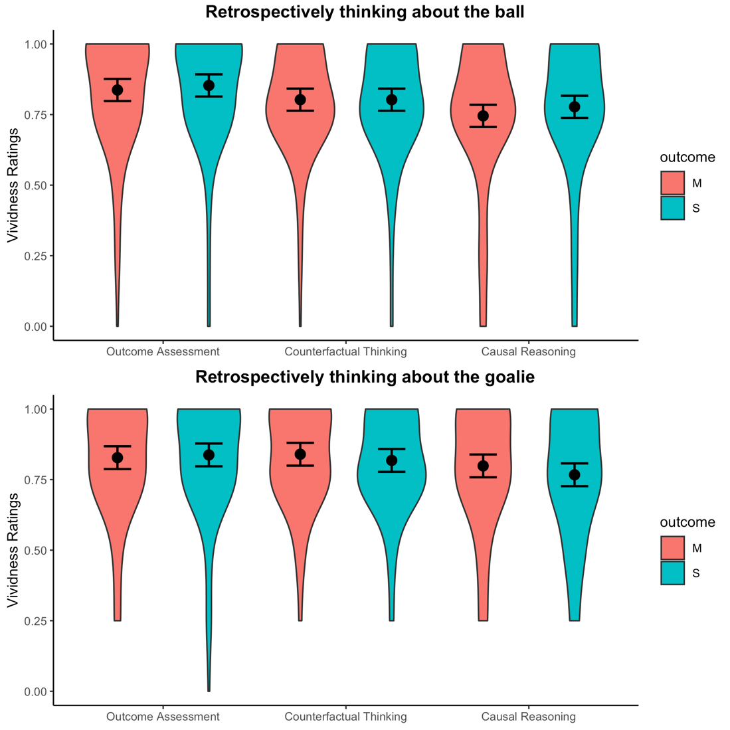

**Figure 2.** Estimated marginal means and standard errors for normalized ratings indicating the vividness of mental images evoked during retrospective outcome assessment, counterfactual thinking, and causal reasoning.

*Table 2.* *Test statistics for all variables in the regression models predicting the vividness of evoked mental images*

|  |  |  |  |
| --- | --- | --- | --- |
| **Predictors** | **Estimates** | **CI** | **p** |
| (Intercept) | **.837** | **.798 –.876** | **< .001** |
| outcome [S] | -.034 | -.075 – .006 | .097 |
| imagination [counterfactual] | **.063** | **.004 – .121** | **.035** |
| imagination [causal] | -.057 | -.140 – .025 | .173 |
| condition [goalie] | **-.092** | **-.132 – -.051** | **< .001** |
| outcome [S] * imagination [counterfactual] | .016 | -.041 – .073 | .584 |
| outcome [S] * imagination [causal] | -.009 | -.066 – .047 | .741 |
| outcome [S] * condition [goalie] | -.006 | -.065 – .052 | .831 |
| imagination [counterfactual] * condition [goalie] | .016 | -.025 – .057 | .438 |
| imagination [causal] * condition [goalie] | -.015 | -.098 – .067 | .712 |
| (outcome [S] * imagination [counterfactual]) * condition [goalie] | .047 | -.012 – .105 | .117 |
| (outcome [S] * imagination [causal]) * condition [goalie] | -.016 | -.073 – .041 | .584 |
| **Random Effects** | | | |
| σ2 | .02 | | |
| τ00 id | .02 | | |
| ICC | .46 | | |
| N id | 212 | | |
| Observations | 1272 | | |
| Marginal R2 / Conditional R2 | .022 / .475 | | |

*Note.* *B* = unstandardized coefficients; *CI* = confidence interval; Boldface text indicates *p* < .05; Created with the *sjPlot* package in R (Lüdecke, 2020)

These findings indicate that the vividness of mental images evoked during retrospective thinking varied across thought type. This, along with our prediction that the vividness of mental images may impact judgements about the outcome, counterfactual outcomes, and causality as well as the confidence in these judgements, we included vividness ratings as a variable in analyses investigating event ratings (described next).

**Event judgements.** We next conducted mixed-effect linear regression analyses, separately for self-focused and other-focused conditions, that modeled normalized *event judgements* as an *outcome* (two levels: miss [reference group] and score) by retrospective thought (three levels: outcome assessment [reference group], counterfactual thinking, and causal reasoning) by vividness three-way interaction with *participant* as a random effect. The purpose of these analyses were to assess whether our experimental manipulation effectively evoked different types of internal thoughts that would result in corresponding differences in outcomes assessment, counterfactual thinking, and causal reasoning.

Findings are illustrated in **Figure 3** and reported in **Table 3**. [Regardless of whether participants were retrospectively focused on the ball or the goalie, participants engaging in outcome assessment tended to correctly judge whether the ball missed or scored, as indicated by higher ratings for score trials compared to missed trials. Participants engaging in counterfactual thinking showed the opposite pattern of results, indicating that they could correctly judge whether the ball would have scored had the ball or the goalie moved in a different direction. Together, these findings indicate that participants could making accurate judgements about the actual outcome as well as a specific counterfactual outcome. Interestingly, judgments of causality varied according to whether participants were retrospectively focused on the ball or the goalie. That is, participants who were retrospectively focused on the ball and, therefore, judging the extent to which the ball’s movement caused the outcome, reported slightly higher ratings for score compared to miss trials. Participants who were retrospectively focused on the goalie, judging the extent to which the goalie’s movements caused the outcome, reported slightly higher ratings for miss compared to score trials. These findings indicate…]

Interestingly, [vividness was also a significant predictor of

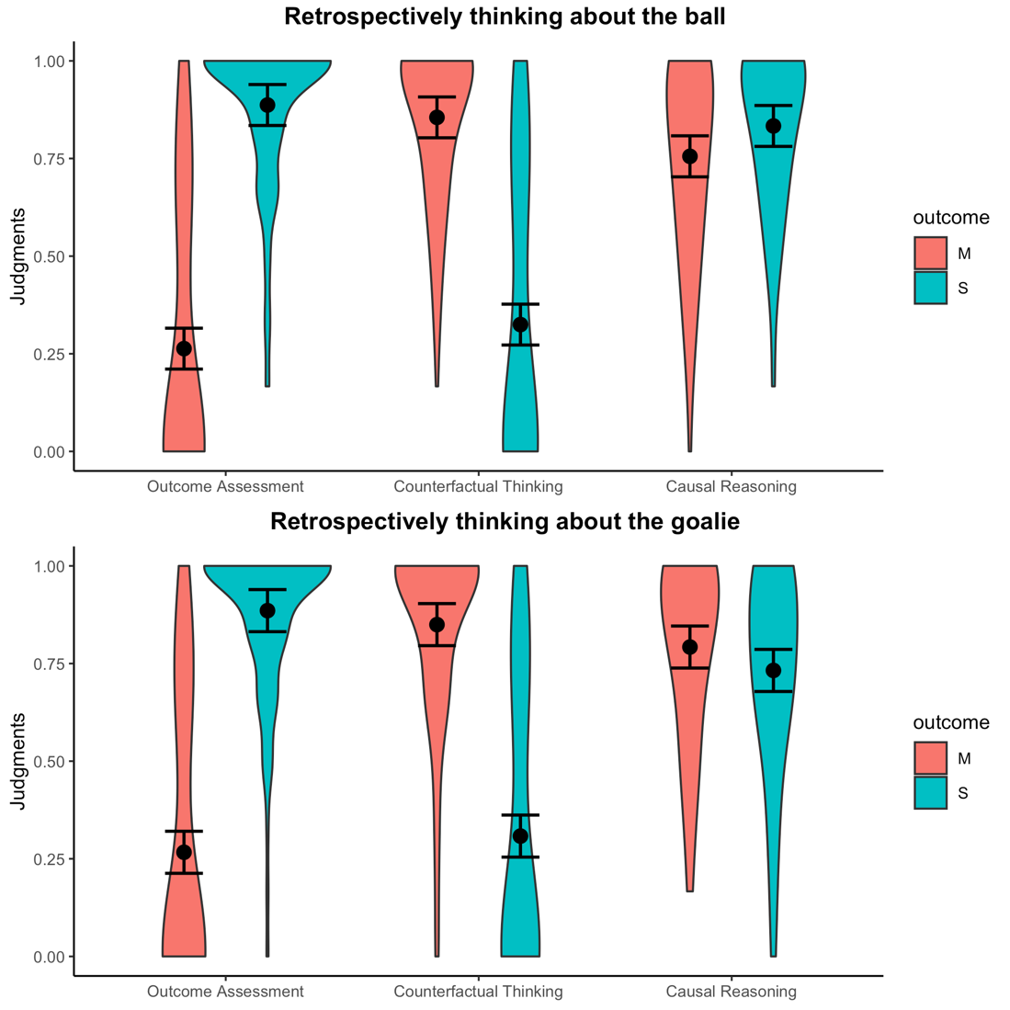

**Figure 3.** Estimated marginal means and standard errors for normalized event judgements from outcome assessment, counterfactual outcomes, and causality

**Predicting causal judgments from internal thoughts.** Our main research question of delineating between process and counterfactual theories of casual reasoning will gauge the extent to which participants relied on outcome assessment or counterfactual thinking to determine causality. To assess this here, we conducted a …

**Eye tracking pilot**

**Proposed analyses and anticipated results**

**Discussion**

**References**

Cheng, P. W., & Novick, L. R. (1992). Covariation in natural causal induction. *Psychological Review*, *99*(2), 365.

Clarke, R., Shepherd, J., Stigall, J., Waller, R. R., & Zarpentine, C. (2015). Causation, norms, and omissions: A study of causal judgments. *Philosophical Psychology*, *28*(2), 279-293.

Damiano, C., & Walther, D. B. (2019). Distinct roles of eye movements during memory encoding and retrieval. *Cognition*, *184*, 119-129.

Dowe, P. (2000). Causality and explanation. *The British journal for the philosophy of science*, *51*(1), 165-174.

Goldvarg, E., & Johnson‐Laird, P. N. (2001). Naive causality: A mental model theory of causal meaning and reasoning. *Cognitive science*, *25*(4), 565-610.

Hart, H. L. A., & Honoré, T. (1985). *Causation in the Law*. OUP Oxford.

Hannula, D. E., Ryan, J. D., Tranel, D., & Cohen, N. J. (2007). Rapid onset relational memory effects are evident in eye movement behavior, but not in hippocampal amnesia. *Journal of cognitive neuroscience*, *19*(10), 1690-1705.

Henne, P., Niemi, L., Pinillos, Á., De Brigard, F., & Knobe, J. (2019). A counterfactual explanation for the action effect in causal judgment. *Cognition*, *190*, 157-164.

Icard, T. F., Kominsky, J. F., & Knobe, J. (2017). Normality and actual causal strength. *Cognition*, *161*, 80-93.

Knobe, J. (2009). Folk judgments of causation. *Studies in History and Philosophy of Science Part A*, *40*(2), 238-242.

Knobe, J., & Fraser, B. (2008). Causal judgment and moral judgment: Two experiments. *Moral psychology*, *2*, 441-8.

Morris, A., Phillips, J. S., Icard, T., Knobe, J., Gerstenberg, T., & Cushman, F. (2018). Causal judgments approximate the effectiveness of future interventions.

Laeng, B., & Teodorescu, D. S. (2002). Eye scanpaths during visual imagery reenact those of perception of the same visual scene. *Cognitive Science*, *26*(2), 207-231.

Lewis, D. (1974). Causation. *The journal of philosophy*, *70*(17), 556-567.

Lüdecke D (2020). *sjPlot: Data Visualization for Statistics in Social Science*. doi: [10.5281/zenodo.1308157](https://doi.org/10.5281/zenodo.1308157), R package version 2.8.3, <https://CRAN.R-project.org/package=sjPlot>.

Petrocelli, J. V., Percy, E. J., Sherman, S. J., & Tormala, Z. L. (2011). Counterfactual potency. Journal of Personality and Social Psychology, 100, 30–46.

Salmon, W. C. (1997). Causality and explanation: A reply to two critiques. *Philosophy of Science*, *64*(3), 461-477.

Walsh, C. R., & Sloman, S. A. (2011). The meaning of cause and prevent: The role of causal mechanism. *Mind & Language*, *26*(1), 21-52.

Wasserman, E. A., Chatlosh, D. L., & Neunaber, D. J. (1983). Perception of causal relations in humans: Factors affecting judgments of response-outcome contingencies under free-operant procedures. *Learning and motivation*, *14*(4), 406-432.

Wolff, P. (2007). Representing causation. *Journal of experimental psychology: General*, *136*(1), 82-111.

1. Comparisons were adjusted using the Tukey method for multiple comparisons.