Documentation
Student name: Georgi Nikolov
- Home page (index.html)
      - Navigation bar (<nav>) for easy access to all five pages.
      - A hero section with a welcoming message and call-to-action button.
      - A “What I do” section showing three main areas of interest (Web technologies, Sports, Learning) using grid layout.
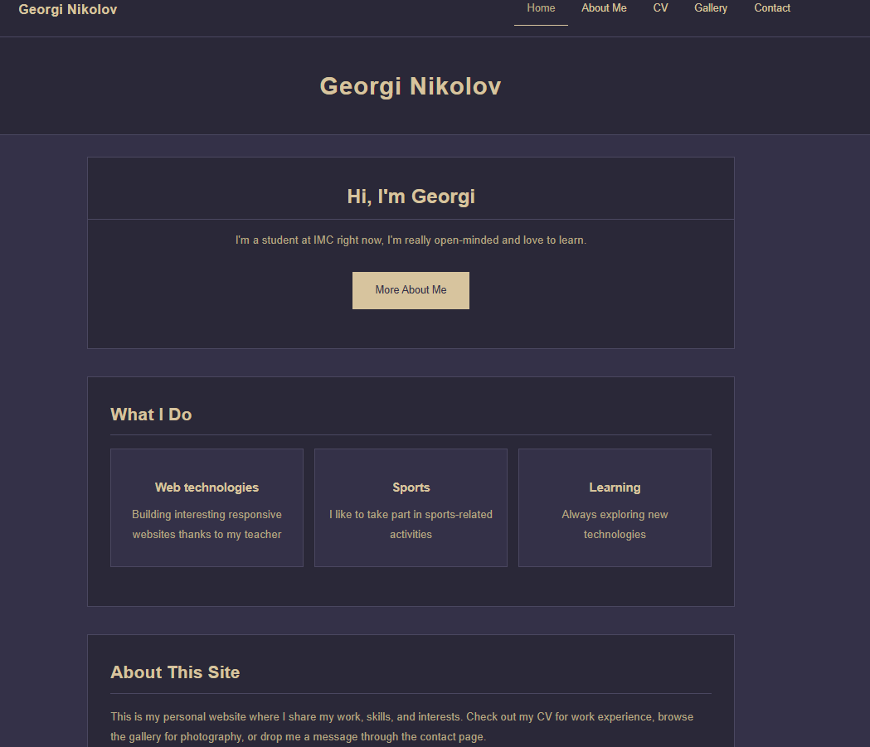
      - A brief “About this site” section explaining the purpose of the website.
- About me page (about.html)
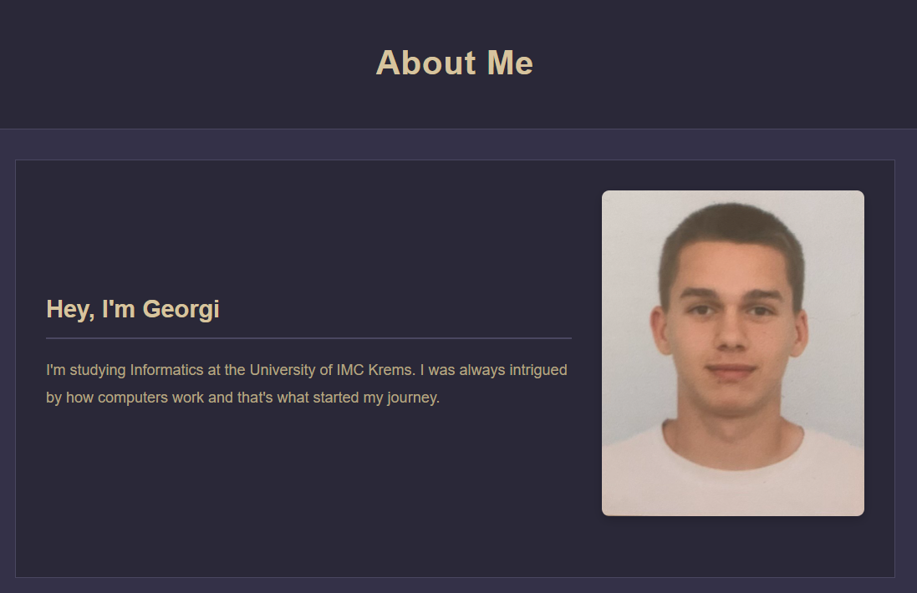
    - A introduction section with a brief description and a picture.

- CV page (cv.html)
    - A “Education” section listing my education with dates
    - A “Experience” section listing my internships and jobs
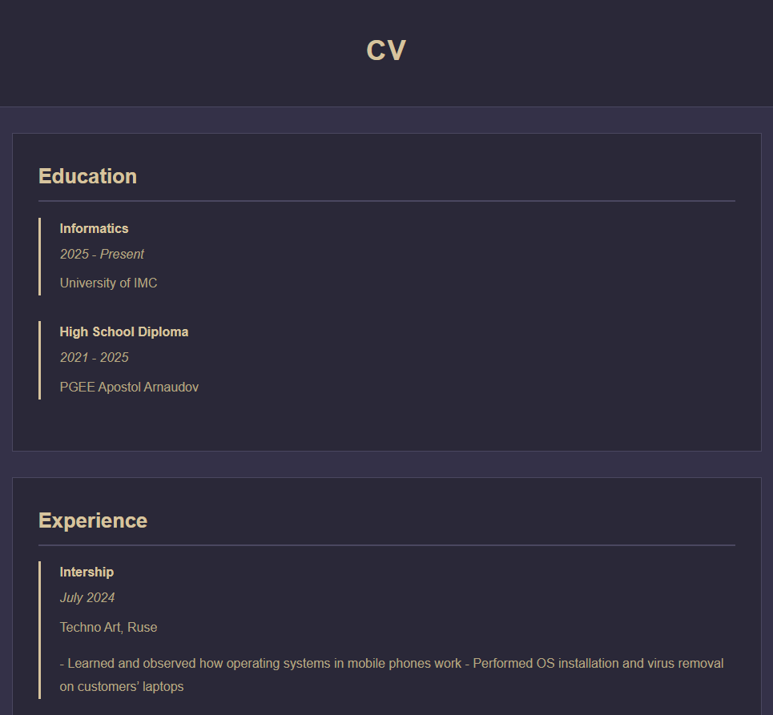

- Gallery page (gallery.html)
    - 12 images displayed in a responsive grid.
    - The grid is set to display three columns on large screens and collapses to a single column on mobile device (@media query in style.css).
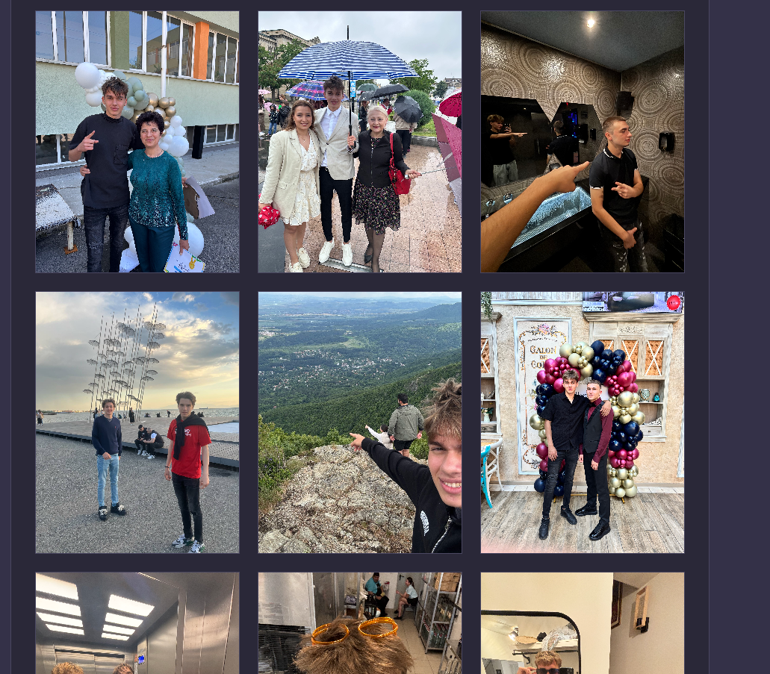
    - Images are set to (object-fit: cover), so they fill the container while maintaining aspect ratio.

- Contact page (contact.html)
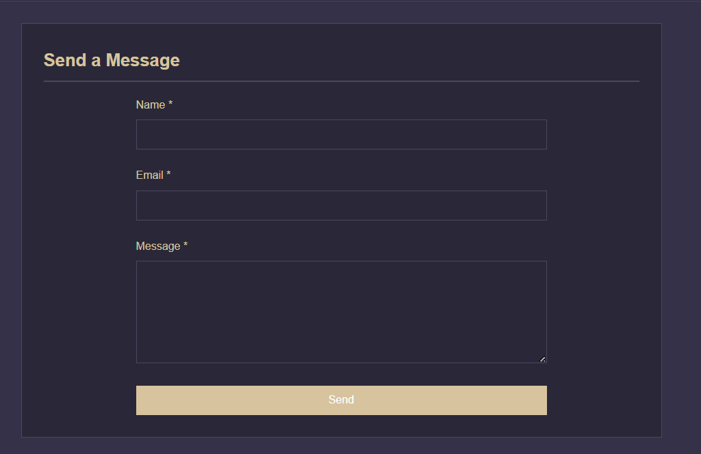
    - A simple contact form with required fields for Name, Email and message

