Documentation
Contents
Documentation 1
Picture of the website 2
Product rendering 2
Bootstrap components 5
Nav-bar: 5
Shopping Cart Modal 6
Add to Cart button/Bootstrap Buttons 9
Checkout Modal (Bootstrap Form With Validation) 10
Confirm Modal 11
Scrolling Animation 12
Sources 13

Picture of the website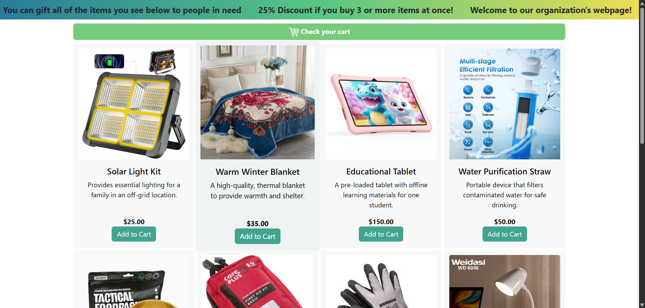

Product rendering
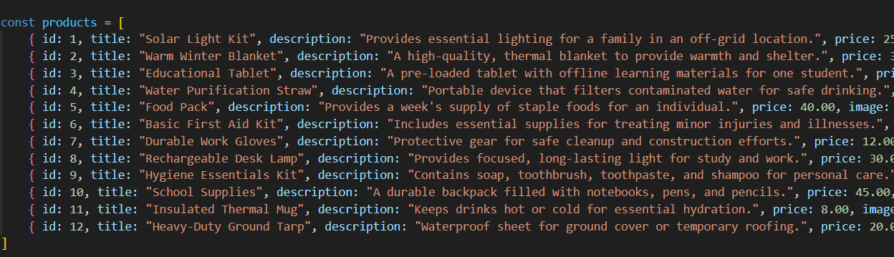
First of all we have the default product array which contains all the products of the website.
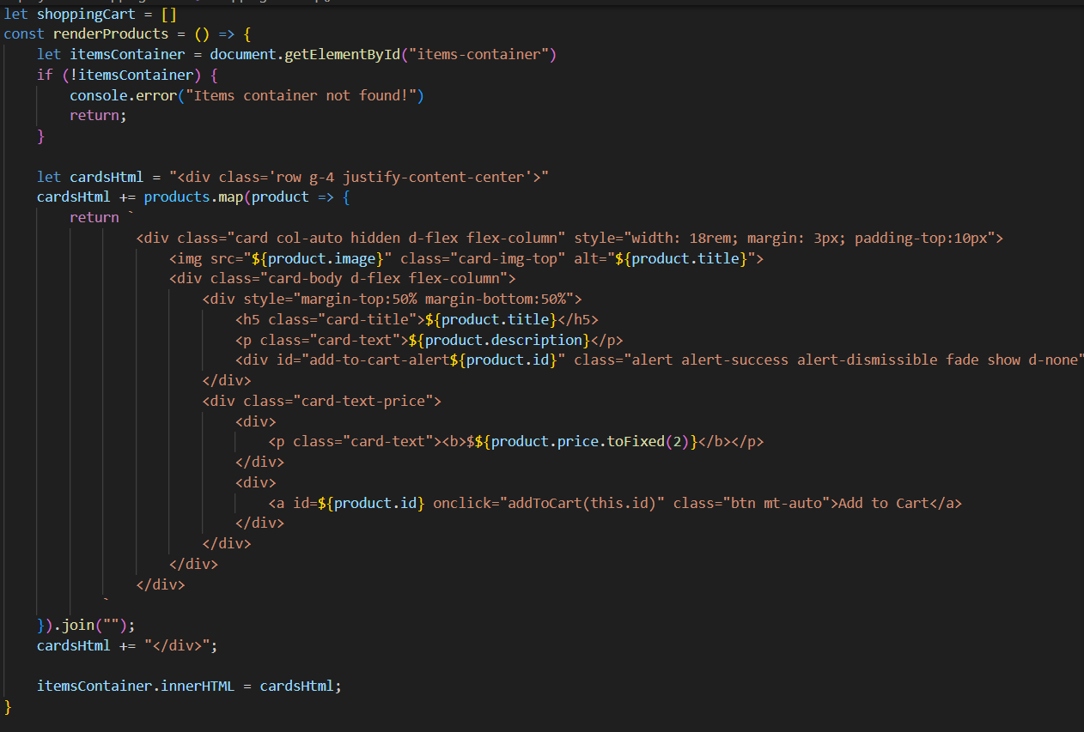
Then we have a function called render products which creates a container div for all the cards in the items-container div. After that we go through the products list with map and for every product in the product list we return a Bootstrap Card which will contain the image,title,description,id and price of the product and we join all of the cards together which we put into the cardsHtml div which we put into the items-container div. We call this render products function once every time we want to view the website.

Fade animation
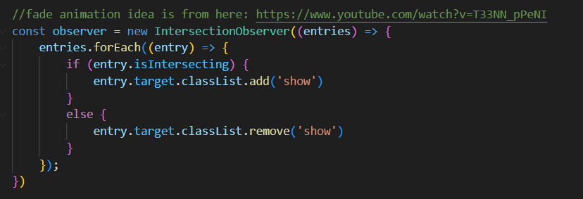
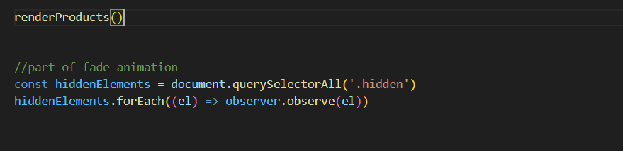
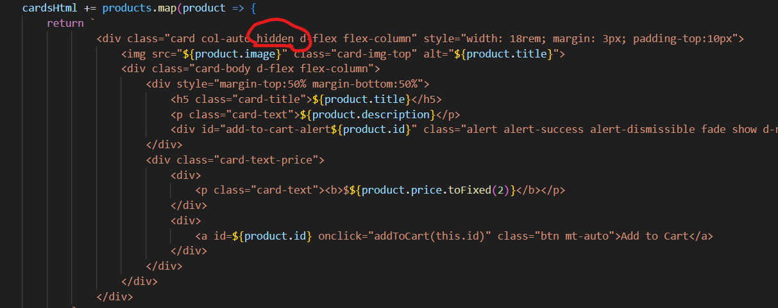
We have an intersection observer at the start of our javascript code which observes all of the elements that have the hidden class on them. Every time that an element which has the hidden class would become visible on our webpage the observer detects it and adds the show class into it’s class list so the item becomes visible again. Also every time an item would be out of our scope of sight it removes the show class from it’s class list so it becomes invisible again, so with a smooth transition we made fading cards by applying the hidden class to every card that we want rendered. It is VERY important that we RENDER the products before calling the observer so there actually is something to observe and it works!

Bootstrap components

Nav-bar
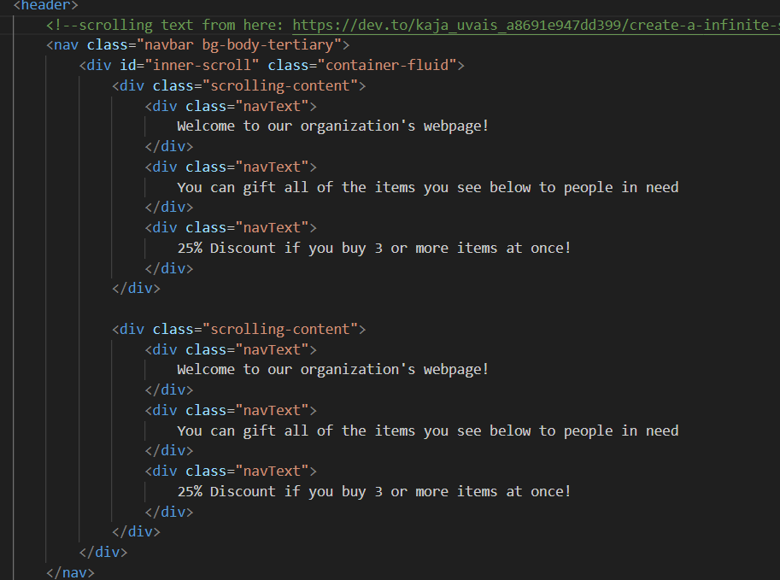
The default bootstrap navigation bar was used for this webpage but only to store the infinitely scrolling div components.

Cards
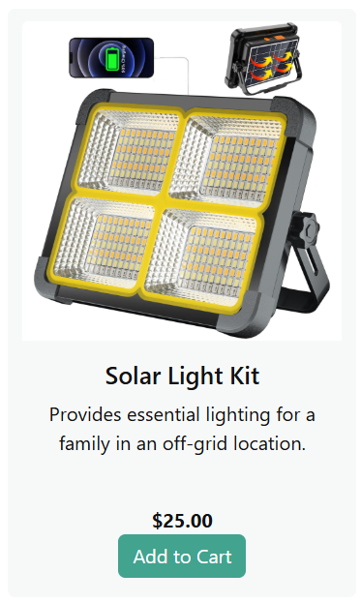
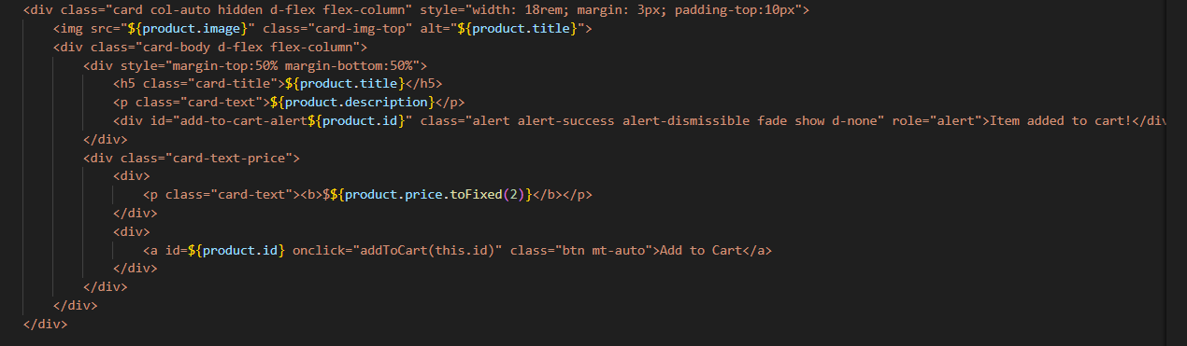
Default bootstrap card component with transform-translate3D hover effect on it so if the cursor is on the card it gets bigger
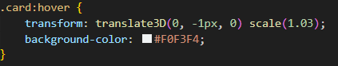

Shopping Cart Modal
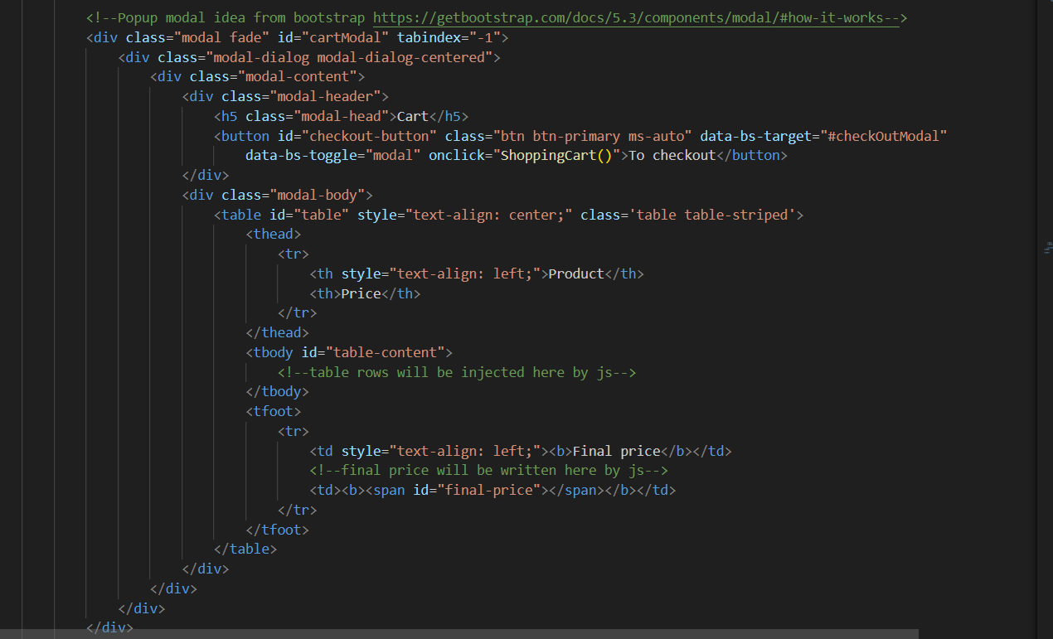
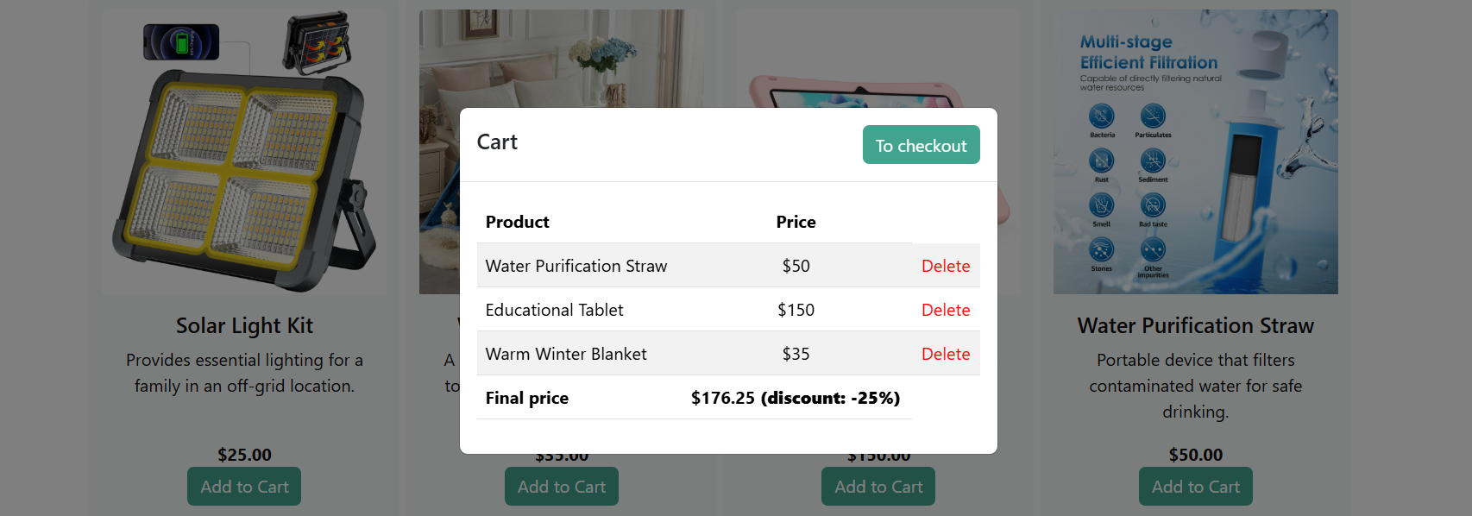

Shopping cart Javascript code
We have a default bootstrap table html element.
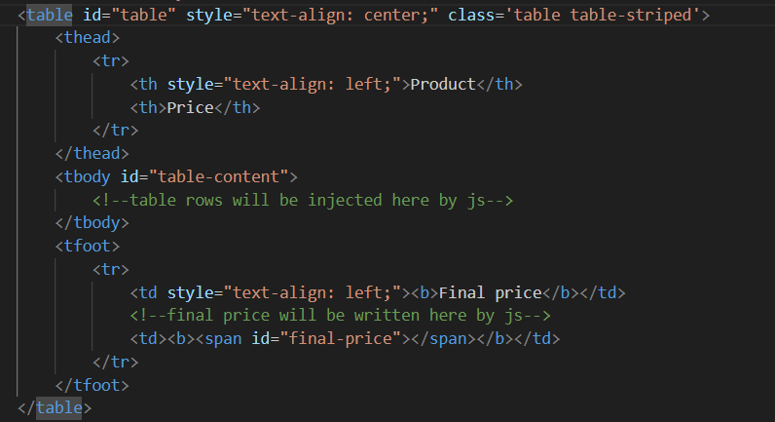
And a ShoppingCart function in our javascript code.
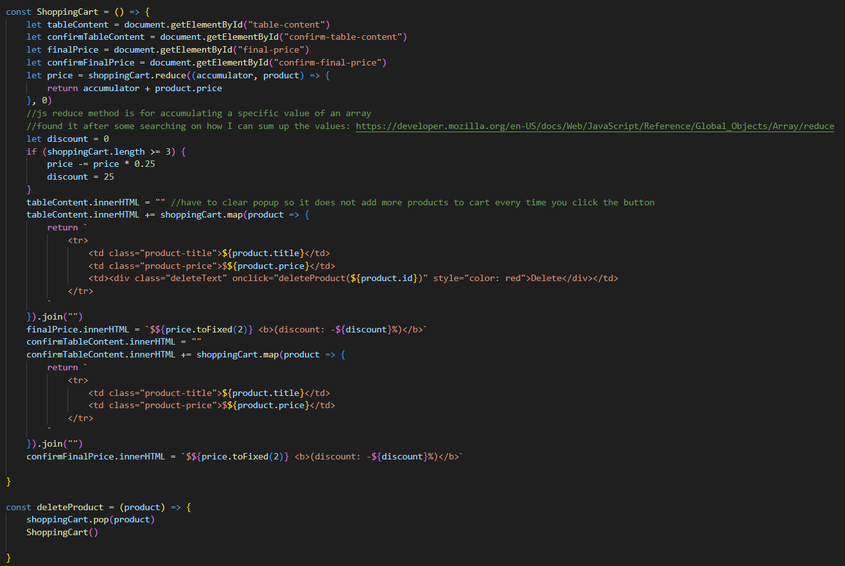

First we define some basic variables.
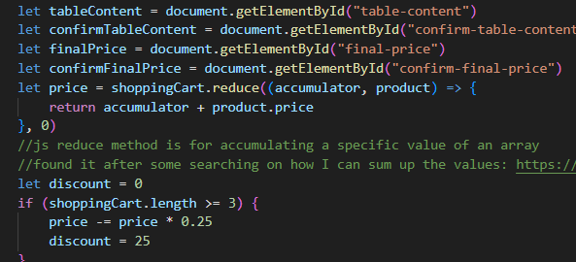
Table content will be where we will render the full table.
Confirm table content will be where we render the confirmation table where we just see all the products that we will purchase and confirm our order in the Confirmation modal after the checkout.
finalPrice and confirmFinalPrice is the final price that we are going to pay.
Discount will be the discount if we are purchasing 3 or more items.
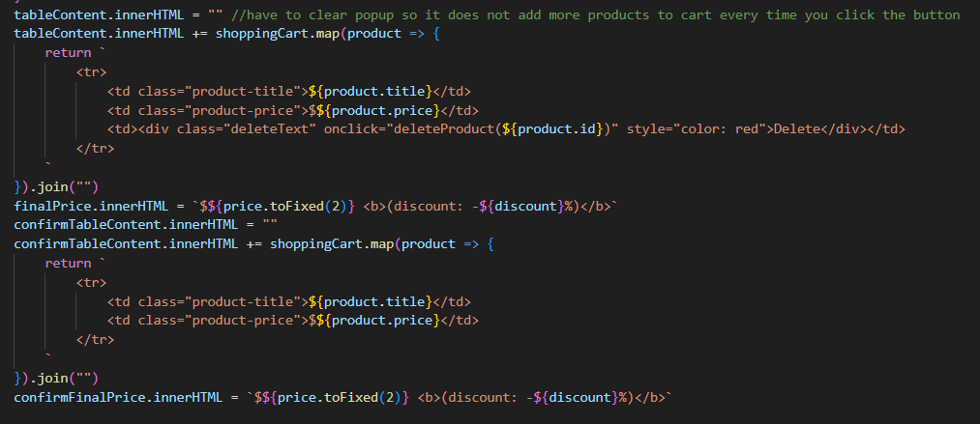
Every time we open the modal we have to clear the table and re-render the products so they do not accumulate. Then we go through the shoppingCart list which we defined outside of the function as a global variable and where our items that we added to the cart are put in. We join them together and return them into the tableContent. We also do this for the confirmTableContent too so we do not have to create a separate function for it and we can do it in one place at one time. We also render a delete button for the table content so we can delete the items we accidentally put into the shopping cart by calling the deleteProduct function with the current product id. We do not render this button into the confirmTable.
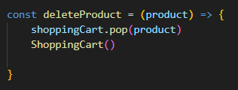
It just pop’s the item from the shoppingCart global array and re-renders the shopping cart by calling the ShoppingCart function.

Add to Cart button/Bootstrap Buttons
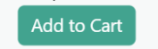
We have a default Bootstrap button as an add to cart button.
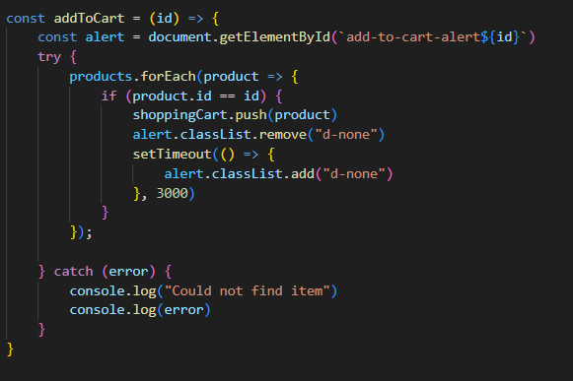
Every time someone click on the button the addToCart function runs. The parameter in the addToCart function (id) is the product’s Id which is needed for rendering an alert that the product is added to the cart which becomes visible every time that the button is clicked inside the card of the product. Every product has an invisible alert element added to them and if the button is clicked we remove the bootstrap d-none property so the element becomes visible then after 3 seconds we remove the d-none property so the alert fades away. We go through all of the elements of the products list and if the id’s are the same we push the element into the shoppingCart array that is defined as a global variable.

Checkout Modal (Bootstrap Form With Validation)
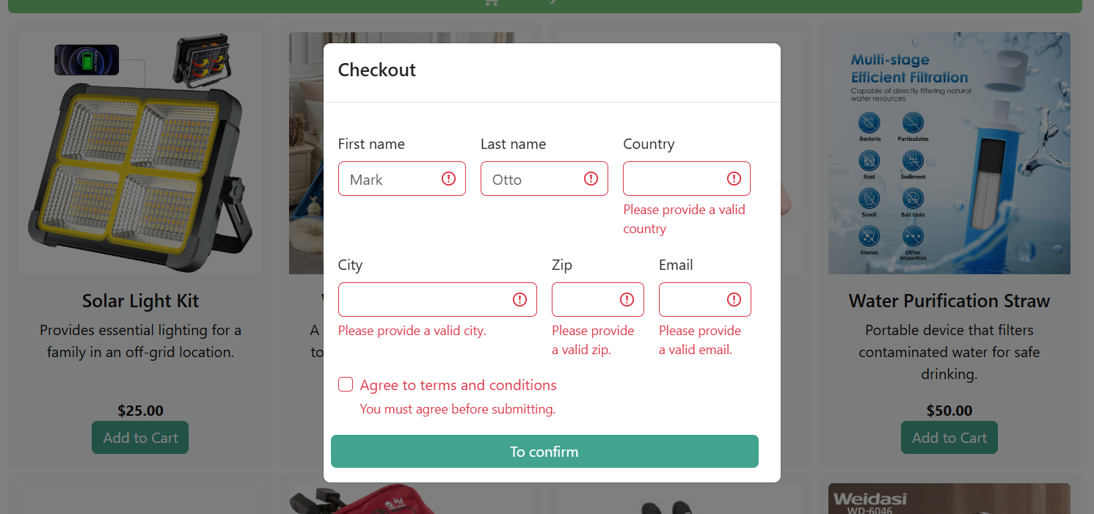
An other default modal component which contains the form with some basic bootstrap validations.
Code for the basic validation
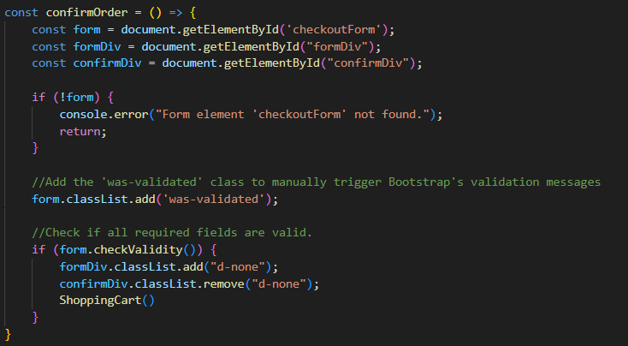

Confirm Modal
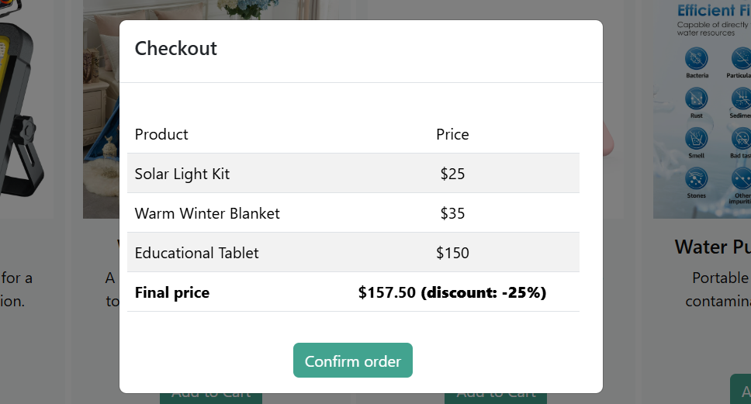
You see again what you ordered and how much it costs. Here you can confirm your order of the items you want to purchase

Scrolling Animation
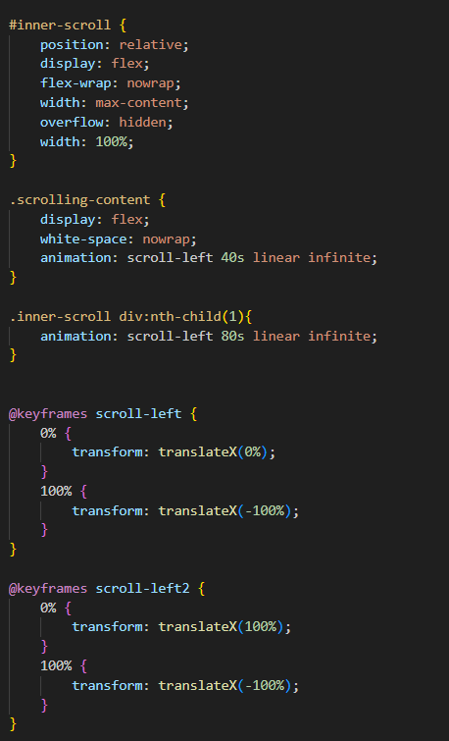
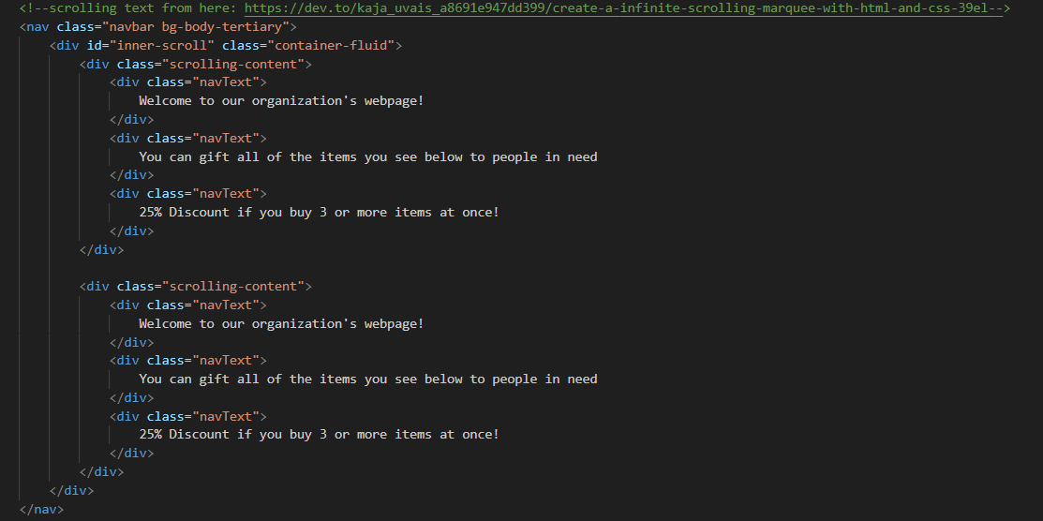
We have 2 times the text in one inner scroll div and we apply the 2 animations separately to the 2 separate divs so it becomes smooth and does not jump back to the start every time the animation ends.

Sources
Scrolling text: https://dev.to/kaja_uvais_a8691e947dd399/create-a-infinite-scrolling-marquee-with-html-and-css-39el
Bootstrap Card: https://getbootstrap.com/docs/5.3/components/card/
Bootstrap Button: https://getbootstrap.com/docs/5.3/components/buttons/
Popup Modal: https://getbootstrap.com/docs/5.3/components/modal/#how-it-works
Form layout and bootstrap validations: https://getbootstrap.com/docs/5.3/forms/validation/
Bootstrap table: https://getbootstrap.com/docs/5.3/content/tables/
Color combination idea: https://htmlcolorcodes.com/color-chart/
Gradient navbar background colors: https://cssgradient.io/
Javascript reduce method: https://developer.mozilla.org/en-US/docs/Web/JavaScript/Reference/Global_Objects/Array/reduce
Fading cards animation idea: https://www.youtube.com/watch?v=T33NN_pPeNI

