DOCUMENTATION
Student Name: Georgi Nikolov

1. SHOP VIEW
The main landing view serves as the product gallery and entry point for donors.
- Navigation Bar: A sticky top navbar featuring the brand name and a dynamic "Basket" button that updates the item count in real-time.
- Product Grid: A responsive grid system displaying donation items. The layout is generated dynamically using a JavaScript loop to iterate through the product data.
for (let i = 0; i < products.length; i++) {
html += `
<div class="col-md-3 col-sm-6">
<h5 class="card-title">${products[i].name}</h5>
<button onclick="addToCart(${products[i].id})">Add to Basket</button>
</div>`;
}
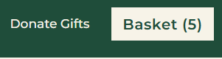
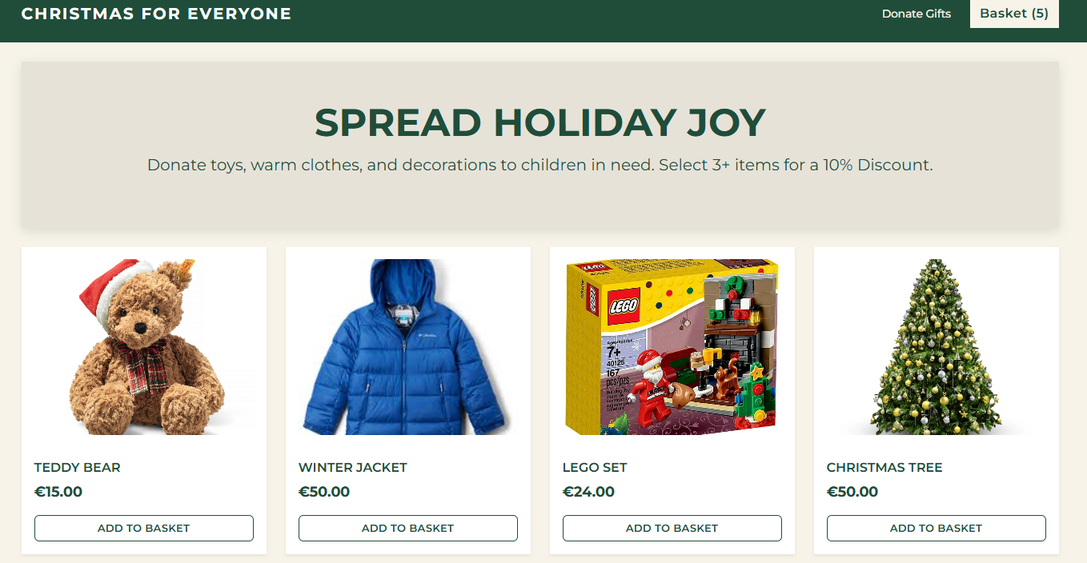
2. CHECKOUT VIEW
This section is initially hidden and appears only when the user proceeds to checkout.
-Information Form: A styled form collecting user details with specific validation rules.
- Validation: Custom logic ensures the Zip code matches Austrian standards (exactly 4 digits) and the email format is correct.
This code ensures the email contains (@).
if (!email.includes("@")) {
showNotification("Please enter a valid email address containing '@'.");
return;

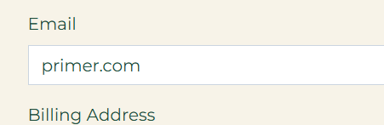
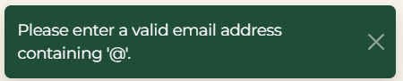

3. CONFIRMATION VIEW
After a successful form submission, the user is presented with a summary receipt.
- Discount Logic: The system automatically checks if the basket contains 3 or more items. If true, a 10% discount is calculated and subtracted from the subtotal.
let discountRate = 0;
if (cart.length >= 3) {
discountRate = 0.10;
}
let total = subtotal - (subtotal * discountRate);

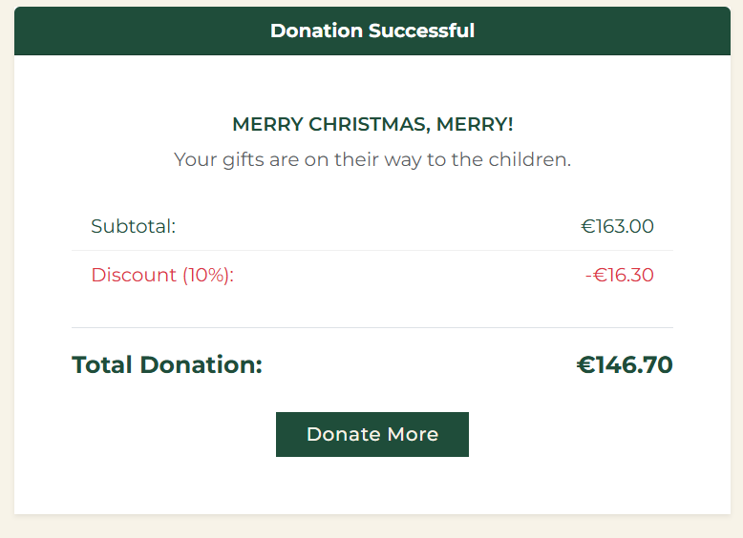

4. TECHNICAL IMPLEMENTATION
- Single Page Application (SPA): The website uses JavaScript to toggle the visibility of the Shop, Checkout, and Confirmation sections without reloading the page.
- Toast Notifications: Instead of standard browser alerts, a custom function triggers Bootstrap Toasts for a smoother user experience.
function showNotification(message) {
document.getElementById('toast-message').innerText = message;
const toast = new bootstrap.Toast(document.getElementById('liveToast'));
toast.show();
}

