**Evaluation**

A screenshot of the confusion matrix can be seen below:

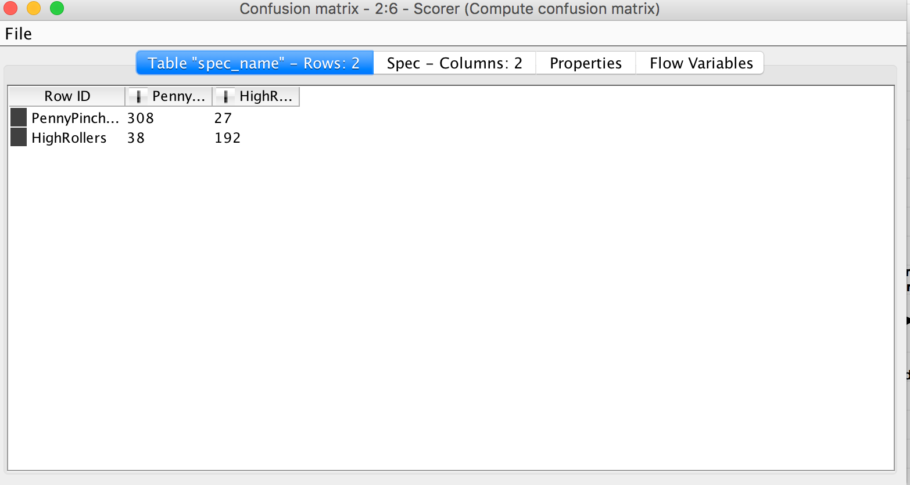

As seen in the screenshot above, the overall accuracy of the model is 88.5%

<Fill In: Write one sentence for each of the values of the confusion matrix indicating what has been correctly or incorrectly predicted.>

308: 308 true PennyPincher are correctly predicted as PennyPinchers

27: 27 true PennyPincher are incorrectly predicted as HighRollers

38: 38 true Highroller are incorrectly predicted as PennyPinchers

192: 192 true Highrollers are correctly predicted as HighRollers