**Analysis Conclusions**

The final KNIME workflow is shown below:

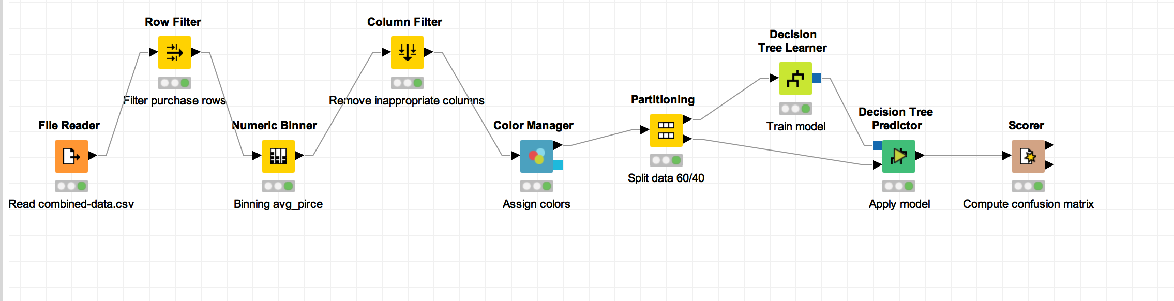

What makes a HighRoller vs. a PennyPincher?

<Fill In 2-3 sentences answering this question based on insights from your analysis.>

1. The platformType makes the type of buyer type, and mobile platforms contributes more than PC platforms.
2. In mobile platform, iphone players are more likely to be HighRoller(83%), while android players tend to be PennyPinchers(86.5%)
3. In PC platform, players are generally PennyPinchers, but part of mac users are HighRollers(37%).

|  |
| --- |
| **Specific Recommendations to Increase Revenue** |
| 1. Android and Windows are two big user group to develop more HighRollers. |
| 2. Considering the potential HighRoller group in mac platform, it’s worth investing to attract more players from mac platform. |