**Graph Analytics**

**Modeling Chat Data using a Graph Data Model**

(Describe the graph model for chats in a few sentences. Try to be clear and complete.)

The graph describes the following network. When one User creates a TeamChatSession, it is then owned by team. Users can join and leave the TeamChatSession. In TeamChatSession, users can create ChatItem that is part of TeamChatSession. ChatItem could also be mentioned by Users. And User could respond to User as well. All the relationships are recorded with timestamp.

Four types of nodes:

1. User
2. Team
3. TeamChatSession
4. ChatItem.

Seven types of relationships:

1. User creates TeamChatSession with timestamp
2. Team owns TeamChatSession with timestamp
3. User joins TeamChatSession with timestamp
4. User leaves TeamChatSession with timestamp
5. User creates ChatItem with timestamp
6. ChatItem is part of TeamChatSession with timestamp
7. ChatItem is mentioned by User with timestamp
8. ChatItem responses to ChatItem with timestamp

**Creation of the Graph Database for Chats**

Describe the steps you took for creating the graph database. As part of these steps

1. Write the schema of the 6 CSV files

1. chat_create_team_chat.csv

userid, teamid, TeamChatSessionID, timestamp

2. chat_item_team_chat.csv

userid, TeamChatSessionID, chatitemid, timestamp

3. chat_join_team_chat.csv

userid, TeamChatSessionID, timestamp

4. chat_leave_team_chat.csv

userid, TeamChatSessionID, timestamp

5. chat_mention_team_chat.csv

chatitemid, userid, timestamp

6. chat_respond_team_chat.csv

chatitemid1, chatitemid2,timestamp

1. Explain the loading process and include a sample LOAD command

# clear out the database

MATCH (n)

OPTIONAL MATCH (n)-[r]-()

DELETE n,r

# create the constraint on nodes’ primary key

CREATE CONSTRAINT ON (u:User) ASSERT u.id IS UNIQUE;

CREATE CONSTRAINT ON (t:Team) ASSERT t.id IS UNIQUE;

CREATE CONSTRAINT ON (c:TeamChatSession) ASSERT c.id IS UNIQUE;

CREATE CONSTRAINT ON (i:ChatItem) ASSERT i.id IS UNIQUE;

# load chat_create_team_chat.csv

LOAD CSV FROM "file:///Users/iBowen/Desktop/chat-data/chat_create_team_chat.csv" AS row MERGE (u:User {id: toInt(row[0])}) MERGE (t:Team {id: toInt(row[1])}) MERGE (c:TeamChatSession {id: toInt(row[2])}) MERGE (u)-[:CreatesSession{timeStamp: row[3]}]->(c) MERGE (c)-[:OwnedBy{timeStamp: row[3]}]->(t)

# load chat_join_team_chat.csv

LOAD CSV FROM "file:///Users/iBowen/Desktop/chat-data/chat_join_team_chat.csv" AS row MERGE (u:User {id: toInt(row[0])}) MERGE (c:TeamChatSession {id: toInt(row[1])}) MERGE (u)-[:Join{timeStamp: row[2]}]->(c)

# load chat_leave_team_chat.csv

LOAD CSV FROM "file:///Users/iBowen/Desktop/chat-data/chat_leave_team_chat.csv" AS row MERGE (u:User {id: toInt(row[0])}) MERGE (c:TeamChatSession {id: toInt(row[1])}) MERGE (u)-[:Leave{timeStamp: row[2]}]->(c)

# chat_item_team_chat.csv

LOAD CSV FROM "file:///Users/iBowen/Desktop/chat-data/chat_item_team_chat.csv" AS row MERGE (u:User {id: toInt(row[0])}) MERGE (c:TeamChatSession {id: toInt(row[1])}) MERGE (i:ChatItem {id: toInt(row[2])}) MERGE (u)-[:CreateChat{timeStamp: row[3]}]->(i) MERGE (i)-[:PartOf{timeStamp: row[3]}]->(c)

# chat_mention_team_chat.csv

LOAD CSV FROM "file:///Users/iBowen/Desktop/chat-data/chat_mention_team_chat.csv" AS row MERGE (i:ChatItem {id: toInt(row[0])}) MERGE (u:User {id: toInt(row[1])}) MERGE (i)-[:Mentioned {timeStamp: row[2]}]->(u)

# chat_respond_team_chat.csv

LOAD CSV FROM "file:///Users/iBowen/Desktop/chat-data/chat_respond_team_chat.csv" AS row MERGE (i:ChatItem {id: toInt(row[0])}) MERGE (j:ChatItem {id: toInt(row[1])}) MERGE (i)-[:ResponseTo {timeStamp: row[2]}]->(j)

1. Present a screenshot of some part of the graph you have generated. The graphs must include clearly visible examples of most node and edge types. Below are two acceptable examples. The first example is a rendered in the default Neo4j distribution, the second has had some nodes moved to expose the edges more clearly. Both include examples of most node and edge types.

Show 50 relationships without direction

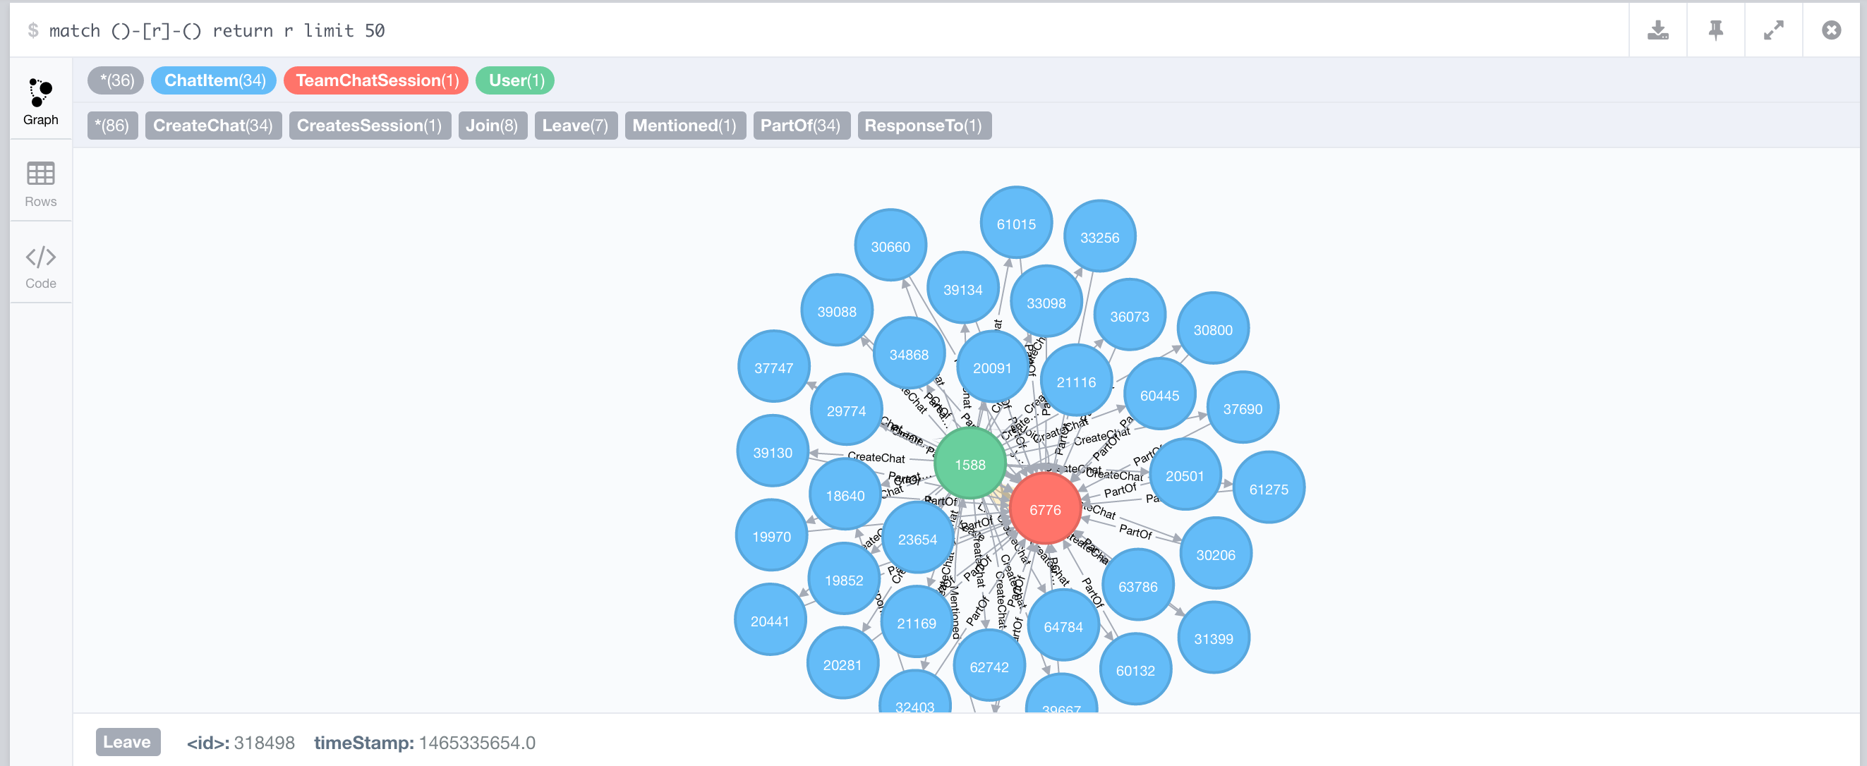

Show 25 relationships with direction

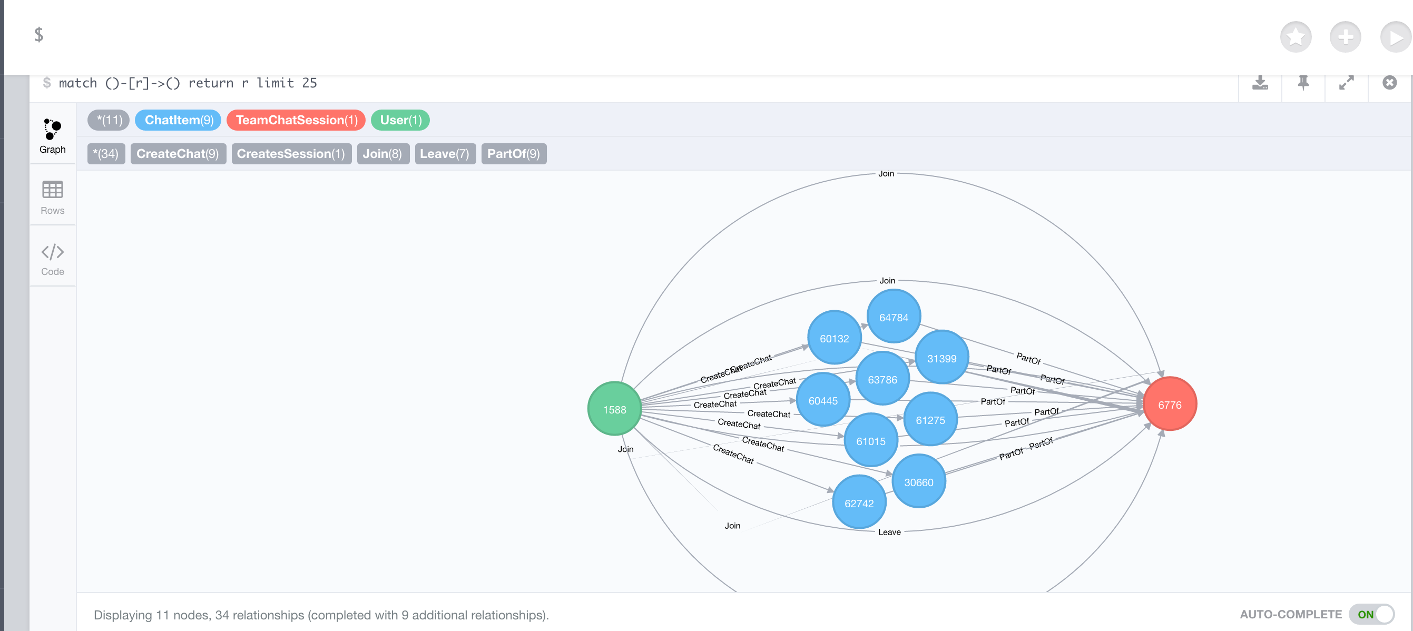

**Finding the longest conversation chain and its participants**

Report the results including the length of the conversation (path length) and how many unique users were part of the conversation chain. Describe your steps. Write the query that produces the correct answer.

# step 1, find the longest path with edge of “ResponseTo”

match p=(i:ChatItem)-[:ResponseTo*]-(j:ChatItem) return length(p) order by length(p) desc limit 1

# step 2, count the number distinct users who create ChatItem in the longest path

match p=(i:ChatItem)-[:ResponseTo*]-(j:ChatItem)

with p order by length(p) desc limit 1

match (u:User)-[:CreateChat]-(i)

where i in nodes(p)

return count(distinct u)

The longest path:

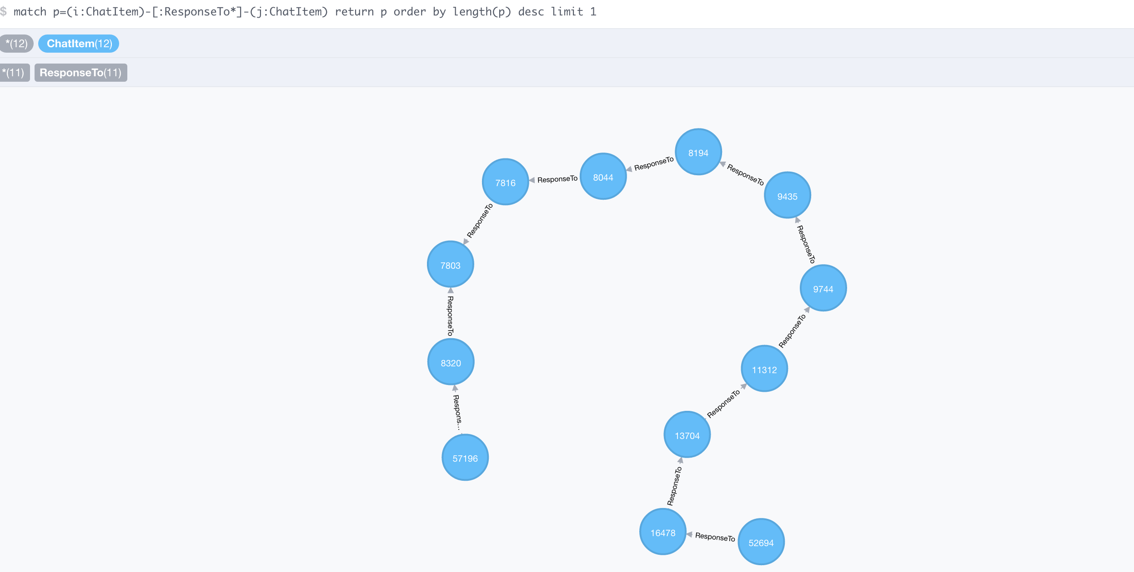

**Analyzing the relationship between top 10 chattiest users and top 10 chattiest teams**

Describe your steps from Question 2. In the process, create the following two tables. You only need to include the top 3 for each table. Identify and report whether any of the chattiest users were part of any of the chattiest teams.

**Chattiest Users**

|  |  |
| --- | --- |
| **Users** | **Number of Chats** |
| 394 | 115 |
| 2067 | 111 |
| 209 | 109 |

**Chattiest Teams**

|  |  |
| --- | --- |
| **Teams** | **Number of Chats** |
| 82 | 1324 |
| 185 | 1036 |
| 112 | 957 |

Finally, present your answer.

match p=(u:User)-[:Join]-(c:TeamChatSession)-[:OwnedBy]-(t:Team) where t.id in [82,185,112,18,194,129,52,136,146,81] and u.id in [394,2067,209,1087,554,516,1627,999,668,461] return p

There is one chattest user id 999 who was part of one chattest team id 52 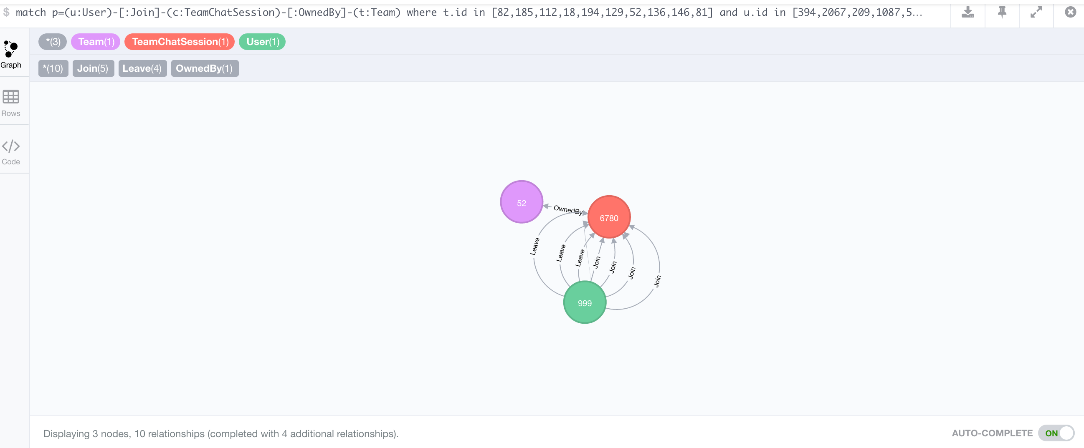

**How Active Are Groups of Users?**

Describe your steps for performing this analysis. Be as clear, concise, and as brief as possible. Finally, report the top 3 most active users in the table below.

**Most Active Users (based on Cluster Coefficients)**

|  |  |
| --- | --- |
| **UserId** | **Coefficient** |
| 461 | 1 |
| 209 | 0.9523809523809523 |
| 516 | 0.9523809523809523 |

1. connect two users if One mentioned another user in a chat

Match (u1:User)-[:CreateChat]->(i:ChatItem)-[:Mentioned]->(u2:User) merge (u1)-[:InteractsWith]->(u2)

2. connect two users if One created a chatItem in response to another user’s chatItem

Match (u1:User)-[:CreateChat]->(i1:ChatItem)-[:ResponseTo]-(i2:ChatItem)<-[:CreateChat]-(u2:User) merge (u1)-[:InteractsWith]->(u2)

3. delete self-loop InteractsWith relationship

match (u1)-[r:InteractsWith]->(u1) delete r

4. get neighbors and set degree based on the number of neighbors on the “InteractsWith” edge.

match (u1:User)-[r:InteractsWith]-(u2:User) with u1, count(distinct u2) as degree

set u1.deg = degree

return u1.id, u1.degreturn u1.id, u1.deg

5. get the number of links amongst neighbors, it includes the following steps:

# find the neighbors users of one user node, and collect all distinct neighbor ids.

# find all links amongst neighbors

# count 1 if there are one or more relationships between two neighbors.

# show the user degree and add all links together

# calculate the clustering efficient

match (u1:User)-[:InteractsWith]-(u2:User)

with u1, collect(distinct u2.id) as neighbors

match (n:User)-[r:InteractsWith]->(m:User)

where (n.id in neighbors) and (m.id in neighbors)

with u1, case when (n)-->(m) then 1

else 0 end as value

with u1, u1.deg as deg, sum(value) as links

set u1.cc = toFloat(links) / (deg * (deg - 1))

return u1.id, u1.deg, u1.cc

match (u:User) where u.id in [394, 2067, 209, 1087, 554, 516, 1627, 999, 668, 461]

with u.id as id, u.deg as degree, u.cc as cluser_coefficient order by cluser_coefficient desc

return id, degree, cluser_coefficient

