1-addic — Guide & Tutorial
What it is, why it exists, how to make it yours, and how to use it, step by step
App: 1-addic, offline edition (the file 1-addic.html) | Prepared by: Claude Code | Date: 7 November 2026 | Tested: 8 November 2026, 581 of 582 logic checks and 25 of 25 browser checks passed, none skipped (Part 4)

Table of contents — right-click → Update Field (or press F9) to build.

In a nutshell
1-addic is one file you open in a web browser. It helps a person in recovery learn practical skills, use them in a hard moment, and see what helps over time. It has short lessons, a personal workbook, quick logs, plans for risky times, and an SOS button that is always one tap away. It needs no internet, no install and no account, and what you write never leaves your device. It is a skills notebook, not medical care. The one habit to learn: export a backup from Settings → Your data every week.

How to use this guide
Part 1 explains the app: what it is, why it exists, when to reach for it and how it thinks. Part 2 helps you make it yours in one sitting: the first-run steps, your reasons, the people you can call, and a routine for the first week. Part 3 is a hands-on tutorial in fifteen short lessons; Lesson 1 is a test drive with sample data, so you can try everything before you type anything real. Part 4 covers problems, known quirks and how this guide was checked. Words with a small number after them are explained at the bottom of the page and again in the Glossary at the end.
You want to… | Go to
Understand what the app is for | Part 1
Set it up for yourself today | Part 2 — Making it yours in one sitting
Try it without typing anything real | Lesson 1 — Test drive with sample data
Get through a craving right now | Lesson 3 — SOS: a craving
Learn a skill | Lesson 6 — Learn a module
See what helps you | Lesson 8 — Track and Insights
See where you stand | Lesson 15 — Your Harbor
Plan for a risky evening | Lesson 9 — The planner and Battle Plans
Never lose your data | Lesson 12 — Back up and restore
Put it on your phone | Lesson 13 — Use it on a phone
Solve a problem | Part 4 — Troubleshooting

Part 1 — Understanding 1-addic

What it is
1-addic is a private recovery-skills app. It turns ideas from recovery work into small, practical steps: notice a craving, wait it out, call someone, plan the evening, look back at the week. It is written for adults, in plain words, and it treats you as the expert on your own life.
The whole app is a single file called 1-addic.html. You open it in Chrome, Edge or another modern browser, on a phone or a computer. It looks and works like an app, but nothing is downloaded and nothing is sent anywhere. Your notes and logs are saved inside that browser, on that device.

Why it exists
Change is hard at the exact moment it matters most: late at night, after a hard day, when a craving is strong. Paper worksheets are rarely in your hand then. Many apps need an account, send data to a company, or punish a bad day by wiping out your progress.
1-addic is built the other way round:
- Help comes first. The SOS button is on every screen, works with no signal, and nothing ever gets in front of it.
- Your data is yours. There is no account and no server. Nothing leaves the device unless you export a backup yourself.
- Progress is kept. A slip restarts only an optional "current run" counter. Your skills, your total days and everything you have learned stay.
- It is honest. A screen that is not finished says so. A number that has not been checked says "please verify".

What it does — at a glance
Area | What it does for you
Today | Your home screen: today's plan, a check-in, and the next small step
Learn | Short lessons in modules, each ending with a hands-on exercise that you keep
Workbook | Everything you have made: your Reasons Card, your trigger list, your plans and journal, ready to read, edit or print
Track | Quick logs of cravings and feelings, morning and evening check-ins, and Insights
Actions | The planner, Battle Plans, pleasant activities and the Weekly Review
SOS | Help in the moment: ride out a craving, cope with a hard feeling, get through a slip, or reach urgent help
Settings | Your data (backup, import, erase), privacy (PIN, discreet mode), look and help

When to use it
- In a hard moment. Tap SOS. It walks you through the next few minutes, one step at a time.
- Once or twice a day. A quick check-in in the morning and the evening takes about a minute.
- When you have ten quiet minutes. Do one lesson, or work on one Workbook page.
- Once a week. The Weekly Review, then a backup.

What it is not
1-addic is not medical or clinical care, and it is not an emergency service. It does not diagnose, treat or replace a doctor, counsellor or support group. If you might be in danger, or might hurt yourself or someone else, open SOS → Urgent help or call your local emergency number now.

It is also not a social network. No one else can see what you write, and the app never asks you to share.

How it thinks: four layers and SOS
The app is built in four layers that feed each other, with SOS standing apart from all of them.
- Learn. A lesson explains one skill in a few short screens.
- Workbook. The lesson ends with an exercise. What you write becomes a Workbook page, such as your Reasons Card or your list of triggers.
- Use it. Track, Actions and SOS use those pages. Your Reasons Card shows up in SOS; your triggers show up when you log a craving.
- See what helps. Your logs turn into Insights, and the best of everything you have made is gathered into My Recovery Plan.
SOS is not a layer. It works on its own, before you have done any lesson, with or without a PIN, and even when the rest of the app is locked.

The rules it follows (and why they protect you)
Rule | What it means | Why it matters
SOS is never blocked | No lesson, tip, tour or lock screen stands between you and SOS | Help has to be there in the worst moment, not after a menu
Urgent help is one tap from SOS | The urgent-help numbers are always on the SOS screen or one tap away | In a crisis there is no time to search
Nothing goes down | Skills, badges, total days and the Harbor only grow | A hard day does not erase the work you have done
No streak resets, no lucky prizes | A slip restarts only the optional current run; there are no random rewards and no points for claiming sober days | Recovery is not a game of chance or a test you can fail
No network | The file cannot send or fetch anything | Your private notes cannot leak
Your words, your device | Contacts and notes stay in this browser | You stay in control of who knows what

The screens
Screen | Where | What you find there
Today | The first tab | Today's plan, check-ins, the next step
Learn | The second tab | The roadmap of modules and lessons
Workbook | The third tab | Your pages, newest first
Track | The fourth tab | Logs, check-ins and Insights
Actions | The fifth tab | Planner, Battle Plans, activities, Weekly Review
Your Harbor | The Your harbor button on Today | Where you stand, what just changed, a next small step
SOS | The SOS button, on every screen | Craving, feeling, slip and urgent help
Settings | The Settings button in the top bar | Your data, privacy, look, help
The top bar also shows the saved label. Read it once in a while: it tells you whether your data will still be there tomorrow.

Part 2 — Making it yours in one sitting
Set aside about twenty minutes, somewhere quiet. You can stop at any step and come back later; nothing is lost.

Onboarding
The first time you open the file, a short welcome walks you through a few screens. Each one can be skipped with Skip, and nothing you skip is lost. You will be asked to:
- read the early-access notice and what the app is not;
- pick your region, so SOS shows the right urgent-help numbers;
- choose a few quick reasons;
- add one person you could call, if you want to;
- decide whether to set a PIN (it is offered, never forced).
If you just want to look around first, use Load sample data (Lesson 1) and come back to onboarding later.

The Reasons Card
Your reasons are the most useful thing you can give the app, because SOS shows them to you when a craving hits. Start with three short lines in your own words. They do not need to be deep or perfect. "I want to remember my evenings." "I want my mornings back." "My sister." You can edit them any time in the Workbook.
Write your reasons on a good day. On a hard day, reading something you wrote yourself works better than anything the app could say.

Safety Nets
A Safety Net is someone you trust. Add one or two. Their names and numbers stay on this device and are never sent anywhere. SOS can then show them with one tap to call.

Your first week's routine
When | What | Time
Every morning | Morning check-in on Today | 1 minute
Every evening | Evening check-in | 1 minute
When a craving or a strong feeling comes | A quick log, or SOS if it is hard | 1–10 minutes
Three times this week | One lesson in Learn | 10 minutes
End of the week | Weekly Review, then a backup | 10 minutes
That is all. Insights start to appear after about a week of logs.

Moving to a phone
The app is most useful on the phone you carry. Copy 1-addic.html to the phone's Download folder and open it in Chrome. If the Files app will not open it, type file:///sdcard/Download/1-addic.html into Chrome's address bar. Lesson 13 shows each step. To bring data you already entered on a computer, export a backup there and import it on the phone.

Backups
Your data lives in one browser on one device. If the phone is lost, or the browser's data is cleared, a backup file is the only copy left. In Settings → Your data, export a backup every week and keep the file somewhere safe, such as your own cloud drive or a USB stick. Importing a backup replaces what is in the app with what is in the file.

Part 3 — Tutorial

Before you start
Open 1-addic.html in a normal (not private) browser window. Check that the saved label in the top bar says "Saved on this device". Each lesson below takes five to ten minutes. The pictures were taken from the real file with the sample data loaded, so the names and times in them belong to the sample, not to you.
Three things are on almost every screen:
- the five tabs along the bottom: Today, Learn, Workbook, Track and Actions;
- the round SOS button in the bottom corner;
- two buttons in the top bar: the moon (light or dark look) and the sliders, which open Settings.

Lesson 1 — Test drive with sample data
Load the marked sample data and look around every screen before you type anything of your own.
- On the first welcome screen, tap Look around with sample data. If you are past onboarding, open Settings (the sliders), tap the Your data tab and tap Load sample data.
- Open Today. It greets "Sample" and shows a morning check-in, today's plan and this week's focus.
- Tap each tab in turn: Learn, Workbook, Track, Actions. Every sample item carries a small Sample tag, so you can always tell it from your own.
- Open Track and read the sample log. Sample entries do not count towards your Insights.
- When you are done, go to Settings → Your data and tap Erase sample data, then Erase the sample. Only the items marked as sample go; anything you wrote stays.
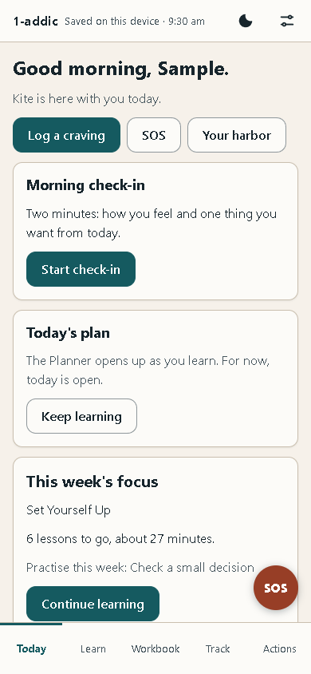
Today with the sample data loaded: a greeting, the Log a craving, SOS and Your harbor buttons, and the Morning check-in card
Sample data is only offered on a fresh notebook. Once you have your own profile, the app will not load the sample over it.

Lesson 2 — Set up
Go through onboarding for real: region, reasons, a Safety Net and the PIN choice.
- Open the file on a fresh notebook. The welcome shows Step 1 of 8 at the top.
- Read the early-access notice and tap Got it, then Next.
- On each step, fill in what you want and tap Next, or tap Skip to leave it for later. You will pick your region (it decides which urgent-help numbers SOS shows), write a few quick reasons, and add a person you could call if you want to.
- When the PIN step comes, choose. A PIN is offered, never forced. You can set one later in Settings (Lesson 14).
- At the end you land on Today. The round SOS button was there the whole time, on every step.
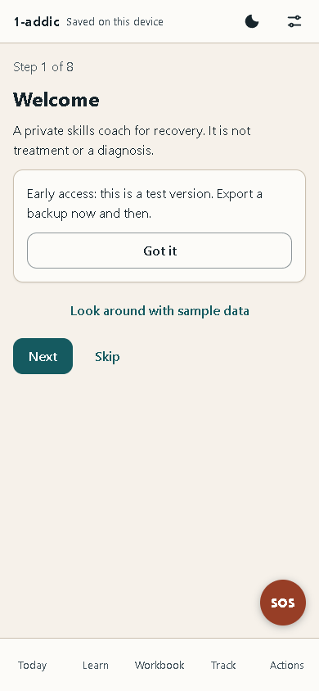
The first onboarding step, Welcome: Step 1 of 8, the early-access notice with Got it, and the Next and Skip buttons

Lesson 3 — SOS: a craving
Use SOS to rate a craving, pick a tool, wait it out and see how it changed.
- Tap the round SOS button, or SOS on Today. The SOS screen opens with Urgent help at the very top.
- Tap I'm craving. A 15-minute timer starts at once.
- Under How strong is it?, tap a number from 0 to 10, or tap Skip.
- Follow the tool it offers, such as Ride the wave. Tap Read aloud to hear it in your device's own voice, and Next to move on. Tools such as Remind me why show your own reasons, and Call someone shows your Safety Nets.
- When the tool ends, you are asked How strong is it now? Tap a number, then choose It passed or Still strong: wait 15 more.
- Whatever you choose, the craving goes in your log, so Insights can learn what helps you.
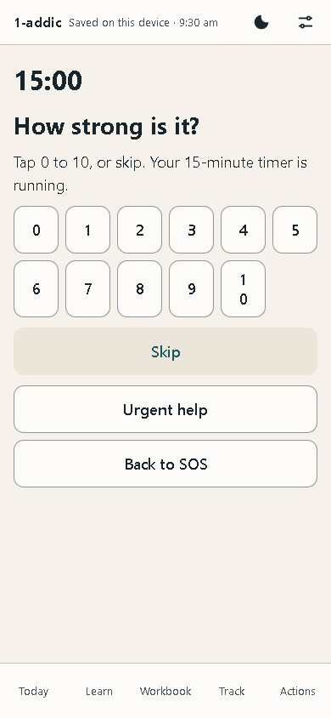
The craving screen: the 15:00 timer, How strong is it? with the numbers 0 to 10, Skip, Urgent help and Back to SOS
To practise before you need it, use the practice run of SOS offered in the Start Here module in Learn. A banner says "Practice drill. Nothing goes in your log", and it does not.

Lesson 4 — SOS: a hard feeling and a slip
Use SOS for a strong feeling, and see what happens (and what does not) after a slip.
- Open SOS and tap A hard feeling.
- Under What are you feeling?, pick the closest one, such as Anxious or stressed or Lonely, and follow the short steps it offers.
- Go back to SOS and tap I slipped. The screen says a slip is not a failure, and that everything you earned stays.
- Tap Log it and go on to note it, or Just reading to leave without logging anything.
- Look at Today and Learn afterwards. Your lessons, Workbook pages, badges and total days are all still there. Only the optional current run starts again.
- Urgent help is on every SOS screen. It shows the numbers for your region, each marked "please verify".
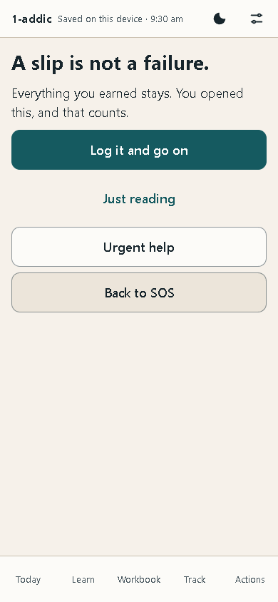
The slip screen: A slip is not a failure, with Log it and go on, Just reading, Urgent help and Back to SOS

Lesson 5 — Quick log and check-in
Log a craving in a few taps and do an evening check-in.
- On Today, tap Log a craving. (On Track, the + Log button offers the same log, and also a feeling, a check-in, an activity or a slip.)
- Move the slider to how strong the craving was, from 0 (none) to 10 (the strongest).
- Under What set it off?, tap any that fit, such as Stress or Loneliness, and tap Save.
- For the evening check-in, open Track, tap + Log, then Check-in, and make sure Evening is picked.
- Set Mood right now, Worry or stress and Strongest craving today, and tap Save.
- Both now show at the top of your log in Track.
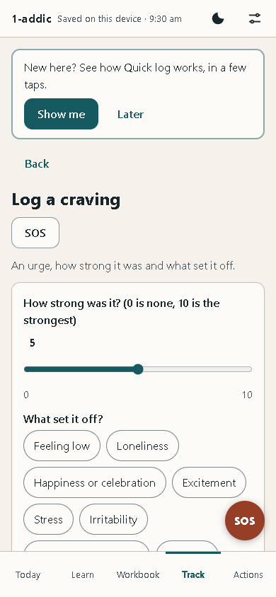
Log a craving: a strength slider from 0 to 10 and the What set it off? choices, such as Feeling low, Loneliness and Stress

Lesson 6 — Learn a module
Take one lesson from start to finish and keep the page it makes.
- Open Learn. The Map shows your journey: eleven stops. Start anywhere; nothing is locked.
- Tap the first stop, Start Here. You see its lessons, how long each takes, and a Checkpoint at the end.
- Tap a lesson. It moves one short card at a time (Step 1 of 8). Tap Listen to hear a card, and Next to go on.
- When a lesson asks you to write, such as Three quick reasons, type in your own words. What you write is kept as a page in your Workbook.
- On the last card, tap Finish lesson.
- Open SOS → I'm craving and use Remind me why: the reasons you just wrote are there.
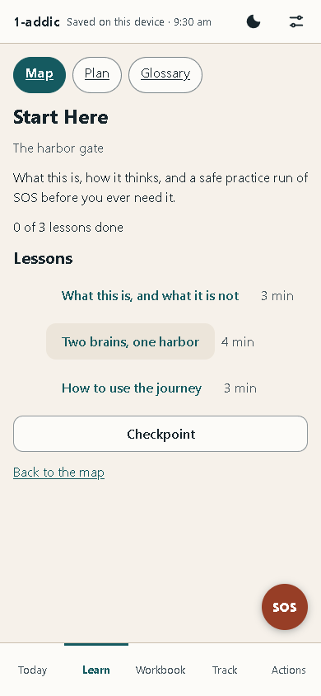
The Start Here module: three lessons with their times, a Checkpoint button and Back to the map

Lesson 7 — The Workbook
Find, edit and print a page you made.
- Open Workbook. My Recovery Plan is at the top, and below it your pages in groups, such as My Why.
- Each page says whether it holds anything yet, for example "Empty for now" or "Nothing saved here yet".
- Tap My Reasons Card. It gathers the reasons from Lesson 6 in one place. Big view shows them large, the way SOS does.
- To change them, open the exercise that made the page (on an empty card, Write my reasons), change or add a line, and save. The change shows in SOS straight away.
- Open any page that holds something, such as Pros and cons, and tap Print to print it or save it as a PDF.
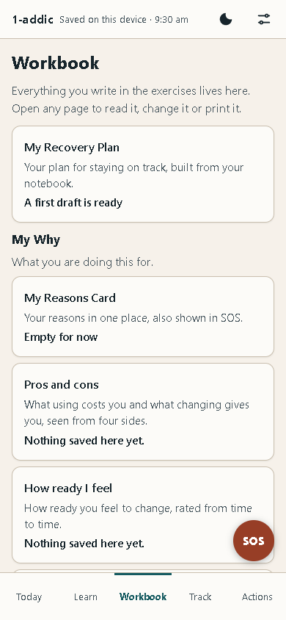
The Workbook: My Recovery Plan at the top, then the My Why group with My Reasons Card, Pros and cons and How ready I feel

Lesson 8 — Track and Insights
Read your logs and the patterns the app finds in them.
- Open Track. Your log lists everything you logged, newest first, grouped by day.
- Each row shows the time, the kind of log and a short summary, such as a mood out of 10.
- Above the log, a line tells you how many logs you have. Insights appear after seven of your own logs.
- Once you have seven, open Insights. You see charts such as Craving strength by week and What set cravings off most.
- Read them lightly. With only a few logs, the app says so under each chart. These are patterns to notice, not rules.
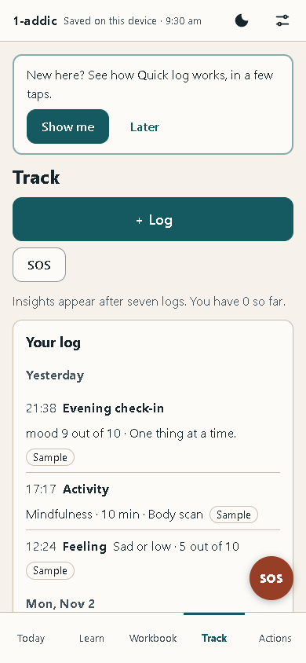
Track: the + Log button, the line about Insights after seven logs, and Your log grouped by day

Lesson 9 — The planner and Battle Plans
Plan a day and attach a Battle Plan to a risky time.
- Open Actions, then Planner. It shows one day; use Previous day and Next day to move.
- Tap Add a block, or Add here next to a stretch of open time, and give the block a name and a time.
- Go back to Actions and open Battle Plans. Tap New Battle Plan.
- Fill in What is the time or place?, What I will do, and any backups (one per line). The other boxes, such as what makes it risky, are optional.
- Tap Save the plan. It shows under Coming up. Tap Change to edit it, or Add to calendar to save a calendar file for that time.
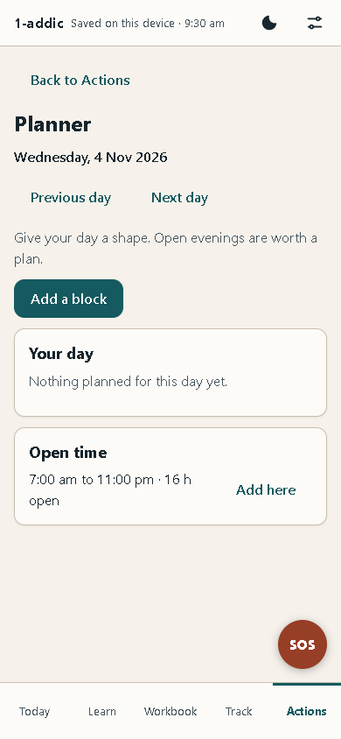
The Planner: a date, Previous day and Next day, Add a block, Your day and a stretch of Open time with Add here
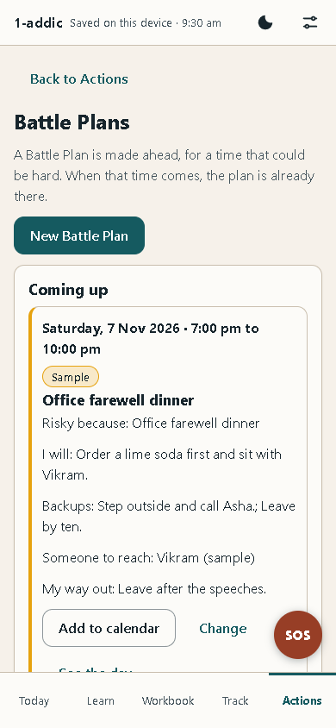
Battle Plans: New Battle Plan, and a sample plan under Coming up with what I will do, backups, someone to reach and a way out

Lesson 10 — The Weekly Review
Look back at the week in five short screens.
- Open Actions, then Weekly Review, and tap Start the review.
- Screen 1, The last seven days: read what the week's log shows. A quiet week is fine.
- Screen 2, The forecast check: see how the times you planned for went. Just notice.
- Screen 3, Where you are now.
- Screen 4, The week ahead: is any time coming up that could be hard? You can make a Battle Plan for it now.
- Screen 5, Want-tos and a focus: up to three things you want to do this week, each with a small reward after. Then finish. Nothing in the review is scored.
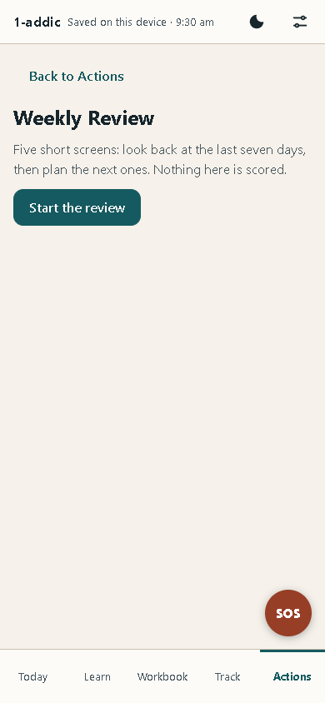
The Weekly Review: five short screens to look back and plan ahead, nothing scored, and the Start the review button

Lesson 11 — My Recovery Plan
See your best skills, signs and people on one page, and print it.
- Open Workbook and tap My Recovery Plan.
- The first time, it is a draft built from your own notebook. Nothing is saved until you tap Save.
- Read each part, such as Why I am doing this and What keeps me well. Use Add a line to add your own, and tick This is still right for me when a part fits.
- Tap Save. Later, Refresh from my data brings in what you have added since.
- Tap Print to keep a copy on paper.
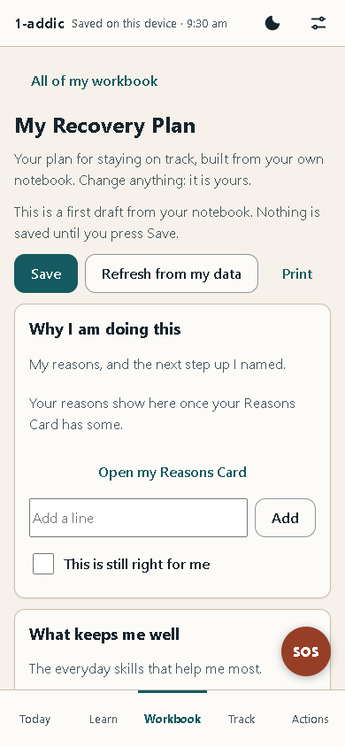
My Recovery Plan: Save, Refresh from my data and Print, then the Why I am doing this part with Add a line

Lesson 12 — Back up and restore
Export a backup, erase the app, and bring everything back from the file.
- Open Settings (the sliders) and tap the Your data tab.
- Under Backup, tap Save a backup file. If you set a PIN, the app asks for it first. Keep the file somewhere private: the file itself is not locked by your PIN.
- To practise a restore, scroll to Erase everything and tap it. Read the question and confirm.
- Under Bring back a backup, tap Choose a backup file and pick the file you saved.
- Confirm Bring back this backup?. Everything on this device is replaced by what is in the file.
- Look around: your logs, pages and plans are all back.
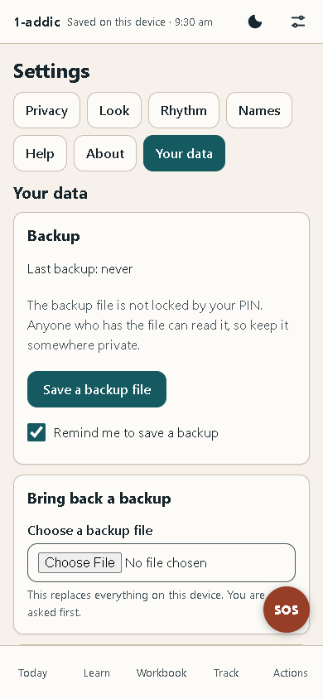
Settings, Your data: the Backup card with Save a backup file and the reminder box, and Bring back a backup with Choose a backup file

Lesson 13 — Use it on a phone
Copy the file to a phone, open it, and move your data across.
- On the computer, save a backup file (Lesson 12).
- Copy 1-addic.html and the backup file to the phone's Download folder, with a cable or in any way you trust.
- On the phone, open Chrome and type file:///sdcard/Download/1-addic.html in the address bar. (Some Files apps can open it directly too.)
- Skip onboarding, open Settings → Your data, and bring back the backup file.
- The same screens now fit the phone: the tabs along the bottom, and SOS in the corner.
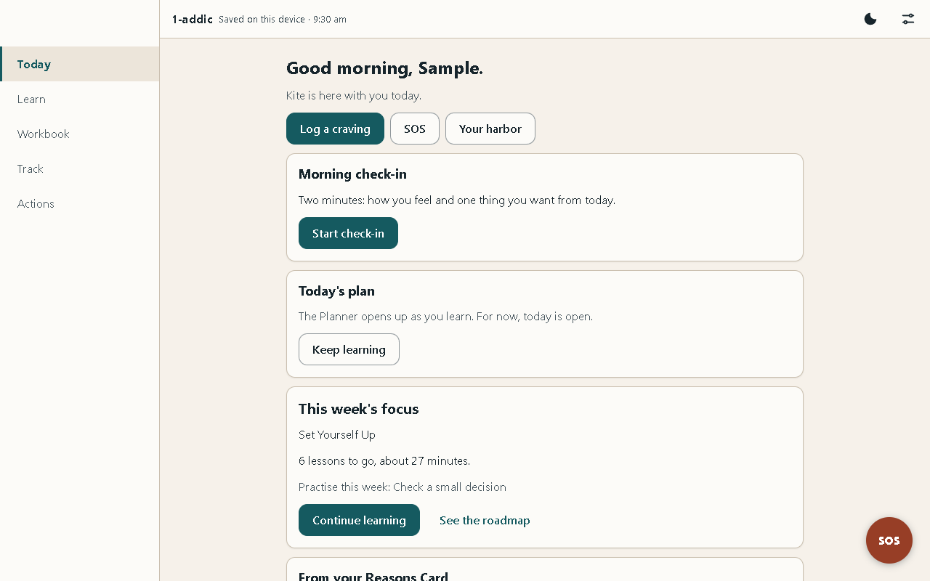
Today on a computer screen
The same Today screen on a phone, 390 pixels wide

Lesson 14 — Lock and discreet mode
Set a PIN, lock the app, and make it look like a plain notebook.
- Open Settings and tap the Privacy tab.
- Tap Set a PIN. Type it under New PIN and again under New PIN again, then tap Set PIN.
- Tap Lock now. The lock screen asks for your PIN. SOS still works here, without the PIN.
- Type your PIN and tap Unlock.
- Back in Privacy, tick Discreet mode. The app now calls itself "Notebook", the SOS button says "Help", and day counters are hidden.
- Lock again to see it: "Notebook" at the top, with Help and Breathe, which both work without the PIN.
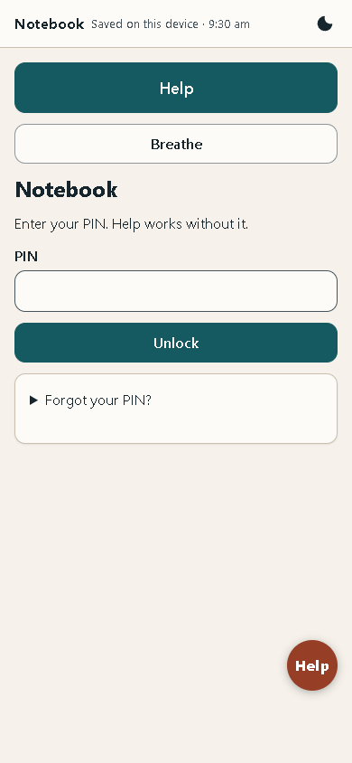
The discreet lock screen: Notebook at the top, Help and Breathe, a PIN box with Unlock, and Forgot your PIN?
A forgotten PIN cannot be recovered. Keep a recent backup (Lesson 12), so that erasing and restoring is always an option.

Lesson 15 — Your Harbor
See where you stand, what changed since you last looked, and one small next step.
- On Today, tap Your harbor, next to Log a craving and SOS. You can also tap the harbor picture on Today. Your Harbor opens. The round SOS button stays in the corner, and the page has its own SOS button at the top.
- What just changed comes first. On your first visit it says "Here is where you stand." After you log something, use a skill or finish a lesson, it lists what grew since your last look.
- The picture shows your harbor. Each place stands for a group of skills: The Lighthouse for thinking clearly, The Cove for calm, The Garden for joy, The Pier for people, and a few more. Below the picture, each place has a button with its level out of 5. Tap one to see its skills and how many more uses take it to the next level.
- Where you stand shows your rank, your XP and your badges. Next small step offers one thing to do next, such as a lesson.
- Your last 14 days marks each day you did something for your recovery with a filled dot. An empty day is just empty: nothing is taken away.
- What to watch lists a few patterns from your own logs that may be worth a look, each with a plan.
A slip never dims a place. Levels only go up, because they count the skills you have used, and that never un-happens. With reduced motion on, on your device or in Settings, the harbor stays still. In Calm mode and in discreet mode the picture is left out, and the list of places still shows.
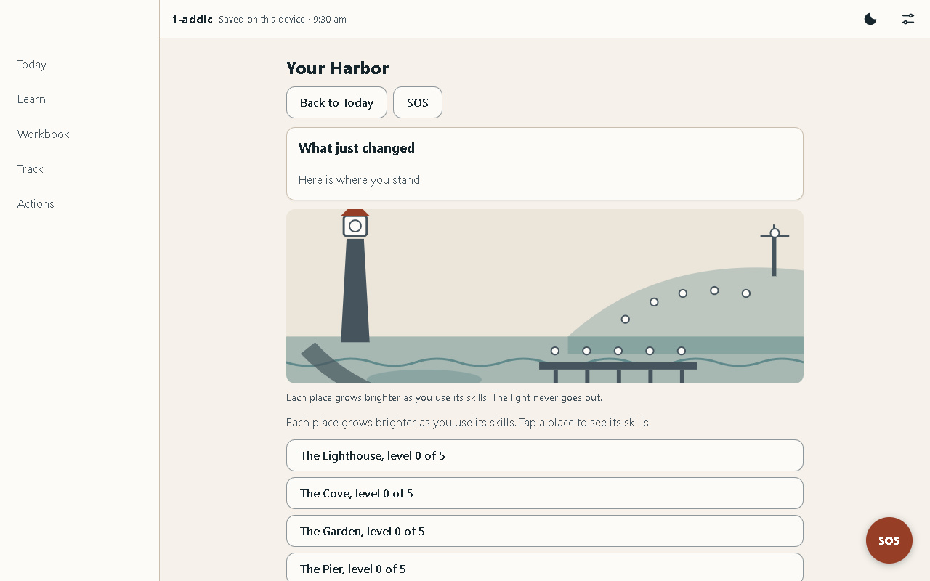
Your Harbor on a computer screen: What just changed, the harbor picture, and the places with their levels
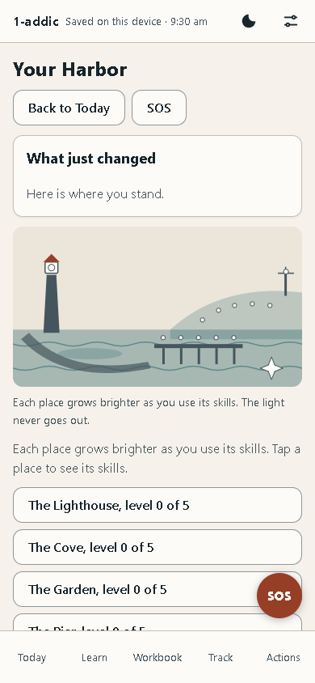
Your Harbor on a phone: Back to Today and SOS at the top, What just changed, the harbor picture, and The Lighthouse, The Cove and The Garden at level 0 of 5

Part 4 — Help

Troubleshooting
What you see | Why | What to do
The top bar says "Not saved — export before closing" | The browser is blocking storage, often in a private window. Your data lives only in memory and is lost when the tab closes | Export a backup now. Then open the file in a normal browser window and import it
The top bar says "Saved (fallback)" | The main storage was not available, so a simpler one is used | Your data is kept, but export backups often and open the file in a normal Chrome window when you can
The Files app will not open the file on a phone | Some Files apps do not hand local pages to the browser | Open Chrome and type file:///sdcard/Download/1-addic.html
My data is gone after opening the file | A different browser, a different folder, a private window, or the browser's data was cleared | Open the file from the same place in the same browser, or import your latest backup (Lesson 12)
I forgot my PIN | The PIN cannot be recovered; that is what keeps your data private | Erase the app and import your latest backup. SOS works the whole time
An urgent-help number does not connect | Numbers change, and each one is marked "please verify" | Call your local emergency number
Load sample data does nothing but show a note | Sample data is only for a fresh notebook, and this one already holds your own profile | Nothing is wrong. Your own entries are kept as they are
A screen says "coming soon" or is locked | That part is not built yet in this version | It will say what it will be. Nothing is broken; the rest works

Known quirks
None of these lose data. They are rough edges to be aware of in this early version.
Quirk | Effect | Status
Some screens are not finished | A screen that is not ready shows "coming soon", a stub with one real action, or a locked card. Never a button that does nothing | Info
One browser, one device | Data does not follow you between browsers or devices on its own. Use export and import | Info
Urgent-help numbers unverified | Every number shows "please verify" until the owner has checked it | Warn
Read-aloud voice | Read-aloud uses your device's own voice, so it sounds different on each phone, and some devices have none | Info
The backup file is not locked | Anyone who has the file can read it, even with a PIN set | Warn

How this guide was checked
The steps in Part 3 were written against the screens of the real file, and every picture was taken from that file by the screenshot script (npm run screens) on 8 November 2026. Two kinds of checks are run on the same file.
- Logic checks (npm test) run the app's engine and data layer directly: nothing derived ever goes down after a slip, an SOS drill writes nothing, a backup restores every record, and a wrong PIN opens nothing. On 8 November 2026, 581 of 582 logic checks passed, in 15 test files. The one that failed checks where the small "New" dots sit on Today; its fix is with the team that builds Today.
- Real-browser checks (npm run test:browser) open the file in Chrome, offline, at phone size, and use the screens by tapping and typing. On 8 November 2026 there were 25 of them, and all 25 passed in one full run, none skipped.
Area | What is checked | Status
Opening | Opens from a plain file with no console errors and no network requests | Pass
Getting around | The five tabs open by link and Back works; no sideways scrolling at phone width | Pass
First run | Onboarding all the way through, and Skip; the guided tour, its Skip, and replaying it from Settings | Pass
SOS | Reachable before onboarding and on the lock screen, never gated | Pass
SOS craving and drill | The craving flow with the timer and both outcomes; a drill saves nothing | Pass
Logging | A quick log and an evening check-in are saved | Pass
Your Harbor | Opens from Today in one tap with SOS still there; shows what changed after a quick log; a slip lowers no place; nothing moves under reduced motion | Pass
Learning | A lesson's page in the Workbook, then shown in SOS | Pass
Privacy | A PIN locks and unlocks; saving a backup asks for it; the discreet lock screen shows "Notebook" and Help | Pass
Settings | A PIN is set and removed from Settings → Privacy; a wrong PIN removes nothing | Pass
Planning | A block added to the Planner is still there after leaving the page | Pass
Backup | Export, erase and import bring back every record | Pass
Looks | The dark theme applies and stays; the print view of the plan; the saved label always shows | Pass
Every row passed in the browser on 8 November 2026, and the logic checks cover the same ground underneath.

The privacy proof
The file carries a Content-Security-Policy that forbids every network request. The browser checks fail if the page makes any request at all, other than to the file itself; on 8 November 2026 the page made none. There are no trackers, no analytics, no ads and no account.
Next steps
A simple routine that keeps 1-addic useful. Every morning and evening: a one-minute check-in. When a craving or a strong feeling comes: a quick log, or SOS if it is hard. Three times a week: one lesson or one Workbook page. Once a week: the Weekly Review, then Settings → Your data → save a backup file, and keep the file somewhere safe. Once a month: read your Reasons Card and My Recovery Plan, and change anything that no longer fits.

Glossary
Term | Definition
Reasons Card | A short list, in your own words, of why you want this change. SOS shows it when a craving hits.
Insights | Patterns the app finds in your own logs, such as the hours when cravings run high. It only shows them once there are enough logs to mean something.
Battle Plans | A short plan for one risky time: what might happen, what you will do instead, and who you can call.
Weekly Review | A five-minute look back at the week, once a week: what went well, what was hard, and what to try next.
My Recovery Plan | One page that pulls together your reasons, the skills that work for you, your warning signs and the people you can call. You can print it.
Harbor | The app's calm picture of your progress: a small harbor whose light grows as you learn and practise. It never dims.
saved label | The words at the top that tell you where your data is: "Saved on this device", "Saved (fallback)" or "Not saved — export before closing".
Safety Net | A person you could call or message when things get hard: a friend, a family member, a sponsor, a counsellor.
Content-Security-Policy | A rule written into the file that tells the browser what the page may load or send. Here it says: nothing from the network, ever.

A short list, in your own words, of why you want this change. SOS shows it when a craving hits.
Patterns the app finds in your own logs, such as the hours when cravings run high. It only shows them once there are enough logs to mean something.
A short plan for one risky time: what might happen, what you will do instead, and who you can call.
A five-minute look back at the week, once a week: what went well, what was hard, and what to try next.
One page that pulls together your reasons, the skills that work for you, your warning signs and the people you can call. You can print it.
The app's calm picture of your progress: a small harbor whose light grows as you learn and practise. It never dims.
The words at the top that tell you where your data is: "Saved on this device", "Saved (fallback)" or "Not saved — export before closing".
A person you could call or message when things get hard: a friend, a family member, a sponsor, a counsellor.
A rule written into the file that tells the browser what the page may load or send. Here it says: nothing from the network, ever.

