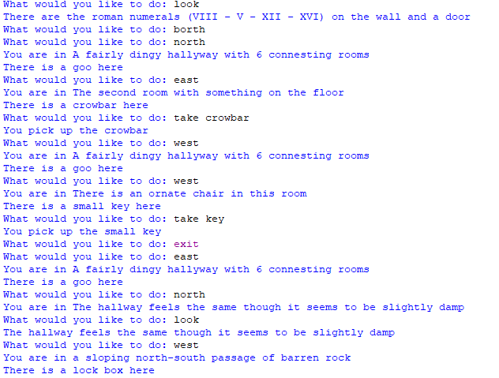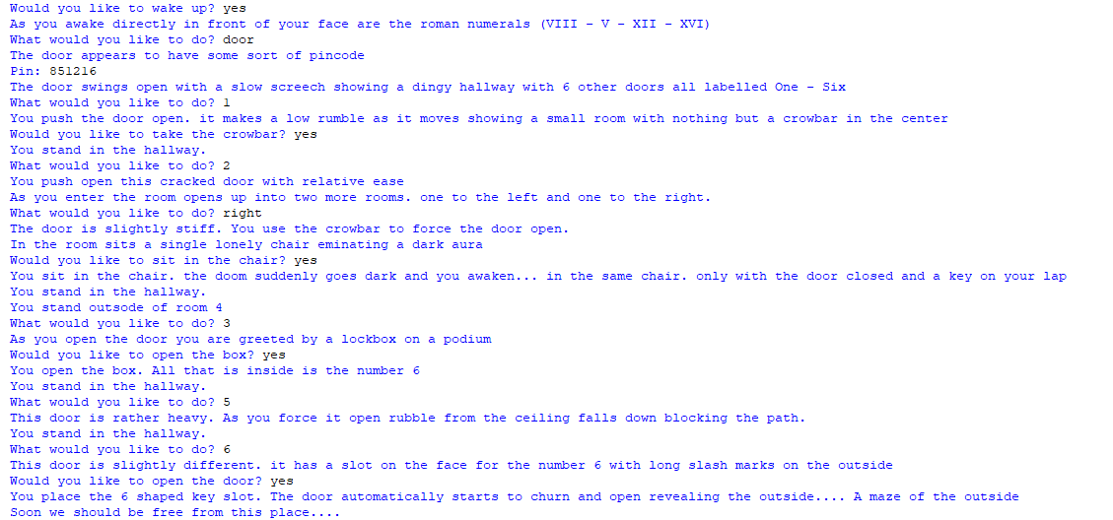This is all the steps I order to complete the game properly. There is an alternate ending in which the player ‘dies’ if they chose left in the second room. However, on receiving feedback for all of this I tried to adapt the system to use streamline approach and instead ended up with an unfinished version with no conditions implemented which will also be uploaded. The game is simple and relies heavily on loops in loops not colliding with each other to function and over all isn’t that stable.

This was a more revised version implementing much better use of classes and overall structure though as seen I struggled implementing conditions for the program to follow making this a large issue as well.