University of Suffolk
By s189994
Programming for mobile
Analysis Report

Introduction
The purpose of this report is to explain the choice of API which I implemented in the project/application, the development process for it, important plugins and libraries implemented as well as the Design (User Experience).

API choice and WHY exactly this one?


“Unlimited Access, without stress, without identification. Deezer Simple API provides a nice set of services to build up web applications allowing the discovery of Deezer's music catalogue” (Developers.deezer.com, n.d.)
The Deezer API was chosen by me because of two reasons:
- The previous year we did website development as we needed to implement Deezer’s API and data.
- I wanted to take the challenge and implement the same API, but on a different platform (application)
Development Process of the Application

- “Khttp” is one of the first libraries that I used in my project code. It is a Mozilla Public License 2.0 licensed library for HTTP requests in Kotlin and it uses only the org.json.json library and native Java.
Code for implementation of Khttp in the build.gradle:

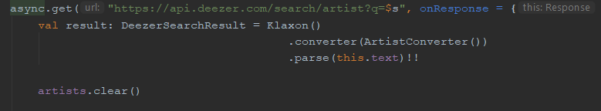
Example code from my application located in the Artist Search Page :

Using the function “async” as well is helping the app to run short operations in sequence, but also it can be done concurrently.

- “Klaxon” is another library, which function is to parse JSON in Kotlin.
Code for implementation:

And importing for being able to use it:
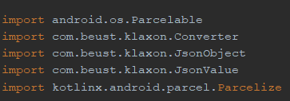

Before implementing the Klaxon parser, I had to make a converter for the data which is going to be sent after the request. For example, for the Artist page converter the code looks like this (from DeezerSearchRezult.kt /models):
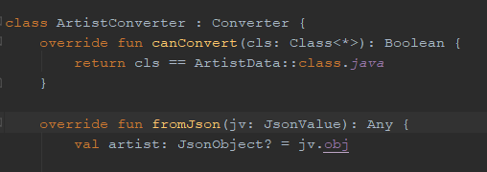

Afterwards I had to declare this converter to the Klaxon object before parsing.
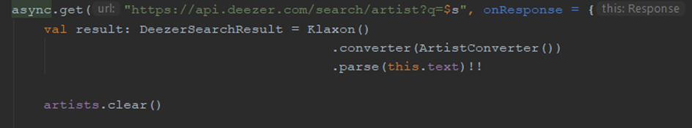

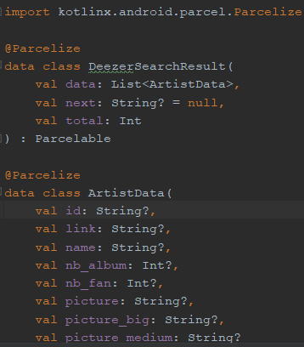
- Next, I used @Parcelize, which made everything easier with all the pulled data from the API of the website. Parcelable is an android extension that supports wide range of types (String, Int for example from my code / models). Before writing whatever code, I had to implement the android extension, which provides your application with different plugins without the need of installing them.

Parcelable is easy to use. Just the press of Alt + K when making a data class (for example: DeezerSearchResult.kt/models) as seen on the code on the right.) It is simple enough to make such a big step on the development of the requested data.

- “Picasso” is also a library, which I used for my application development. It is very useful because it allows for image loading in your application. After implementing it into the build.gradle of the project I imported it in the controllers of the application as I wanted the pictures from the models (added already by Parcelable and converted) to show whenever a request is made.
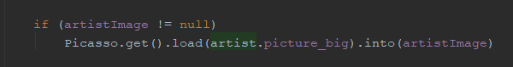
“Picasso” in my application – Example (from ArtistAdapter.kt/adapters) :

- Another important implementation that had to be made is the Android Permission for the internet. I realized that when I didn’t receive any response from the API. The logic is that every API use Internet connection to make a response to a user’s request, which needs this implementation on all costs for the application to work.
Into AndroidManifest.xml I just had to type this:

Some of the Important parts that I had to add in my application are also:
- “Recycler view List” – “To feed all your data to the list, you must extend the RecyclerView.Adapter class. This object creates views for items and replaces the content of some of the views with new data items when the original item is no longer visible.” (Android Developers, 2018).
Example in my code (ArtistAdapter.kt/adapters) :

- “Array list” it is needed because the data that’s going to be requested from the API is like a list – in my case I had to return an empty array list in which the data was going to stand after the user presses or searches.
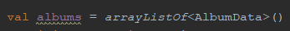

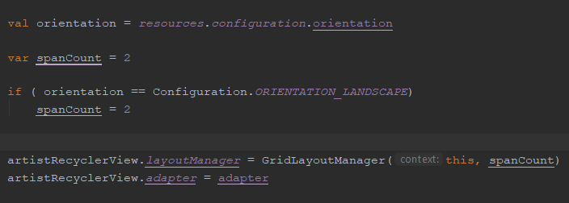
- “Orientation checking” – The idea for this was when an artist is searched in the search box, whatever the orientation of the device is, there should appear data (picture, name) in certain number of columns or rows.

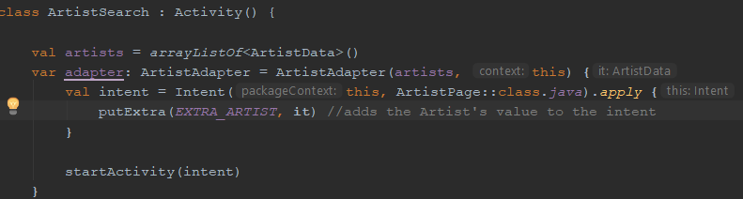
- “Intent” parameter – “...An object that provides runtime binding between separate components, such as two activities” (Android Developers, 2018)
Inside of the Main controller’s code:
As part of it is “EXTRA_MESSAGE” - “This method adds the Data value to the intent. An Intent can carry data types as key-value pairs called extras.” (Android Developers, 2018). In the case of the code I put on the top, it is for ArtistData (from ArtistSearch.kt/controllers).
- Another function I used is “onDataChanged/ TextWatcher”.
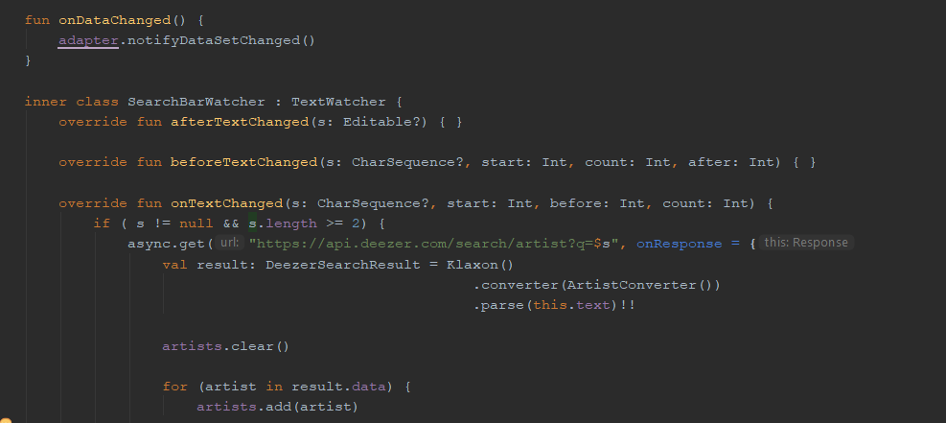
My idea came from Google – whenever you are typing something in the search bar, the result data changes whenever you type a new letter. My code has a condition “onTextChanged”- after the second letter the user types, the result artist data appears according to the letters (the first letters of the names/groups). Whenever the word changes (more letters are added) the result is different and more accurate.

Design and User Interface

The design of the application pages is simple with the idea to be easy for the users to navigate themselves through the application.

- Colours used: Black, white, grey
- Needed layouts for the design of pages:
- Search page – Portrait layout, Landscape Layout, Tablet mode layout (Portrait → Landscape)
- Artist Page - Portrait layout, Landscape Layout, Tablet mode layout (Portrait → Landscape)
- Album Page - Portrait layout, Landscape Layout, Tablet mode layout (Portrait → Landscape)
- Needed layouts for the design of the list-view:
- Search page - Artist_list_item (as portrait, landscape and tablet mode)
- Artist page - Album_list_item (as portrait, landscape and tablet mode)
- Album page -Track_list_item (as portrait, landscape and tablet mode)

- On a Phone
*Red circles == Clickable places

      - ARTIST SEARCH PAGE

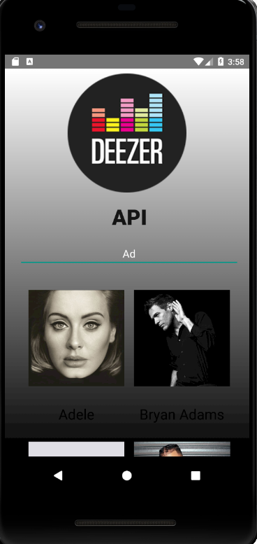
The pictures Fig1 and Fig2 shows the Search page of the application with already shown results. Whenever you write in the text box more than 2 letters, the application sends a request and receives recommendations of Artists which names (or group names) start with those two letters.
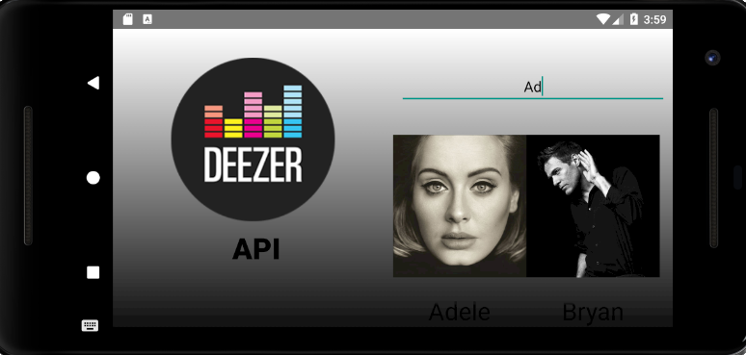
Whenever the text changes (either you add new letters or remove them) the result changes according to the sequence of letters in the search bar.

Fig1
Fig2

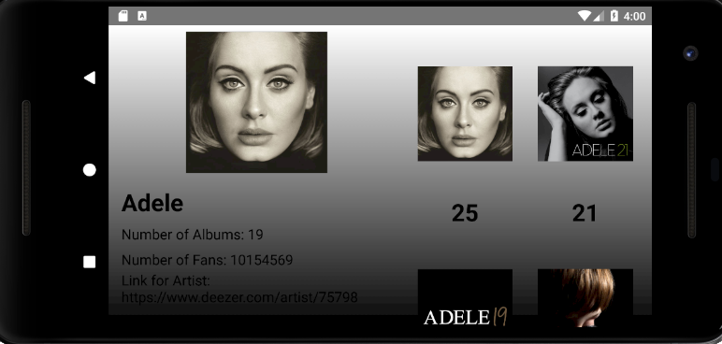
Fig4
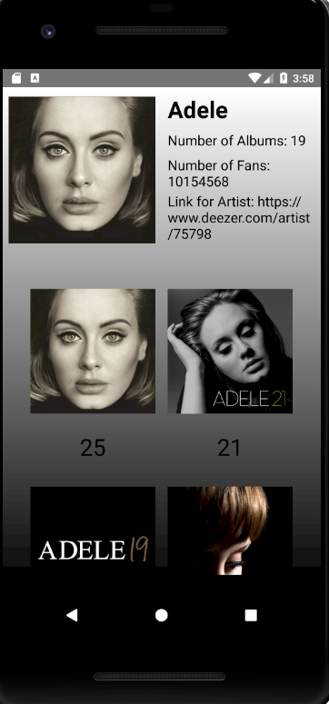
Fig3
      - ARTIST “ALBUMS” PAGE
If for example we press a picture of an artist, or even his/her name, the application puts us on another page – the Artist page. Fig3 and Fig4 show the portrait and landscape mode of this page. We can see that under the name of the artist, there is more pulled information about the artist (number of albums, number of fans and link for the artist). This page presents the albums of the clicked artist. The user can easily scroll the album list (because of the Recycle view).
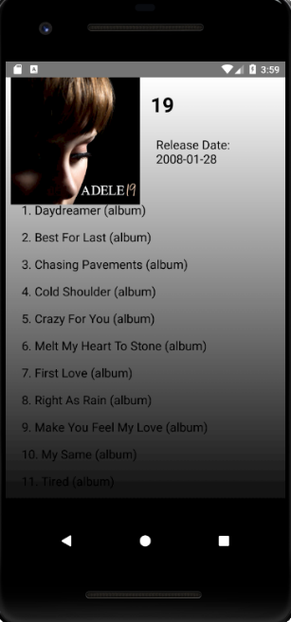
      - ALBUM “TRACKS” PAGE
The next page is the Album page, which is shown on Fig5 and Fig6. The same as the Artist page, is has information about the album release, picture and name of the selected album. The recycler view here has an important role, because if the user wants to find a certain song and the songs are a lot, they must be able to be scrolled up and down.
Fig6
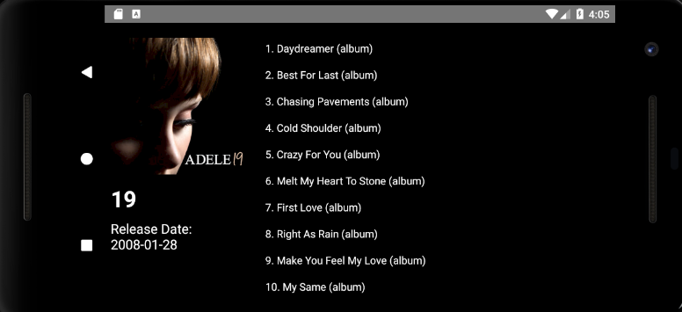

Fig5

- On a Tablet
The same functions and design as the phone mode, but bigger screen!
- Portrait Mode

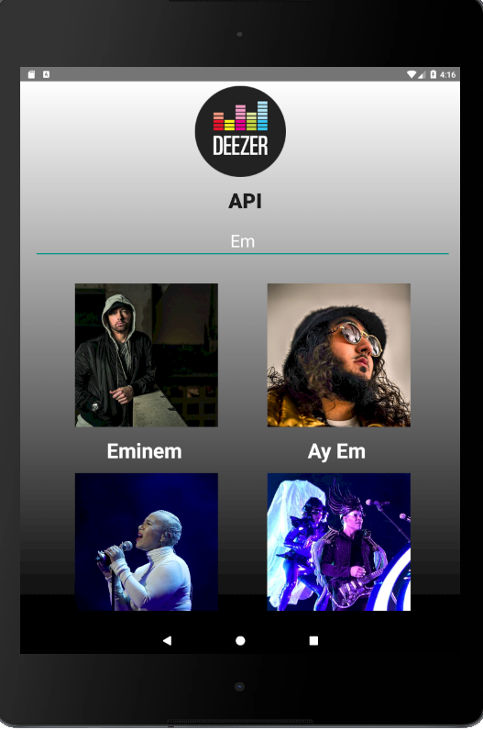
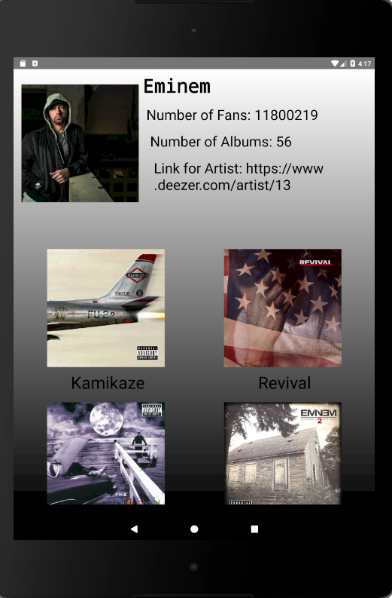
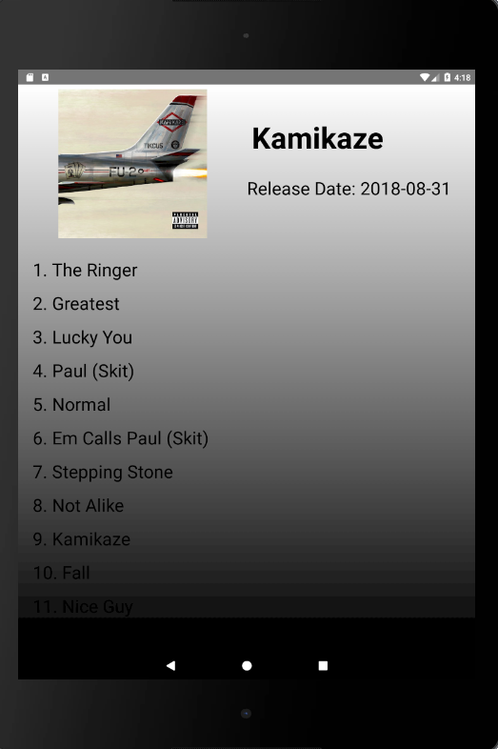

- Landscape mode

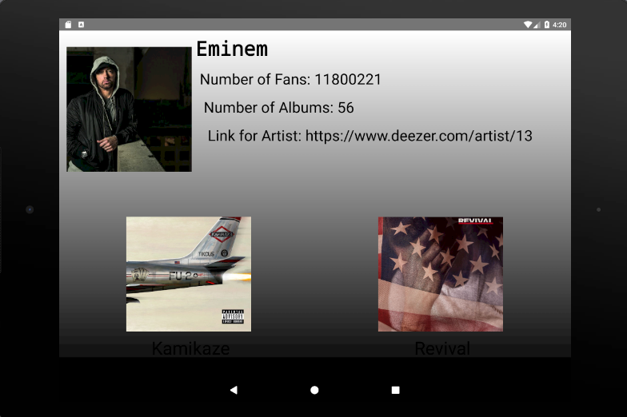
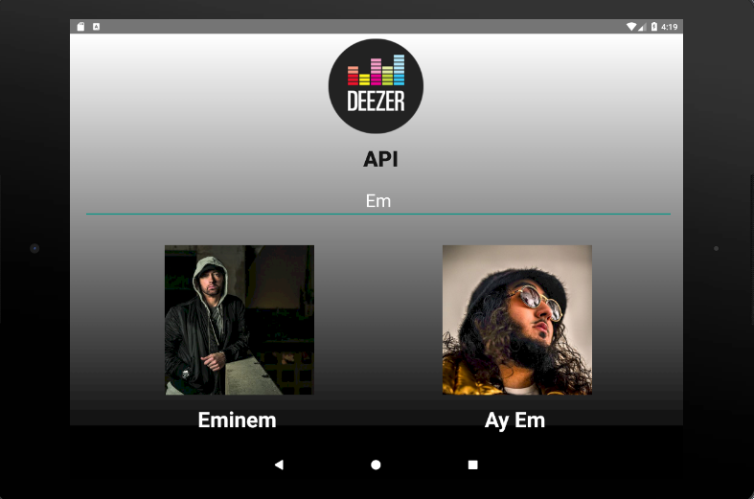

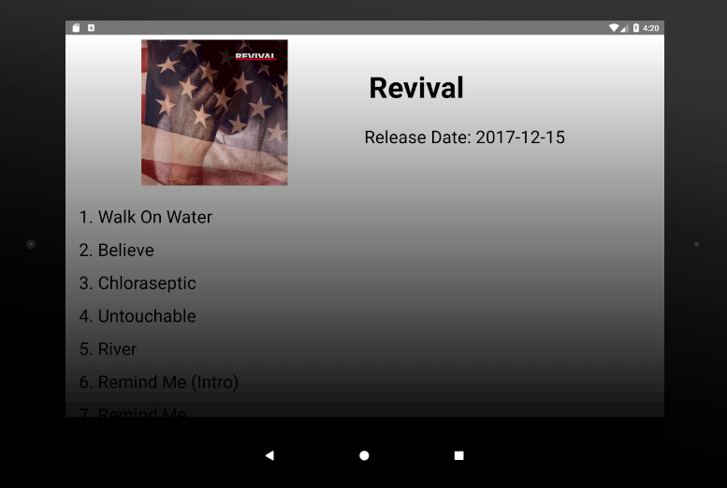

Bibliography
      - Zhulanow, Y. (n.d.). Kotlin Android Extensions. [online] Kotlin. Available at: https://kotlinlang.org/docs/tutorials/android-plugin.html [Accessed 15 Nov. 2018].
      - Clemens, K. (2015). Installation — khttp 1.0.0 documentation. [online] Khttp.readthedocs.io. Available at: https://khttp.readthedocs.io/en/latest/user/install.html#jitpack [Accessed 15 Nov. 2018].
      - jitpack. (n.d.). JitPack | Publish JVM and Android libraries. [online] Available at: https://jitpack.io/#jkcclemens/khttp/master-SNAPSHOT [Accessed 15 Nov. 2018].
      - GitHub. (2017). /khttp. [online] Available at: https://github.com/jkcclemens/khttp [Accessed 15 Nov. 2018].
      - (2018). What permission do I need to access Internet from an Android application?. [online] Stack Overflow. Available at: https://stackoverflow.com/questions/2378607/what-permission-do-i-need-to-access-internet-from-an-android-application [Accessed 15 Nov. 2018].
      - Android Developers. (2018). Create a List with RecyclerView | Android Developers. [online] Available at: https://developer.android.com/guide/topics/ui/layout/recyclerview#kotlin [Accessed 15 Nov. 2018].
      - GitHub. (2018). googlesamples/android-RecyclerView. [online] Available at: https://github.com/googlesamples/android-RecyclerView/ [Accessed 15 Nov. 2018].
      - GitHub. (2018). cbeust/klaxon. [online] Available at: https://github.com/cbeust/klaxon [Accessed 15 Nov. 2018].
      - Stack Overflow. (2017). How to add an item to an ArrayList in Kotlin?. [online] Available at: https://stackoverflow.com/questions/46235579/how-to-add-an-item-to-an-arraylist-in-kotlin?rq=1 [Accessed 15 Nov. 2018].
      - Square.github.io. (n.d.). Picasso. [online] Available at: http://square.github.io/picasso/ [Accessed 15 Nov. 2018].
      - Android Developers. (2018). Start another activity | Android Developers. [online] Available at: https://developer.android.com/training/basics/firstapp/starting-activity [Accessed 15 Nov. 2018].
      - Developers.deezer.com. (n.d.). Deezer for developers. [online] Available at: https://developers.deezer.com/api [Accessed 15 Nov. 2018].

