Vocational school for computer programming and innovation



School project

Theme:

Registration System ​and ​Profile Management

|  |  |
| --- | --- |
| Prepared by:  Ivo Dimov  Georgi Koradov  Aleksander Patrashkov | Consultant:  Petar Georgiev |
| Burgas 2020 | |

**Contents**

1. Theme 3

2. Authors 3

3. Consultant 4

4. Summary 4

4.1. Goals 4

5. Project complexity level 4

5.1. Logical and functional description of the solution 4

5.2. Functions 5

5.2.1. Class Presentation 5

5.2.2. Class Data 6

Table 1 3

Table 2 3

Table 3 5

Table 4 6

Figure 1 4

# Theme

The main idea is to create registration system that can be used everywhere.

# Authors

Our team consist of three members. The contact information and respective roles are descripted in Table 1:

|  |  |
| --- | --- |
| Members | Role |
| Georgi Stoichev Koradov – IX V | Designer, Developer |
| Ivo Miroslavov Dimov - IX A | Manager, Designer |
| Aleksander Kostadinov Patrashkov - IX B | Designer, Developer |

Table

# Consultant

|  |  |
| --- | --- |
| Name: | E-mail: |
| Petar Georgiev |  |

Table

# Summary

## Goals

Our goal is to help our users register easier.

# Project complexity level

We encountered small problems with the code and the organization of the team.

## Logical and functional description of the solution

Here is a block scheme of our project:

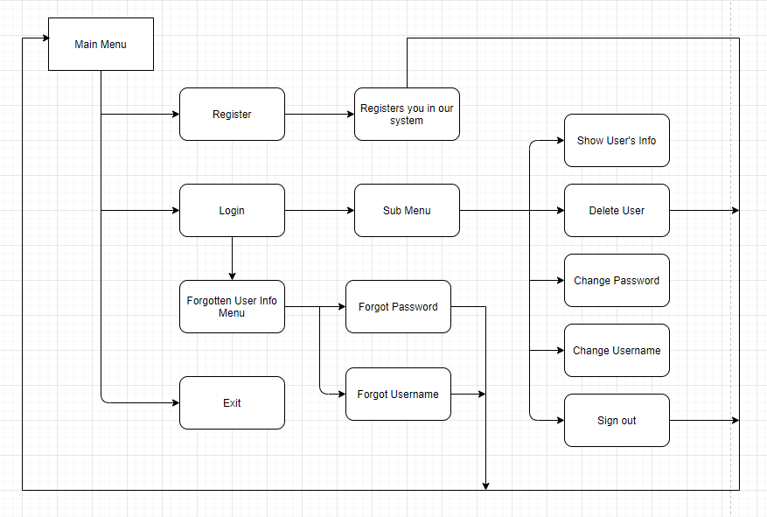

Figure

## Functions

### Class Presentation

|  |  |  |
| --- | --- | --- |
| Name | Parameters | Description |
| forgottenPassword | string username- used to verify the username, int telephoneNumber- used to verify the telephone number, int count- counting variable, PROJECT2* users- pointer to an array of structures | Checks if your username and telephone number are correct and changes the password of the user |
| forgottenUsername | int telephoneNumber- used to verify the telephone number, int count-counting variable, PROJECT2* users -pointer to an array of structures | Checks if your telephone number is correct and changes the username of the user |
| forgottenUserInfoMenu | int& counter-counting variable, PROJECT2* users- pointer to an array of structures | Display 2 option if you have enterred your password/username incorrect 3 times in a row |
| changeUsername | int& counter-counting variable, PROJECT2* users- pointer to an array of structures | You can change your username when you log in your account |
| changePassword | int& counter-counting variable, PROJECT2* users- pointer to an array of structures | You can change your pasword when you log in your account |
| subMenu | int& counter-counting variable, PROJECT2* - users- pointer to an array of structures users, int user-identity, string username- used to verify the username | SubMenu that shows different options |
| registration | int& counter-counting variable, PROJECT2* users- pointer to an array of structures | Creating new user account |
| signIn | int& counter-counting variable, PROJECT2* users- pointer to an array of structures | Login System |
| mainMenu | PROJECT2* users- pointer to an array of structures, int& counter- counting variable | The main menu of the program |

Table

### Class Data

|  |  |  |
| --- | --- | --- |
| Name: | Parameters: | Description: |
| checkForWrongInput | double variable- replaces the variable | Makes you enter a new option until you have entered a correct one |
| checkPassword | string password-  used to verify the password | Checks if your password contains small and big letters |
| getUserIndexById | PROJECT2* users- pointer to an array of structures, int& counter- counting variable, int user- identity | Returns the index of the user |
| findUserByUsername | string username- used to verify the username, int count- counting variable, PROJECT2* users- pointer to an array of structures | Checks if you entered your Username Correctly |
| findUserByPassword | string password- used to verify the password, int count- counting variable, PROJECT2* users- pointer to an array of structures | Checks if you entered your Password Correctly |
| findUserByTelephoneNumber | int telNumber-used to verify the telephone number, int count- counting variable, PROJECT2* users- pointer to an array of structures | Checks if you entered your Telephone Number Correctly |
| usersPasswordToStars | PROJECT2 users- an array of structures | Hides the user's pasword |
| deleteUser | PROJECT2* users- pointer to an array of structures, int& counter- counting variable, int user-identity | Deletes the user's info |
| showUser | PROJECT2 users-an array of structures | Displays the user's info |
| showAllUsers | PROJECT2* users- pointer to an array of structures, int& counter- counting variable, string username- used to verify the username | function for showing all customers with loop |
| checkForforgottenPassword | string username- used to verify the username, int telephoneNumber- used to verify the telephone number, int count- counting variable, PROJECT2* users- pointer to an array of structures | Checks if the username and the telephone number are correct |
| checkForForgottenUsername | int telephoneNumber- used to verify the telephone number, int count-counting variable, PROJECT2* users- pointer to an array of structures | Checks if the telephone number is correct |
| grantAccess | string username- used to verify the username, string password- used to verify the password, int count-counting variable, PROJECT2* users- pointer to an array of structures | Checks if you entered your Username and Password Correctly |

Table