**What is Google Android?**

Android is a mobile operating system (OS) based on the Linux kernel

Android architecture

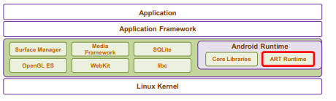

A View : an object that draws something on the screen that the user can interact with

A ViewGroup : an object that holds other View (and ViewGroup) objects

**Linear Layout** - lay child View elements vertically or horizontally

Android:layout_weight = “1”

android:layout_gravity="…" left, center, right, top, bottom

**Relative** **Layout** - lay child elements in positions relative to the parent or siblings elements

Android:layout_alignParentTop, Bottom,Left,Right

Android:layout_centerInParent, Vertical, Horizontal

Android:layout_below, above, toLeftOf toRightOf = “@+id/myButton”

**Frame** **Layout**

**Table** **Layout** - lay child View elements into rows and columns.

**ScrollView**

**Life cycle**