Clinical Case Article Title
Author Name¹, Author Name², Author Name³…
ABSTRACT

The abstract or summary should summarize the case, the problem it addresses, and the message it conveys. Abstracts of case studies are usually very short, preferably not more than 150 words.

A case report is a detailed report of the symptoms, signs, diagnosis, treatment, and follow-up of an individual patient. Case reports usually describe an unusual or novel occurrence and as such, remain one of the cornerstones of medical progress and provide many new ideas in medicine. Some reports contain an extensive review of the relevant literature on the topic. The case report is a rapid short communication between busy clinicians who may not have time or resources to conduct large scale research.

The most common reasons for publishing a case are the following: 1) an unexpected association between diseases or symptoms; 2) an unexpected event in the course observing or treating a patient; 3) findings that shed new light on the possible pathogenesis of a disease or an adverse effect; 4) unique or rare features of a disease; 5) unique therapeutic approaches; variation of anatomical structures.

INTRODUCTION

T
he introduction gives a brief overview of the problem that the case addresses, citing relevant literature where necessary. The introduction generally ends with a single sentence describing the patient and the basic condition that he or she is suffering from..
CASE
This section provides the details of the case in the following order:
- Patient description
- Case history
- Physical examination results
- Results of pathological tests and other investigations
- Treatment plan
- Expected outcome of the treatment plan
- Actual outcome.
The author should ensure that all the relevant details are included and unnecessary ones excluded.
DISCUSSION
This is the most important part of the case report; the part that will convince the journal that the case is publication worthy. This section should start by expanding on what has been said in the introduction, focusing on why the case is noteworthy and the problem that it addresses.

This is followed by a summary of the existing literature on the topic. (If the journal specifies a separate section on literature review, it should be added before the Discussion). This part describes the existing theories and research findings on the key issue in the patient's condition. The review should narrow down to the source of confusion or the main challenge in the case.

Finally, the case report should be connected to the existing literature, mentioning the message that the case conveys. The author should explain whether this corroborates with or detracts from current beliefs about the problem and how this evidence can add value to future clinical practice.
Figures and Tables
Place figure captions above the figures in 8pt regular font. If figure has two parts, include the labels “(A)” and “(B)” as part of the artwork.

Use the abbreviation “Fig.” even at the beginning of a sentence.

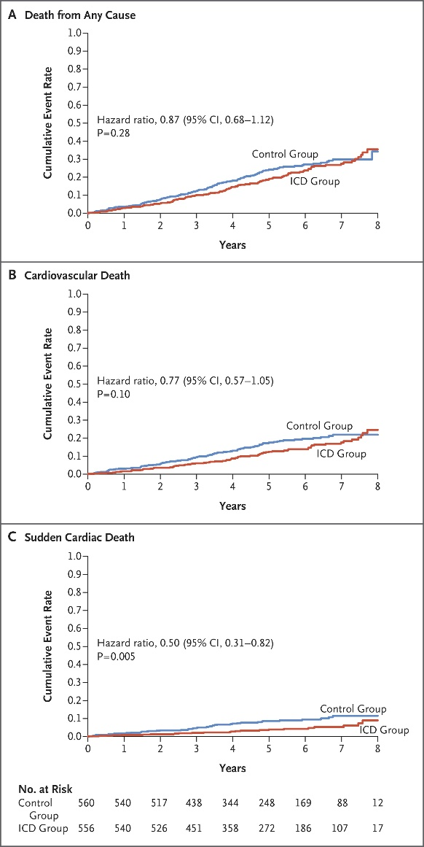

FIGURE 1. Example of the figure caption

Place table titles above the tables in 8pt regular font.

Please verify that the figures and tables you mention in the text actually exist.

If the size of Figure or Table is more than the column size, the same may be adjusted in single column format without disturbing rest of the content.

TABLE 1. Example of table styles

 | Table Column Head
 | Subhead | Subhead | Subhead
1
2
3
4
5
Other recommendations
- SI units are strongly encouraged.
- Use one space after periods and colons;
- Use a zero before decimal points: “0.25,” not “.25.”;
- Use “cm3,” not “cc.”;
- Indicate sample dimensions as “0.1 cm x 0.2 cm,” not “0.1 x 0.2 cm2.”
- Do not mix complete spellings and abbreviations of units: use “kg/m²” or “kilograms per square meter,” not “kilograms/m².”
- When expressing a range of values, write “2 to 7” or “2-7,” not “2~7.”
- A periods and commas must be within quotation marks, like “this period.” Other punctuation must be “outside”!
- Avoid contractions; for example, write “do not” instead of “don’t.”
- The serial comma is preferred: “A, B, and C” instead of “A, B and C.”
CONCLUSION
A case report ends with a conclusion or with summary points, depending on the journal's specified format. This section should briefly give readers the key points covered in the case report. Here, the author can give suggestions and recommendations to clinicians, teachers, or researchers. Some journals do not want a separate section for the conclusion: it can then be the concluding paragraph of the Discussion section.
NOTES ON PATIENT CONSENT
Informed consent in an ethical requirement for most studies involving humans, so before you start writing your case report, take a written consent from the patient as all journals require that you provide it at the time of manuscript submission. In case the patient is a minor, parental consent is required. For adults who are unable to consent to investigation or treatment, consent of closest family members is required.

Patient anonymity is also an important requirement. Remember not to disclose any information that might reveal the identity of the patient. You need to be particularly careful with pictures, and ensure that pictures of the affected area do not reveal the identity of the patient.
AUTHOR AFFILIATION
A "byline" or "affiliation" is an acknowledgment of the organization that has supported you to conduct your research, and should be recorded on the published version of your output.
SUPPLEMENTARY MATERIALS
Supplementary material is relevant material that is additional to the main article. It can be anything from tables to presentations, to video and audio files.

These supplementary materials add another dimension to your article, and help with increasing its online reach and broadening the scope of its impact within your discipline.

Research shows that articles with supplementary material are downloaded and cited more often than those without. By including data and supporting materials to your article, researchers can access your work more easily. Funders are also able to identify clear links to data, making sure you meet your certain funding requirements.
Types of supplementary material
- Infographics - You can summarize your findings and attract readers to your article by including an infographic, alongside your article;
- Tables and charts - Include the full range of data and statistics from your research without over-cluttering your article;
- Video - Engage your audience and deliver the main points of your article across to your audience with multimedia;
- Audio - Consider adding relevant audio files to enhance your readers’ understanding and engagement with your research.
ACKNOWLEDGEMENTS
Mention all people who contributed substantially to the study but cannot be regarded as co-authors, and acknowledge all sources of funding. The recommended form is: “This work; was supported by the Medical Research Council [grant number xxxx]”. If no specific funding was provided, use the following sentence: “This research received no specific grant from any funding agency in the public, commercial, or not-for-profit sectors.” (RIN 2008). If relevant, disclose to the editors any other conflicts of interest, e.g., financial or personal links with the manufacturer or with an organization that has an interest in the submitted manuscript (Goozner et al 2009). If you reproduce previously published materials (e.g., figures), ask the copyright owners for permission and mention them in the captions or in the acknowledgements. If you were helped by a language professional (e.g., author’s editor or translator), a statistician, data collectors, etc., you should acknowledge their assistance for the sake of transparency (ICMJE 2017, Battisti et al 2015). It must be clear that they are not responsible for the final version of the article. You need to ensure you have the consent of all the people named in this section.
REFERENCES
Make sure that you have provided sources for all information extracted from other publications. In the list of references, include all data necessary to find them in a library or in the Internet. For non-English publications, give the original title (transliterated according to English rules if necessary), wherever possible followed by its translation into English in square brackets (CSE 2014). Avoid citing inaccessible, coercive and irrelevant references. Wherever appropriate, cite primary research articles instead of reviews (DORA 2013). Do not include unpublished data in the list of references – if you must mention them, describe their source in the main body of the article, and obtain permission from the producer of the data to cite them.

The American Medical Association (AMA) citation style is strongly encouraged.
AMA in-text citation
Example: As suggested by Nandita,1 carpal tunnel syndrome can also result from …
AMA book citation
Format: Author last name Initials. Book Title: Subtitle. Publisher; Year.
Example:
- Conrad P, Gallagher EB. Health and Health Care in Developing Countries: Sociological Perspectives. Temple University Press; 1993.
AMA journal citation
Format: Author last name Initials. Article title. Journal Name. Year;Volume(Issue):Page range. DOI or URL.
Example:
- Conrad P, Gallagher EB. Health and Health Care in Developing Countries: Sociological Perspectives. Temple University Press; 1993.
AMA website citation
Format: Author last name Initials. Page title. Website Name. Published Month Day, Year. Accessed Month Day, Year. URL.
Example:
- Murphy B. 5 tips to survive first-year anatomy lessons in medical school. American Medical Association. Published August 24, 2022. Accessed September 2, 2022. https://www.ama-assn.org/medical-students/medical-school-life/5-tips-survive-first-year-anatomy-lessons-medical-school.

