Instructions on How to Use GaR[1]

This section gives details of how to run the Growth at Risk (GaR) program from the Excel interface.

1. Overview of the Excel Structure
2. Install the latest available version of Python from the IMF Software Center (if you are at the IMF) or online via anaconda.com.[2] This distribution is under the name Python (Anaconda)

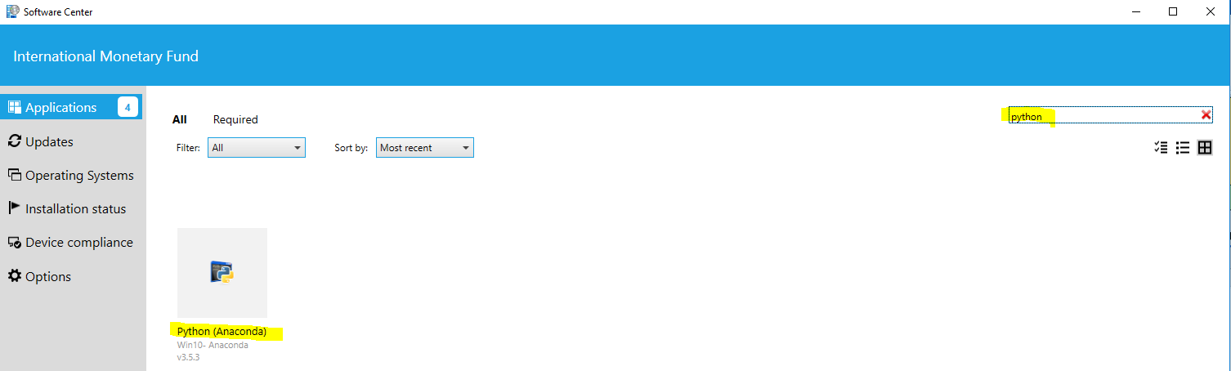

1. Open the Excel file GaR.xlsm
2. Click on “Enable Content” to allow the macros to work.

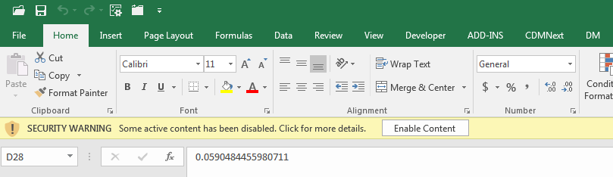

1. Go to the sheet Input_parameters:

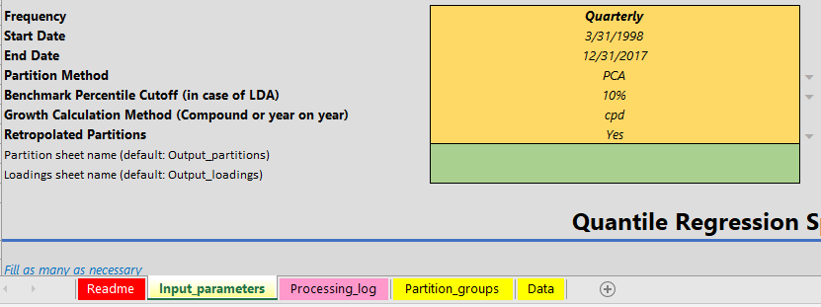

1. There are **5 buttons** from the top:
2. Run the partitions
3. Run quantile reg
4. T-skew fit
5. Scenario Test
6. Historical Distribution

The buttons have to be ran in order from the top.

Before pushing the first button the sheet Data must be filled. Please make sure your current application is Excel, then click on the button once. For each button, please specify the options available in the cells in the same section.

The Excel file must reside in the folder containing the folder GAR. Failure to do this will result in the following popup message when the buttons are pushed:

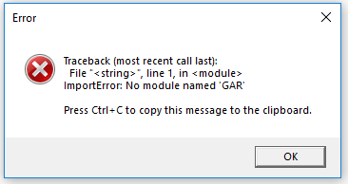

After each step is complete, a popup will show up showing information on the output:

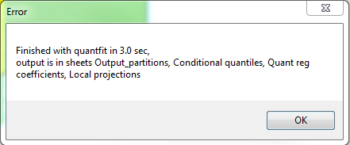

A similar popup will appear if there are any errors.

After pressing each button, the log of the process can be seen in the sheet “Processing_log”. Each button will create new sheets as necessary, with tabs shown in blue.

The next section explains inputting data and details of each button.

1. Data Input

Below are the steps necessary to fill the data before running each button.

1. In the input Excel file, select the sheet Data.
2. In the Data sheet, the data are filled by column for each dataset you want to use, and the 1st row must show the name of each column.
3. The 1st column of the Data sheet must be the dates, with the column name date.

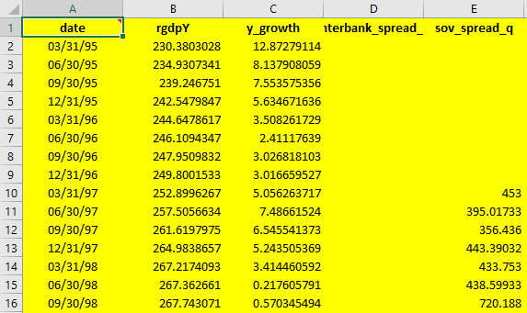

1. All other columns may be filled with numerical data. Leave missing values empty.

Do not fill them with NA, N/A, etc.

When the program runs, the data in this sheet will be read in with the specified start and end dates. **If data is not yet available at the end, the most recent value will be used to forward fill until the end date.** The data filled in this way will be shown in red. **If there are intermediate data points not available, these values will be interpolated using the data nearest to them.** The data filled in this way will be shown in blue.

1. It is necessary that there is one column that contains the forecasted variable in level.

This is used to calculate growth, and in the above is shown as rgdpY in column B. Copy the column name in the 1st row for this column and paste it in the sheet Input_parameters in the cell under **Common Parameters** and next to Real GDP column name:

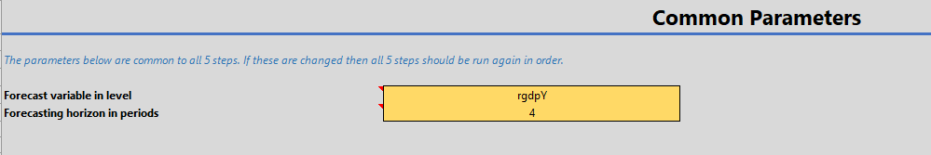

The other parameter for **Common Parameters** is for how many periods ahead to forecast. These parameters will be used for all buttons where applicable.

1. In the sheet Partition_groups, give a name to each partition group you want in the 1st row, and in each column specify the columns names from the 1st row of sheet Data to specify the columns belonging to each group.

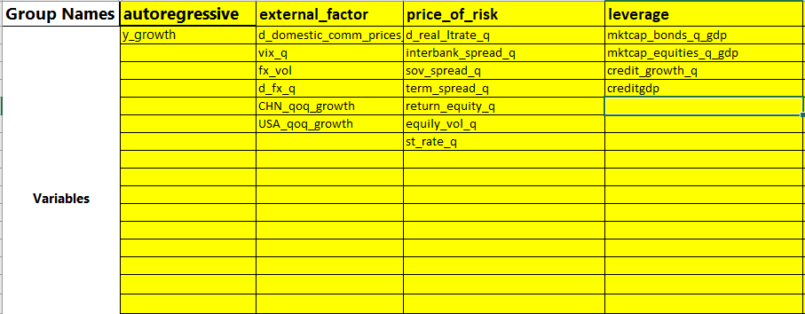

In the above example 4 partitions have been created with names autoregressive, external_factor, price_of_risk, and leverage. For each of these partitions the series names are copied from the first row of the sheet Data.

1. Running the Partitions

The first step will be to run the partitions on the data and the partition groups that we specified in the previous subsection. In the sheet Input_parameters, you should have the 2 cells for **Common Parameters** filled.

1. In the input Excel file, select the sheet Input_parameters.
2. The parameters for the partitions are in the section **Partition Parameters**.

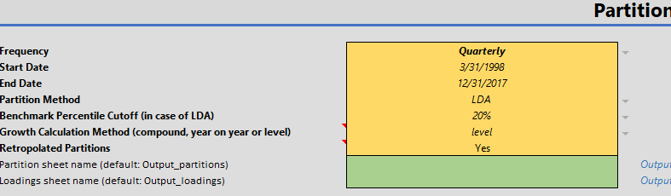

Click on each cell and use the pulldown menu to select the

* Frequency
* Partition Method : PCA or LDA
* Benchmark Percentile Cutoff (if LDA has been chosen for partition method)
* Growth Calculation Method : (cpd stands for compound growth, yoy stands for year-over-year, leve shifts the real GDP values to the past by the specified horizon.
* Retropolated Partitions : Choose Yes to allow Retropolated Partitions (see the technical appendix for details)

The other cells specify the Start Date and End Date, make sure to match these with the values in the date column in the Data sheet.

Optionally, you can specify the output sheet names for the partitions and loadings in the green cells. If these are left empty they will default to “Output_partitions”, and “Output_loadings”, respectively. This is useful if you want to play with the parameters and compare the output sheets.

Once these values have been set, you can press the button

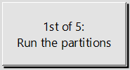

to run the partitions.

Once the button is pressed a popup will show the program is running. When the program is finished, a popup will show that the program is running

(do not try to click on the button multiple times), and when finished, another popup will show up with information on the time it took and the outputs. If the output sheet(s) already exist, they will be overwritten.

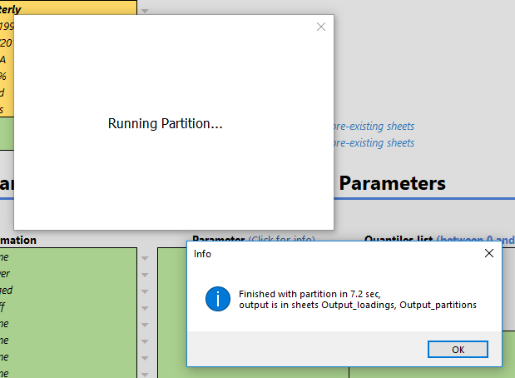

In the output sheets (Output_partitions and Output_loadings if not specified), useful information about the partitions are shown. In the sheet for loadings, the variables, which group they belong to, the loadings in the partition, and beginning date of the partition are shown in the output sheet for partitions, the loadings for each group are shown for each period, along with the transformed GDP growth rate shifted by the specified horizon. An illustrative figure is included for the partitions, and this figure is also saved automatically in .pdf format in a folder called figures with the date that it was created.

The sheet Processing_log will contain information on the latest operation that was run, and can be useful to check whether the operation finished.

1. Running the Quantile Regressions

The second step is to run the quantile regressions. Again, inputs must be filled on the sheet Input_parameters. In column A specify the name of the columns from the Data sheet that should be used as regressors and specify any transformations to these columns as necessary from the pulldown menu next to the column names.

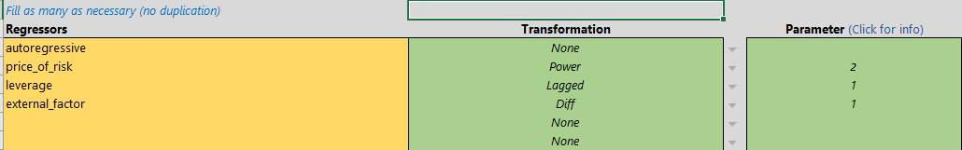

The options are None, Lagged, MVA, Power, Diff, Change Rate (growth rate). For transformations like Lagged which need a value specified for the number of lags, this should be specified in column C as necessary.

Next, in column E specify the quantile values that should be estimated. The first 5 values, 0.10, 0.25, 0.50, 0.75, and 0.90 are fixed and cannot be removed. It is possible to add more quantile values as necessary.

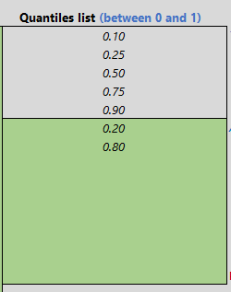

As with the partitions, it is possible to specify the two output sheet names, which is useful when the user wants to compare the output from two different results.

When the button for quantile regressions is pressed, a popup similar to the one for partitions will show, followed by another popup showing that the operation has ended. Again, the sheet Processing_log will contain more details on the operation.

The output will be in two sheets which are by default called “Quant reg coefficients” and “Conditional quantiles”. The sheet for “Quant reg coefficients” will show the quantile fit regression results for each regressor and quantile, along with other associated information. This is also shown as a figure of each quantile coefficient shown against quantile. Similarly to the partition fit, this figure is saved as png format in the folder figures. The “Conditional quantiles” sheet will show information on the conditional quantiles.

1. Running the T-skew Fit

The third step is to run the t-skew fit to the quantile distributions in the previous step. Again, the sheet Input_parameters has a section where necessary parameters can be inputted.

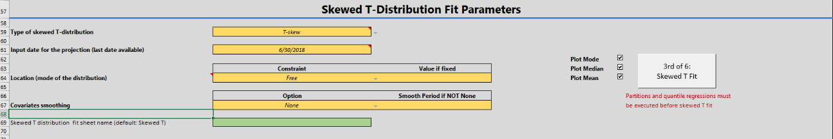

If there are external restrictions on the location of the mode, this can be specified as a fixed value, along with the value in the next cell. If it is to be left to be free choose Free. There are also more advanced options that can be specified for the t-skew fit distribution, but these should be avoided unless the user has a firm understanding of what they are doing.[3]

Once the button for the T-skew Fit is pressed, similar popups to the previous buttons will show the status. The output will be in a sheet named “T-skew_fit” by default and will show information on the fitted t-skew distribution. A figure showing the distribution is created in the sheet and is also saved in the figures folder. To the right of this figure in the sheet, the x and y values of the curve are reproduced for a range of values so that the user can recreate this plot in Excel if desired. Another table further to the right shows information on the quantile values.

The tool also provides the possibility to run the Tskew fit with two different specifications (Laurent and Giot (2003) and Zhu and Galbraith (2010)). Zhu and Galbraith (2010) allows to model separately the right and left kurtosis.

Also, the GaR tool allows the user to smooth the covariates for when projecting the density: instead of projecting, for instance,  based on a given date , the user can decide to use a moving average of over the last year: . This is useful when some particular dates have outliers in it. However, the prefer way should be to run the quantile regression using the moving average as regressors (for instance), as explained in step 2.

1. Running the Historical Distribution

The fourth step is to run the historical distribution. The distribution start and end dates, along with the time period incremental need to be specified. The output will be in the sheet “Historical distribution” by default.

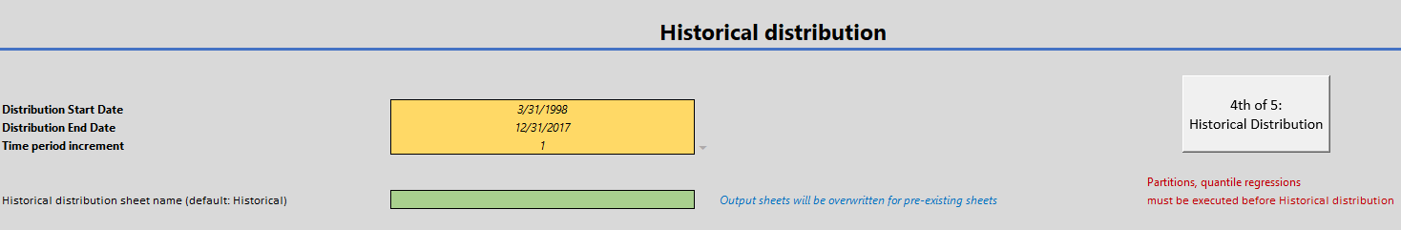

1. Designing scenarios tests (counterfactual scenarios)

The fifth step allows the user to shock variables of interest to design counterfactual scenarios in a ceteris paribus way, by holding other variables constant (this is not a structural shock as in a VAR sense). The variables to shock and how to shock can be specified in the sheet Input_parameters. For each variable to shock, the shock can be expressed in standard deviations or percentages. Also, the location of growth can also be specified with a Fixed (constrained) of Free value (unconstrained). When the button for Scenario Test is pushed the results are written out to the sheet “Scenario Test” by default.

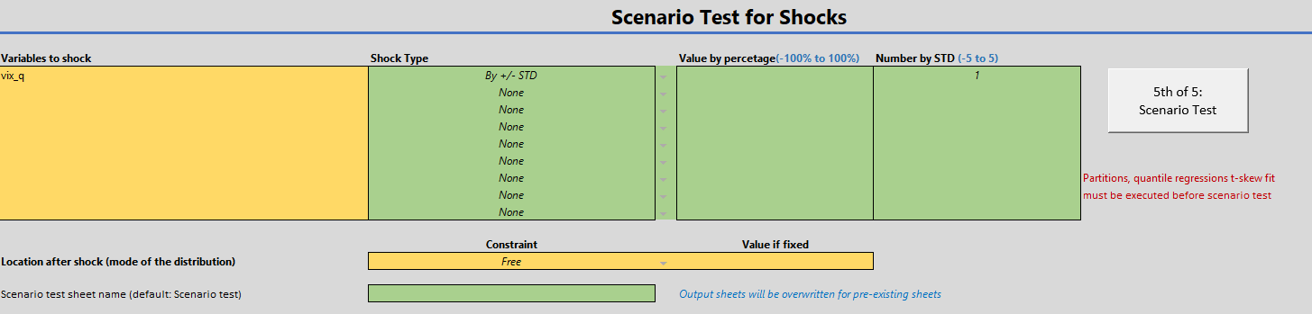

1. Multiple horizons projections

The sixth step allows the user to run the model at different horizons and at different dates, to compare how the densities evolve across time with the covariates. The concept is the same as in step 4. (Tskew fit) and the set of parameters are similar. The output presents the probability densities at different horizons, as well as the cumulative probabilities.

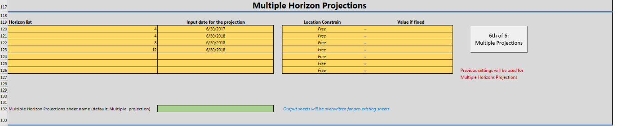

1. This version: February 2019. Drafted by Romain Lafarguette ([rlafarguette@imf.org](mailto:rlafarguette@imf.org)), Kei Moriya ([kmoriya@imf.org](mailto:kmoriya@imf.org)) and Changchun Wang ([cwang2@imf.org](mailto:cwang2@imf.org)). Reuse of this tool and IMF data does not imply any endorsement of the research and/or product. Any research presented should not be reported as representing the views of the IMF, its Executive Board, or member governments.
2. Anaconda (www.anaconda.com) is a free and open-source distribution of Python for scientific programming, containing by default all the packages needed to run the GaR excel tool. The GaR tool can also work with a plain Python distribution, providing that the required packages have been installed (pandas, numpy, scipy, etc.)
3. Basically, the user can parametrized the constraints of the Python optimization algorithm