## **727721eucs031**

**Gokul T**

DAY-9

Task 1

**package** day9;

**import** org.testng.annotations.Test;

**import** org.testng.Assert;

**import** org.testng.annotations.DataProvider;

**public** **class** task1 {

**int** a,b,c;

@Test(dataProvider = "dp",priority=2)

**public** **void** add(Integer a, Integer b) {

c=a+b;

System.***out***.println("Sum = " + c);

Assert.*assertEquals*(c,15);

}

@Test(dataProvider = "dp",priority=4)

**public** **void** sub(Integer a, Integer b) {

c=a-b;

System.***out***.println("Sub = " + c);

Assert.*assertEquals*(c,5);

}

@Test(dataProvider = "dp",priority=3)

**public** **void** mul(Integer a, Integer b) {

c=a*b;

System.***out***.println("Mul = " + c);

Assert.*assertEquals*(c,50);

}

@Test(dataProvider = "dp",priority=1)

**public** **void** div(Integer a, Integer b) {

c=a/b;

System.***out***.println("Div = " + c);

Assert.*assertEquals*(c,2);

}

@DataProvider

**public** Object[][] dp() {

**return** **new** Object[][] {

**new** Object[] { 10, 5 },

};

}

}

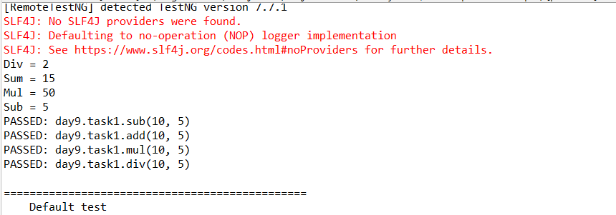

Task 2 and 3

package day9;

import java.util.concurrent.TimeUnit;

import org.openqa.selenium.By;

import org.openqa.selenium.WebDriver;

import org.openqa.selenium.WebElement;

import org.openqa.selenium.chrome.ChromeDriver;

import org.openqa.selenium.chrome.ChromeOptions;

import org.testng.Assert;

import org.testng.annotations.Test;

import io.github.bonigarcia.wdm.WebDriverManager;

public class task2and3 {

@Test

public void test() {

WebDriverManager.chromedriver().setup();

ChromeOptions co=new ChromeOptions();

co.addArguments("--remote-allow-origin=*");

WebDriver driver=new ChromeDriver(co);

driver.get("https://www.godaddy.com/");

driver.manage().window().maximize();

String pagetitle=driver.getTitle();

String expectedtitle="Domain Names, Websites, Hosting & Online Marketing Tools - GoDaddy IN";

Assert.assertEquals(pagetitle, expectedtitle);

String pageurl=driver.getCurrentUrl();

String expectedurl="https://www.godaddy.com/en-in";

Assert.assertEquals(pageurl, expectedurl);

}

@Test(groups= {"b"})

public void test2() throws InterruptedException {

WebDriverManager.chromedriver().setup();

ChromeOptions co=new ChromeOptions();

co.addArguments("--remote-allow-origin=*");

WebDriver driver=new ChromeDriver(co);

driver.get("https://www.godaddy.com/");

driver.manage().window().maximize();

driver.manage().timeouts().implicitlyWait(2000,TimeUnit.MILLISECONDS);

WebElement dom=driver.findElement(By.xpath("//*[@id=\"id-631b049a-e9c0-4d24-8710-c504745206dd\"]/div[2]/div[1]/ul/li[1]"));

dom.click();

Thread.sleep(10000);

WebElement dns=driver.findElement(By.xpath("//*[@id=\"id-631b049a-e9c0-4d24-8710-c504745206dd\"]/div[2]/div[1]/ul/li[1]/div/div[2]/div[1]/ul/li[2]/a"));

dns.click();

}

@Test(groups= {"c"})

public void test3() throws InterruptedException {

WebDriverManager.chromedriver().setup();

ChromeOptions co=new ChromeOptions();

co.addArguments("--remote-allow-origin=*");

WebDriver driver=new ChromeDriver(co);

driver.get("https://www.godaddy.com/");

driver.manage().window().maximize();

driver.manage().timeouts().implicitlyWait(2000,TimeUnit.MILLISECONDS);

WebElement dom=driver.findElement(By.xpath("//*[@id=\"id-631b049a-e9c0-4d24-8710-c504745206dd\"]/div[2]/div[1]/ul/li[1]"));

dom.click();

Thread.sleep(10000);

WebElement dns=driver.findElement(By.xpath("//*[@id=\"id-631b049a-e9c0-4d24-8710-c504745206dd\"]/div[2]/div[1]/ul/li[1]/div/div[2]/div[1]/ul/li[2]/a"));

dns.click();

String title=driver.getTitle();

System.out.print(title);

String exptitle="GoDaddy Domain Search - Buy and Register Available Domain Names";

Assert.assertEquals(title, exptitle);

}

}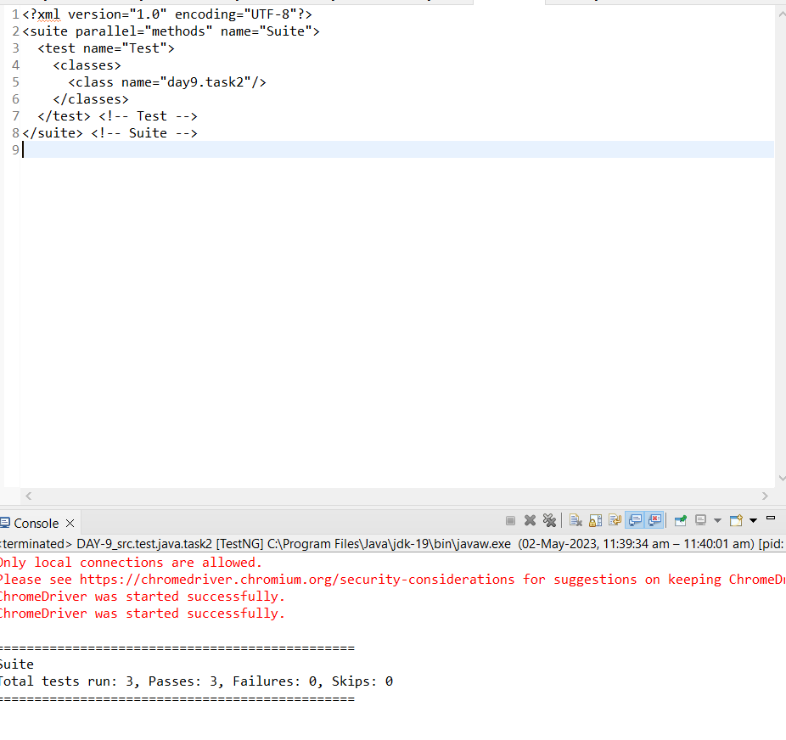

Task 4

package day9;

import org.openqa.selenium.By;

import org.openqa.selenium.WebDriver;

import org.openqa.selenium.WebElement;

import org.openqa.selenium.chrome.ChromeDriver;

import org.openqa.selenium.chrome.ChromeOptions;

import org.testng.annotations.BeforeMethod;

import org.testng.annotations.Parameters;

import org.testng.annotations.Test;

import io.github.bonigarcia.wdm.WebDriverManager;

public class task4 {

WebDriver driver;

@Test

public void f() throws InterruptedException {

Thread.sleep(4000);

WebElement user=driver.findElement(By.xpath("//*[@id=\"app\"]/div[1]/div/div[1]/div/div[2]/div[2]/form/div[1]/div/div[2]/input"));

user.sendKeys("Admin");

WebElement pass=driver.findElement(By.xpath("//*[@id=\"app\"]/div[1]/div/div[1]/div/div[2]/div[2]/form/div[2]/div/div[2]/input"));

pass.sendKeys("admin123");

WebElement sub=driver.findElement(By.xpath("//*[@id=\"app\"]/div[1]/div/div[1]/div/div[2]/div[2]/form/div[3]/button"));

sub.click();

}

@Parameters({"browser"})

@BeforeMethod

public void beforeMethod(String browser1) {

if(browser1.equals("chrome")) {

WebDriverManager.chromedriver().setup();

ChromeOptions co=new ChromeOptions();

co.addArguments("--remote-allow-origin=*");

driver=new ChromeDriver(co);

driver.get("https://opensource-demo.orangehrmlive.com/web/index.php/auth/login");

driver.manage().window().maximize();

}

}

}

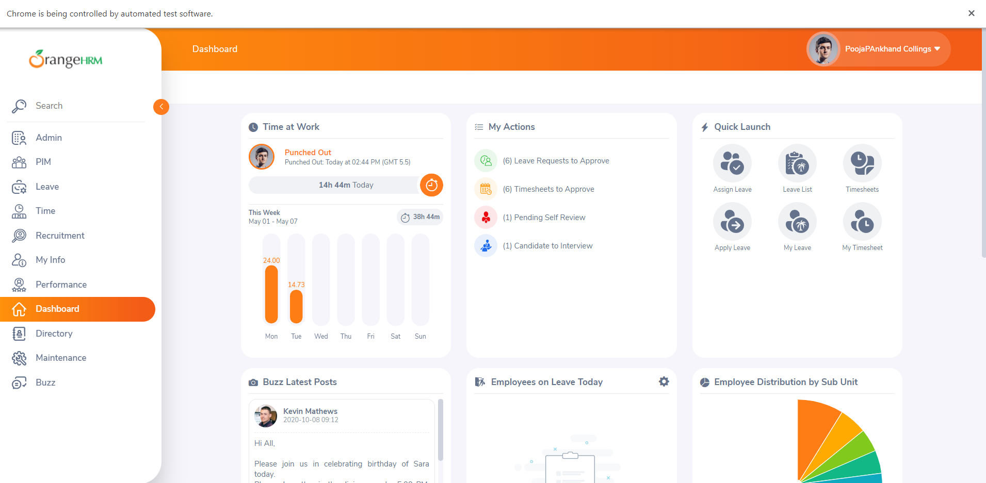

Task 5

package day9;

import org.openqa.selenium.By;

import org.openqa.selenium.WebDriver;

import org.openqa.selenium.WebElement;

import org.openqa.selenium.chrome.ChromeDriver;

import org.openqa.selenium.chrome.ChromeOptions;

import org.testng.annotations.AfterMethod;

import org.testng.annotations.BeforeMethod;

import org.testng.annotations.Test;

import io.github.bonigarcia.wdm.WebDriverManager;

public class task5{

WebDriver driver;

@Test

public void test() throws InterruptedException {

Thread.sleep(4000);

WebElement user=driver.findElement(By.xpath("//*[@id=\"app\"]/div[1]/div/div[1]/div/div[2]/div[2]/form/div[1]/div/div[2]/input"));

user.sendKeys("Admin");

WebElement pass=driver.findElement(By.xpath("//*[@id=\"app\"]/div[1]/div/div[1]/div/div[2]/div[2]/form/div[2]/div/div[2]/input"));

pass.sendKeys("admin123");

WebElement sub=driver.findElement(By.xpath("//*[@id=\"app\"]/div[1]/div/div[1]/div/div[2]/div[2]/form/div[3]/button"));

sub.click();

}

@BeforeMethod

public void beforeMethod() {

WebDriverManager.chromedriver().setup();

ChromeOptions co=new ChromeOptions();

co.addArguments("--remote-allow-origin=*");

driver=new ChromeDriver(co);

driver.get("https://opensource-demo.orangehrmlive.com/web/index.php/auth/login");

driver.manage().window().maximize();

}

@AfterMethod

public void afterMethod() {

driver.close();

}

}

