Exercise: Transformation in HL7 FHIR with Mirth-connect
Before starting the exercise: 15 min
Docker installation, e.g. with Docker Desktop
Mirth-connect installation
For installation instructions, see GitHub: https://github.com/IMISE/MI-Lab-CSV-FHIR-transformation

Task 1: Mirth-connect
- Logging into Mirth-connect
Follow the readme in GitHub, then you can log in to Mirth-connect.
user: admin, password: admin
After logging in for the first time, you will be prompted to reset your user name and password. Follow the instructions.
- Creating channels
Go to Channels and click New Channel under Channel Tasks. Add one channel each for Patient and Encounter.
- Configuring the channels
Edit the channels you added earlier and perform the following steps for each channel:
  - Data Types
Now, under "Summary" → "Channel Properties," set the data types of the source and destination connectors as shown in the image. The drop-down arrow can be used to change the inbound and outbound types.
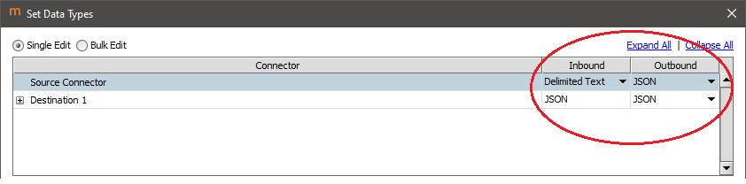
Explanation: The source connector has a CSV (data type: delimited text) as the inbound and the mapped FHIR JSON message as the outbound. The destination has the JSON message as both the inbound and outbound.
  - Source connector
Open the respective channel and click on Source.
- Set the Connector Type to "File Reader."
- Under "Source Settings," change the Process Batch to Yes. This will read all rows of the CSV and not just the header.
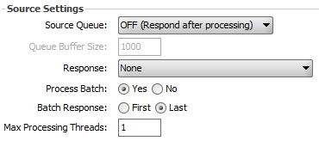
- Under File Reader Settings, change the Directory:
  - Patient Channel: "/opt/connect/appdata/Patient"
  - Encounter Channel: "/opt/connect/appdata/Encounter/"
Explanation: The directory "/opt/connect/appdata/" in the Docker environment is mapped externally to the directory "Setup/mirth-connect/".
- Set the Filename Filter Pattern to "*.csv" so that only CSV files are read.
- Change the After Processing Action to Move and define the following directory for both channels:
"/opt/connect/appdata/Processed/"
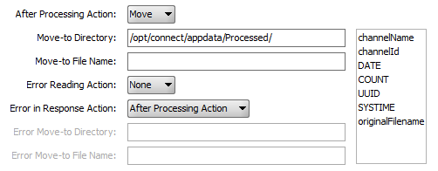
Explanation: This moves the CSV file to a different directory after Mirth-Connect reads it. This prevents the data record from being read multiple times.
  - Destination Connector
In order for Mirth Connect to load the transformed FHIR data to a Hapi FHIR server, you must adjust the destination for the FHIR server.
- Click on Destinations and set the Connector Type to "HTTP Sender."
- In the HTTP Sender Settings:
  - Set the URL to "http://hapi:8080/fhir/".
Note: Since Mirth-Connect and the Hapi FHIR server are in the same Docker network, they can communicate via the name of the Docker container (here: hapi) and the port in the network (here: 8080). See Docker documentation.
  - Change the Content Type to "application/json" so that the data is sent in JSON format.
  - Set the content to "${JsonUtil.prettyPrint(${message.rawData})}" so that the messages are sent formatted as JSON.
Important: These steps must be performed for both channels (Patient, Encounter)!
- Importing transformers
To transform the CSV files to FHIR, a source transformer must be added for the channels.
In each channel, click on the "Source" tab, then "Channel Tasks," then "Edit Transformer." This will take you to the source transformer. Now import any existing transformers that need to be expanded in the next task. To do this, click on "Import Transformer" under "Transformer Tasks." The transformers to be imported are located in the exercise folder under "Material/Transformer/":
MII-Patient Transformer.xml and MII-Encounter Transformer.xml
- Configuration of the transformers
In the following, columns from the CSV data set are mapped to the corresponding FHIR fields in a JSON message template. The JSON template is a template for messages to a FHIR server and was already provided in the imported transformer.
Navigate back to the respective channel to "Source" → "Channel Tasks" → "Edit Transformer."
Add a new step in the Source Transformer under "Transformer Tasks" → "Add new Step." Each Transformer step maps an attribute of the CSV file to a FHIR field. Only two steps need to be added for the patient and encounter transformers. The other steps are already there.

Important: Each new Transformer step must have the type "Message Builder." You can change the type using the drop-down arrow on the right.
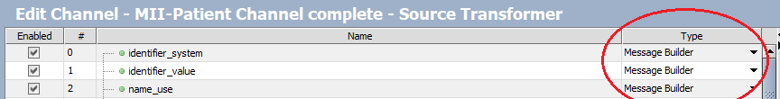
Tip: Click on the "Message Template" tab on the right to view the CSV template (top) and FHIR message template (bottom).
Under the "Message Trees" tab, you can see the templates as a tree structure and use the plus sign to expand them and drag and drop them into the corresponding mapping fields.

- For the Patient Transformer, map the following to FHIR by adding a new step for each:
  - Name_family
  - Gender
- For the Encounter Transformer, map the following to FHIR by adding a new step for each:
  - Record number
Tip: Here, the admission number is in the FHIR message template identifier.value.
  - Reference to subject (patient)
Tip: Since each case references a patient, the reference in the mapping field should begin with:
'Patient?identifier=' + msg['row'][0].... It is important that only 'Patient?identifier=' is written in single quotation marks.
- Deploying the channels and loading the data
Save and deploy the channels. Then copy the corresponding CSV files of the data to be mapped (MIMIC IV Patients.csv and MIMIC IV Case.csv) to the folders created in task 1.3a).
Important: It is important that patients are loaded first, as cases require a reference to existing patients.
Note: By deploying the channels, inputs into the orders monitored by Mirth Connect's "Source Connector" lead directly to POST requests being sent to the FHIR server linked under "Destination Connector." Sent requests and any error messages can be viewed under "View Messages." The successful transmission of data is verified by ClinFHIR in task 2.

Additional information: Emptying FHIR data
If there were errors or the data set was read multiple times, you can empty the data from the FHIR server.
This can be done via the terminal in the "Setup/" folder:
- docker-compose down
- docker volume rm setup_hapi_data
- docker-compose up -d
This will completely reset the HAPI FHIR database, including all patients and encounters.
Important: This also restarts Mirth Connect, so you will need to reopen the launcher and log in again. All saved Mirth Connect data will be retained.

Task 2: ClinFHIR
- Adding local FHIR servers to ClinFHIR
Open ClinFHIR locally in your browser: http://localhost:8000/launcher.html
- Change the data server by clicking on "Edit" under "Current Servers" on the right. Then select "Public HAPI R4 Server" from the drop-down menu next to "Data Server" and confirm with "Save."
Important: Before you can add a new server, you must change the data server from "InterSystems FHIR Server R4" to "Public HAPI R4 Server."
- Now add the Hapi FHIR server that contains your mapped FHIR data. To do this, click on "Add Server" under "Current Servers" and add the Hapi FHIR (Version R4) server:
URL: http://localhost:8090/fhir/
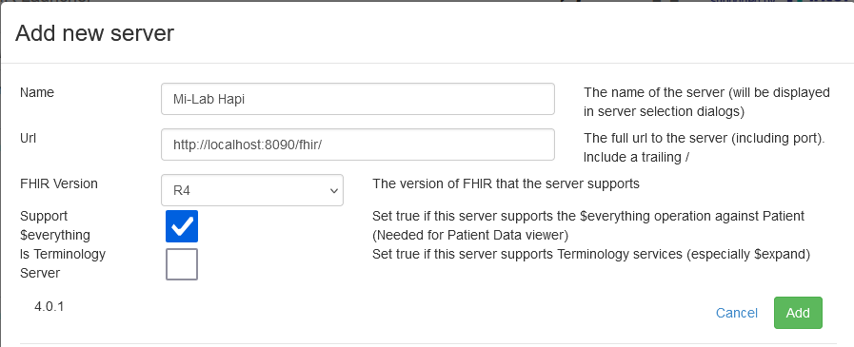
Confirm with "Add" to add the server.
- Now click on "Edit" under "Current Servers" again and select the Hapi server you added from the drop-down menu under "Data Server." You defined the name of the server yourself in the previous task.
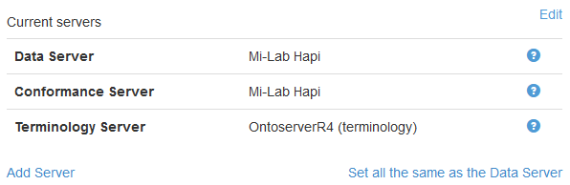

- Patient Viewer
Use "Patient Viewer" to view the added patients and encounters and answer the following questions:
- How old is the patient with ID 58 (Identifier: 10015860)?
- How many cases are there for the patient with ID 2 (identifier: 10003400)?
- Has the patient with ID 2 (identifier: 10003400) already died?
- Server Query
Use 'Server Query' to view the added patients and encounters and answer the following questions:
- How many patients are female?
- How many patients have already died?
- How many cases belong to patients who have already died?

