MI-Lab Ü 2 Walkthrough and further documentation
Preparation: Installation instructions with Docker, see GitHub Readme.

Walkthrough of the transformation of CSV files to FHIR with Mirth-Connect. Each with screenshots and further explanations and test cases.

MI-Lab Ü 2 Walkthrough and further documentation 1
1.2) Channel 2
1.3.1) Source Connector 3
1.3.2) Destination Connector 5
1.3.3) Data Types 6
1.4) Importing transformers 7
1.5) Configuring transformers 9
1.5.1) MII patient 9
a) Name_family 9
b) Gender 10
1.5.2) MII encounter 11
a) Record number 11
b) Reference 11
1.6) Deploying the channels and loading the data 12
2.1) Configuring ChlinFHIR 15
2.2) ChlinFHIR Patient Viewer 15
2.3) ChlinFHIR server query 15

1.2) Channel
Create the channels (on the left under "Channel Tasks"). You can choose any name you like.
Patient Channel: MII patient
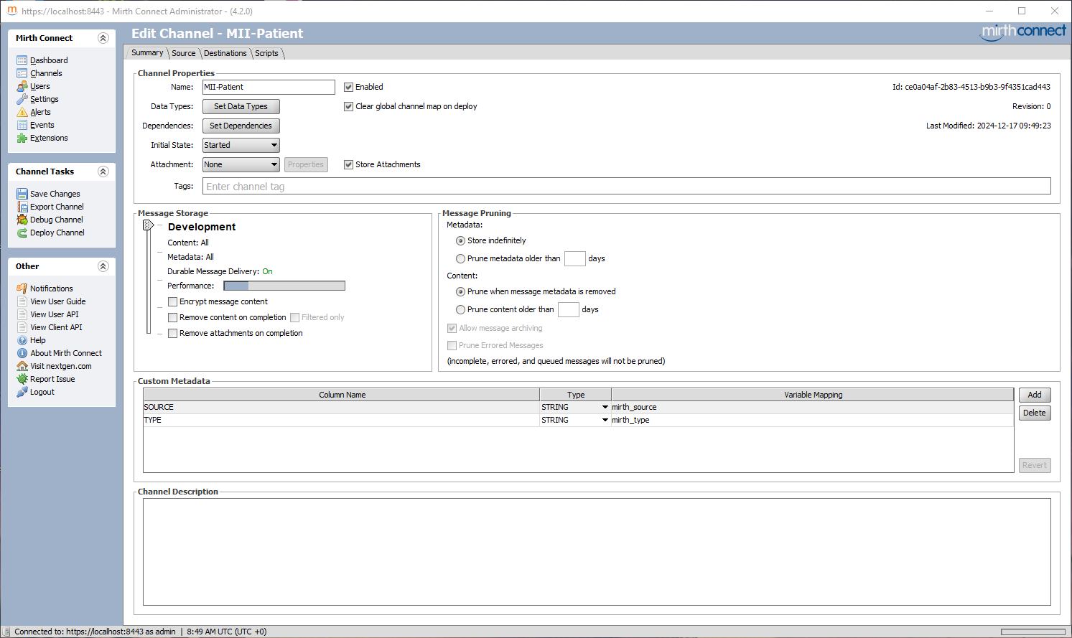
Encounter Channel: MII Encounter
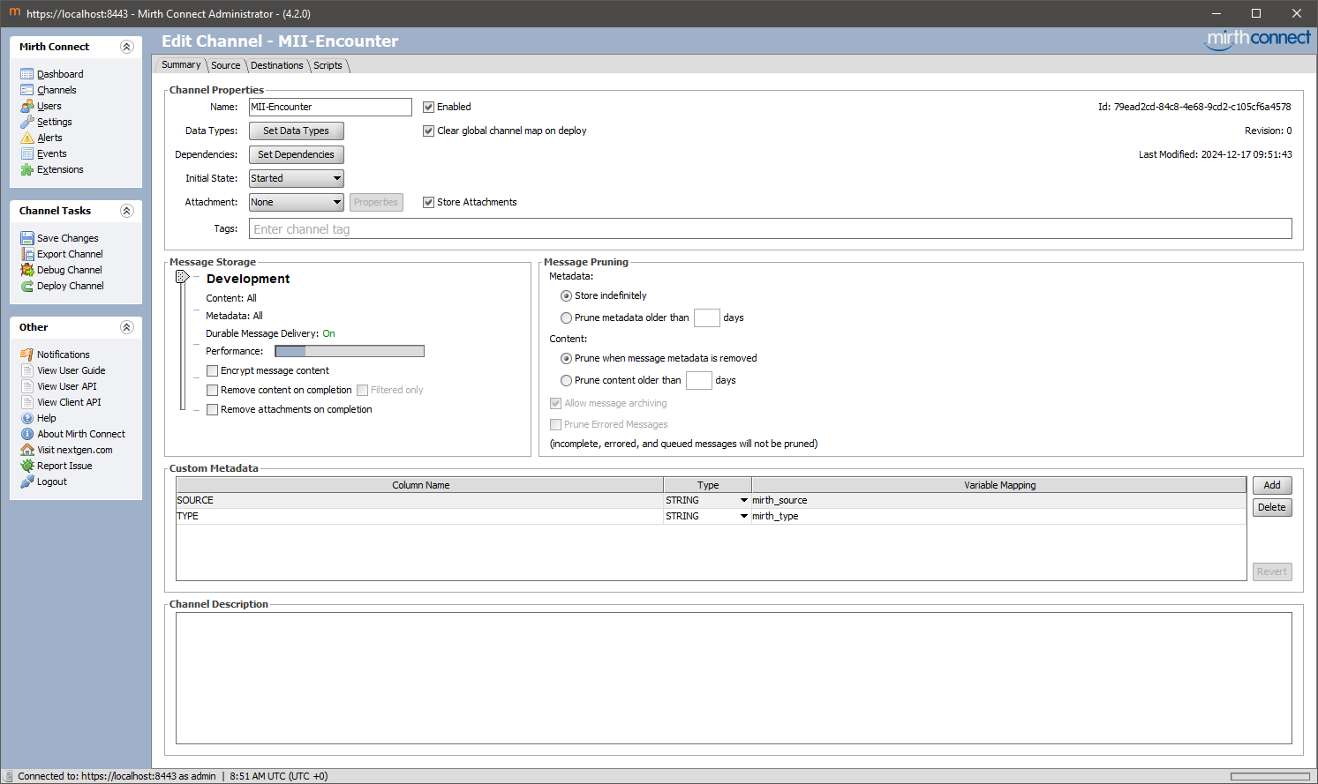
Complete channels for import are available on GitHub at: https://github.com/IMISE/MI-Lab-E02-CSV-to-FHIR/tree/main/MaterialChannels /

1.3.1) Source Connector
Switch to the "Source" tab in the channel. Configure the source connector as follows.
Explanation: The directory "/opt/connect/appdata/" in the Docker environment is mapped externally to the directory "Setup/mirth-connect/". This allows Mirth Connect to read all data and subfolders located in the "Setup/mirth-connect/" folder.
MII-Patient Source Connector:
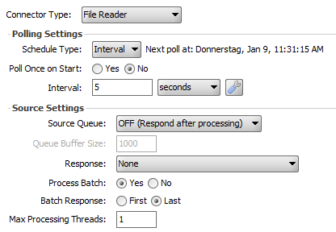
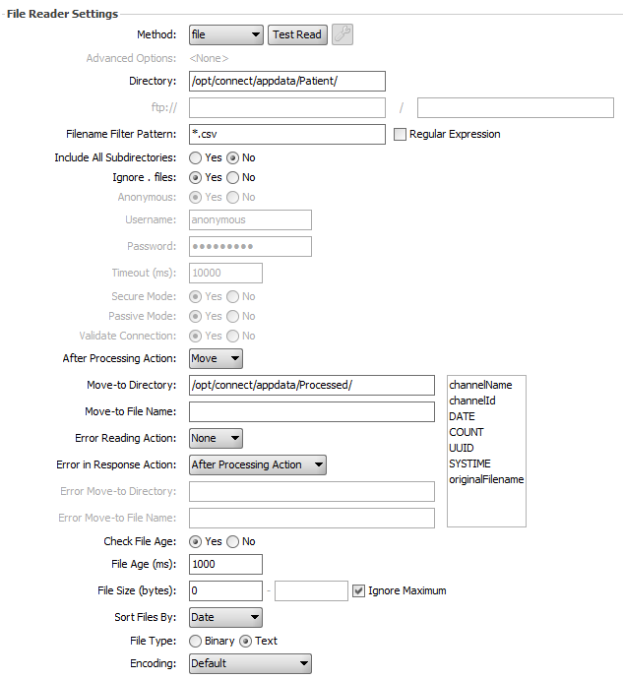
MII-Encounter Source Connector:

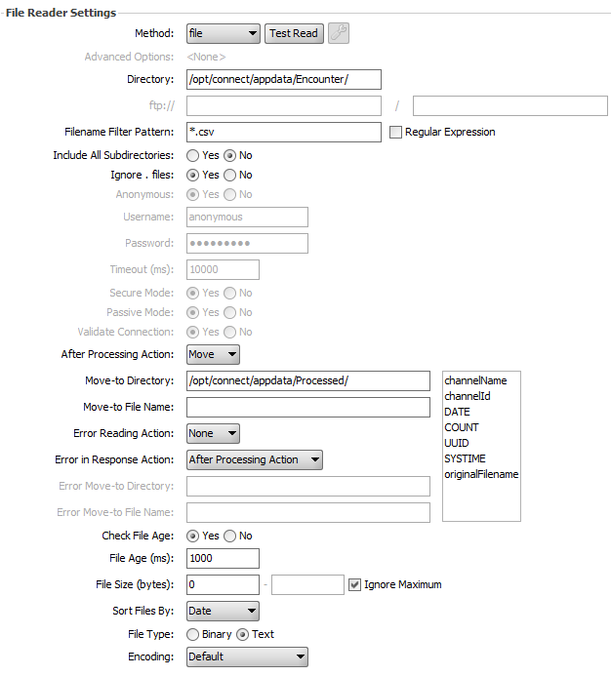

Test: To test whether Mirth-Connect can find the folder, click on "Test Read" under "File Reader Settings" → "Method". If Mirth-Connect can find the folder, the following message will appear: Successfully connected to: /opt/connect/appdata/Patient or Encounter.

1.3.2) Destination Connector
Switch to the "Destinations" tab in the channel:
MII-Patient Destination Connector:
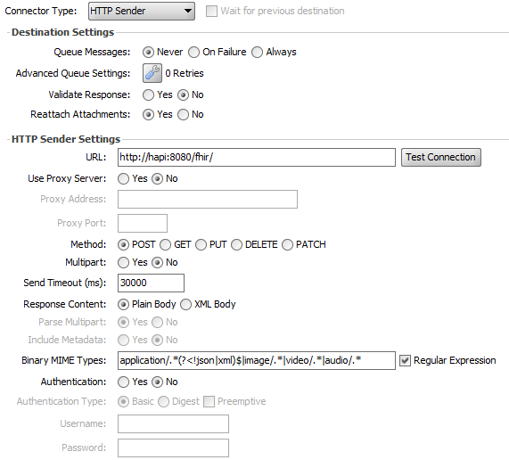
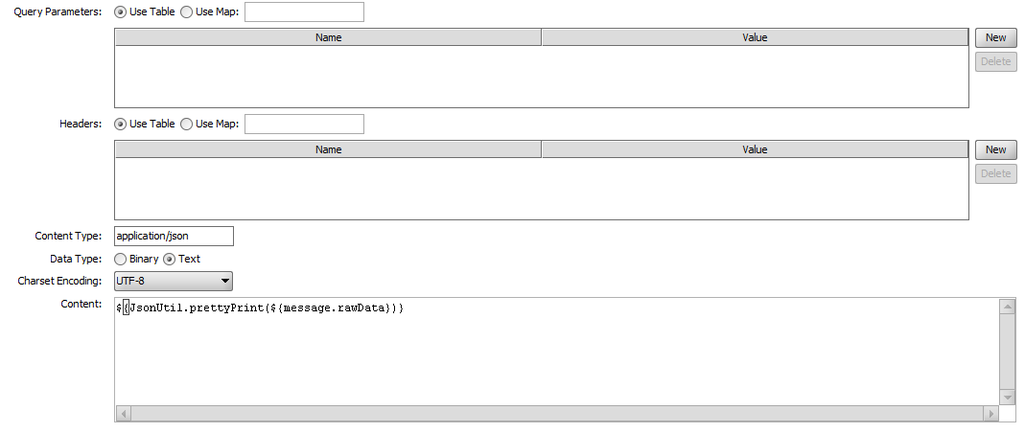
MII-Encounter Destination Connector:
The changes here are the same as in the MII Patient Destination Connector. Therefore, there are no images here.

Explanation URL: The URL of the Hapi FHIR server is specified here as "http://hapi:8080/fhir". Since Mirth-Connect and the Hapi FHIR server are located in the same Docker Compose network, they can communicate via the container name and the internal ports. If you want to access the FHIR server via the browser/curl, you must use "http://localhost:8090/fhir" because this happens outside the Docker Compose network and therefore the ports that are open to the outside must be used. For further explanations, see the Docker documentation: https://docs.docker.com/compose/how-tos/networking/

Test: Click "Test Connection" to test whether Mirth-Connect can connect to the Hapi FHIR server. The following should be returned:
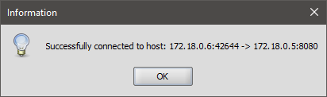

1.3.3) Data Types
Switch to the "Summary" tab in the channel.
Under "Set Data Types," set the inbound and outbound as follows:
MII Patient:
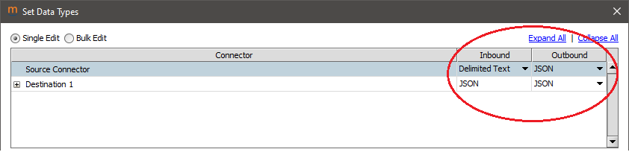
MII Encounter:
The changes here are the same as for MII Patient. Therefore, there are no images here.

1.4) Importing transformers
Switch to the "Source" tab in the channel.
Import transformers
Click on "Channel Tasks" > "Edit Transformer."
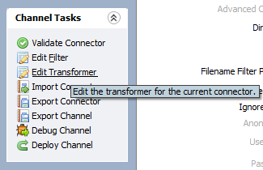
Import the respective transformer under "Transformer Tasks" → "Import Transformer":
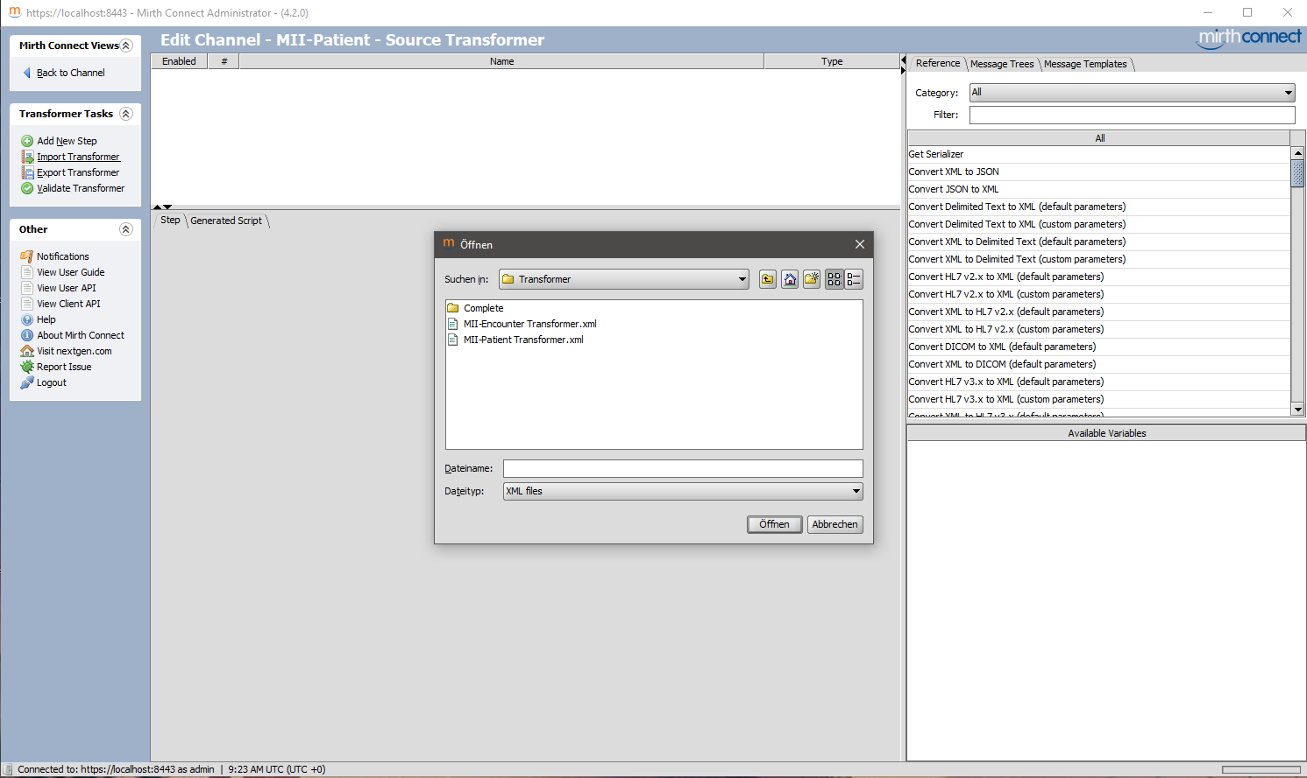
MII patient transformer:
Transformer imported successfully. Here, the "Message Template" tab was selected on the right:
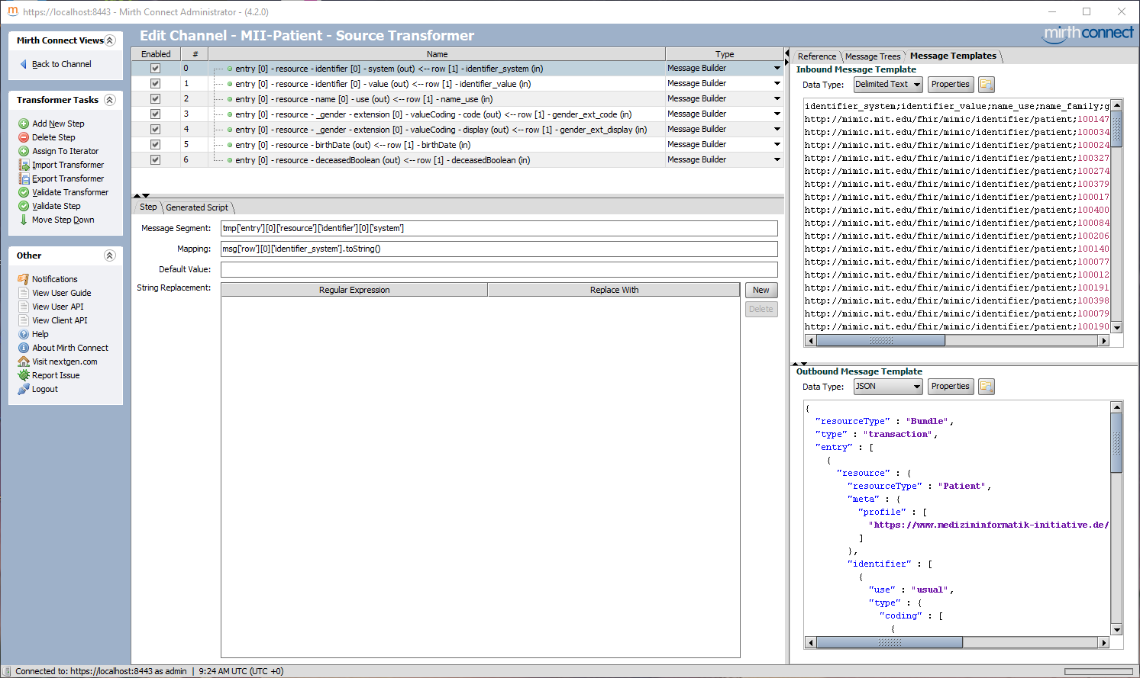

MII Encounter Transformer:
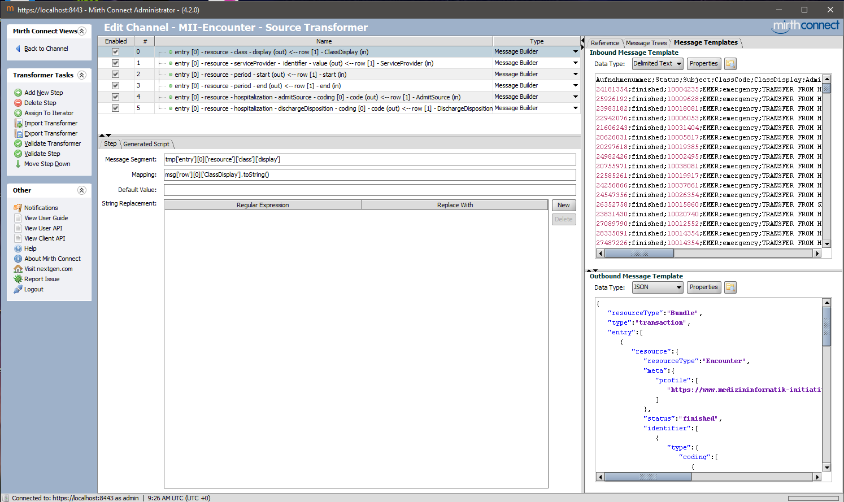
Important: If the templates are not displayed on the right as shown in the respective second screenshots, click on the "Message Template" tab in the upper right corner.

1.5) Configuring the transformers
This is where the actual mapping step for the transformation from CSV to FHIR takes place. The previously imported transformers consist of several steps. Each step is equivalent to an attribute to be mapped. In the task, two mapping steps must be added to the other existing steps. So, two steps for "MII Patient Transformer" and two steps for "MII Encounter Transformer."
Important: After adding a new step, the type to the right of "Mapper" must be changed to "Message Builder"!
Message Builder - Replaces attribute from outbound FHIR template with attribute from inbound CSV data record.
Mapper - Maps attribute from a message to a variable in Mirth-Connect. This is not intended in this exercise.
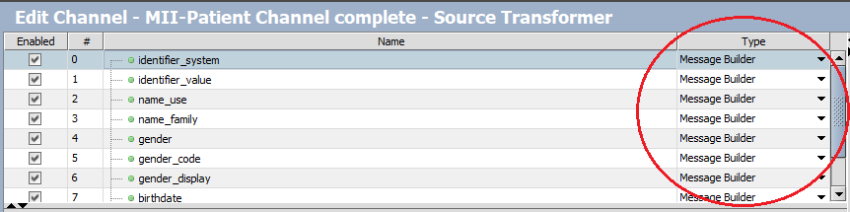

1.5.1) MII patient

Name_family
Under "Transformer Tasks," click "Add New Step":
Change the type to "Message Builder"!

Tip: If you select the "Message Trees" tab on the right, you can drag and drop the respective segments into the fields. Only fields with a green dot can be selected. Here for "name_family":
(top) (bottom)
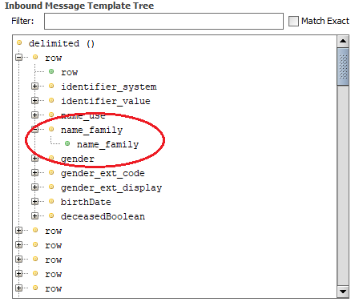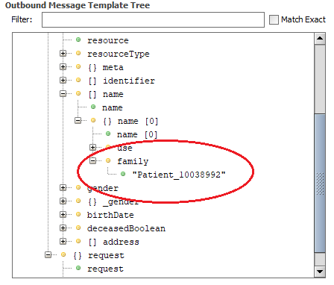
Drag the "name_family" field from the Inbound Message Template Tree (left image) in the Transformer Step into the "Mapping" field:
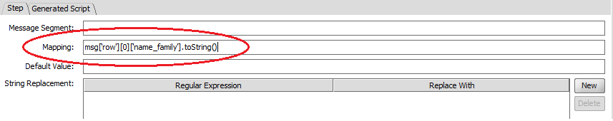
Now drag the field "Patient_100389992" under name-&gt;family in the Outbound Message Template (image on the right) in the Transformer Step into the "Message Segment" field:
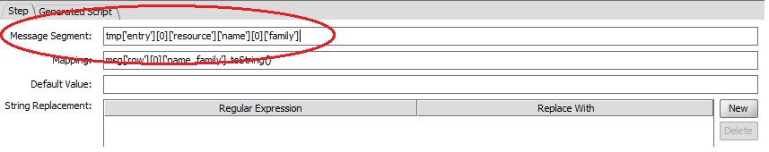
The finished Transformer step for the attribute name_family of the patient now looks like this:
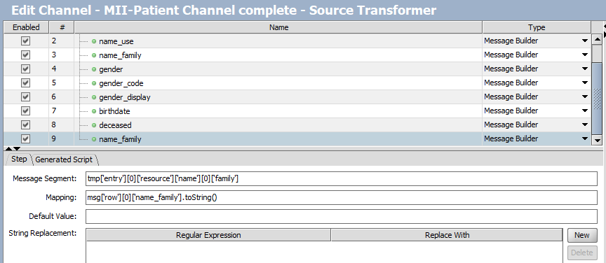

Gender
The complete Transformer step for the attribute gender of the patient will then look as follows:
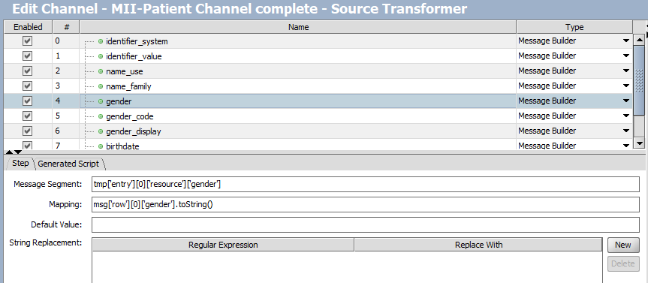

1.5.2) MII Encounter

Record number
Here, the record number is in the FHIR message template identifier.value.
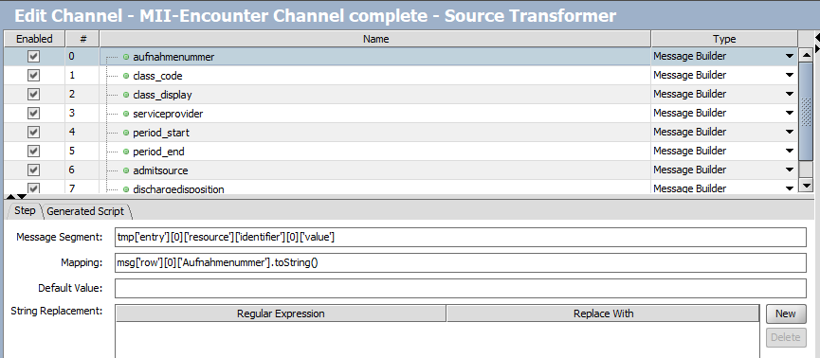

Reference
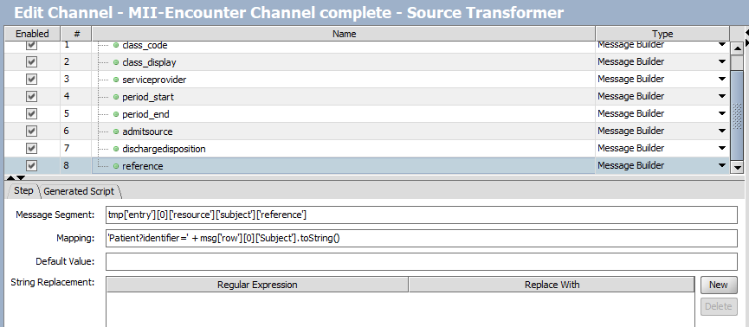
Since each case references a patient, each reference should begin with 'Patient?identifier='.
Important: Only the first part 'Patient?identifier=' is enclosed in single quotation marks ('...'). The rest is not!
Therefore, the mapping is: 'Patient?identifier=' + msg['row'][0]['Subject'].toString()

1.6) Deploying the channels and loading the data

Under "Channel Tasks," click "Redeploy All" to activate both channels.
Important: Both channels should have the status "Enabled." You can change this under:
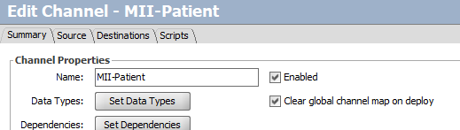

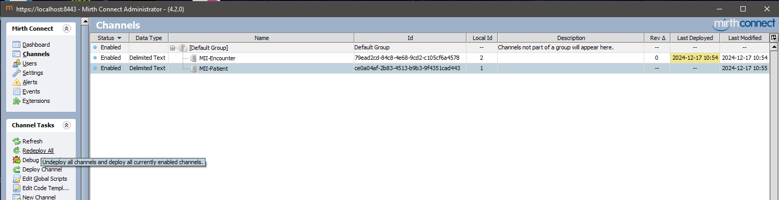
Deployed Channels:
Once these are deployed, you can start copying the patient CSV file to the folder.
When Mirth-Connect reads the files, the following should be displayed:
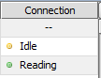
MII Patient:
100 patients should be sent successfully (Sent):
Under "View Messages," you can view the sent messages and see any errors:
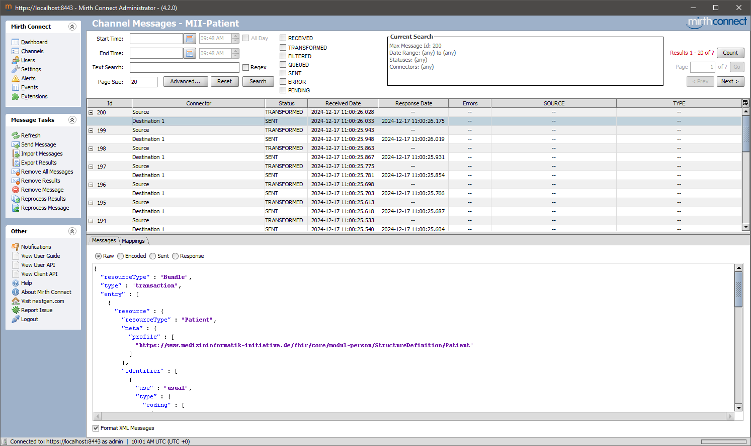
Test: To test whether all patients have been successfully loaded onto Hapi, enter http://localhost:8090/fhir/Patient?_summary=count in your browser:
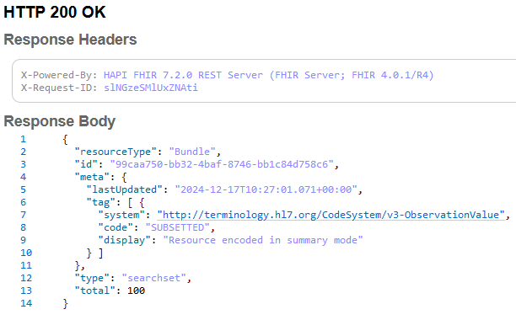

MII Encounter:
275 cases should be sent successfully (Sent):
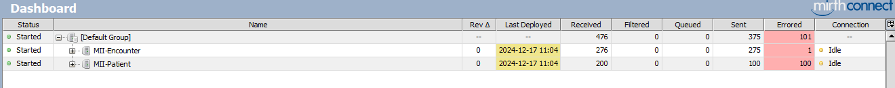
Under "View Messages," you can view the messages that were sent and see any errors:
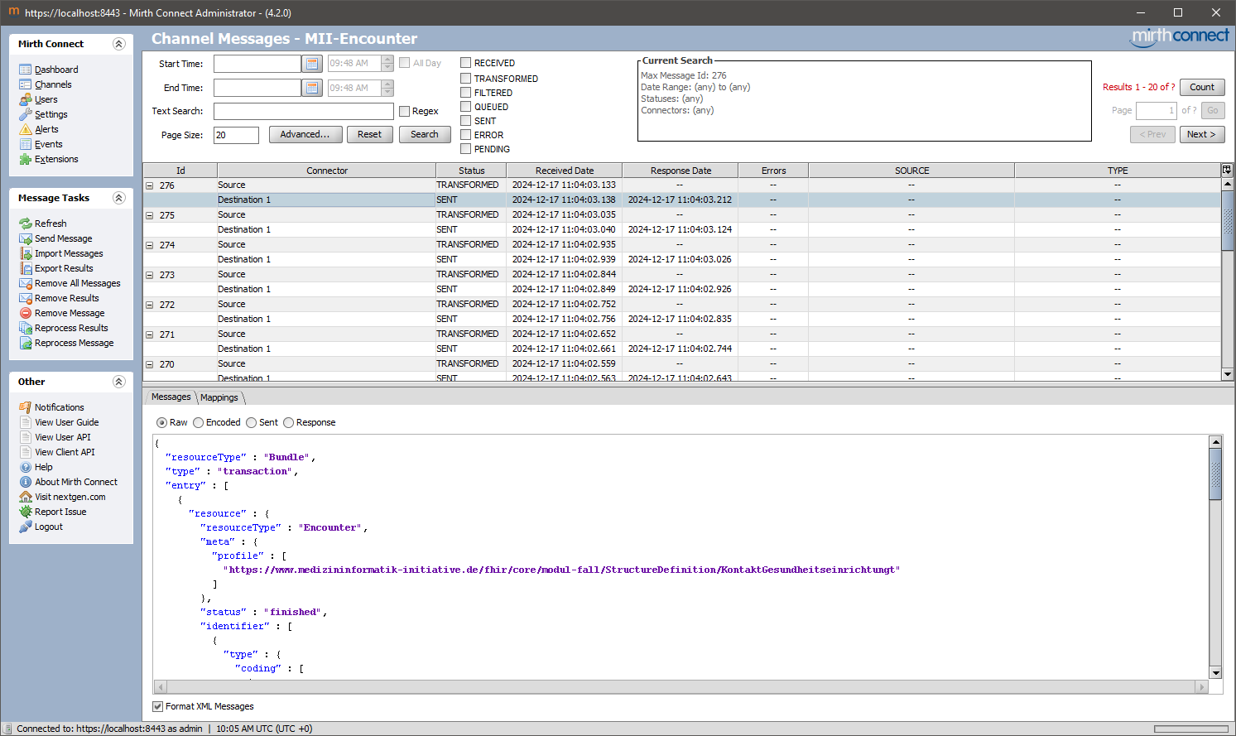
Test: To test whether all patients have been successfully loaded onto Hapi, enter http://localhost:8090/fhir/Encounter?_summary=count in your browser.

2.1) Configuring ChlinFHIR
Change the data server at the top right under "Edit" and select "Public HAPI R4 Server" from the drop-down menu and confirm with "Save."
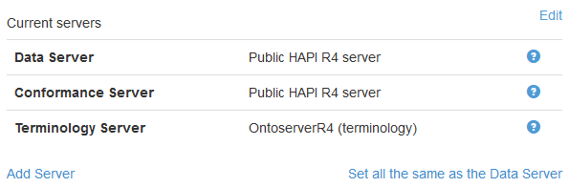
Important: Before the local FHIR server can be added, you must change the data server from "InterSystems FHIR Server R4" to "Public HAPI R4 Server."
Then add the FHIR server under "Add Server":
URL: http://localhost:8090/fhir/
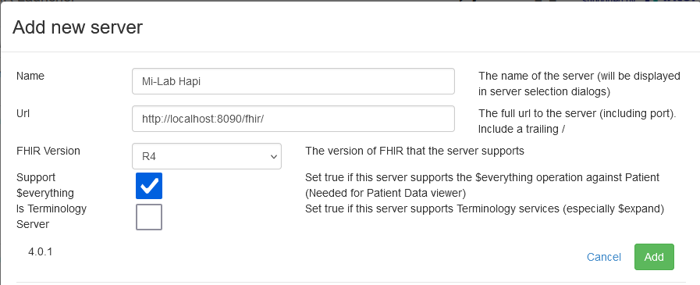
Then select the newly added FHIR server from the list of all data servers under "Edit Server" and confirm with "Save."
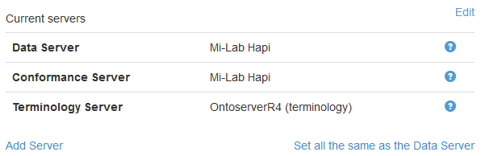

2.2) ChlinFHIR Patient Viewer
2.2.1) How old is the patient with ID 58 (identifier: 10015860)?
Solution: 53 years old (date of birth: January 1, 1971)
2.2.2) How many cases are there for the patient with ID 2 (identifier: 10003400)?
Solution: Resource Reference Graph
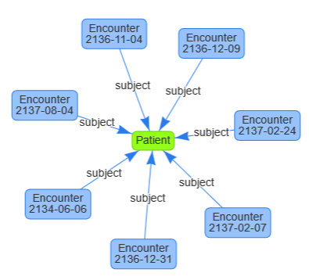 Solution: 7 cases

2.2.3) Is the patient with ID 2 (identifier: 10003400) already deceased?
Solution: Yes (deceasedBooolean: false)

2.3) ChlinFHIR Server Query
2.3.1) How many patients are female?
Solution: Patient?gender= female&amp;_count=100
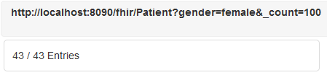
2.3.2) How many patients have already died?
Solution: Patient?deceased= true&amp;_count=100
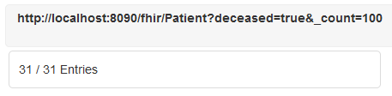
2.3.3) How many cases belong to patients who have already died?
Solution: Encounter?patient.deceased= true&amp;_count=200
