ARX MIMIC Exercise
Based on the ARX exercise by Dr. Fabian Prasser. Sample solution

Task 1
- Open ARX and create a new project. Import the data set “MIMIC IV Demo full Ü3.csv”. .
- Select the columns "age", "insurance", "language", "martial_status", "race" and "weight" one after the other and select the attribute type "Quasi-identifying" for each. Now import the corresponding hierarchy for each attribute you have selected under "File" → "Import hierarchy".
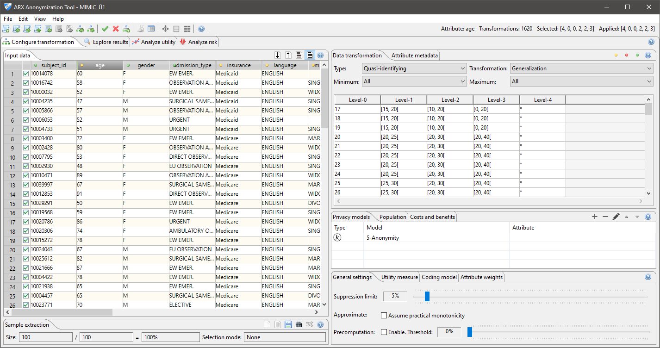
Background
- Generalization hierarchies are used to transform values
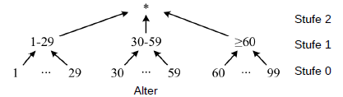
- In ARX, generalization hierarchies are usually represented as tables
- Each row of such a table contains the mapping rule for an attribute value
- For the hierarchy shown here, for example, the following representation results:
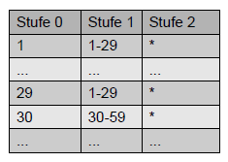
- Note: To ensure that anonymization procedures are carried out securely with ARX, it is essential that each individual mapped in a data record is represented by exactly one entry!

- Now protect the entries in the data set from re-identification. Specify a maximum re-identification risk of 20% for each entry in the data set. Use attribute generalization and entry suppression to protect the data set. Ensure that no more than 5% of the entries are removed.
Under "General Settings," select a suppression limit of 5%. This is the limit on the proportion of entries that can be removed.
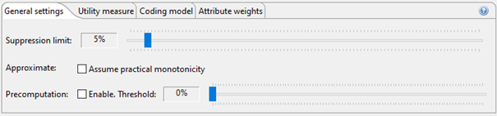
Now specify the risk thresholds/data protection models. Add a new protection model to the list of all active protection models. Select k-anonymity with k=5 (risk threshold 1/5=20%).
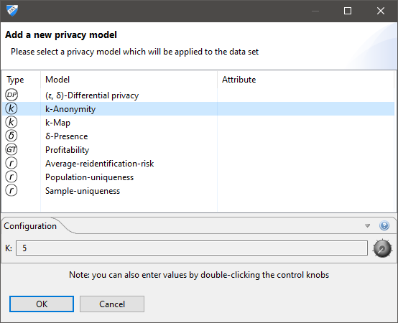
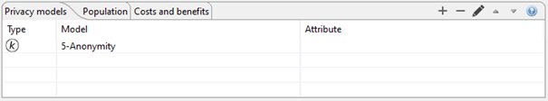
- Now anonymize the data record using the menu bar (✅). Once anonymization has been successfully completed, information about the process will be displayed in the upper right corner of ARX.

Background
- Transforming the input data reduces the uniqueness of value combinations
- This creates groups of entries, also known as classes
- The size of the group in which the data record belonging to an individual is located determines the probability with which the entry can be assigned to the individual
- For example, if an entry is in a group of size k, it can only be correctly assigned to the individual with a probability of 1/k
- This probability is called the re-identification risk
- The attributes used to form groups are called quasi-identifiers
- The k-anonymity data protection model requires a class size of at least k for each entry.
- This means that k-anonymity limits the re-identification risk of each entry to a maximum of 1/k
- The transformation of input data is usually done by generalizing attribute values and removing (also called "suppressing") entries.
- Usually, an upper limit is set for the number of entries that may be removed ("suppression limit").

Task 2)
Examine the solution space. Find alternative solutions with near-optimal information loss. Examine differences from the previous solution.

Background
- Generalization hierarchies
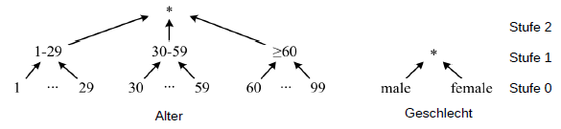
- Solution space
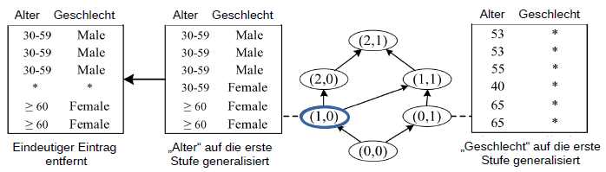
- Each transformation (marked in the figure) in the solution space defines a unique combination of generalization levels, one for each quasi-identifier.
- In addition, entries are often automatically removed ("suppression").

- Use the ARX exploration perspective:
- Green: anonymous transformation
- Yellow: optimal solution
- Rectangle: selected transformation

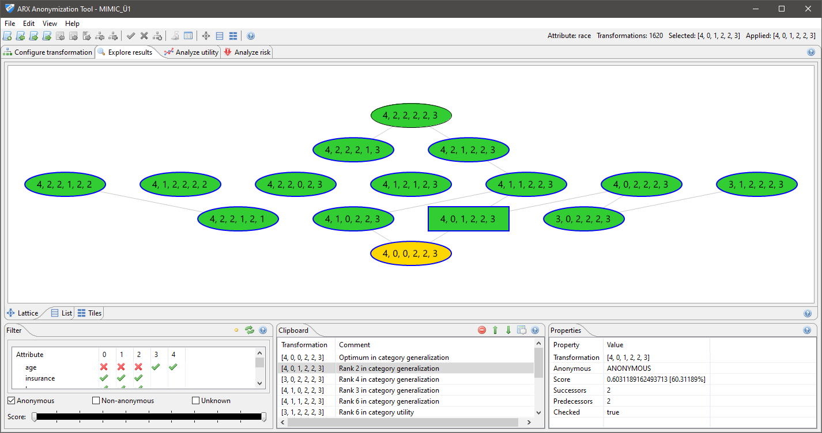

Note: Right-click on a transformation and select "Apply transformation" to apply a selected transformation to the data set.
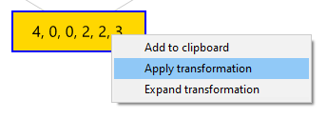
- Now switch to the ARX quality analysis perspective:
- Left: Data input
- Right: Output of the applied transformation
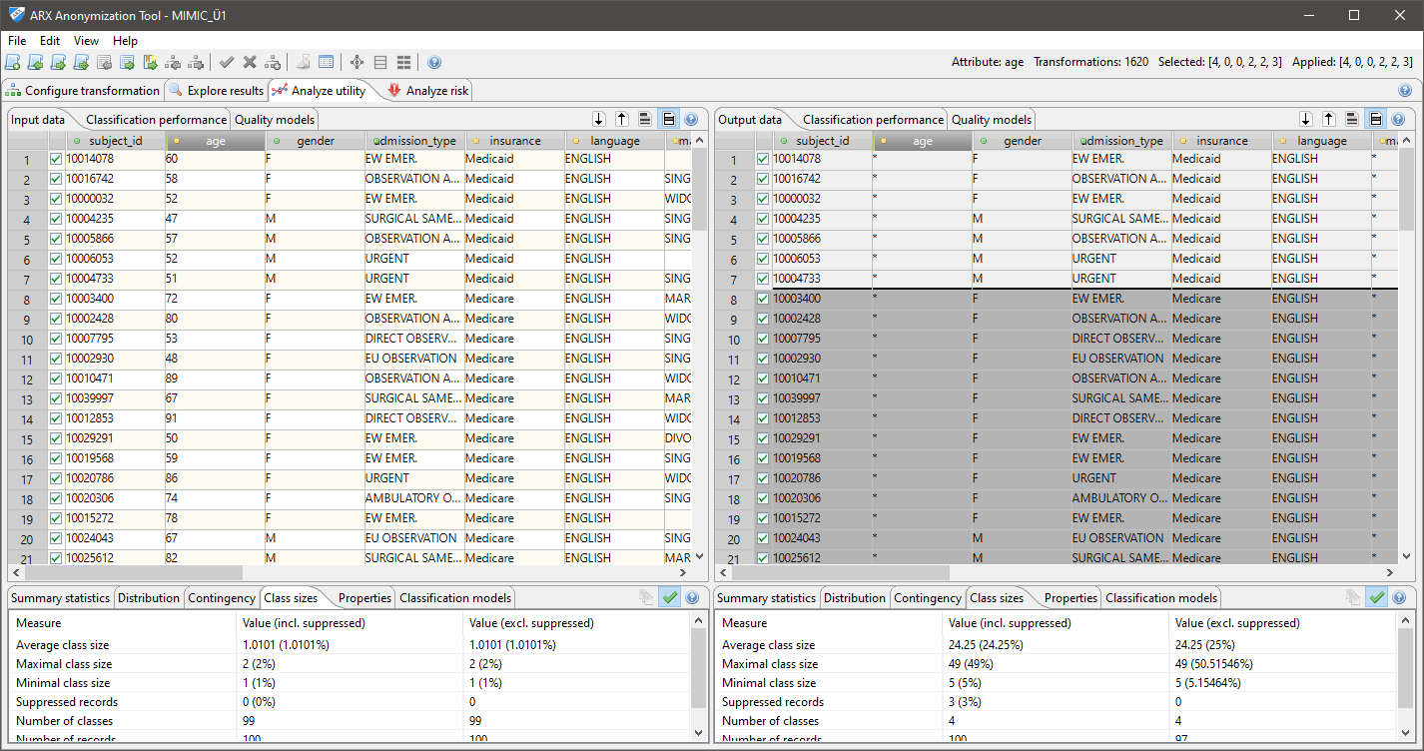
- Look at the "Class sizes" tab and answer the following questions:
Fill in:
● Optimal transformation
● [_, _, _, _, _, _, _, _, _]
● Properties
● Completely removed attribute(s): ___ (_________)
● Suppressed entries: ____ (__,_%)
● Information loss: __,_%
● Average class size: __,_
● Your selection
● [_, _, _, _, _, _, _, _, _]
● Properties
● Completely removed attribute(s): ___ (_________)
● Suppressed entries: ____ (__,_%)
● Information loss: __,_%
● Average class size: __,_

Task 3)
Analyze the re-identification risks of entries in a 5-anonymous data set. Here, 20% corresponds to 5-anonymity. Examine how re-identification risks have changed as a result of anonymization.

Background
- The size of the group in which an entry is located determines the probability with which it can be correctly assigned to the associated individual, i.e., the re-identification risk.
- Even with a k-anonymous data set, it must be assumed that a significant proportion of entries can be correctly assigned through random mapping of individuals to suitable groups.
- These considerations assume that the attacker already knows that data about the individuals they are trying to map is available in the dataset.
- This worst-case scenario is called the prosecutor model

- Switch to the "Analyze Risk" tab and select "Attacker models":
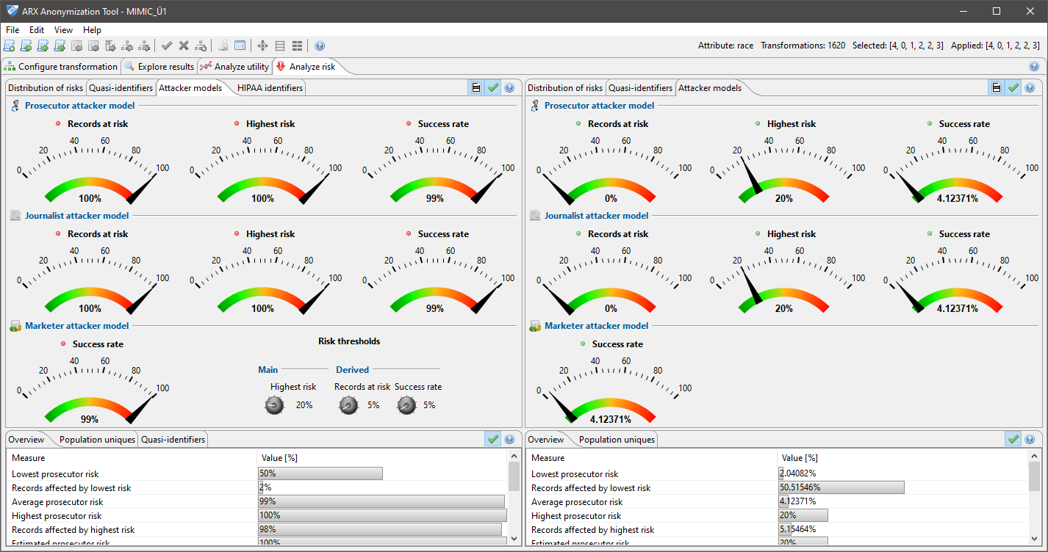
Fill in:
– Prosecutor re-identification risk for the input data set
● __,_% of entries are exposed to a risk of more than 20%
● The expected relative number of correctly re-identified entries is __,_%
● The lowest risk is ___%, the highest risk is ___%
● The highest risk affects ___% of the data records
– Prosecutor re-identification risk for the output data set
● __,_% of entries are exposed to a risk of more than 20%
● The expected relative number of correctly re-identified entries is __,_%
● The lowest risk is ___%, the highest risk is ___%
● The highest risk affects ___% of the data records

Task 4)
Create a generalization hierarchy for the attribute "age" with the following structure:
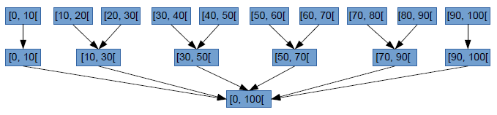
- Select "Edit → Create hierarchy..." from the application menu.
With ARX, you can create three types of hierarchies:
- Based on intervals
Example: Age, lab values
- Based on an order of attribute values
Example: Coded diagnoses
- By masking
Example: Postal code
- Select "Use intervals" and click "Next." Now select the "Range" tab:
Set the lower limit to "0" and the upper limit to "100".
- Then click on the interval displayed. Define a base interval of size 10:
Set the lower limit to "0" and the upper limit to "10".
- Now add another generalization level.
  - Right-click on the base interval and select "Add new level".
  - Then right-click on the newly created node and select "Add after" to insert a sibling node on the same level.
  - To define the interval ]10, 30], two intervals from the level below must be combined. Therefore, define a size of 2:
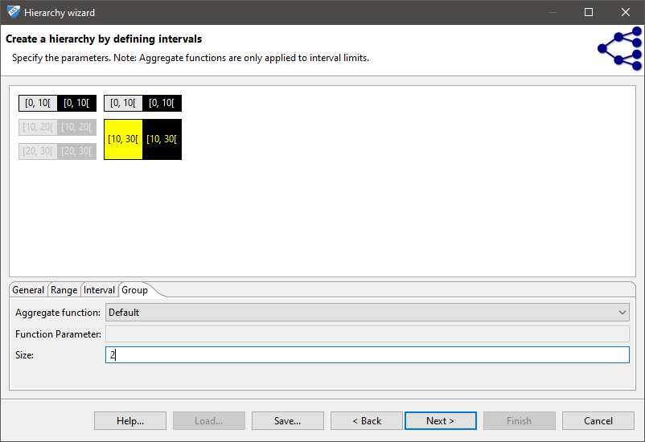
- Then create the intervals [30, 50[, [50,70[, [70, 90[, [90, 100[.
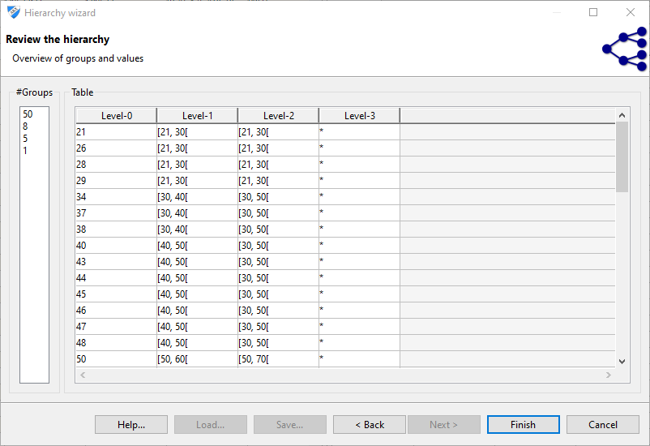

Task 5)
Continue familiarizing yourself with ARX. Examine...
- ... the distribution of the attribute "age"
- ... statistical parameters of the distribution of the attribute "age"
- ... the contingency between "age" and "marital-status"
- ... the effect of the anonymization process on the predictability of the attribute "marital-status"

Background:
- Since it is often difficult to find an appropriate solution to an anonymization problem automatically, ARX provides various functionalities for analyzing the usefulness of the output data
- To investigate the effects of the anonymization process on a common application scenario, ARX implements a method from the field of machine learning
- For this purpose, a logistic regression model is trained to predict the value of a class attribute for entries in the input data set based on a given set of feature attributes
- The impact of the anonymization process is reflected in a decrease in the accuracy of the classifier when it is trained with the anonymized output data instead of the input data
- The values displayed by ARX are to be regarded as guidelines.

- Switch to the ARX quality analysis perspective. Select the attribute "age" by clicking on the corresponding column and then on the "Distribution" tab.
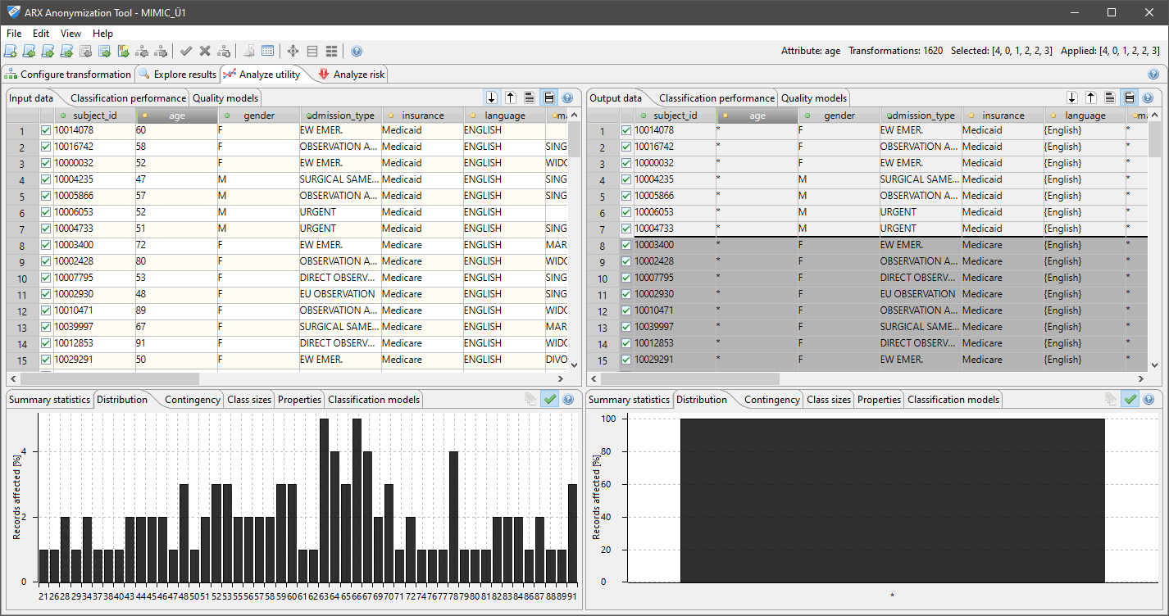
- Select the "Summary statistics" tab and compare the "Scale of measure." First select the attribute "age," then the attribute "marital-status," and then select the "Contingency" tab.
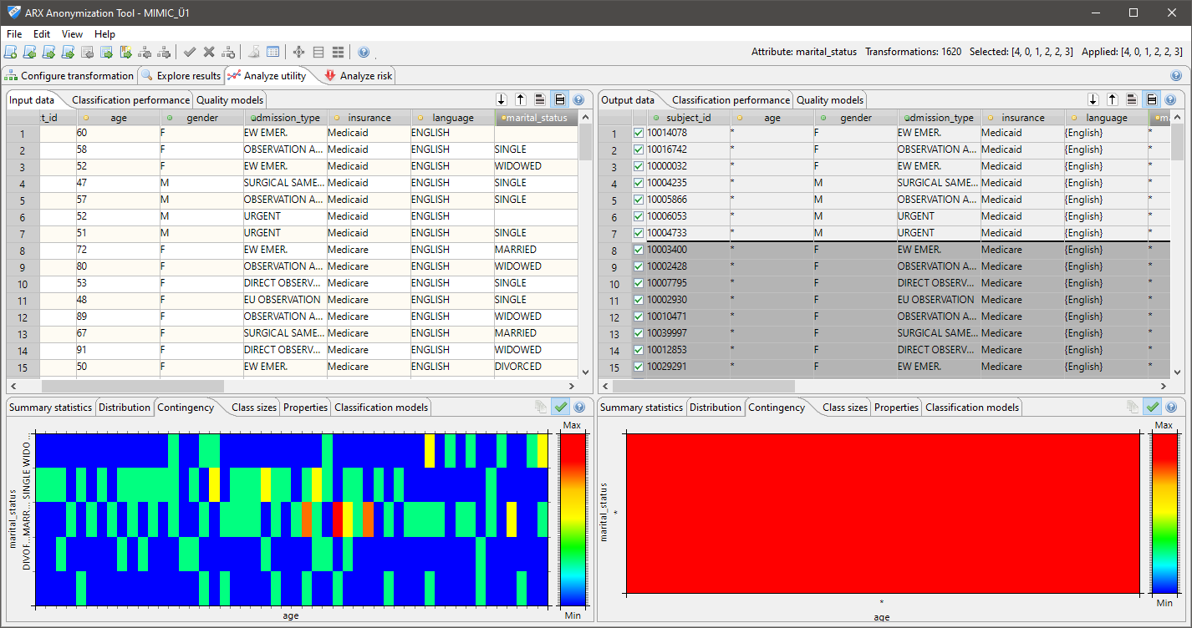
The contingency table is displayed as a heat map. Coarsening through generalization of attribute values. Distortion through suppression of entries. All entries for martial_status have been removed.
- Now select the "Classification performance" tab. The classifier predicts values for the class attributes based on the feature attributes. Now compare the accuracy of the classifier before and after the anonymization process.
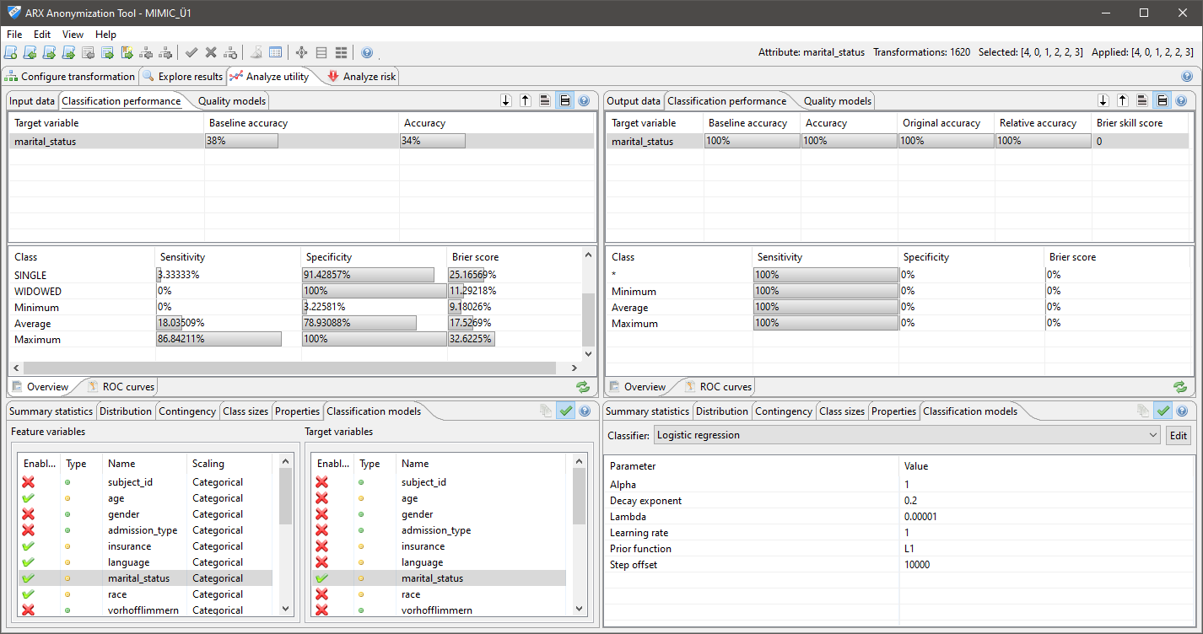
Here, the accuracy has increased from 35% to 100%.

Task 6)
Analyze the effect of suppression on information loss.
information loss. Anonymize the data set with different thresholds for the maximum number of entries to be removed ("suppression limit").

Background:
- Generalization of attribute values reduces the uniqueness of entries
- Entries in a data set often lose their uniqueness only when a very high level of generalization is applied (outliers).
- To prevent the entire data set from having to be heavily generalized, these entries can be automatically removed
- This reduces the loss of information
- Note: This is a fundamental feature of many anonymization methods. Frequently occurring "patterns" are usually extracted.

- Switch to the ARX configuration perspective.
- Determine the maximum threshold value that is worth investigating. Anonymize the data set with a "suppression limit" of 100%.
Switch to the ARX quality analysis perspective
- The limit corresponds to the relative number of suppressed entries (rounded up). You can find this key figure in the "Class sizes" tab.

- Then anonymize the data set with "suppression limits" of 0%, 2%, ..., up to and including the specified limit value (rounded up).

Fill in:
- The threshold value is ___%
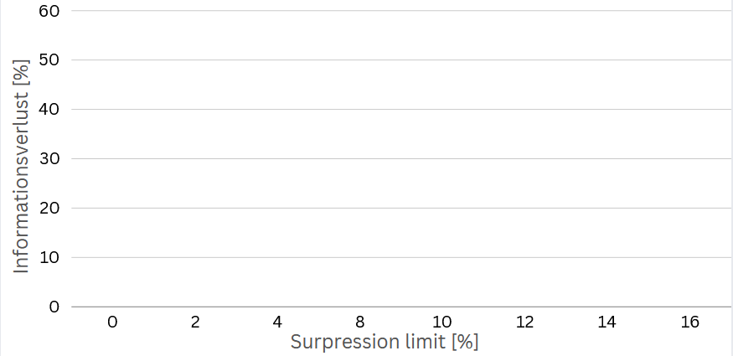

Task 7
Analyze the effect of microaggregation on the output data. Compare microaggregation and generalization. Consider the attribute "age."

Background
- Generalization and microaggregation reduce the uniqueness of values
- In generalization, a common, more general value is mapped:
50 → [50,70]
60 → [50,70]
70 → [50,70]
- Microaggregation is a method for numerical attributes in which values are replaced by an aggregate:
50 → Avg(50,60,70) = 60
60 → Avg(50,60,70) = 60
70 → Avg(50,60,70) = 60

- Anonymize the data set using different transformation methods for "age"
- Generalization
- Microaggregation with mode
Switch to the quality analysis perspective after each anonymization process. Note the parameters from the "Summary statistics" and "Class sizes" tabs.

Fill in:
 | Input | Generalization | Microaggregation
Scale of measure
Mode
Median
Min
Max
Suppressed records

