ARX Exercise MIMIC Sample Solution
Task 1)
Import interim solution: mimic_ü2.deid
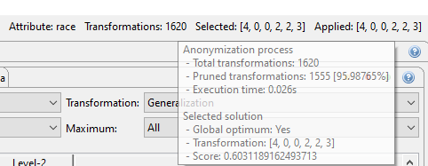
Optimal solution:
[4, 0, 0, 2, 2, 3]
1620 transformations
Information loss (score) = 60%

Task 2)
Import interim solution: mimic_ü2.deid
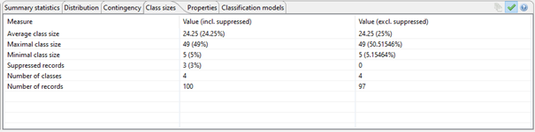
Optimal transformation:
[4, 0, 0, 2, 2, 3]
Completely removed attributes: age, marital status, race, weight
Suppressed entries: 3 (3%)
Information loss: 60%
Average class size: 24 (24%)
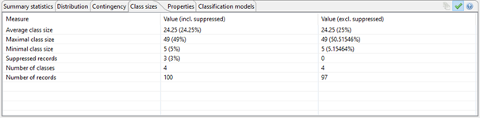
Second-best transformation:
[4, 0, 1, 2, 2, 3]
Completely removed attributes: age, marital status, race
Suppressed entries: 3 (3%)
Information loss: 60%
Average class size: 24 (24%)

Task 3)
Transformation: [4, 0, 0, 2, 3, 3] (Optimal solution)
Prosecutor re-identification risk for the input data set
- 100% of entries are exposed to a risk of more than 20%
- The expected relative number of correctly re-identified entries is 99%
- The lowest risk is 50%, the highest risk is 100%
- The highest risk affects 98% of the data records
Prosecutor re-identification risk for the output data set
- 0% of entries are exposed to a risk of more than 20%
- The expected relative number of correctly re-identified entries is 4%.
- The lowest risk is 2%, the highest risk is 20%.
- The highest risk affects 20% of the data records
Finding 1: In the worst case, entries can be correctly re-identified despite 5-anonymity
Finding 2: On average, the risk for individual entries is well below the threshold value of 20%.
Task 6
Threshold value is: 14% (number of suppressed records at 100%)
14: 54%, 10:55%, 7:60%, 4:60%, 2:69%, 0:69%
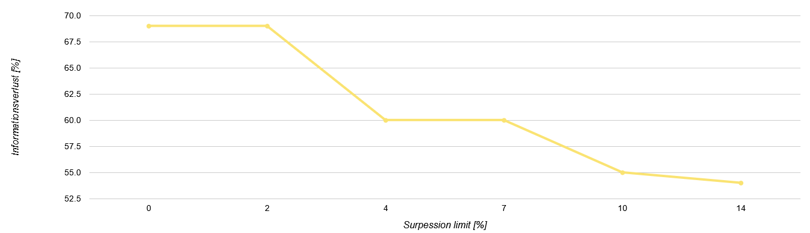

Finding 1: Significant reduction in information loss
- It is usually sufficient to remove a very small portion of the entries.
Finding 2: No significant flattening (only from 7% suppression limit)
Further finding: ARX execution times increase with increasing "suppression limit"

Task 7)
Import interim solution: mimic_ü7.deid
Suppression limit = 5%
Input
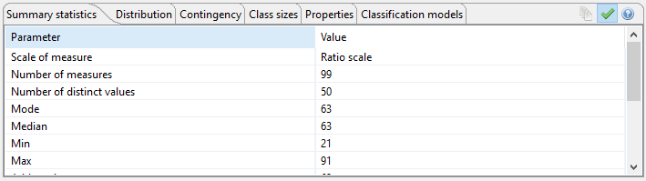
Generalization:
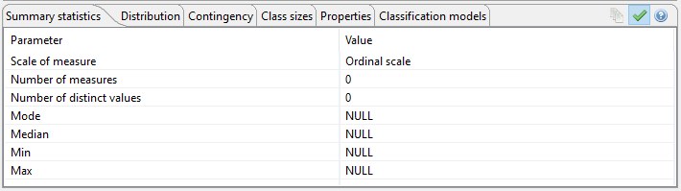
Microaggregation:
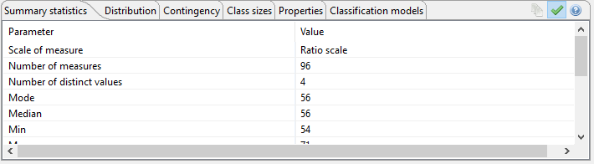

 | Input | Generalization | Microaggregation
Scale of measure | Ratio | Ordinal | Ratio
Mode | 63 | NULL | 56
Median | 63 | NULL | 56
Min | 21 | NULL | 54
Max | 91 | NULL | 71
Suppressed records | 0 | 3 | 3

Finding 1: A generalized numerical variable is ordinal scaled in ARX
Finding 2: Microaggregation preserves the scale level
Finding 3: Microaggregation is not truth-preserving

