Ü4 LDH Solutions
The solutions are based on the contents of the LDH: https://ldh.imise.uni-leipzig.de/
f your own LDH instance is used for the exercise, solutions may differ — especially for Task 1.
- Institution and Project
Search for “Institut für Medizinische Informatik, Statistik und Epidemiologie (IMISE)”. Navigate to “Related Items”, where it states:
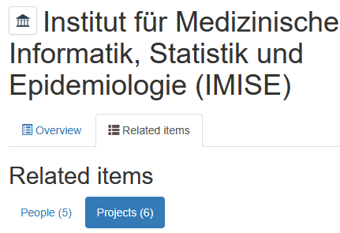
Therefore, there are 6 projects within this institution.
- Creating an Investigation
Under the project “MI-Lab”, add an Investigation:
In the top-right corner, click the “Add new” button and select “Investigation”.

  - Extended Metadata Schema
Select “MIAPPE metadata v1.1” and complete the metadata fields.
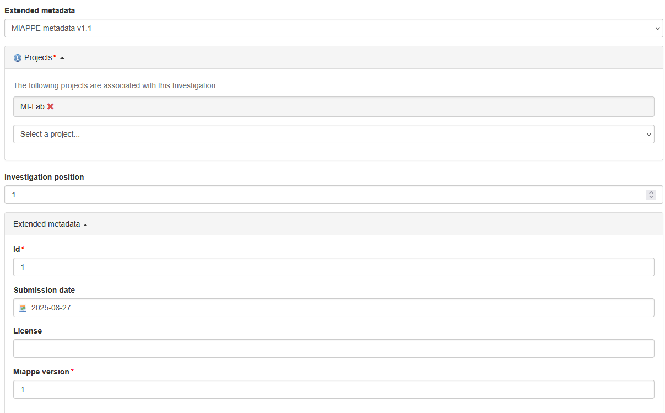
  - Access Rights
Configure the access rights for this Investigation so that only people from your project can access it.
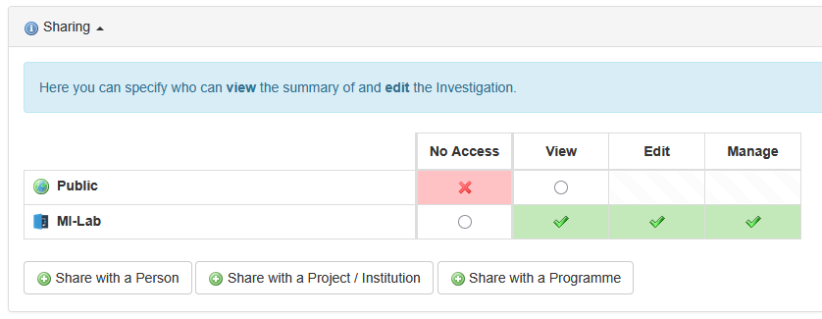
Why are access rights necessary for clinical studies?
Not everyone on the internet should be able to view study-specific data such as datasets. However, members of the study team need full access to all relevant data.
Why should not all data from a clinical study be made openly available?
Data related to study participants is personal and sensitive information and must not simply be published openly on the internet.

- Creating a Study
This is similar to the solution for Task 2. The only difference is that under the Investigation, you must select “Add new” → “Study”.
- Creating an Experimental Assay
  - Documents
Why should these documents be uploaded in addition to the dataset?
These documents are essential for better reusability and interpretability. In addition to the data itself, they are necessary because they ensure: scientific context and understanding (study protocol), reliability (data quality rules), and comprehensibility (data dictionary).
What are these documents used for in a clinical study?
See also the lecture slides.
FDMP:
The FDMP describes how these three components are embedded overall and how data and documentation are handled throughout the entire research lifecycle.
Study Protocol:
Important for transparency and reproducibility. Other researchers can understand why and how the data was collected.
Data Quality Rules:
Describe which validation and plausibility checks are applied to the data (e.g., value ranges, missing data, duplicate records).
Data Dictionary:
Contains definitions of the variables (e.g., column name, meaning, data type, units, coding systems).
It is indispensable for any kind of data reuse or integration, because otherwise nobody knows what variables such as “HR” or “ICU_stay_id” actually mean.
It also enables interoperability, since variables can be machine-readable annotated or mapped to standards such as SNOMED CT or LOINC.

