Exercise sheet 5: TranSMART solutions
Before starting the exercise: Install TranSMART with Docker, see GitHub.
TranSMART is available at http://localhost:80
user: admin, password: admin

Overview of the study
- Open the tree structure under "Public Studies" &gt; "MIMIC" on the left under "Navigate Terms" and add the following variables to subset 1:
Age
The subset does not need to be saved.
- Go to the "Summary Statistics" tab. What is the mean and median age of the patients?
Solution: Mean: 61.75, median: 63
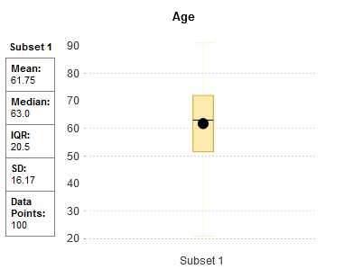
- What percentage of patients are male or female?
Solution: 43% female, 57% male
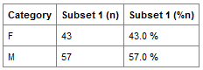

Comparing subsets
- Go back to the "Comparison" tab and delete the subset from task 1 by clicking on "Clear Panel."
- Now add new variables to the subsets. You can find the variables under "Public Studies" → "MIMIC" → "Clinical Data" → "Diagnosis."
Subset 1: Variable "E78.5" under "Diagnosis" → "Hyperlipidemia"
Subset 2: Variable "I48.0" under "Diagnosis" → "Atrial fibrillation"
- Now go to the "Summary Statistics" tab:
How many patients are in each subset and how many patients have both diagnoses?
Solution:
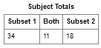
What is the mean age of patients suffering from hyperlipidemia or atrial fibrillation?
Solution:
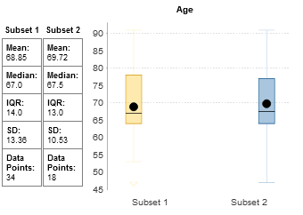

Box plot
Perform the task with the two subsets "hyperlipidemia" and "atrial fibrillation"
from the previous task 2.
- Go to the "SmartR" tab and select "Boxplot Workflow" from the drop-down menu. Drag the variable "hematocrit" under "Clinical Data" → "Lab Values" into the left field "Numerical Variables." Click on "Fetch Data."
- After the data has been loaded, switch to "Run Analysis" and create boxplots with "Raw Values."
Solution:
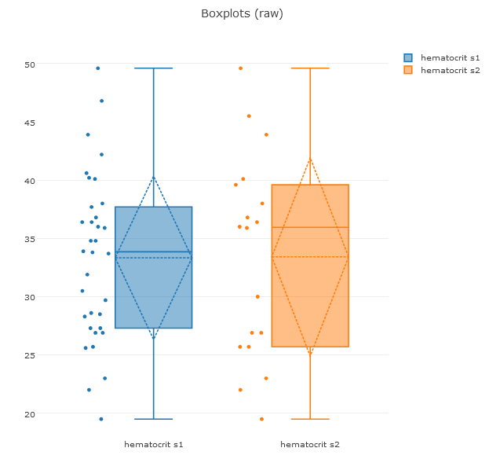
- What is the mean hematocrit value for patients with hyperlipidemia or atrial fibrillation? For which diagnosis is the mean value higher?
Solution: Hyperlipidemia (subset 1): 33.85, atrial fibrillation (subset 2): 35.95

Correlation analysis
Perform the task with the "Atrial fibrillation" subset. The subset is changed in the "Comparison" tab.
Then go to the "SmartR" tab and select "Correlation Workflow."
- Select the numerical variables "age" and "weight." Click on "Fetch Data" and then go to the "Run Analysis" tab.
- Create a correlation analysis with "Raw Values" and the Pearson method.
Solution: (excerpt only)
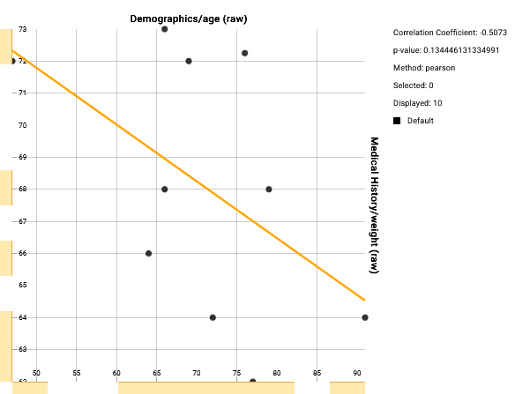
- What is the correlation coefficient and what does it say about the age and weight of patients diagnosed with atrial fibrillation?
Solution: Coefficient=-0.5
=&gt; The older the patients get, the less they weigh.

Survival time analysis
- First, perform this exercise with the "Hyperlipidemia" subset. The subset can be changed in the "Comparison" tab.
- Go to the "Advanced Workflow" tab and select "Analysis" from the drop-down menu.
Create a Kaplan-Meier curve with the following variables:
Time: age
Category: -
Censoring variable: alive
Solution:
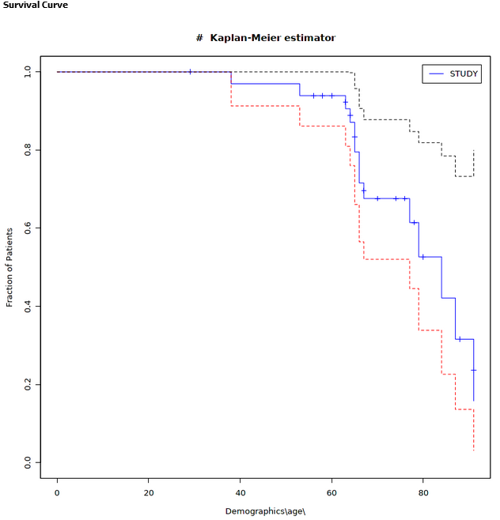
- Now change the subset to "Atrial fibrillation." The subset is changed in the "Comparison" tab.
Now perform a survival analysis again as in task 5.b.
Solution:
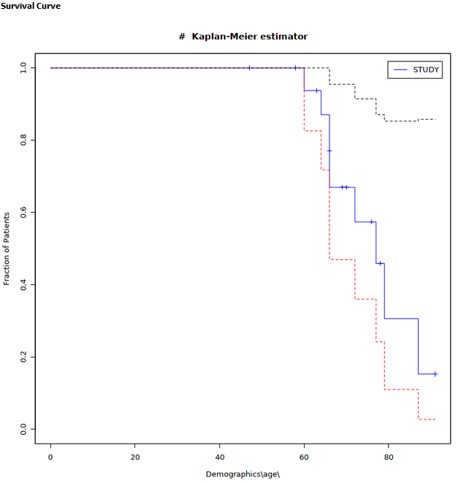
- Now compare the two Kaplan-Meier curves for patients diagnosed with hyperlipidemia and atrial fibrillation. How many patients are still alive at age 80?
Solution: Hyperlipidemia = 50%, atrial fibrillation = 30%

