App Dev Project Report

1. Student Details
Name: Moomin Bin Nissar
Roll Number: 24F2007137
Email: 24f2007137@ds.study.iitm.ac.in
About Me: I am a student in the BS in Data Science and Applications program at IIT Madras with a strong interest in Machine Learning and web application deployments.

2. Project Details

Project Title: Placement Management Portal – V2

Problem Statement:

We're designing a modern, responsive Placement Management Portal for the web. The goal? Make life easier for students, companies, and administrators during campus recruitment by giving them a single platform that works in real time. With this system, the recruitment process feels less like a maze—no more chasing paperwork or juggling spreadsheets. Everything runs smoother.

Admins get total control. Companies get tools to create and manage placement drives with fewer headaches. Students can quickly scan, filter, and apply for opportunities, then stay updated on their application status as things happen. It’s all about cutting out the busy manual work and making sure everyone’s on the same page.

Approach:

This app runs on a decoupled, modern web setup. Flask handles the backend as a lightweight API, while Vue.js powers the frontend, making everything feel quick and responsive.

Frontend (Vue.js): At the frontend, Vue.js builds a Single Page Application—not server-side rendered, but a true SPA. Users get a fast and flexible interface. Vue’s component system makes it easy to design modular dashboards for both Admins and Students. These dashboards pull in data asynchronously, relying on API calls to keep everything up to date.

Backend (Flask API): Flask works purely as a RESTful API here. It handles all business logic, processes client requests as they come in, and sends JSON responses over to the Vue.js frontend.

Database & ORM: On the backend, SQL Alchemy maps out relational database models and manages how everything communicates with the SQLite database. The schema is set up to keep data integrity tight, covering main entities like users, companies, placement drives, and every application.

Access Control & Authentication: The system enforces strict role-based access control (RBAC). Authentication is solid—either through token-based methods like JWT or secure API sessions. Endpoints stay protected, and the Vue.js interface shifts based on who just logged in.

3. AI/LLM Declaration
During this project, I used Gemini (3.5 Pro) as a supporting tool—a kind of auxiliary aid during development and learning. AI contributed to about 15–25% of the process, mostly helping as a conceptual guide, with structure, and when I got stuck debugging. Here’s where the assistance made a difference:

• Frontend Transition & Learning: I leaned on Gemini to build a basic understanding of the Vue.js Composition API. It also helped me set up clean asynchronous communication between the HTML/Vue frontend and the Flask backend for the early features.

• Component Scaffolding: I used Gemini for rough drafts of some UI components. These were starting points—I then customized, styled, and integrated each one by hand.

• Feature Engineering & Debugging: When I ran into tricky reactivity problems on the frontend, API bugs, or when I needed advice on how to handle more complex features, Gemini offered troubleshooting guidance and some useful logic suggestions.

Human Ownership & Integrity Statement: Gemini helped me get up to speed with Vue and worked as a debugging ally. But the heart of the project—core application architecture, relational database design (SQL Alchemy/SQLite), RESTful API logic, and the final system integration—was entirely my own work with minor efficiency assistance from Gemini.

4. Technologies and Frameworks Used

Library |  | Version | Purpose
 | Flask | 3.1.3 | Core backend framework, functioning purely as a RESTful API to serve JSON data to the frontend.
Flask-SQLAlchemy & SQLAlchemy |  | 3.1.1 / 2.0.50 | Object-Relational Mapper (ORM) used to model database schemas and handle all SQL queries programmatically.
SQLite |  | Native | Lightweight, zero-configuration relational database for storing structural records of users, drives, and applications.
Celery |  | 5.6.3 | Distributed task queue utilized to offload time-consuming, asynchronous background processes (e.g., processing heavy application exports or sending status emails).
Redis |  | 8.0.0 | In-memory data store acting as the message broker for Celery and supporting backend caching configurations.
Flask-Migrate & Alembic |  | 4.0.7 / 1.18.4 | Database migration tools used to track and apply incremental database schema updates without data loss.
Bootstrap 5 |  | V5 | Responsive CSS framework integrated within Vue components to design clean, mobile-friendly interfaces.
Flask-Login |  | 0.6.3 | Manages user session state and provides server-side authentication helpers for securing backend API endpoints
Flask-Caching |  | 2.4.0 | Implements endpoint caching to minimize database hits on frequently accessed, static recruitment data.
Python-Dotenv |  | 1.2.2 | Manages environment configurations and protects sensitive application credentials.
Vue.js |  | V3 | Modern frontend JavaScript framework using the Composition API to build reactive, modular user interfaces and separate dashboards.

5. Database Schema / ER Diagram
Tables:
- Users — Stores authentication and account information for all users of the system.
- Student — Stores additional profile information for student users.
- Company — Stores details about companies that conduct placement drives.
- Placement_drive — Represents recruitment drives created by companies.
- Applications — Stores applications submitted by students for placement drives.
Relationships:
- One-to-One → User → Student
- One-to-One → User → Company
- One-to-Many → Company → Placement_drive
- One-to-Many → Student → Applications
- One-to-Many → Placement_drive → Applications
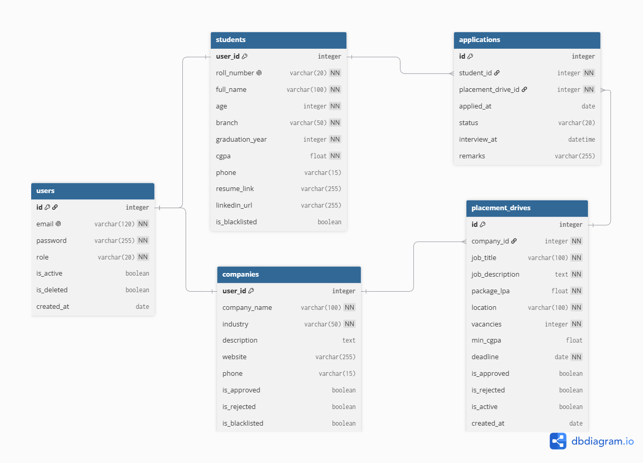

8. Video Presentation
Drive Link:
https://drive.google.com/file/d/1xR9I8ZlL5cGWG807rSFMGD53ofyIrxXD/view?usp=sharing

