BDA_3 AI-Enhanced ETL demo

Part 1: Experiment Plan
Goal: extract data and related comment information from PDF files using an AI-enhanced ETL method.
Inputs: Topic or seed URL(s) or direct PDF links.
Outputs: cleaned JSON per PDF and this experiment report.

Part 2: Architecture
Architecture: simple pipeline: Crawler -> PDF download -> Extract -> Cleaner (heuristics/LLM) -> Report generator
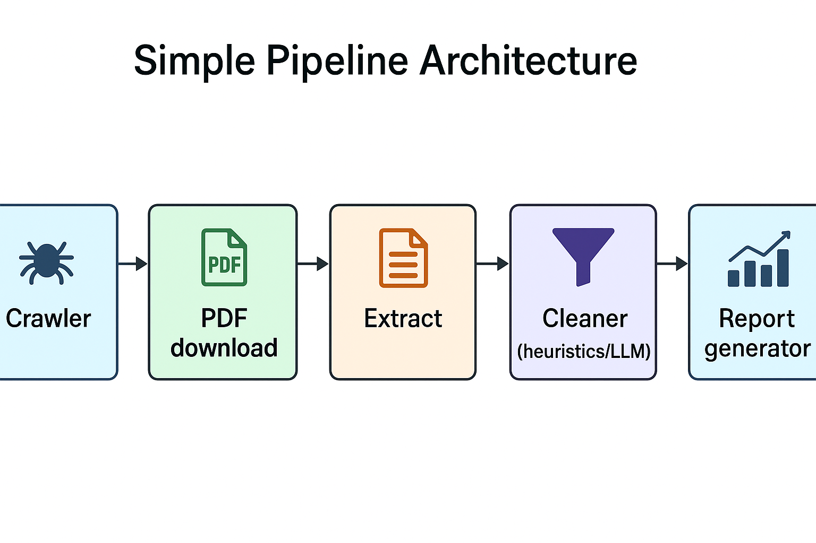

Part 3: Steps and Screenshots
Step 1: Run crawler to download PDFs into data/raw_pdfs
Prompt: create crawler to download pdf file
Response: PDF files downloaded into data/raw_pdfs
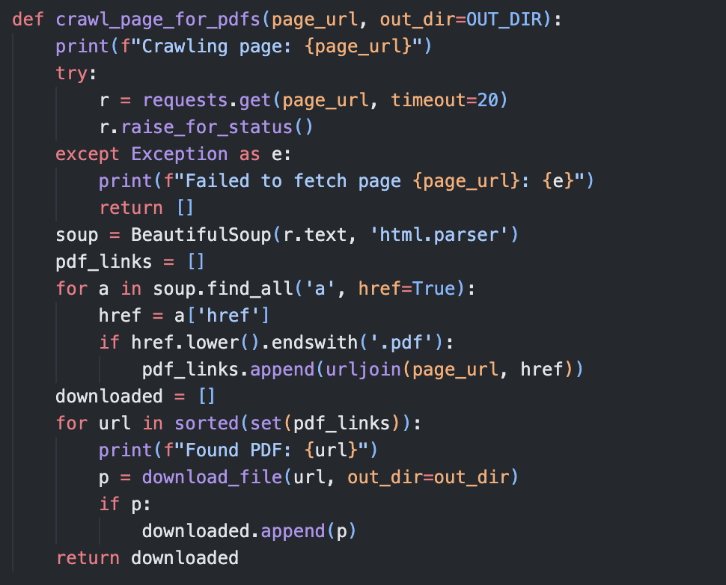
Step 2: Run cleaner to extract text and comments from PDFs
Prompt: run cleaner
Response: JSON files in data/processed
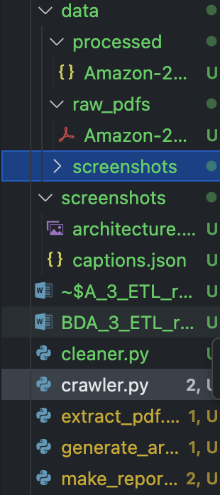
Step 3: Cleaner
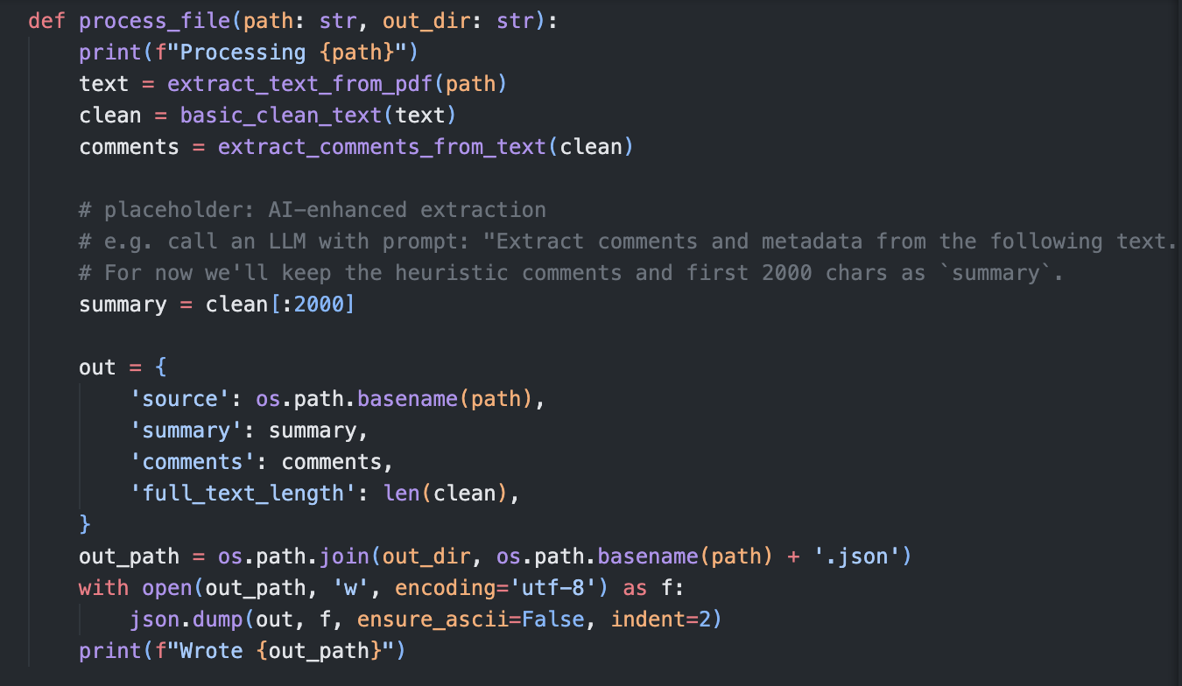

Processed files and extracted comments
Source: Amazon-2024-Annual-Report.pdf
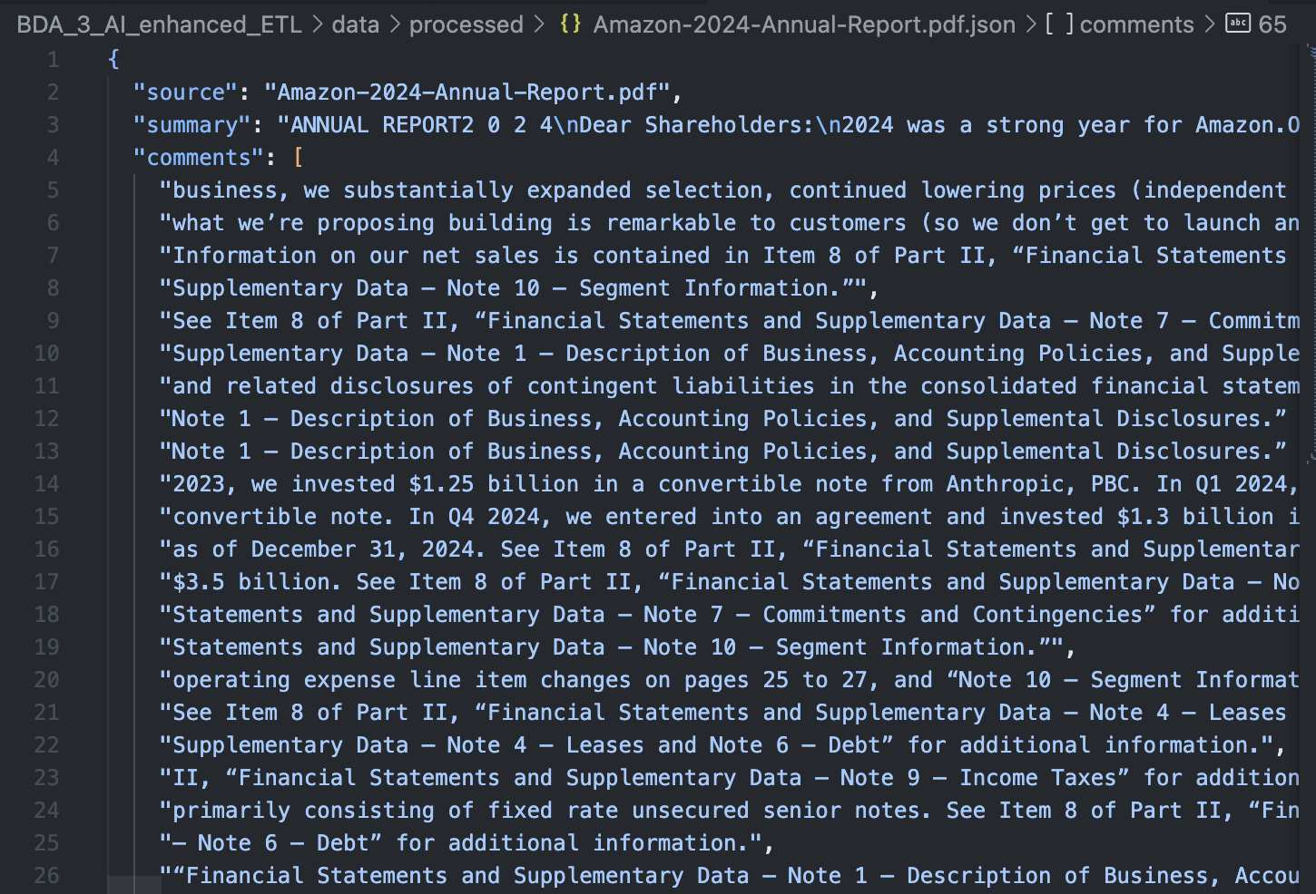
Full text length: 319924
Top comments:
- business, we substantially expanded selection, continued lowering prices (independent research firm,Profitero, found Amazon the lowest-priced online U.S. Retailer for the eighth year in a row), and for thesecond year in a row, we shipped at record speed to our Prime members. AWS launched a slew of newinfrastructure and AI services that make it even easier to build remarkable customer experiences, includingour latest custom AI silicon (Trainium2), a new set of frontier foundation models in Amazon Nova, andsignificant expansion of available models and features in our leading Generative AI (“GenAI”) servicesAmazon SageMaker and Amazon Bedrock. Prime Video continued to offer compelling original shows,including new seasons for Fallout, Reacher, The Boys, andThe Lord of the Rings: Rings of Power, movies like
- what we’re proposing building is remarkable to customers (so we don’t get to launch and ask “wait, whydid we think customers would find this interesting?”). And, the FAQ is designed to force ourselves to ask the
- Information on our net sales is contained in Item 8 of Part II, “Financial Statements and Supplementary Data — Note 10 —
- Supplementary Data — Note 10 — Segment Information.”
- See Item 8 of Part II, “Financial Statements and Supplementary Data — Note 7 — Commitments and Contingencies —

