Distributed Training Systems – Comprehensive Answers

Part 1: Basic Concept Questions
1. Difference between Data Parallelism and Model Parallelism
• Data Parallelism: Each worker holds a complete copy of the model but trains on a different subset of data. Gradients are aggregated using All-Reduce.
Use case: Training large datasets with moderate model size (e.g., ResNet on ImageNet).
• Model Parallelism: The model is split across multiple devices — each device holds part of the model. Used for models too large for one GPU.
Use case: Training extremely large models (e.g., GPT-3, BERT-large).
2. All-Reduce Mechanism
All-Reduce aggregates tensors (usually gradients) across devices and distributes results back to all workers.
Advantages over Parameter Server:
• No central bottleneck (peer-to-peer communication)
• Better scalability and bandwidth utilization
• Lower latency and higher fault tolerance
3. PyTorch DDP Implementation Workflow
PyTorch DDP creates multiple processes (one per GPU). Each performs forward/backward passes locally, then gradients are averaged using All-Reduce, and all models update synchronously.
4. Core Components of Ray and Role of Object Store
Core Components: Driver, Scheduler, Worker Nodes, Object Store.
The Object Store keeps immutable objects in shared memory for fast, zero-copy access between tasks.
5. Main Limitations of Spark MLlib
• Focused on classical ML (no GPU optimization)
• Inefficient for deep neural networks
• JVM-based — poor compatibility with Python DL frameworks
Thus, not suitable for deep learning training directly.
6. Role of TorchDistributor in Spark
TorchDistributor runs distributed PyTorch (DDP) jobs on Spark clusters, bridging data processing (ETL) and model training. It automates setup, communication (NCCL), and process management.

Part 2: Framework and Application Questions
7. Ray Programming Model with @ray.remote and Actors
Ray is built on remote functions and actors:
@ray.remote defines stateless parallel functions; Actors define stateful tasks that maintain state across invocations.
8. Workflow Diagram – PyTorch DDP on Spark using TorchDistributor
Workflow Steps:
1. Spark loads and preprocesses data.
2. TorchDistributor initializes PyTorch environment across executors.
3. Each executor becomes a DDP process.
4. Data shards are distributed to processes.
5. All-Reduce synchronizes gradients.
6. Model checkpoints saved to shared storage.
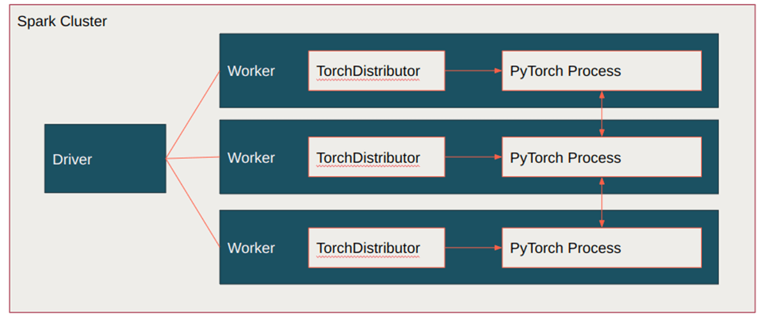
9. Ray Train vs Ray Tune
• Ray Train: Distributed training framework.
• Ray Tune: Hyperparameter tuning library.
Ray Tune orchestrates multiple Ray Train jobs with varied configs to find optimal models automatically.
10. Comparison of Distributed Training Solutions
Solution | Advantages | Disadvantages
PyTorch DDP | Simple, efficient, low overhead | Manual setup, no ETL integration
PyTorch on Spark (TorchDistributor) | ETL + training integration, scalable | Slightly more overhead, Spark dependency
Ray Train | Flexible, scalable, supports tuning | Complex setup, smaller community

Part 3: Comprehensive Design and Analysis
11. End-to-End Training Pipeline (Spark + PyTorch + TorchDistributor)
Steps:
1. Load raw data via Spark from HDFS/S3.
2. Tokenize text using Spark UDFs (e.g., Hugging Face tokenizer).
3. Use TorchDistributor to launch distributed PyTorch DDP.
4. Each executor trains on a shard; All-Reduce synchronizes.
5. Save final model checkpoints to shared storage.
12. Architecture Choice per Scenario
Scenario | Best Architecture | Reason
A: Vision Transformer, multi-GPU | PyTorch DDP | Best GPU efficiency and low latency
B: ETL + Training on Spark | Spark + TorchDistributor | Integrated pipeline with data + training
C: Frequent tuning & deployment | Ray Train + Ray Tune | Automated tuning and scalable retraining

Part 4: Extended Design and Analysis
13. End-to-End Training Pipeline Example (DistilBERT)
Framework: Spark + PyTorch + TorchDistributor
Steps:
1. Load and clean text data via Spark.
2. Tokenize text and convert to tensors.
3. Launch distributed PyTorch training with TorchDistributor.
4. Each executor trains on its shard.
5. Save model checkpoints to S3/HDFS.
6. Evaluate and deploy using TorchServe or Ray Serve.
14. Architecture Selection (Reanalysis)
Scenario | Recommended Architecture | Reason
A: Vision Transformer, multi-GPU | PyTorch DDP | Synchronous GPU workloads, high-speed comms
B: ETL + Training on distributed cluster | Spark + TorchDistributor | Combines Spark ETL with PyTorch training
C: Frequent tuning & deployment | Ray Train + Ray Tune + Ray Serve | Full workflow for tuning and serving

