Knowledge Graph Construction using LLM + Neo4j

I. Questions
1. A diagram which illustrate the main workflow of knowledge graph construction.
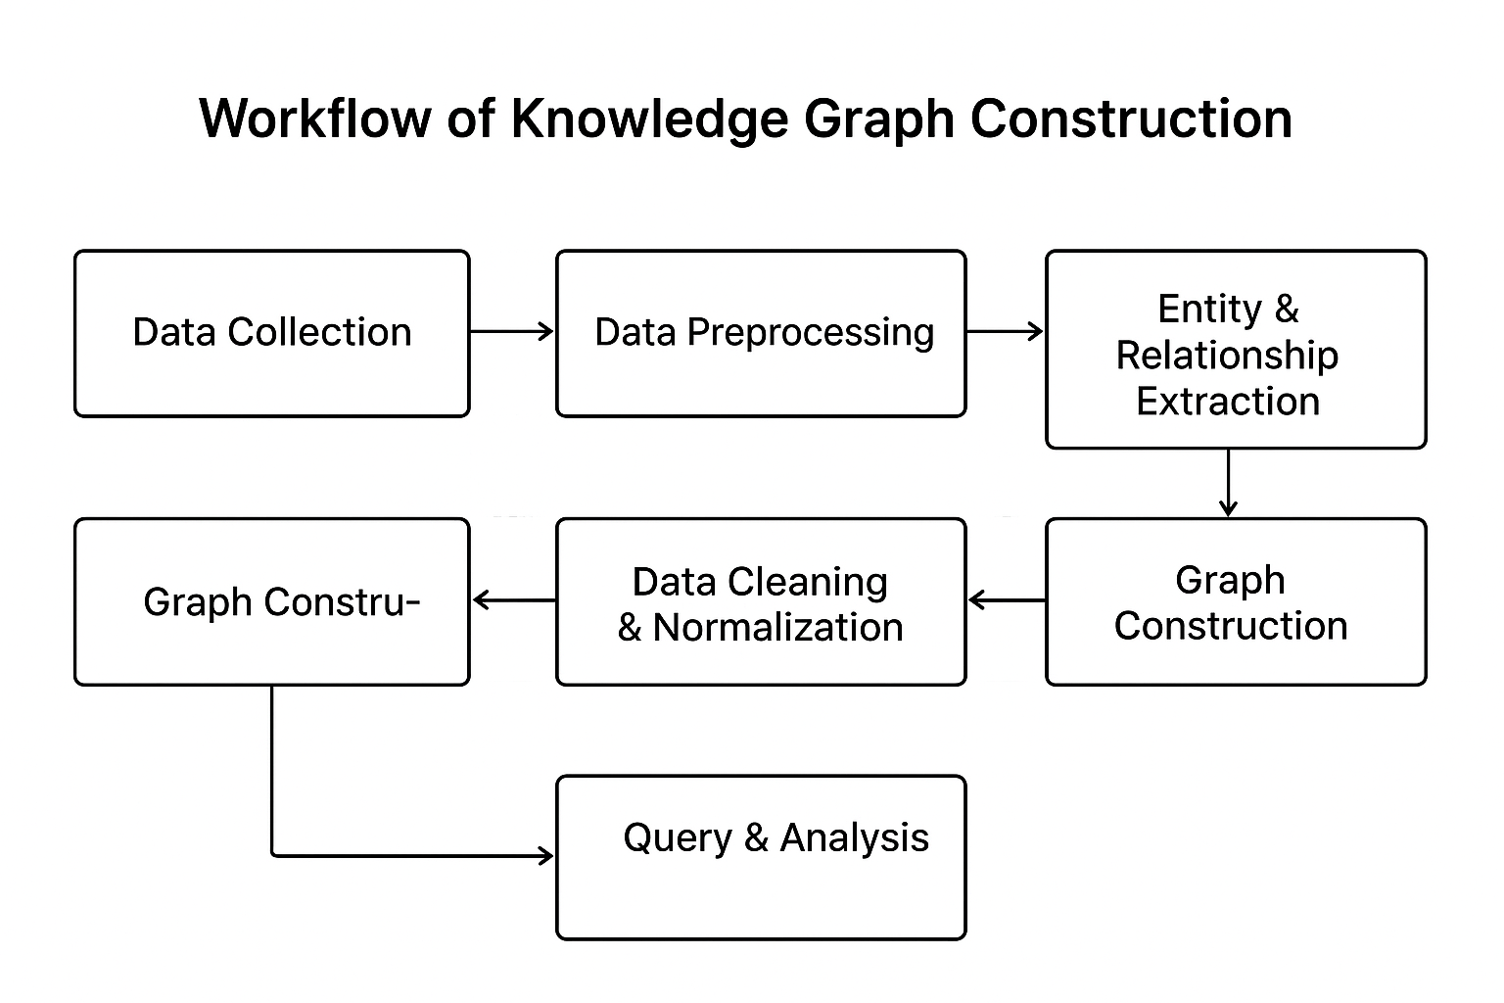
2. What is the 'Property Graph Model'? Please provide an example of its representation in Neo4j. What are the differences between a Property Graph and an ER Diagram?
The Property Graph Model is a data model where data is represented as nodes, relationships, and properties. Each node and relationship can have properties (key-value pairs) that describe their attributes.
Example in Neo4j:
CREATE (p:Person {name: 'Alice', age: 30})-[:WORKS_AT {since: 2020}]->(c:Company {name: 'OpenAI'})
Differences:
- ER Diagram: Focuses on conceptual modeling of entities, attributes, and relationships.
- Property Graph: Emphasizes instance-level representation, supports properties on both nodes and edges, and is optimized for traversal queries.
3. Explain the differences between 'Zero-shot Extraction' and 'Few-shot Extraction,' along with their suitable application scenarios.
- Zero-shot Extraction: The model extracts entities and relations without any task-specific training examples, relying solely on prompt instructions. Suitable for new domains or when labeled data is unavailable.
- Few-shot Extraction: The model is given a few annotated examples in the prompt to guide extraction. Suitable when a small set of labeled examples is available for better accuracy.
4. In the experiment, why is it necessary to clean the triplets output by the LLM? Please list two common cleaning operations.
Cleaning is necessary because LLM outputs may contain noise, inconsistent formats, or invalid relationships.
Common operations:
1. Remove duplicate or incomplete triplets.
2. Correct direction or inconsistency in relationships.

II. Experiment
Design an automated knowledge graph construction pipeline based on LLM + Neo4j. The pipeline includes: Data Preprocessing, Entity and Relationship Extraction, Data Cleaning and Conversion, Graph Construction and Visualization, and Natural Language to Cypher query.

1. Data Preprocessing

Objective
Convert raw, unstructured news text into deterministic, processable segments suitable for downstream LLM extraction.

Method

Read raw sources (JSONL, CSV, RSS, HTML, PDFs). Extract text fields (title, body, date, source).

Normalize text: NFKC normalization, remove control characters, collapse whitespace, unify quotes and punctuation.

Segment text: sentence-splitting or semantic chunking (e.g., 200–600 token chunks). Use rule-based split (regex) or a library (nltk/spacy).

Minimal metadata enrichment: attach doc_id, date, source, URL for provenance.

Inputs / Outputs

Input: raw article records (JSONL rows or CSV rows).

Output: list of cleaned segments: {doc_id, segment_id, text, date, source}.

Contract / success

Success: every output segment length is within configured bounds, no control chars, and metadata present.

Error modes: empty or malformed records skipped with a logged warning.

Practical tips

Keep both title and body (title often contains key events). Include date and source in the segment text or metadata.

For long articles, chunk on paragraph/sentence boundaries to preserve context for relation extraction.

2. Entity and Relationship Extraction
Objective: Extract structured triplets from the text.
Method: Use an LLM (e.g., Qwen) for zero-shot or few-shot extraction, specifying entity types and relationship types clearly in the prompt.
- Objective
Extract structured triplets (subject, predicate, object) from each text segment, plus minimal provenance (confidence, source sentence).
- Method
  - Use an LLM (zero-shot or few-shot). Build a prompt that:
    - Specifies the exact JSON schema you want returned (array of {"subject","predicate","object","confidence","span","type_subject","type_object"}).
    - Defines allowable entity types (Company, Person, Date, Event, Index, Sector, Attribute) and relationship types (acquired, reported, announced, affected_by, experienced, mentioned_in, outperformed, merged_with, etc.).
    - Provides 2–4 few-shot examples in the prompt (input text → desired JSON).
  - Post-process LLM output: parse JSON, validate required fields, convert to Triplet dataclass.
- Inputs / Outputs
  - Input: cleaned segments.
  - Output: list of triplets with metadata: {subject, predicate, object, subject_type, object_type, confidence, span, source_segment_id}.
- Contract / success
  - Success: output is valid JSON matching schema; high precision on entity spans and relation label.
  - Error modes: malformed JSON, hallucinated entities, wrong relation type. Mitigate by:
    - Using schema-enforcing wrappers (e.g., function-calling APIs, or ask LLM to return only JSON).
    - Adding validation heuristics and fallback rule-based extractors.
- Prompt example (short)
  - System / instruction: “Extract factual triplets from the text. Output only valid JSON array of objects with keys: subject, predicate,
  - object, subject_type, object_type, confidence (0–1), span (the substring). Use types: Company, Person, Index, Event, Attribute, Other.”
  - Few-shot examples: include 2 examples showing input sentence and exact JSON.
  - Final line: “Now extract from this sentence: <SEGMENT_TEXT>”
- Implementation note
  - Use a small batch size, deduplicate segments, and include IP/region-safe rate-limiting for API calls.

3. Data Cleaning and Conversion
Objective: Standardize the output format and remove erroneous data.
Method: Write cleaning functions to fix relationship direction, unify entity naming, and convert results into (head, relation, tail) triplets.
- Objective
Standardize extraction results (normalize names/types), remove errors, fix directions, and convert into canonical triplet format for graph insertion.
- Method
  - Normalization:
    - trim/normalize whitespace and punctuation,
    - canonicalize company names (e.g., remove “Inc.” / “Ltd.” or map aliases to canonical IDs if available),
    - lowercase/underscore predicates where needed (e.g., “acquired” → acquired).
  - Deduplication:
    - Remove exact duplicate triplets; merge near-duplicates (same subject/object with synonymous predicates).
  - Direction & relation validation:
    - Use simple rules (e.g., for acquired, subject must be company A and object company B — if swapped, flip relationship).
  - Validation:
    - Ensure types are consistent (if subject_type != Company for an acquired relation, flag for review).
  - Output conversion:
    - Convert to canonical Triplet form: {"subject": "...", "subject_type":"...", "predicate":"...", "object":"...", "object_type":"...", "meta": {...}}.
  - Save cleaned triplets as JSONL for audit and Neo4j ingestion.
- Inputs / Outputs
  - Input: raw triplets from LLM.
  - Output: cleaned canonical triplets (JSONL), plus diagnostics (removed_count, ambiguous_count).
- Contract / success
  - Success: cleaned file has consistent property names, no null subjects/objects, and duplicates removed.
  - Error modes: ambiguous types or low-confidence triplets — either drop or mark with meta{'low_confidence': True}.
- Practical rules
  - Keep provenance: source_segment_id, source_text, confidence for each triplet.
  - Maintain a small mapping table for common company aliases (optional but gives big improvements).
  - Optionally apply an entity-linking pass to map names to identifiers (Ticker/LEI/Wikidata).

4. Graph Construction and Visualization
Objective: Import the triplets into Neo4j and visualize the graph.
Method: Use the Py2neo library and Cypher queries (e.g., MERGE) to create nodes and relationships, then visualize in Neo4j Browser.
- Objective
Load the cleaned triplets into Neo4j as nodes and relationships and visualize/interrogate the knowledge graph.
- Method
  - Node & Relationship model:
    - Nodes: Label by type (Company, Person, Index, Event, Attribute, Entity).
    - Properties: name (canonical name), aliases, identifiers, metadata (first_seen, source_count).
    - Relationships: type = predicate (uppercased/underscored, e.g., :ACQUIRED, :REPORTED), include properties (confidence, source_segment_id, date).
  - Insertion strategy (idempotent):
    - Use MERGE for nodes: MERGE (a:Company {name: 'Acme Inc.'})
    - Use MERGE for relationships to prevent duplicates:
      - MERGE (a)-[r:ACQUIRED {source: 'file.jsonl', date: '2025-04-02'}]->(b)
      - Or use MERGE node and CREATE UNIQUE relationship with checks.
  - Recommended library:
    - py2neo or neo4j Python driver (official). Use transaction batching for performance.
  - Visualization:
    - Open Neo4j Browser (http://localhost:7474), run MATCH (a)-[r]->(b) RETURN a,r,b LIMIT 100 for quick view.
    - Use Bloom or Neo4j Bloom for easier UX and saved perspectives.
  - Example Cypher (generated from triplet):
    - MERGE (a:Company {name: 'Acme Inc.'})
MERGE (b:Company {name: 'SmallCo'})
MERGE (a)-[r:acquired {source: 'financial_news_events.json'}]->(b);
- Inputs / Outputs
  - Input: cleaned triplets JSONL.
  - Output: nodes and relationships persisted into Neo4j.
- Contract / success
  - Success: graph contains nodes and relationships that match triplets; re-running is idempotent (no duplicates).
  - Error modes: connection/auth errors to Neo4j, malformed properties. Add transactional retry and error logging.
- Performance notes
  - For tens of thousands of triplets, batch inserts in transactions (e.g., batches of 500–2000). Use parameters to avoid Cypher injection.
  - Consider using CSV load + LOAD CSV for very large imports.

5. Natural Language to Cypher Query
Objective: Allow querying the knowledge graph using natural language.
Method: Use an LLM to translate user natural language questions into Cypher queries, enabling intuitive graph interrogation.
- Objective
Enable users to query the KG using natural-language and receive corresponding Cypher queries (and results).
- Method
  - Small rule-based translator for common question types (who, what, which company, show relations) for offline use.
  - For flexible queries, use an LLM mapping natural language → Cypher:
    - Provide LLM with schema context: node labels, common relation names, property names, and short examples.
    - Instruct to output only valid Cypher, optionally wrapped in JSON: {"cypher":"...","explain":"..."}.
    - Validate final Cypher through a "dry-run" (EXPLAIN or PROFILE) with the DB to catch syntax/semantic errors before execution.
  - Safety: disallow or sanitize non-read statements; enforce only read queries unless explicitly authorized.
- Inputs / Outputs
  - Input: natural language question.
  - Output: Cypher string + optional explanation and preview of expected columns.
- Contract / success
  - Success: generated Cypher runs on DB and returns useful columns/rows or an informative error.
  - Error modes: LLM generates invalid Cypher — run a dry-run and ask for correction or fallback to a clarifying question.
- Example rule mapping
  - “Which companies acquired other companies?”
→ MATCH (a:Company)-[r:acquired]->(b:Company) RETURN a.name, b.name, r.date LIMIT 100
Validation, Monitoring and QA
- Validate extractions against a small hand-labeled test set. Track precision/recall per relation type.
- Keep audit logs: original segment, extracted triplet, confidence, cleaning actions applied.
- Monitor ingestion: number of nodes/edges created per day; flag spikes.
- Have a manual review UI (small CSV/JSONL) for low confidence or unusual relations.
Datasets
Financial News Market Events Dataset for NLP 2025
https://www.kaggle.com/datasets/pratyushpuri/financial-news-market-events-dataset-2025
