**University of Colorado Dust Accelerator**

**Facility Description for Outside Users**

***(revised 3/26/14)***

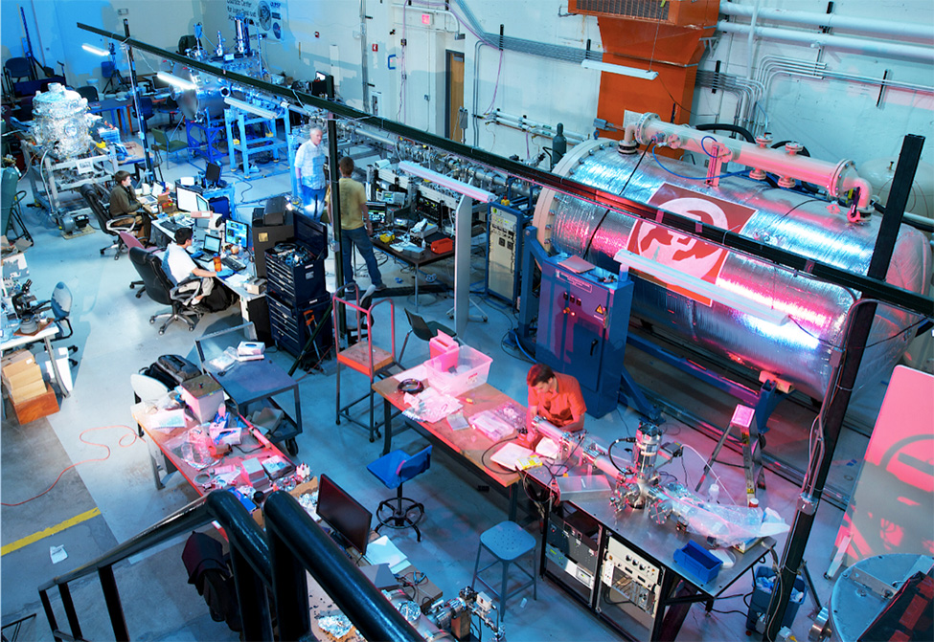

The Institute for Modeling Plasma, Atmospheres, and Cosmic Dust (IMPACT) houses a 3 MV linear electrostatic dust accelerator which is used for a variety of impact research activities as well as calibrating dust instruments for space applications. The dust accelerator is equipped with a 3 MV Pelletron generator capable of accelerating micron and submicron particles of various materials to velocities approaching 100 km/s.

The figure below illustrates the operation principle: the dust source is mounted onto the HV terminal of the Pelletron and individual charged dust particles are accelerated by the electrostatic field. A pair of pickup tube detectors is used to measure the velocity of each particle and the logic circuit of the Particle Selection Unit (PSU) selects the particles within a desired range of velocity and charge. The rest of the particles are deflected and do not reach the experimental chamber.

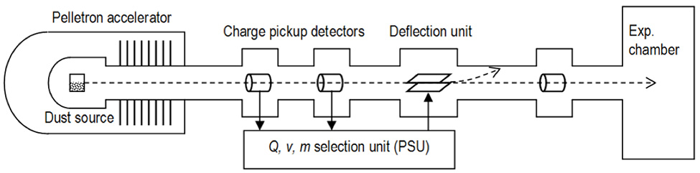

The entire system is oil-free and can be pumped down to the low 10-7 Torr range using a combination of turbomolecular pumps and cryopumps. All turbomolecular pumps are magnetically levitated to reduce vibrations, and all high-vacuum pumps are backed with oil-free forepumps. The laboratory also houses a separate, 20 kV "mini-accelerator" used to test various dust sources before installation into the main accelerator.

**Target Chambers**

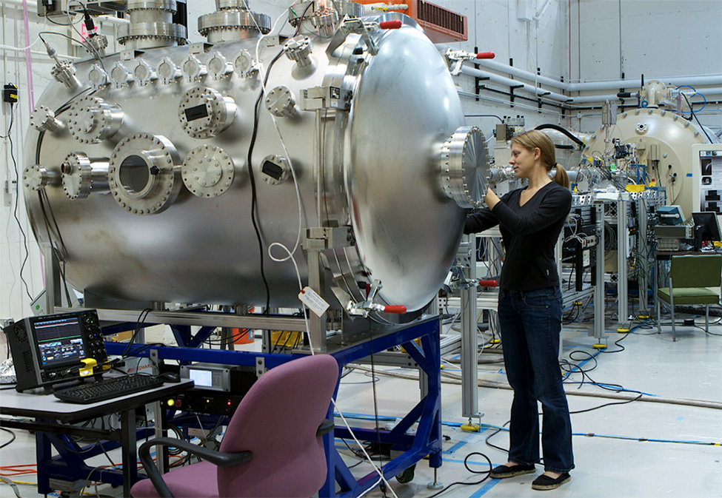

The photo above shows the large experimental chamber (LEIL) mounted at the end of the beam line. The LEIL chamber is 1.22 m in diameter, 1.52 m long, and has a volume of 2 m3. An externally-controlled moving translation stage is installed in the chamber which allows control over the impact position in one dimensions (transverse to the beam line) without breaking vacuum. All ports are standard conflat, of various sizes, and a variety of different viewports and electrical feedthroughs are available.

**Dust size and velocity distribution**

Dust particles with diameters ranging from 0.05 - 5 μm have been accelerated to velocities of 0.5 - 65 km/s. A detailed map of the distribution of launched dust particles is shown in the figure below.

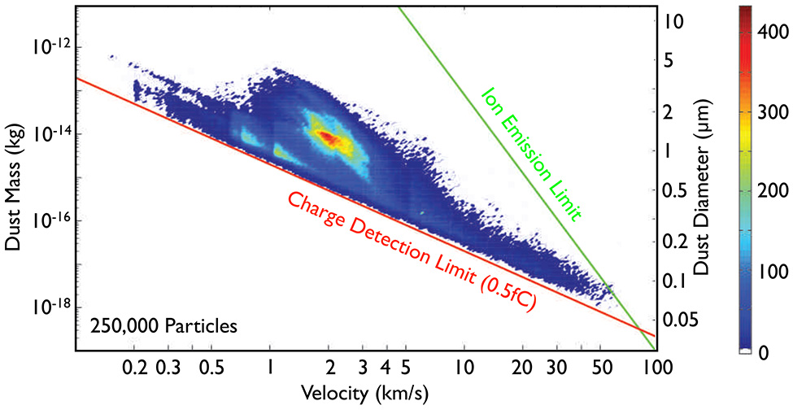

**Selection capability**

An FPGA-based unit performs two functions, using the pickup-detector signals as inputs. First, it digitally filters the raw signals to detect particles with extremely low charge levels (on the order of 4000 electrons) within the background detector noise. Secondly, it acts as a "particle selection unit", which downselects a user-selectable sub-population of the launched dust. Users can downselect based on particle velocity, charge, or mass.

**Dust rates and beam size**

The rate of particles reaching the target is highly dependent on the downselection criteria used. The rate of particles with no downselection is typically between 1 and 10 per second. If, for example, particles are velocity-limited to ≥10 km/s, the rate goes down to around 10-20 per minute. Higher velocity thresholds or additional selection criteria reduce the rates further.

The shape of the dust beam is typically Gaussian with a characteristic width of ~6 mm.

**Available materials**

The most common material in use at the accelerator is spherical iron particles, ranging in size from ~50 nm - 2 μm in diameter, and subsequently downselected as needed by the particle selection unit. Additional spherical metallic materials can also be used, though only a small variety have been tested so far. (It is expected that any spherical metallic particle can be launched, but they must be tested in the mini-accelerator before use).

Insulating particles such as silicates (olivine, SiO2, etc.) which have been coated with a very thin layer of platinum or conductive polymer (polypyrrole) can also be used, though use of coated silicates is typically reserved for more specialized applications.

**Data acquisition details**

Waveforms from each of the three pickup tube detectors are recorded with a 12-bit NI PXI-5124 unit running at 10-100 MSamp/s.

User data is recorded on either a LeCroy Waverunner 104Xi-A oscilloscope (4 channels, 12-bit, 5 GSamp/s 1 GHz bandwidth) or an NI PXI-5124 unit (2 channels, 12-bit 200 MSamp/s combined). Users may of course augment the DAQ systems as needed.

**Data "package" provided to user**

At the conclusion of an experimental run, users are provided with a data "package" which contains data on the launched particles, as follows:

CSV file; contains "metadata" on each particle: timestamp (ms resolution), velocity, mass, charge, radius.

HDF5 file; contains all of the above, in addition to the waveforms recorded by all NI units (i.e. all raw pickup-detector waveforms plus user data from the PXI-5124 unit).

LeCroy files; contain all user waveforms recorded by the LeCroy 104Xi-A oscilloscope.

**References:**

*3 MV Hypervelocity Dust Accelerator at the Colorado Center for Lunar Dust and Atmospheric Studies*, A. Shu, et al., *Rev. Sci. Instrum.* **83**(7) 075108 (2012).

*Characteristics of a New Dust Coordinate Sensor*, P. Northway, et al., *Meas. Sci. Technol.* **23** 105902 (2012).

*FPGA Cross-Correlation Filters for Real-Time Dust Detection and Selection*, E. Thomas, et al., *Planet. Space Sci.* **89** 71-76 (2013).

The dust accelerator is available for use by outside groups, following approval from the Colorado accelerator team.

To apply for accelerator beam time and to discuss usage costs, please fill out the application form (available at impact.colorado.edu) and send it to one of the following contact personnel:

Prof. Tobin Munsat Prof. Mihaly Horanyi

390 UCB 390 UCB

Boulder CO, 80309 Boulder, CO 80309

tobin.munsat@colorado.edu mihaly.horanyi@colorado.edu