Inclination damping on Titan and Callisto

Brynna G. Downey,¹ Francis Nimmo¹

¹ Dept. of Earth and Planetary Sciences, University of California, Santa Cruz, CA 95064
bgdowney@ucsc.edu

Abstract. Callisto has a subsurface ocean that under the influence of obliquity tides dissipates energy, which damps its inclination. The inclination damping timescale is ~700 Myr for Callisto at its measured inclination of 0.19°. The lifetime estimate is insensitive to the drag coefficient at the bottom of the ice shell, the ice shell thickness, and Callisto’s Love numbers. To explain why Callisto has a nonzero inclination that has a lifetime much less than the age of the solar system, either Callisto’s ice shell is stiffer than expected, lowering the amount of energy dissipated and increasing the lifetime of its inclination, or passage through one or more mean-motion resonances within the last 1 Gyr excited its inclination. Callisto is near a mean-motion resonance with Ganymede but otherwise far from other mean-motion resonances. Invoking dissipation for Jupiter as in Fuller et al. (2016) would mean that Callisto and the other Galilean satellites migrated larger distances than traditionally assumed, allowing for more feasible mean-motion resonances that Callisto could have passed through. Dermott et al. (1988) predict inclination excitations for first and second order resonances, and allowing obliquity tides to damp the inclination in between resonance crossings can explain Callisto’s current inclination.
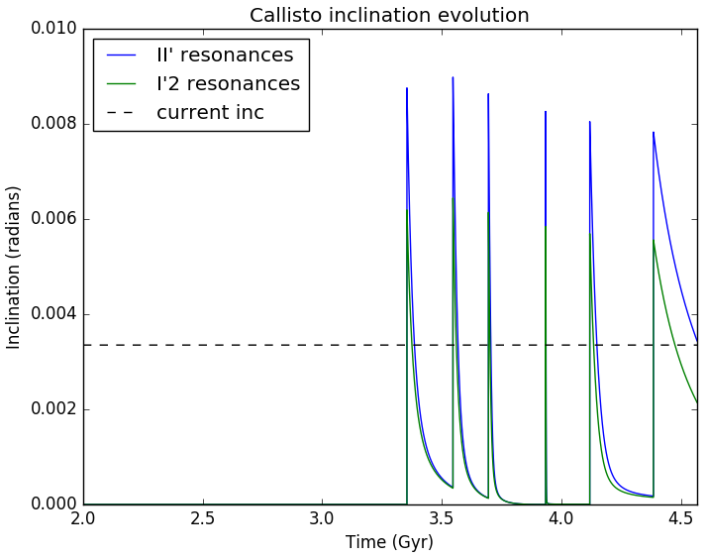
Figure 1: Inclination evolution of Callisto. The spikes are inclination excitations after passing through mean-motion resonances with Ganymede (mixed i-Ganymede i-Callisto resonances in blue and i²-Callisto resonances in green). The inclination damps because of obliquity tides. The semi-major axis evolutions for Callisto and Ganymede (not shown) follow the Fuller et al. (2016) model with t_{α}’s of 39 Gyr and 217 Gyr respectively.

E.M.A. Chen, F. Nimmo, G.A. Glatzmaier, Icarus 229, 11-30 (2014).
J. Fuller, J. Luan, E. Quataert, Mon. Not. R. Astron. Soc. 458, (2016).
S. Dermott, R. Malhotra, C.D. Murray, Icarus 76, 295-334, (1988).

