Using the solar wind to map the history of the Solar System: SIMS analysis of small bodies

Micah J. Schaible,¹ Cathy A. Dukes,² Menelaos Sarantos³, Robert E. Johnson,² Jasper S. Halekas,⁴ Michael R. Collier³

¹ School of Chemistry and Biochemistry, Georgia Institute of Technology, Atlanta, GA
² Department of Materials Science, University of Virginia, Charlottesville, VA
³ Goddard Space Flight Center, NASA, Greenbelt, MD
⁴ Department of Physics and Astronomy, University of Iowa, Iowa City, IA
mjschaible@gatech.edu

Abstract. The composition of small bodies can be used to constrain the provenance, history, and dynamical evolution of the materials condensed from the pre-solar nebula. Obtaining a measurement of the large-scale compositional distribution of small bodies throughout the Solar System today will allow questions regarding the origins and history of the material available on early Earth. Additionally, having a means to rapidly characterize the elemental compositions of bodies could help identify valuable resources for exploration and in situ resource utilization purposes. A robust and sensitive technique for obtaining elemental composition of small bodies exposed to irradiation is the collection and analysis of sputtered secondary ions (SIMS). First proposed as a compositional analysis technique over 30 years ago [1,2], SIMS can achieve excellent signal to noise ratios due to low ion backgrounds and high detection sensitivities. Using sputtered flux estimates obtained from Monte Carlo modeling and comparing with experimental sputtering measurements made using lunar soil, it has been demonstrated that sufficient secondary ions are sputtered from small bodies to allow for region-specific compositional mapping [3]. The figure on the left shows how solar wind sputtered Mg⁺ subject to the ambient IMF is distributed around an 11km diameter body, and the figure on the right shows how analysis of the sputtered ion ratios can be used to determine the most likely origin of the body. This measurement scheme has been proposed for two recent small body mission proposals and is well suited to a smallsat mission design.
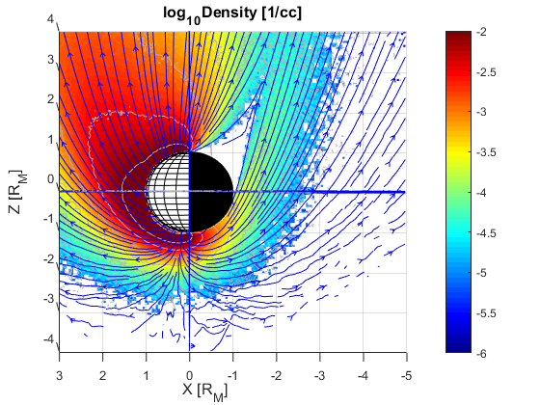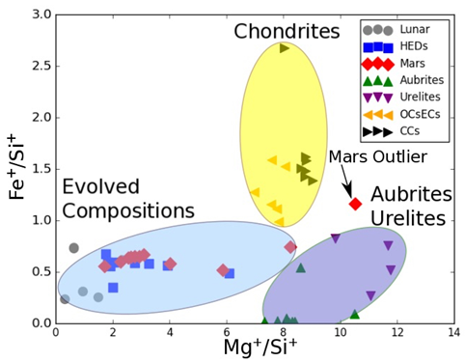
References: [1] Managadze, G.G. and R.Z. Sagdeev (1988), Icarus, 73, 294-302. [2] Johnson, R.E., and R.A. Baragiola (1991), GRL, 18(11), 2169–2172. [3] Schaible, M.J., et al. (2017), JGR - Planets, 122

